Comparative Cognition Numerosity Analysisof Cowlog Data Part V

Kelly Wallace

April 12, 2018

This is the last script! This makes the actual full data frame with numerosity, shuttlebox, and detour information combined. For now I've got the shuttlebox data analysis in here.

Note for later on- the boxplots with sex I was having trouble putting hte labels on so I hardcoded them into the title, need to fix it.

## Warning: package 'ggplot2' was built under R version 3.2.4

## Warning: package 'dplyr' was built under R version 3.2.5

## Warning: package 'rmarkdown' was built under R version 3.2.5

## Warning: package 'knitr' was built under R version 3.2.5

## Warning: package 'readr' was built under R version 3.2.5

## Warning in left_join_impl(x, y, by$x, by$y, suffix$x, suffix$y): joining  
## factors with different levels, coercing to character vector

## Warning in left_join_impl(x, y, by$x, by$y, suffix$x, suffix$y): joining  
## factor and character vector, coercing into character vector

Shuttlebox Measures:

shuttlebox_average_distance_from_correct_stimulus_during_gaps shuttlebox_slope

Detour Measures: detour_trial_1_did_fish_solve_barrier_problem detour_trial_1_barrier_problem_time_around_barrier_minus_time_to_contact_barrier

Numerosity Measures: average_performance_across_all_9_testing_trials_using_T30_to_T50_data average_latency_to_enter_correct_side

## Warning: replacing previous import by 'tidyr::%>%' when loading 'broom'

## Warning: replacing previous import by 'tidyr::gather' when loading 'broom'

## Warning: replacing previous import by 'tidyr::spread' when loading 'broom'

## Warning: Removed 20 rows containing non-finite values (stat_boxplot).

## Warning: Removed 20 rows containing non-finite values (stat_n_text).

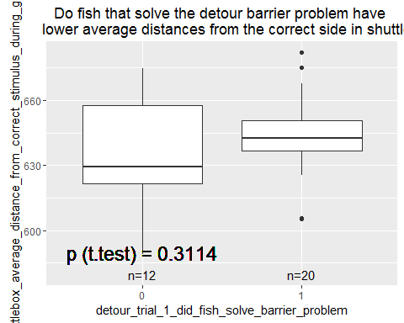

## Warning: Removed 20 rows containing non-finite values (stat_boxplot).

## Warning: Removed 20 rows containing non-finite values (stat_n_text).

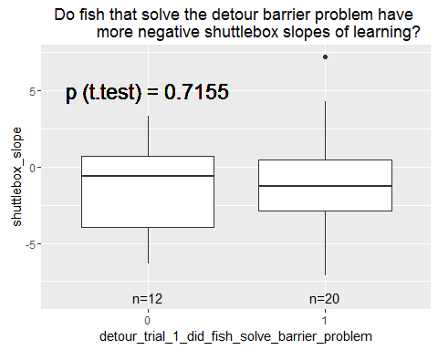

## Warning: Removed 20 rows containing non-finite values (stat_boxplot).

## Warning: Removed 20 rows containing non-finite values (stat_n_text).

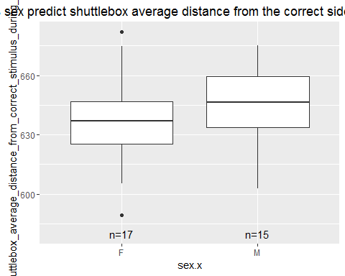

## Warning: Removed 20 rows containing non-finite values (stat_boxplot).

## Warning: Removed 20 rows containing non-finite values (stat_n_text).

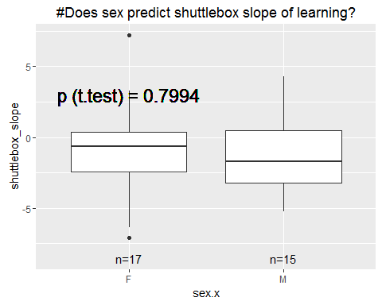

##   
## Call:  
## lm(formula = df.full$shuttlebox_average_distance_from_correct_stimulus_during_gaps ~   
## df.full$detour_trial_1_barrier_problem_time_around_barrier_minus_time_to_contact_barrier)  
##   
## Residuals:  
## Min 1Q Median 3Q Max   
## -39.376 -8.230 -0.567 8.252 37.866   
##   
## Coefficients:  
## Estimate  
## (Intercept) 645.48291  
## df.full$detour_trial_1_barrier_problem_time_around_barrier_minus_time_to_contact_barrier -0.01990  
## Std. Error  
## (Intercept) 5.56163  
## df.full$detour_trial_1_barrier_problem_time_around_barrier_minus_time_to_contact_barrier 0.03237  
## t value  
## (Intercept) 116.060  
## df.full$detour_trial_1_barrier_problem_time_around_barrier_minus_time_to_contact_barrier -0.615  
## Pr(>|t|)  
## (Intercept) <2e-16  
## df.full$detour_trial_1_barrier_problem_time_around_barrier_minus_time_to_contact_barrier 0.546  
##   
## (Intercept) ***  
## df.full$detour_trial_1_barrier_problem_time_around_barrier_minus_time_to_contact_barrier   
## ---  
## Signif. codes: 0 '***' 0.001 '**' 0.01 '*' 0.05 '.' 0.1 ' ' 1  
##   
## Residual standard error: 20.07 on 18 degrees of freedom  
## (32 observations deleted due to missingness)  
## Multiple R-squared: 0.02057, Adjusted R-squared: -0.03385   
## F-statistic: 0.378 on 1 and 18 DF, p-value: 0.5464

## Warning: Removed 32 rows containing non-finite values (stat_smooth).

## Warning: Removed 32 rows containing missing values (geom_point).

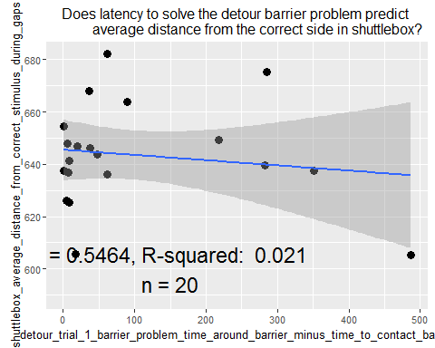

##   
## Call:  
## lm(formula = df.full$shuttlebox_slope ~ df.full$detour_trial_1_barrier_problem_time_around_barrier_minus_time_to_contact_barrier)  
##   
## Residuals:  
## Min 1Q Median 3Q Max   
## -6.2488 -2.0181 -0.2976 1.2866 8.0686   
##   
## Coefficients:  
## Estimate  
## (Intercept) -0.8422214  
## df.full$detour_trial_1_barrier_problem_time_around_barrier_minus_time_to_contact_barrier -0.0003933  
## Std. Error  
## (Intercept) 0.9333031  
## df.full$detour_trial_1_barrier_problem_time_around_barrier_minus_time_to_contact_barrier 0.0054316  
## t value  
## (Intercept) -0.902  
## df.full$detour_trial_1_barrier_problem_time_around_barrier_minus_time_to_contact_barrier -0.072  
## Pr(>|t|)  
## (Intercept) 0.379  
## df.full$detour_trial_1_barrier_problem_time_around_barrier_minus_time_to_contact_barrier 0.943  
##   
## Residual standard error: 3.369 on 18 degrees of freedom  
## (32 observations deleted due to missingness)  
## Multiple R-squared: 0.0002913, Adjusted R-squared: -0.05525   
## F-statistic: 0.005244 on 1 and 18 DF, p-value: 0.9431

## Warning: Removed 32 rows containing non-finite values (stat_smooth).

## Warning: Removed 32 rows containing missing values (geom_point).

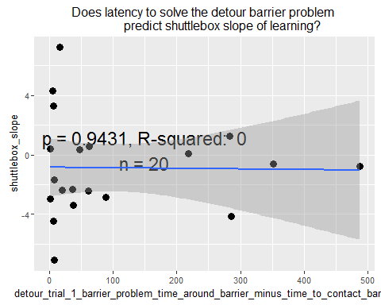

##   
## Call:  
## lm(formula = df.full$shuttlebox_average_distance_from_correct_stimulus_during_gaps ~   
## df.full$average_performance_across_all_9_testing_trials_using_T30_to_T50_data)  
##   
## Residuals:  
## Min 1Q Median 3Q Max   
## -33.640 -11.666 3.291 12.804 37.859   
##   
## Coefficients:  
## Estimate  
## (Intercept) 643.97  
## df.full$average_performance_across_all_9_testing_trials_using_T30_to_T50_data -16.08  
## Std. Error  
## (Intercept) 19.39  
## df.full$average_performance_across_all_9_testing_trials_using_T30_to_T50_data 40.21  
## t value  
## (Intercept) 33.22  
## df.full$average_performance_across_all_9_testing_trials_using_T30_to_T50_data -0.40  
## Pr(>|t|)  
## (Intercept) <2e-16  
## df.full$average_performance_across_all_9_testing_trials_using_T30_to_T50_data 0.694  
##   
## (Intercept) ***  
## df.full$average_performance_across_all_9_testing_trials_using_T30_to_T50_data   
## ---  
## Signif. codes: 0 '***' 0.001 '**' 0.01 '*' 0.05 '.' 0.1 ' ' 1  
##   
## Residual standard error: 20.28 on 19 degrees of freedom  
## (31 observations deleted due to missingness)  
## Multiple R-squared: 0.008341, Adjusted R-squared: -0.04385   
## F-statistic: 0.1598 on 1 and 19 DF, p-value: 0.6938

## Warning: Removed 31 rows containing non-finite values (stat_smooth).

## Warning: Removed 31 rows containing missing values (geom_point).

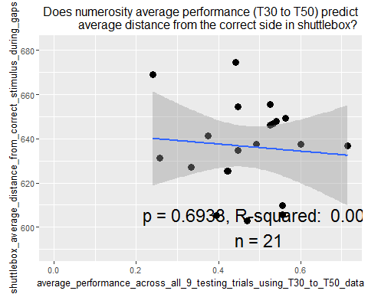

##   
## Call:  
## lm(formula = df.full$shuttlebox_slope ~ df.full$average_performance_across_all_9_testing_trials_using_T30_to_T50_data)  
##   
## Residuals:  
## Min 1Q Median 3Q Max   
## -5.7420 -1.8797 0.2013 0.8278 7.4102   
##   
## Coefficients:  
## Estimate  
## (Intercept) -5.057  
## df.full$average_performance_across_all_9_testing_trials_using_T30_to_T50_data 8.758  
## Std. Error  
## (Intercept) 2.916  
## df.full$average_performance_across_all_9_testing_trials_using_T30_to_T50_data 6.047  
## t value  
## (Intercept) -1.735  
## df.full$average_performance_across_all_9_testing_trials_using_T30_to_T50_data 1.448  
## Pr(>|t|)  
## (Intercept) 0.099  
## df.full$average_performance_across_all_9_testing_trials_using_T30_to_T50_data 0.164  
##   
## (Intercept) .  
## df.full$average_performance_across_all_9_testing_trials_using_T30_to_T50_data   
## ---  
## Signif. codes: 0 '***' 0.001 '**' 0.01 '*' 0.05 '.' 0.1 ' ' 1  
##   
## Residual standard error: 3.049 on 19 degrees of freedom  
## (31 observations deleted due to missingness)  
## Multiple R-squared: 0.09942, Adjusted R-squared: 0.05202   
## F-statistic: 2.097 on 1 and 19 DF, p-value: 0.1638

## Warning: Removed 31 rows containing non-finite values (stat_smooth).

## Warning: Removed 31 rows containing missing values (geom_point).

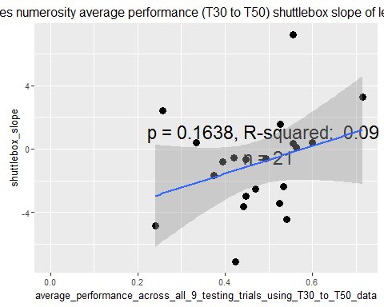

##   
## Call:  
## lm(formula = df.full$shuttlebox_average_distance_from_correct_stimulus_during_gaps ~   
## df.full$average_latency_to_enter_correct_side)  
##   
## Residuals:  
## Min 1Q Median 3Q Max   
## -34.953 -10.085 1.396 11.151 37.750   
##   
## Coefficients:  
## Estimate Std. Error t value  
## (Intercept) 640.7954 8.2635 77.546  
## df.full$average_latency_to_enter_correct_side -0.1022 0.1635 -0.625  
## Pr(>|t|)   
## (Intercept) <2e-16 ***  
## df.full$average_latency_to_enter_correct_side 0.54   
## ---  
## Signif. codes: 0 '***' 0.001 '**' 0.01 '*' 0.05 '.' 0.1 ' ' 1  
##   
## Residual standard error: 20.15 on 19 degrees of freedom  
## (31 observations deleted due to missingness)  
## Multiple R-squared: 0.02013, Adjusted R-squared: -0.03145   
## F-statistic: 0.3903 on 1 and 19 DF, p-value: 0.5396

## Warning: Removed 31 rows containing non-finite values (stat_smooth).

## Warning: Removed 31 rows containing missing values (geom_point).

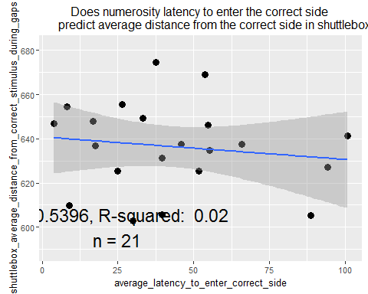

##   
## Call:  
## lm(formula = df.full$shuttlebox_slope ~ df.full$average_latency_to_enter_correct_side)  
##   
## Residuals:  
## Min 1Q Median 3Q Max   
## -6.0041 -1.7523 0.2107 1.1586 8.1908   
##   
## Coefficients:  
## Estimate Std. Error t value  
## (Intercept) -1.29067 1.31398 -0.982  
## df.full$average_latency_to_enter_correct_side 0.00805 0.02601 0.310  
## Pr(>|t|)  
## (Intercept) 0.338  
## df.full$average_latency_to_enter_correct_side 0.760  
##   
## Residual standard error: 3.205 on 19 degrees of freedom  
## (31 observations deleted due to missingness)  
## Multiple R-squared: 0.005017, Adjusted R-squared: -0.04735   
## F-statistic: 0.09581 on 1 and 19 DF, p-value: 0.7603

## Warning: Removed 31 rows containing non-finite values (stat_smooth).

## Warning: Removed 31 rows containing missing values (geom_point).

