## **Model Outlining Summary**

## **Overall summary of both data sets:**

## Reduced aggregation data Test_set_summary:

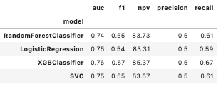

## Clinical aggregation data Test_set_summary:

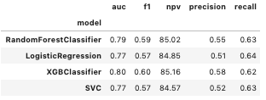

## **Detailed summary of both data sets:**

## **Reduced aggregation (Top 9 continuous aggregated + 4categorical +2 onetime measurements [2class])**

### Correlation (abs) of predictors

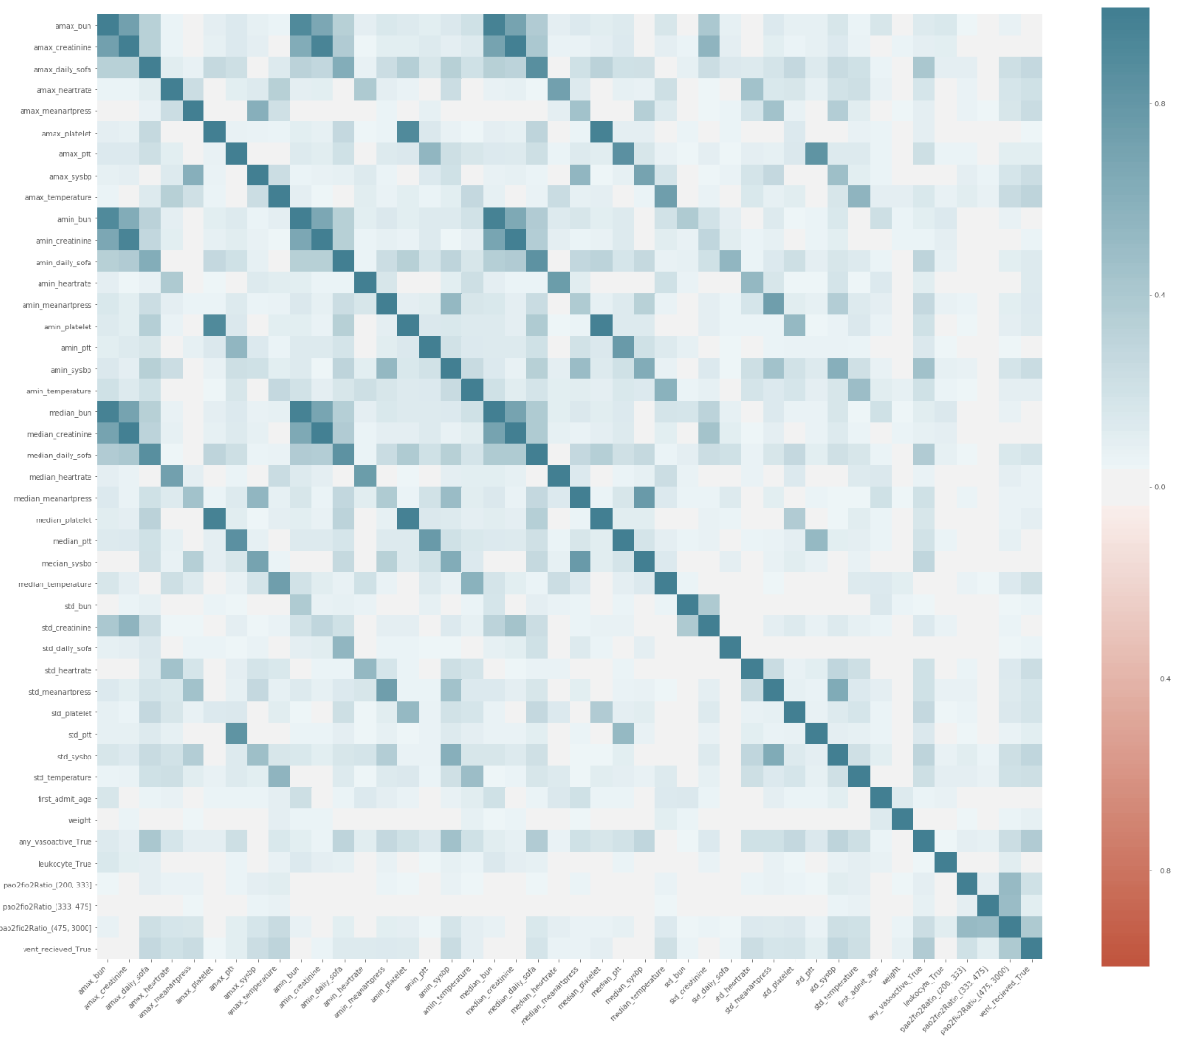

**Dropped one of the two predictors if corr>0.7.

## **Test_set_summary:**

* + 

### Svm

* Cv
  + 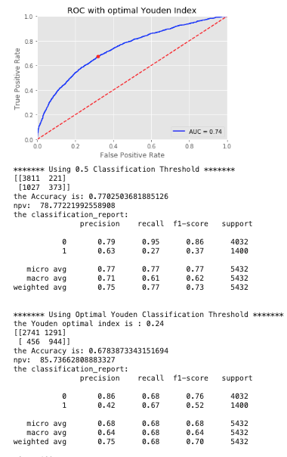
* Test
  + 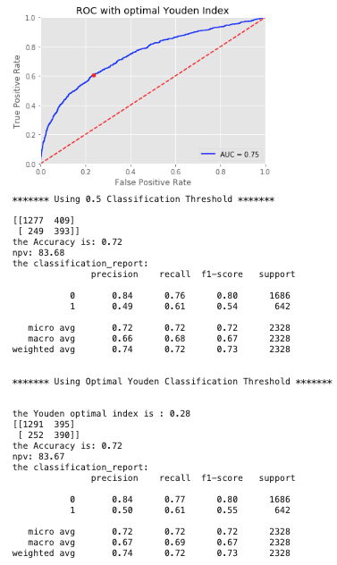

### Xgboost

* Cv
  + 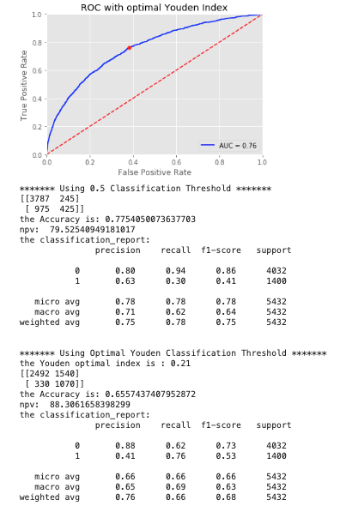
* Test
  + 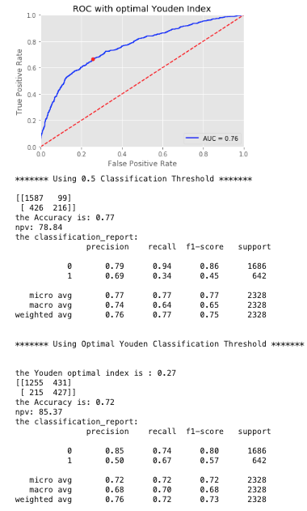
* Variable importance
  + 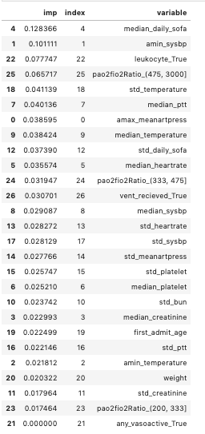

### RF

* Cv:
  + 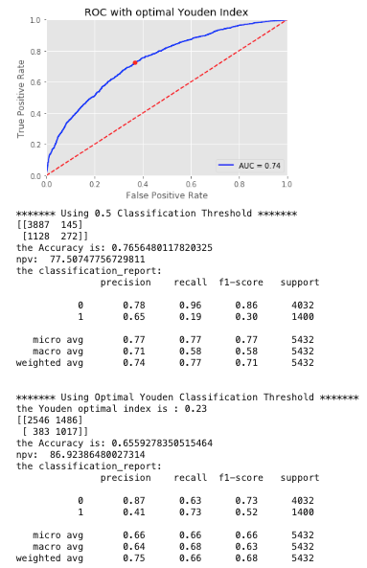
* Test:
  + 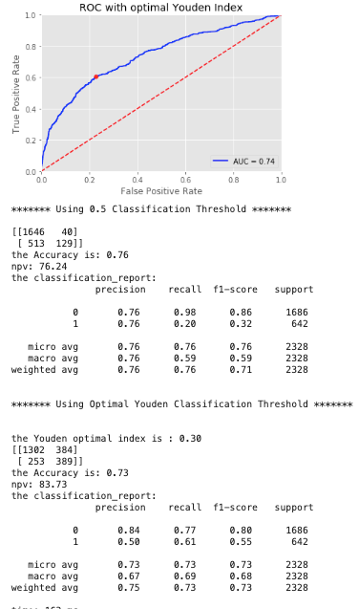
* Variable importance
  + 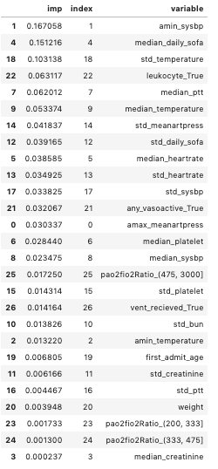

### Logistic Regression

* Cv:
  + 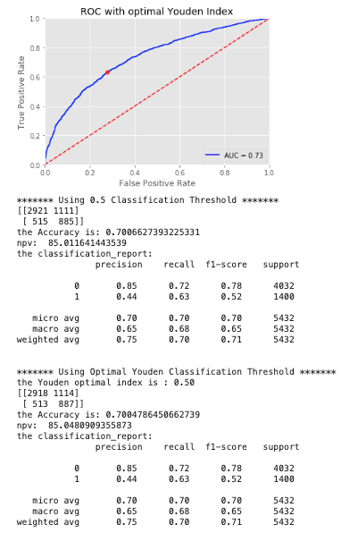
* Test
  + 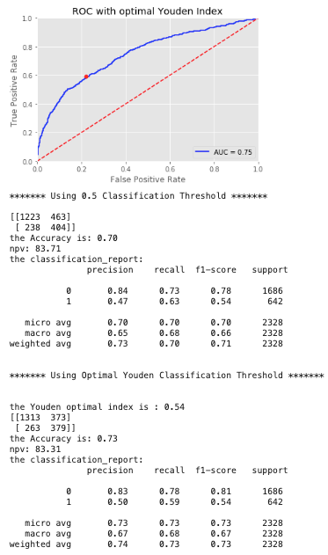

## **Clinically Guided Aggregation dataset**

### Correlation (abs) of Predictors

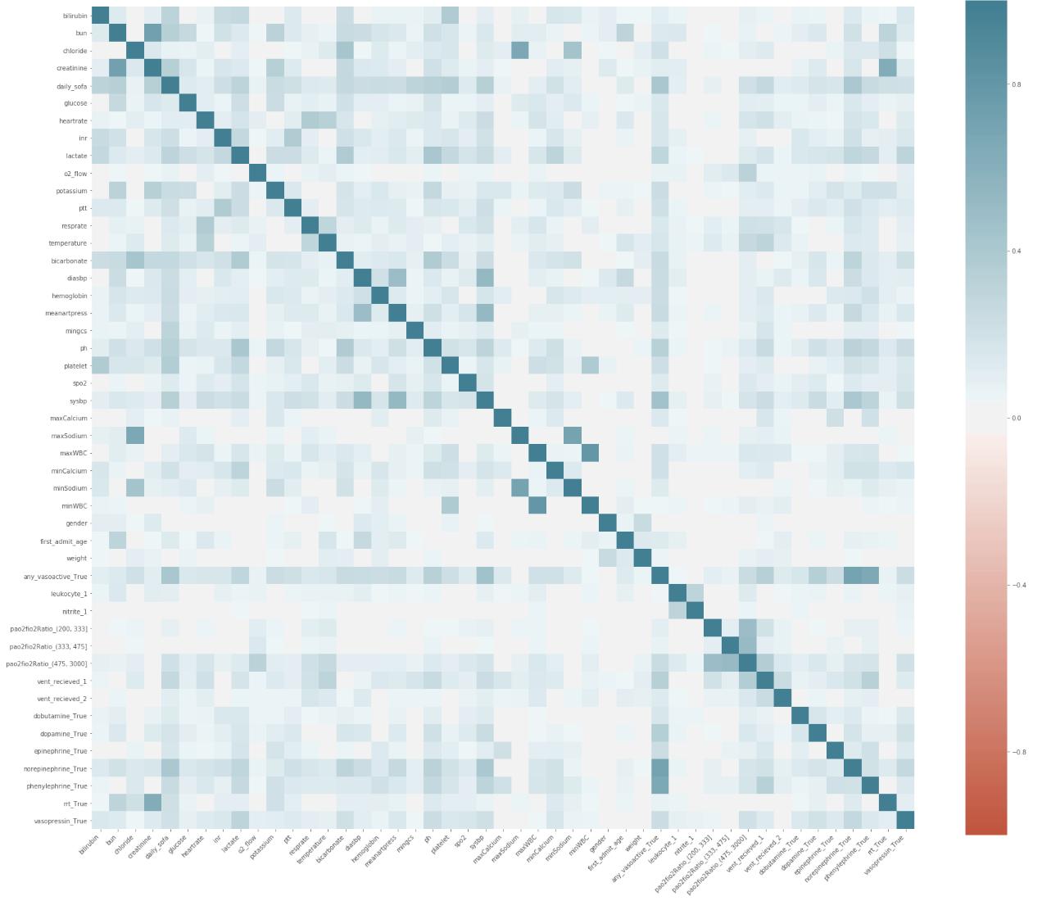

**Dropped one of the two predictors if corr>0.7.

Total test_set eval:



### Svm

* Cv
  + 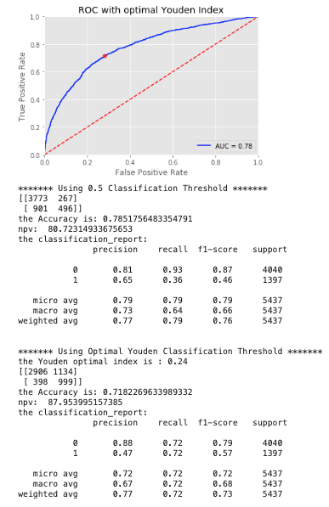
* Test
  + 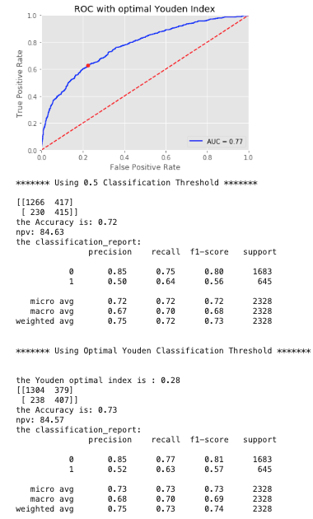

### Xgboost

* Cv

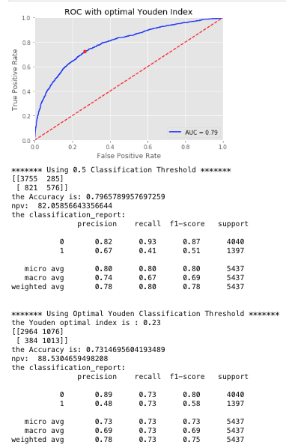

* Test
  + 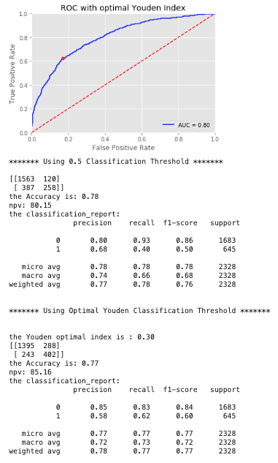
* Variable importance
  + 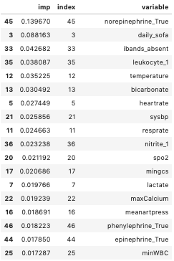

### RF

* Cv:
  + 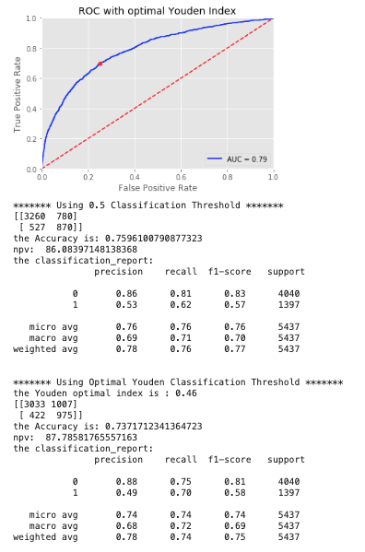
* Test:
  + 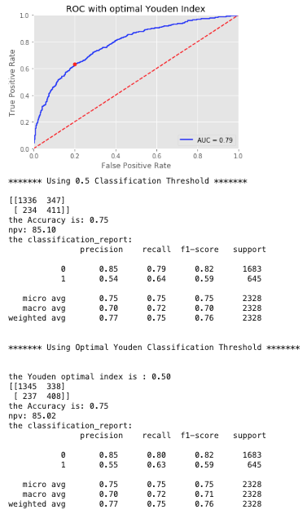
  + Variable importance:
    - 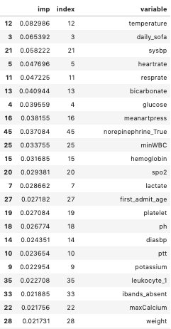

### Logistic Regression

* Cv:
  + 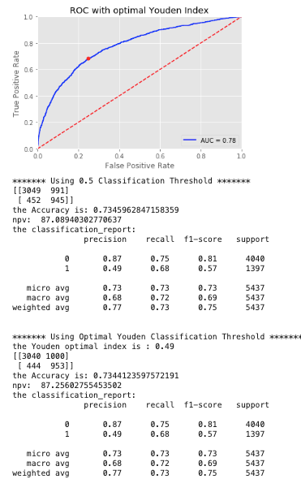
* Test
  + 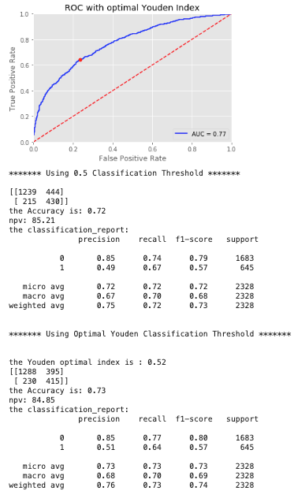

## **Local model**

### Logistic Regression

* Without CV; m=200 [this is for only max values, other predictors were omitted for training time]:
  + 