**Challenge 1:**

Create MySQL Database with inventory.

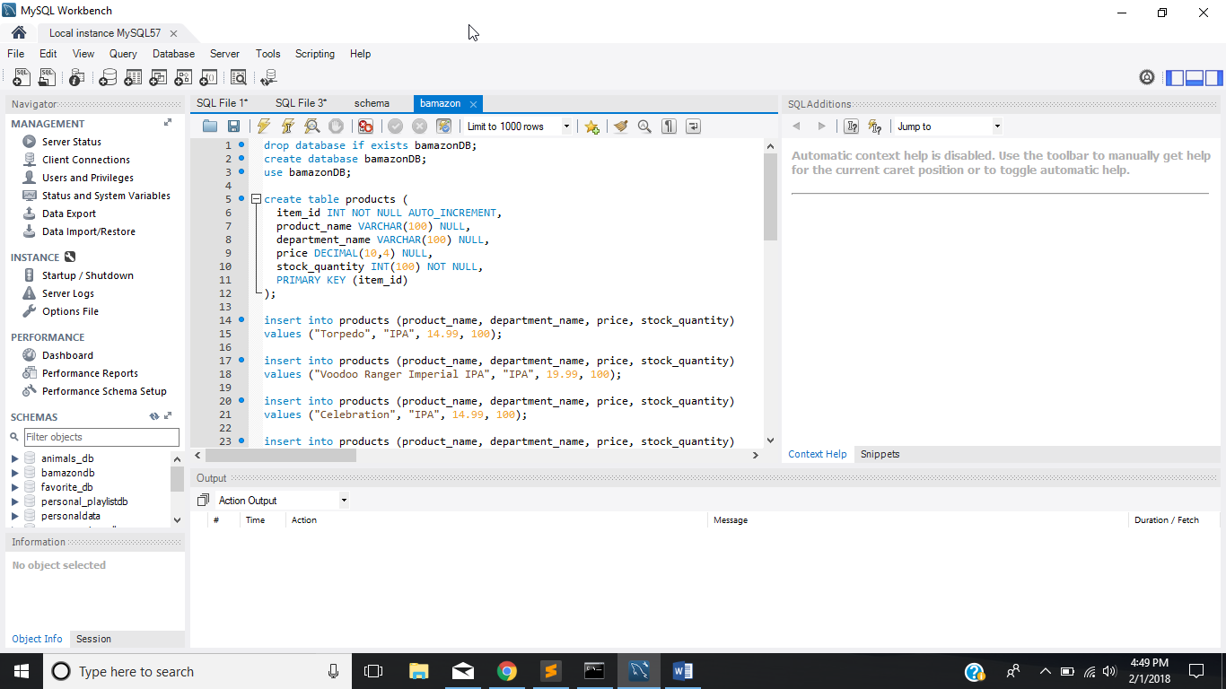

MySQL Database Inventory will appear in the command window when bamazoncustomer.js is run.

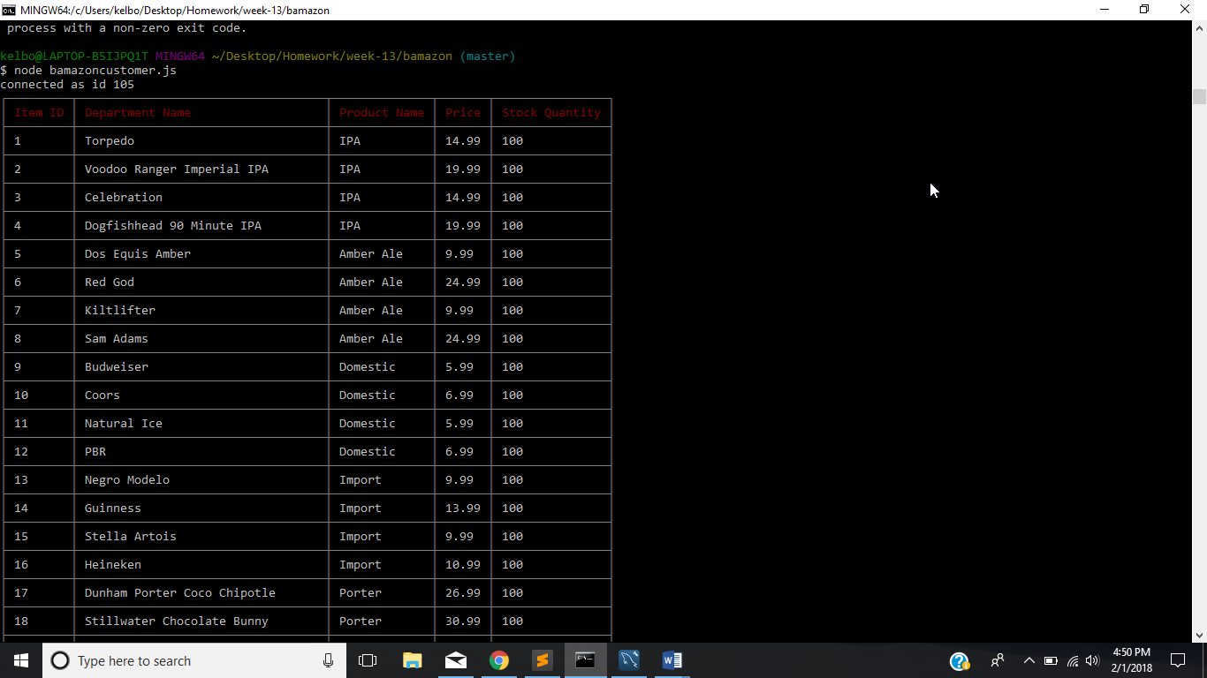

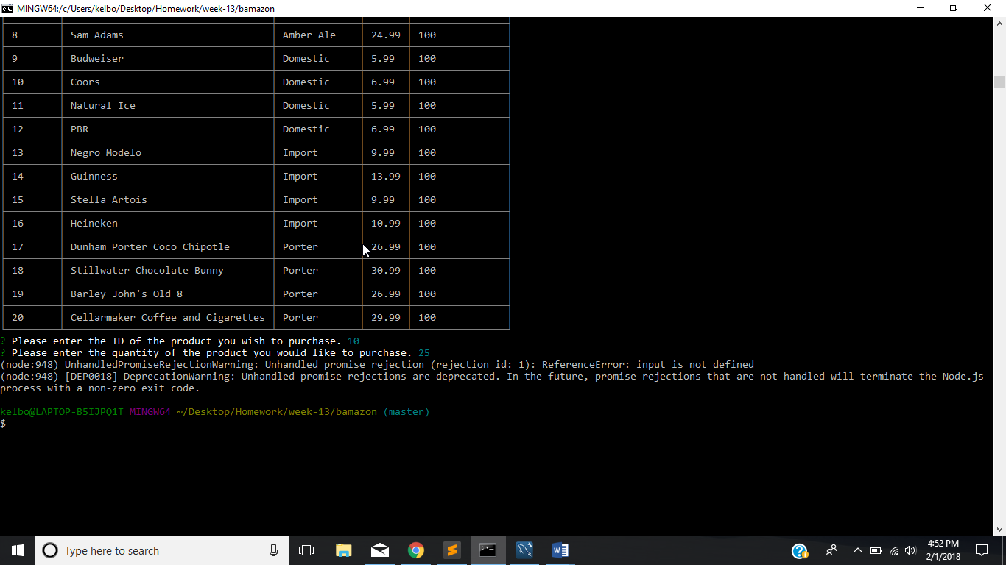

Using inquirer.prompt, the user will be asked two questions right after the inventory is displayed when bamazoncustomer.js is run.

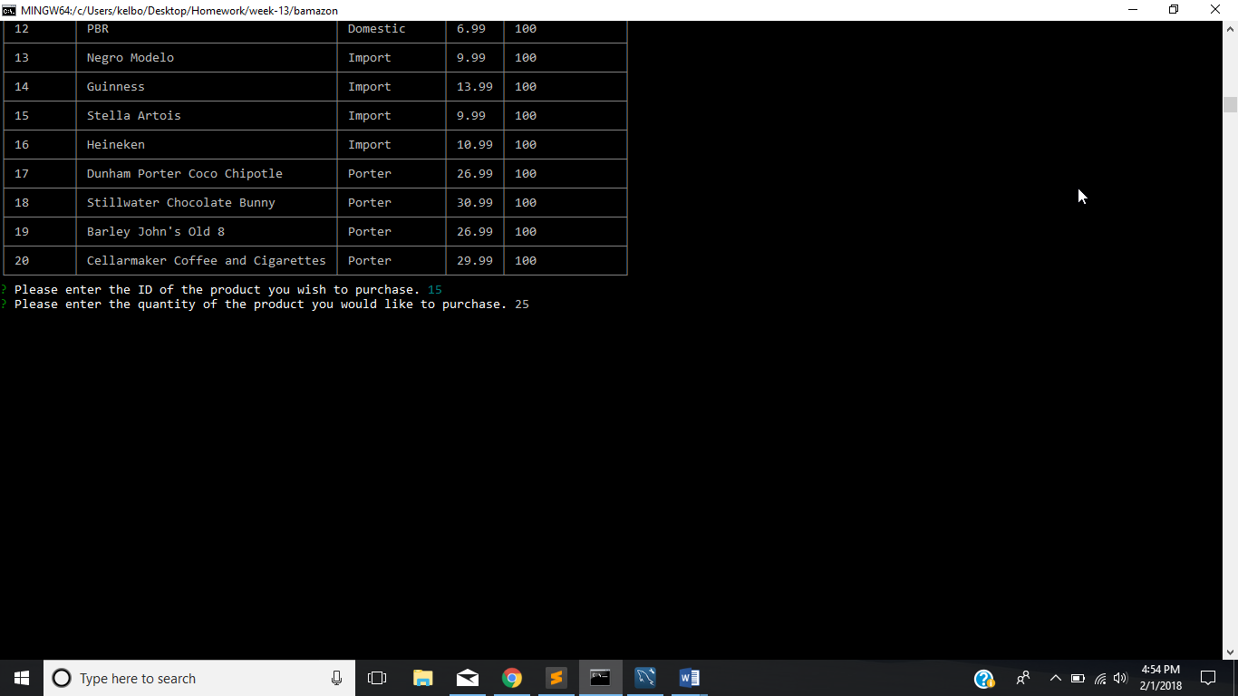

After the input is entered by the user the total items purchased and total cost of purchase will appear (unfortunately, that didn’t happen for me as I continually received the following error:

(node:21100) UnhandledPromiseRejectionWarning: Unhandled promise rejection (rejection id: 1): ReferenceError: input is not defined

(node:21100) [DEP0018] DeprecationWarning: Unhandled promise rejections are deprecated. In the future, promise rejections that are not handled will terminate the Node.js process with a non-zero exit code.)

