Dinosaur Reference
for Children

Print Resources

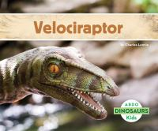 | 1. Velociraptor  Lennie, Charles
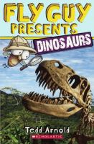 | 2. Flying Guy Presents: Dinosaurs  Arnold, Tedd
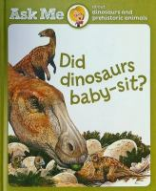 | 3. Ask Me About Dinosaurs and Prehistoric Animals
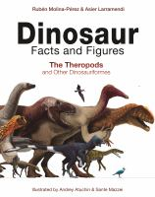 | 4. Dinosaur: Facts and Figures  Molina-Pérez, Rubén
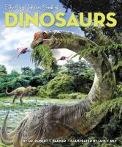 | 5. The Big Golden Book of Dinosaurs  Bakker, Robert T.
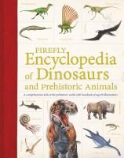 | 6. Firefly Encyclopedia of Dinosaurs and Prehistoric Animals
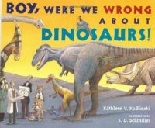 | 7. Boy, Were We Wrong About Dinosaurs!  Kudlinski, Kathleen V.
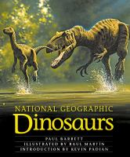 | 8. National Geographic Dinosaurs  Barrett, Paul M.
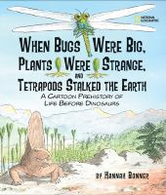 | 9. When Bugs Were Big, Plants Were Strange, and Tetrapods Stalked the Earth  Bonner, Hannah
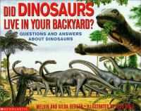 | 10. Did Dinosaurs Live in Your Backyard?  Berger, Melvin
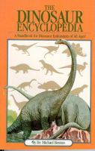 | 11. The Dinosaur Encyclopedia  Benton, M. J.

