Dinosaur Reference
for Children

Print Resources

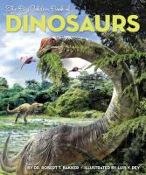 | 1. The Big Golden Book of Dinosaurs  Bakker, Robert T. | 567.9 B

