Evaluating Models
Every model has advantages (merits) and limitations. Understanding what these are allows us to move more flexibly between different types of models, which can help us develop a more complete explanation of how and why phenomena occur.
What types of phenomena will we try to explain with the different models below?
 | Which frame(s) are you using to evaluate this model? | What are some advantages (merits) of this model? | What are some limitations  of this model?
Model 1:  2 foam panels slipping/breaking   | ❑ Stability or change over time or space  ❑ Thinking across different scales  ❑ Cause and effect in M-E-F relationships
Model 2:  Inverter magnets   | ❑ Stability or change over time or space  ❑ Thinking across different scales  ❑ Cause and effect in M-E-F relationships
Model 3:  Particle-level Simulation (optional)  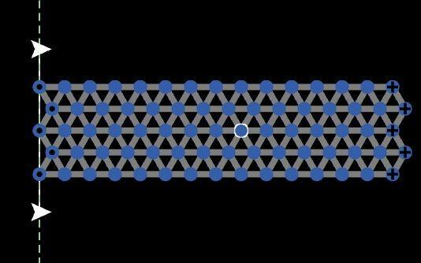  Wilensky, U. 1999. NetLogo. http://ccl.northwestern.edu/netlogo/. | ❑ Stability or change over time or space  ❑ Thinking across different scales  ❑ Cause and effect in M-E-F relationships

