Name: ______________________________________ | Date: ___________________

Krakatoa (Case Study) - find link in Schoology message
Answer the following questions to explain what causes a volcano to
(1) appear stable over long periods of time and then
(2) experience sudden catastrophic change.

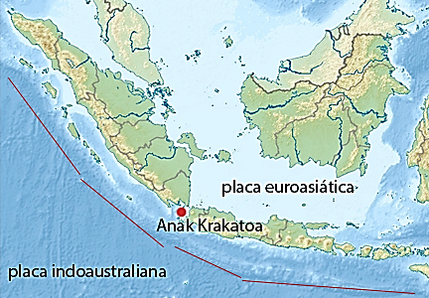
Anak Krakatau is a volcano off the coast of Indonesia. It lies near the boundary between the Indo-Australian Plate and the Eurasian Plate.

Interactions between these two plates transfer energy into the rock near the boundary. This causes pockets of rock to melt and become magma. Gases in the hot magma put pressure on the solid rock above as a result of particle collisions. The upward force from this pressure can cause the crust to deform over time and eventually break, allowing magma to reach the surface.

- Which interactions at the particle scale do we need in order to explain why the crust above the magma will break, allowing magma to reach the surface?
- The attraction due to electric forces (bonds) between the particles of rock will weaken when the particles are forced apart by the upward forces.
- The attraction due to electric forces (bonds) between the particles of rock will get stronger when the particles are forced apart by the upward forces.
- The attraction due to gravity between the particles of rock and Earth will get stronger when the particles are forced apart by the upward forces.
- The repulsion due to gravity between the particles of rock and Earth will weaken when the particles are forced apart by the upward forces.

The dome of Anak Krakatau first appeared above the ocean in 1927. For almost 100 years, it grew very slowly as magma seeped and sputtered from the top. Until 2018, it grew taller at a rate of about 2 meters per year. At left is Anak Krakatau in 1929 when it was just a rock, barely a few meters above the waves. At right is the volcanic island of Anak Krakatau in 2013.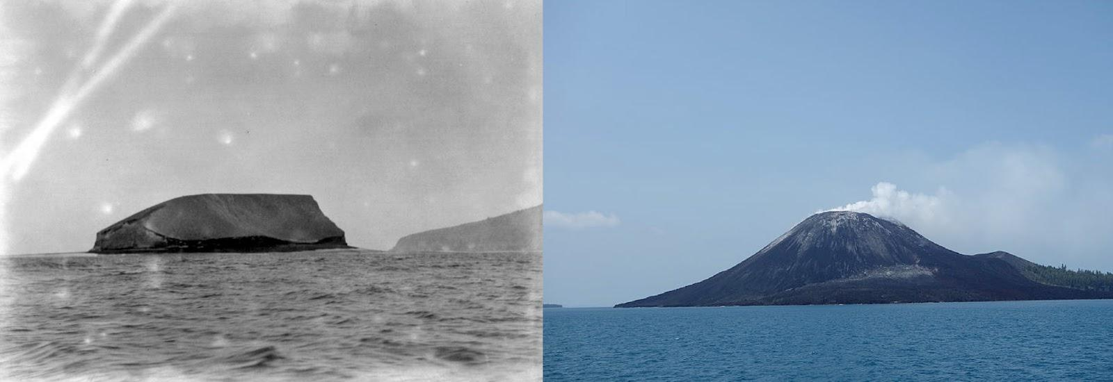

A physics student studying Anak Krakatau created the following model of the volcanic island to represent this period of growth. The student modeled the rock and dirt on the surface of the volcano as cubes of matter that each have a mass of m. The student modeled two types of forces on each cube of matter: (1) downward forces due to the weight of the rocks and dirt that make up Earth’s crust (F_{w}), and (2) upward forces from the pressure of the heated gases in the magma pushing on the solid rock above it (F_{P}).
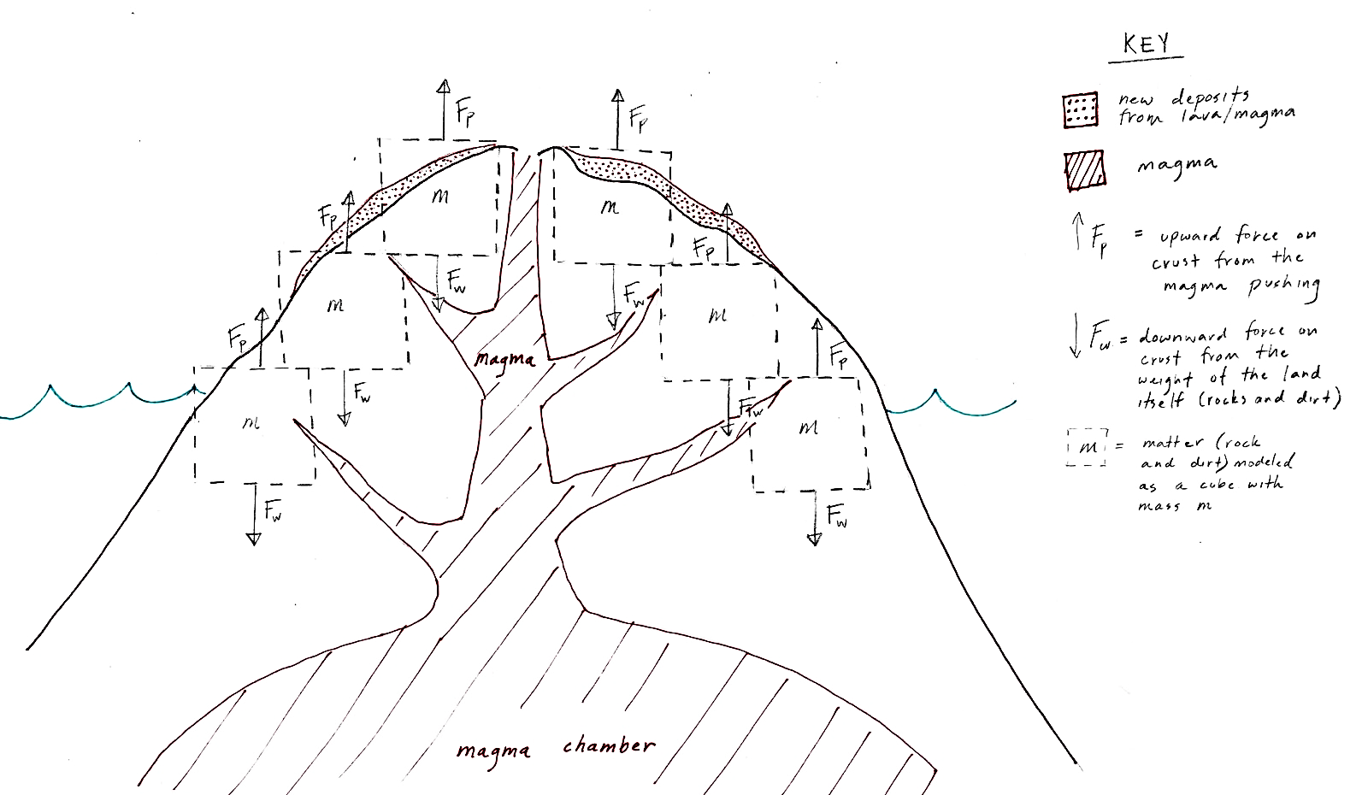
- Using this model, which of the following do you predict about stability and change in the system at this scale?
- There are many forces acting on the matter at this scale, so the system will be unstable.
- The forces on each cube of matter are roughly balanced at this scale, so the system will be stable.
- The upward forces from the magma are much stronger than the forces from the weight of the rock at this scale, so the system will be unstable.
- There are no forces acting on the system, so the system will be stable.

On December 22, 2018, a quarter of a square kilometer of land slipped off the side of Anak Krakatau and into the ocean in a massive landslide. Within hours, the side of the volcano exploded, causing a massive wave of water that devastated nearby communities. The diagram below illustrates the series of events.
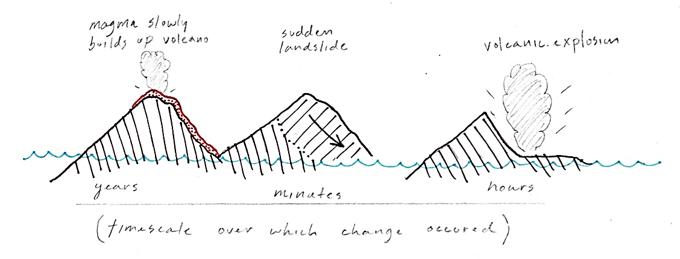
Scientists believe that the landslide triggered the explosive eruption. “At first we thought that, OK, the eruption triggered the collapse,” said Edo Nurshal, a research assistant at the Bandung Institute of Technology in Indonesia. “Actually, the condition is vice versa.”
The physics student made a new model to represent one of the cubes of mass on the volcano in the minutes after the landslide, but before the explosion.
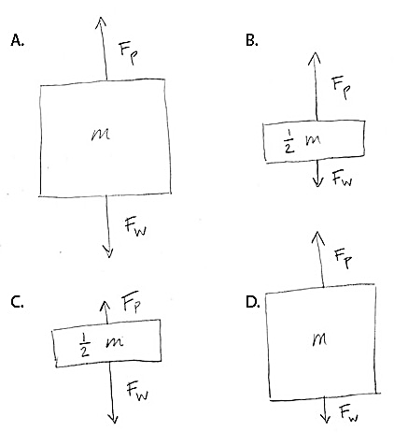
- Which of the free-body diagram models to the right can help explain why the landslide triggered the explosion?
- A
- B
- C
- D

- Which of the following best explains what might have happened to trigger the explosive transfer of energy after the landslide, using the model you chose above?
- The magnitude of the forces upward from the magma became larger (F_{P}). The resulting unbalanced forces upward from the magma transferred energy out of the system.
- The magnitude of the forces downward from the weight of the crust (F_{w}) became larger. The resulting unbalanced forces downward transferred energy out of the system.
- The magnitude of the forces upward from the magma became smaller (F_{P}). The resulting unbalanced forces downward transferred energy out of the system.
- The magnitude of the forces downward from the weight of the crust (F_{w}) became smaller. The resulting unbalanced forces upward from the magma (F_{P}) transferred energy out of the system.

- Geysers, landslides, and ice chunks breaking off of a glacier are all processes on Earth's surface that happen very suddenly, like volcanic eruptions do. Choose one of these processes that you think you could explain using ideas from the M-E-F triangle.
- Geysers that erupt every few hours
- Landslides right after a rainstorm (We will focus on this situation. Happens in California) As the rain falls on a hillside, what happens to the mass of the soil? What would this do to the stability of the soil on the slope?

- Ice chunks breaking off of a glacier a few days after the warmest month on record

- Which lens(es) would be the most useful to explain why the process you chose could occur so suddenly after a long period of no change?
- Stability over time or space
- Change over time or space
- Thinking at/across different scales

- How could the lens(es) you chose help you explain the process you chose?

