Notes Unit 2 Lesson 4

 With a partner
How do the edges of the foam in image A better represent the structure of the plates along their edges than B?

Every _____________ has _____________ and _____________. Understanding these can help us move more flexibly between different types of models for explaining _______________________________________ occur.

Video #1 Questions
What would you see happening to the matter at these locations?

What if anything was different about the matter at the locations where the matter broke off versus it did not? What if anything was different about the forces acting on the matter at those locations?

 | Which frame(s) are you using to evaluate this model? | What are some advantages of this model? | What are some limitations of this model?
Model 1:  2 foam panels slipping/breaking   | ❑ Stability or change over time or space  ❑ Thinking across different scales  ❑ Cause and effect in M-E-F relationships

Turn and Talk
Pick one of the ideas below
- All solids elastically deform up to a point.
- Pieces of a solid can break off when the matter reaches its elastic limit.
What is happening at the particle level that helps explain either of these behaviors of matter?

Video #2 Questions
What relationships do you notice between the distance between the magnets and the forces acting on them?

Predict what you think the net force will be on these parts as we bring them together?

What does this tell us about the magnitude of the repulsive versus attractive forces acting on the magnets at this point in the system?

 | Which frame(s) are you using to evaluate this model? | What are some advantages of this model? | What are some limitations of this model?
Model 2:  Inverter magnets  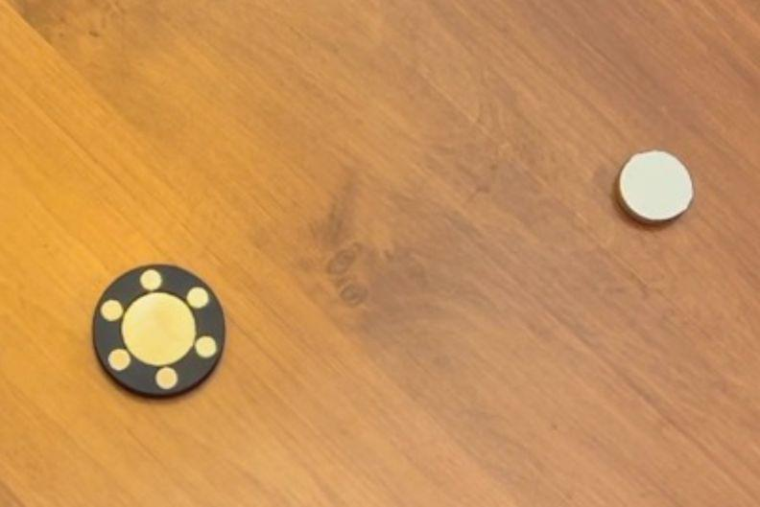 | ❑ Stability or change over time or space  ❑ Thinking across different scales  ❑ Cause and effect in M-E-F relationships

Progress Tracker
Unit Question: How do forces in Earth’s interior determine what will happen to the surface we see?
Science Question | What did we do? | What did we figure out?

Lesson 4: What is changing in the matter at a particle level

before an earthquake

when a solid elastically deforms or breaks?

