Mahaffy Reading Notes Week 15
NOTE: I may be out this week collecting data in schools, I’ll update you!
Peng & Hicks, 2021
- I think it’s really interesting that they are basically redefining the terminology we read in, what, week 1 or 2? I think that the way they are defining reproducibility and replicability is certainly a colloquial way of talking about these things, but I think the table of data and methods is way clearer to me than their definitions. This table:
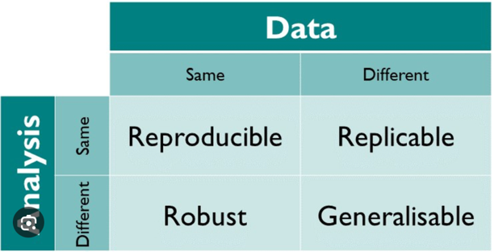
I continue to return to that as my “guiding light” for terminology in this space, and I think these authors do not define replicable in this way. In fact, I think that what they are describing as replicable is probably all in category reproducible (depending on the scope- no analytic changes, clearly, but say rounding errors, etc.).
- I’m kind of surprised by some of the ideas they forward here—I feel like they have this very narrow view of reproducibility as, basically, was there a mistake in this person’s project, but over the semester I have come to think of reproducibility as much more than that. They seem to be really hung up on reproducibility being about increasing our trust in an analysis because you can see “under the hood” which helps us know if the analysis was complex (which they seem to equate to good…), and if the “scientific claim is true”. I think that they are missing a lot of the really useful things that reproducibility can be- the idea of evaluating robustness of a claim, generalizability, etc. This is a good starting place, but is a jumping off point, in my mind, for the many additional “tools” that reproducibility can give us!
Stikov et al., 2019
- First of all, I have never seen the PDF referred to as the computer equivalent of paper which makes total sense but also is wild
- It’s nice to see Jupyter notebooks having their day in the sun, I do think that generally they are an underutilized tool for imaging work. When I am training undergrads to write scripts, they take a LONG time to understand the file structure of computers, what a path is, and where to put that information in a script. Not only does Jupyter notebooks help with some light version control, but the feature of it coloring chunks of code of highlighting where errors occur is INCREDIBLY useful as a teaching tool!
- I just want to throw out there that I am on team “if it’s tax-payer funded, then the products of that research should be in the public domain as much as is ethically possible.” While I respect their point about this potentially driving people away from academia, I feel like right now there are about a million reasons why someone could leave academia and this is just one, so to not put things into the public domain for this reason feels wild. I feel like, generally, there has been a shift in sentiment- we now often talk about how no one becomes an academic for the money, this sentiment shift seems really related to the concern of decreasing the “best and brightest” in academia by sharing code and research products publicly.

