Phase 6:  
Integration and Delivery

By: Anthony K.  
Kelly P.  
Tamilesh B.  
4/6/2020

**Phase 6**

To find where our scripts are located, you must go into the directory called Phase 6:

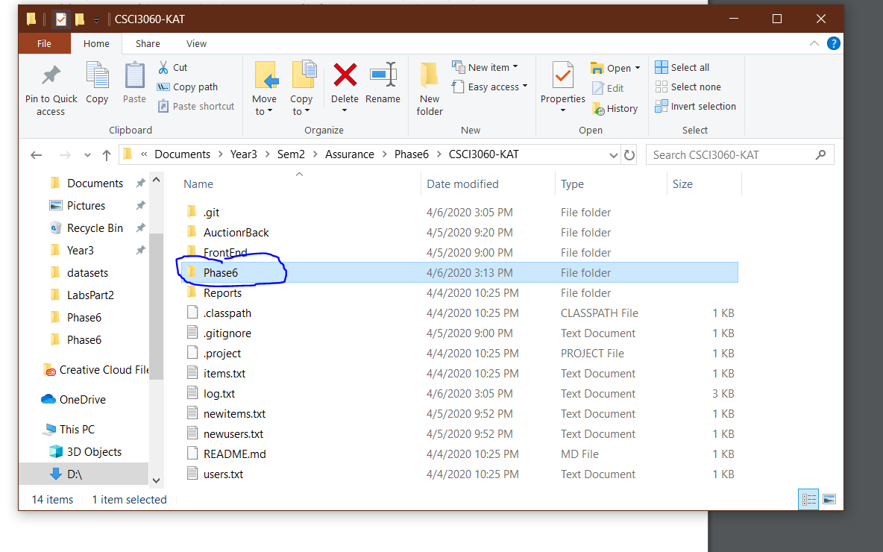  
*Directory to run the shell scripts*

After going to the directory you will find two shell scripts labeled as daily.sh and weekly.sh. **You must be using a Linux environment, or the program will not work**. If you want to run the daily script you have to type in the command ./daily or ./weekly. That will run all the commands in the cases folder:

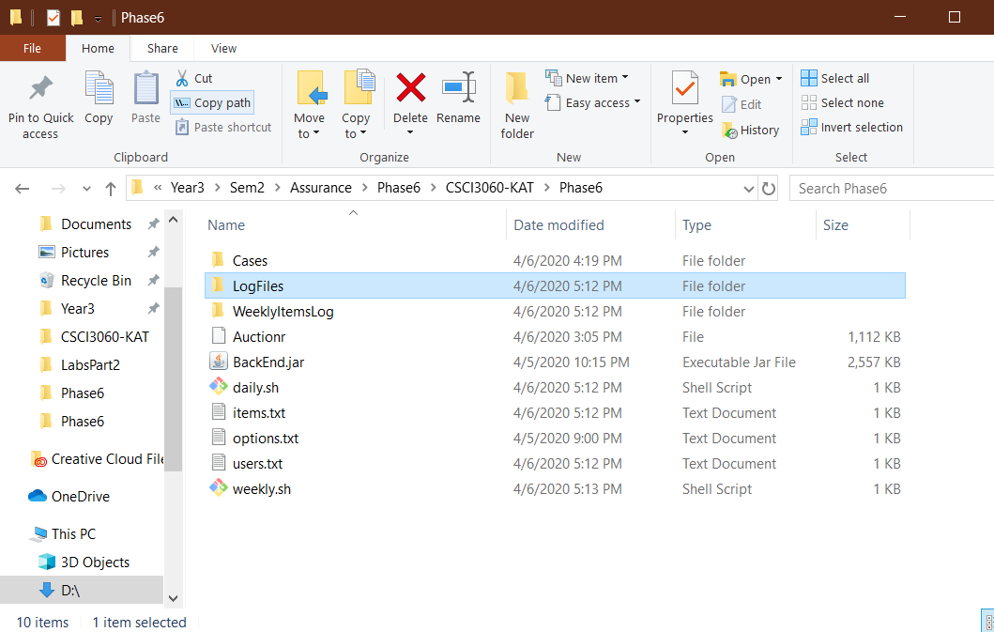  
*The location of Daily and Weekly Shell Scripts as well as the set of transaction session inputs*

The cases folder contains the following daily transactions:

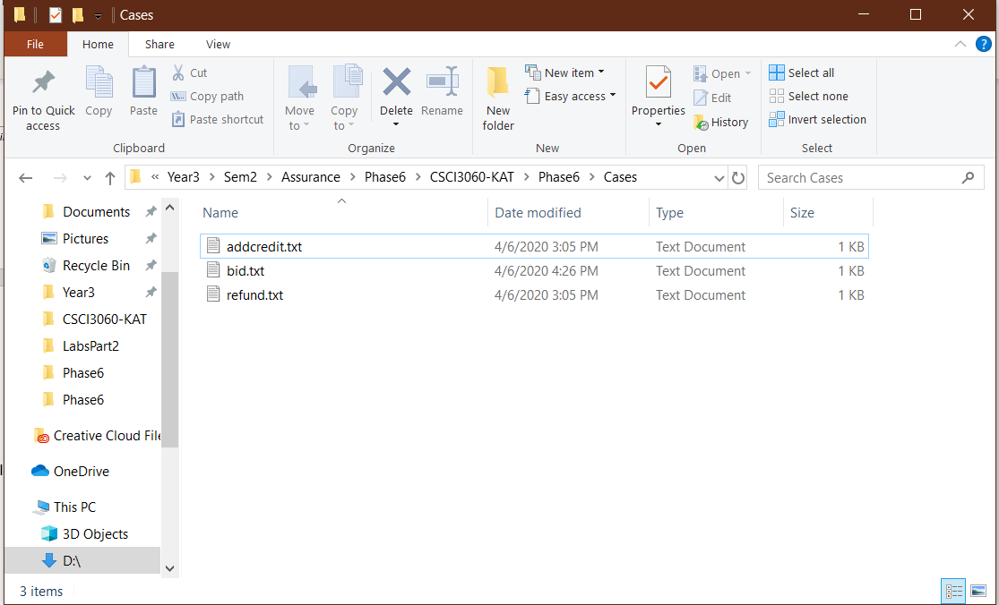  
*A printout of the set of transactions sessions inputs for one run of Daily Scripts*

The Merged Daily Transaction file is in the folder called Logfiles and the Items File after five daily run is in WeeklyItemsLog.

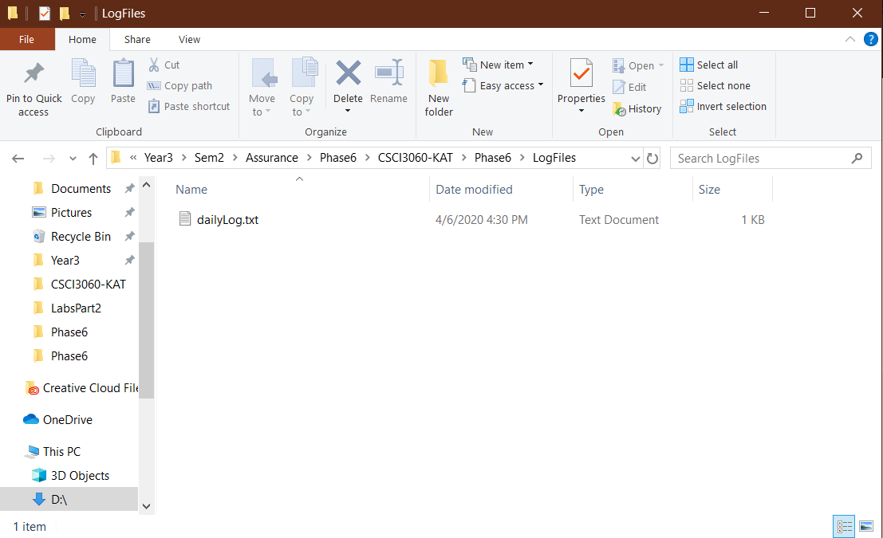  
*Location of where the printout merged Daily Transaction file*  
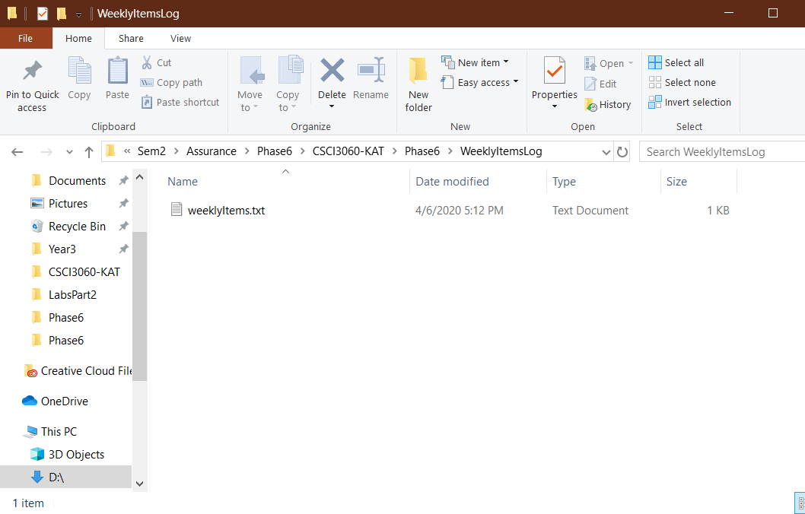  
*Location of Items File listing after five daily runs*

**Example of running the program:**

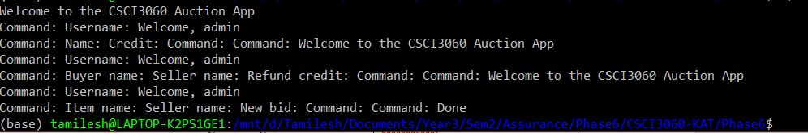





|  |  |  |
| --- | --- | --- |
| Error | How did we fixed it | FrontEnd/BackEnd |
| Error on Execution Create Advertise | Change the log file to different advertisements | BackEnd |
| Error on Validation for Create Command | Changed == for string comparison to String.Equals(String Value) | BackEnd |
| Error on Execution for Create Command | Changed == for string comparison to String.Equals(String Value) | BackEnd |
| Couldn’t run back end | Created a Jar file to execute with bash scripts | Back End |

**Integration Defect Report**

*A list of integration problems when connecting BackEnd with FrontEnd*