Juan Cardenas, Josh Herrick, Kao Yang, Kelly Dimick (Group C)
Module 6.2 Assignment
10/18/2026
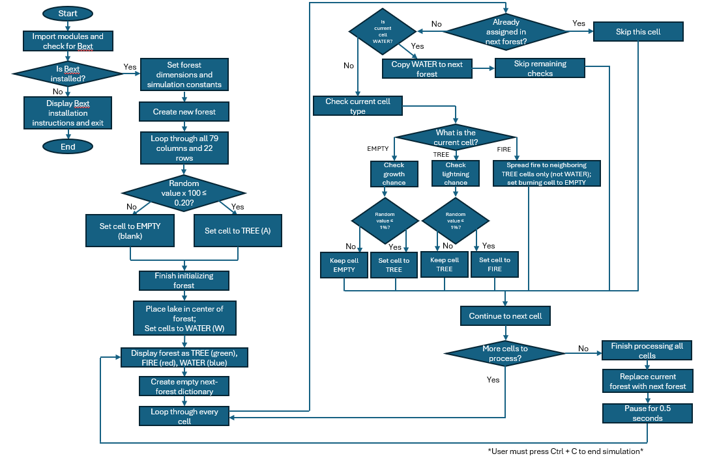
Updated Flowchart

Code changes:
Added new constants to define the lake’s location and size:
LAKE_CENTER_X = WIDTH // 2
LAKE_CENTER_Y = HEIGHT // 2
LAKE_RADIUS_X = 10
LAKE_RADIUS_Y = 4
Added a new cell type of Water
Added a new function to create the water:
def isLakeCell(x, y):
return (((x - LAKE_CENTER_X) ** 2) /
(LAKE_RADIUS_X ** 2)
+ ((y - LAKE_CENTER_Y) ** 2) /
(LAKE_RADIUS_Y ** 2)) <= 1
Modified Forest Creation:
IF isLakeCell(x, y)
WATER
ELSE
TREE or EMPTY
Added Water Processing During Simulation:
if forest[(x, y)] == WATER:
nextForest[(x, y)] = WATER

Added Water Display Logic:
elif forest[(x, y)] == WATER:
bext.fg('blue')
print(WATER, end='')

No additional fire-break logic needed to be created because fire already spread only to tree cells.
A permanent lake was added to the center of the forest using an ellipse formula. Water cells remain unchanged throughout the simulation and are displayed in blue. Because fire only spreads to neighboring tree cells, the lake acts as a natural firebreak that prevents wildfires from spreading through the water feature.

