Contents
Index
[Trial version] {ewl RoboEx32.dll, WinHelp2000, }
[Trial version] Untitled
[Trial version] Introduction
[Trial version] Data Modeling
[Trial version] Zeidon Objects
[Trial version] Dialogs / AutoDesign
[Trial version] System Overview
[Trial version] The Application Development Challenge
[Trial version] Zeidon Differentiation
[Trial version] Zeidon Objects
[Trial version] Results
[Trial version] Object Analysis
[Trial version] Physical Database Generation
[Trial version] Report and Dialog Generation
[Trial version] Complex Algorithms
[Trial version] Long Business Transactions
[Trial version] Cascade Deletions and Integrity Rules
[Trial version] Security and Integrity
[Trial version] Work Flow
[Trial version] Performance Across Distributed Systems
[Trial version] Distribution of Applications and Software Components
[Trial version] Application Maintenance and Testing
[Trial version] Application Development with Zeidon
[Trial version] The Application Life-Cycle
[Trial version] Analysis
[Trial version] Data Prototyping
[Trial version] Design
[Trial version] Construction
[Trial version] About Zeidon Basics
[Trial version] Intended Audience
[Trial version] Other Zeidon Documentation
[Trial version] On-line Help
[Trial version] Overview
[Trial version] Entities
[Trial version] Relationships
[Trial version] Cardinalities
[Trial version] Attributes
[Trial version] Domains
[Trial version] Subject Areas
[Trial version] The Data Modeling Tool
[Trial version] Overview
[Trial version] Zeidon Object Structure
[Trial version] Entities
[Trial version] Relationships
[Trial version] Attributes
[Trial version] Object Instances
[Trial version] Processing Object Instances
[Trial version] Activating and Committing Object Instances
[Trial version] Empty Object Instances
[Trial version] Creating and Deleting Entity Instances
[Trial version] Setting Entity Instance Attributes
[Trial version] Accepting Subobjects
[Trial version] Modifying a Cursor Position
[Trial version] Object Behaviors
[Trial version] Object Rules
[Trial version] Derived Attributes
[Trial version] Advanced Object Instance Processing
[Trial version] Multiple Views to an Object Instance
[Trial version] Naming Views
[Trial version] Read-Only Processing
[Trial version] Subobjects
[Trial version] Temporal Subobjects
[Trial version] Temporal Entities
[Trial version] Accepting and Canceling Subobjects
[Trial version] The Objects Tool
[Trial version] Overview
[Trial version] Window Definitions
[Trial version] Window Controls
[Trial version] Control Data Mapping
[Trial version] Registering Views
[Trial version] Menus and Options
[Trial version] Control Events
[Trial version] Window Actions
[Trial version] DIL Messages
[Trial version] Disabling Actions and Graying Controls/Options
[Trial version] Modal and Modeless Windows
[Trial version] Autodesigning Dialogs and Windows
[Trial version] Autodesign Case Types
[Trial version] Dialog Structure and Content
[Trial version] User Interface Specification
[Trial version] Overview
[Trial version] Application Components
[Trial version] Tools
[Trial version] Configuration Management
[Trial version] The Zeidon Repository
[Trial version] Central Project Libraries
[Trial version] Central Project Library Releases
[Trial version] Reusing CPLR's
[Trial version] Migrating to New CPLRs
[Trial version] Local Project Library Releases
[Trial version] Checking Out
[Trial version] Copying Out
[Trial version] Refresh
[Trial version] Zeidon Runtime Environment

[Amber demo]

{ewl RoboEx32.dll, WinHelp2000, }

Top

[Amber demo]

 | Basic’s Manual  Version 2001 - Release 010407
 | Introduction
 | Data Modeling
 | Zeidon Objects
 | Dialogs / AutoDesign
 | System Overview

Top

[Amber demo]

Introduction
The Application Development Challenge
Zeidon Differentiation
Zeidon Objects
Results
Application Development with Zeidon
About Zeidon Basics
Other Zeidon Documentation

Top

[Amber demo]

Data Modeling
Overview
Entities
Relationships
Attributes
Domains
Subject Areas
The Data Modeling Tool

Top

[Amber demo]

Zeidon Objects
Overview
Zeidon Object Structure
Entities
Relationships
Attributes
Object Instances
Processing Object Instances
Object Behaviors
Advanced Object Instance Processing
The Objects Tool

Top

[Amber demo]

Dialogs / AutoDesign
Overview
Window Definitions
Autodesigning Dialogs and Windows

Top

[Amber demo]

System Overview
Overview
Application Components
Tools
Configuration Management
Zeidon Runtime Environment

Top

[Amber demo]

The Application Development Challenge
The IS Industry has been anticipating an order-of-magnitude productivity boost in application development for over a decade. Several new solutions, including CASE, Artificial Intelligence and Object Oriented Programming, have created momentary excitement that often have led to large investments by IS departments. But in the end they have led only to incremental improvements in productivity. The movement to the simplicity of PC workstations also held out initial hope for improved productivity. But in the end the anticipated gain was probably a net loss, as the distributed PC environment turned out to be anything but simple.
A host of new products were introduced during the early 90's that took some of the sting out of adding GUI interfaces and sometimes even assisted the distribution of functions across a network. But these products only helped to counter the new complexities of GUI and distributed systems. The net result is that the vision of snapping reusable pieces together to build applications has remained only a dream and the time and cost of building and maintaining applications is as high today as it was in the days of 3270's and mainframes.
Though the hope for an order-of-magnitude boost in productivity may have been squelched by recent experience, the desire and need is still there. But that desire and need is countered by a healthy skepticism and a new attitude that requires proof before investment.
The challenge is to deliver on the productivity dream in an IS world burned by broken promises.

Top

[Amber demo]

Zeidon Differentiation
The intent for the Zeidon Application Development System is to fulfill that desire and need. The intent is to introduce a clear leap in productivity over the products that have been introduced in the 90's and to achieve the order-of-magnitude productivity boost that continues to be desired.
A leap in productivity cannot be achieved with incremental changes in the process of appliciation development. Incremental changes can only lead to incremental improvements. The productivity leap will only come by addressing the application development problem in a new way, utilizing some form of paradigm shift.
Furthermore, such a new solution must stretch across the whole process of application development, not just to one or a few components. Though object oriented programming was a paradigm shift, one of its problems was highlighted in its very name: it was only a solution to the programming problem at best. Automating an application is a whole process encompassing many steps from analysis to maintenance and software distribution. Any paradigm shift that really solves the problem must be directed at all of those components.
The Zeidon Application Development System is a paradigm shift that delivers an order-of-magnitude productivity boost. That boost is provided by:
• An extension to the object oriented concept that emphasizes composites rather than subtyping.
• An integrated solution built on composite objects that addresses all components of the application development process, from analysis and design to maintenance and system distribution.
• Object Engines running on heterogeneous platforms that access physical databases and manage, route and control composite objects.

Top

[Amber demo]

Zeidon Objects
Object oriented programming introduced some valuable concepts, but if it hoped to be of use in addressing IS problems, it also made a major mistake. That mistake was in focusing the solution almost entirely around subtyping. There are indeed problem sets, such as simulation and GUI controls, where the structure of the problem matches the subtyping structure of object oriented programming, but few IS problems are among them. The objects which we are likely to encounter in IS problems are best understood as composites of data, not as subtypes. For example, imagine comparing how two banks handle accounts. Although understanding account subtypes might be of some value, the similarities and dissimilarities between accounts would best be understood by analyzing the logical data content and structure of the acounts at each bank, along with the processes performed on those accounts. But even the processes could not be fully understood without understanding the impact of those processes on the transformation of data that comprise the accounts.
Zeidon extends the concepts of objects from object oriented programming and alters the focus from subtypes to composites. To tie those objects to persistent data and to automate the implementation of access to relational and legacy data, Zeidon ties the content of objects to an Entity/Relationship data model, which is in turn tied to the definition of physical data. Thus the components of a Zeidon object are the entities, relationships, attributes and domains defined in a data model.
But objects not only need components, they need logical structure, a structure which can be represented graphically and can contain the kind of application semantics that could be used later to automate processing. In constructing an object from an E/R diagram (diagramatic representation of a data model), we select entities that will be a part of the object by following relationship paths from entity to entity. The end result is something that looks much like a tree. It has several characteristics not normally found in trees, however, such as:
• Following two different paths down the tree could lead to the same entity instance.
• Paths in the tree may loop recursively for any number of levels, as with the "part-contains-part" inventory problem.
• Since objects overlap, following a path down one object could lead to an entity instance in another object.
The result is something we might call a "super tree". In Zeidon, we call it a Logical Object Definition.
These composite objects, or super trees, are managed by Object Engines that run on various heterogeneous platforms. An object instance can be "activated" on a server Object Engine, which will access all the individual entity instances that make up the object. The resulting object instance can then be routed, updated, queued and processed in various ways and finally returned to the server Object Engine for updating to the physical database.

Top

[Amber demo]

Results
The concept of a "super tree" integrating the whole development life cycle sounds promising. But there is a considerable gap between a promising concept and a solution that genuinely delivers an order-of-magnitude productivity boost. Though real proof comes only in the practical results of applying the Zeidon solution to real problems, we might gain some understanding of how this is achieved by reviewing some of the advantages of the Zeidon integrated solution.
Related Topics:
Object Analysis
Physical Database Generation
Report and Dialog Generation
Complex Algorithms
Long Business Transactions
Cascade Deletions and Integrity Rules
Security and Integrity
Work Flow
Performance Across Distributed Systems
Distribution of Applications and Software Components
Application Maintenance and Testing

Top

[Amber demo]

Object Analysis
The gains during analysis come primarily from two sources. First, a Zeidon object is a graphical representation of application processing against a data model. The discipline of defining the entities and relationship paths that will make up an object and the semantics that go with it provides a graphical way to understand application functionality and provides verification that the data content and relationship paths in the data model are valid. Second, rapid prototypes generated from the objects allow users to verify their understanding of the data and processes they are analyzing.

Top

[Amber demo]

Physical Database Generation
Physical databases are automatically generated from the E/R data model. As prototyping feedback alters the model, extensive physical database modifications can be made (such as switching from concatenated keys to system generated keys) without modifying the definitions of dialogs, reports or processes.

Top

[Amber demo]

Report and Dialog Generation
The semantics from the object definition allow rigorous windowing dialogs and reports to be automatically generated (Zeidon Autodesign feature). Window design is primarily an iterative process of evaluating the last generated dialog, modifying the object semantics and user interface specifications, and regenerating dialogs. The ease with which complex dialogs can be generated allows a very rapid prototyping life cycle that gives end users almost immediate feedback on their data model and object model designs.

Top

[Amber demo]

Complex Algorithms
The semantics in the object structure greatly simplify the definition of complex algorithms that transform object data. Working storage and data buffers are allocated and managed automatically. The super tree structure simplifys the navigation of complex structures, such as those created by recursive relationships. Object instances containing hundreds of entity instances are activated from and commited to the physical database with single commands. The specification of complex rules are facilitated by a design language that works in conjunction with the super tree structure.

Top

[Amber demo]

Long Business Transactions
Much of the complexity in rigorous IS applications is in the handling of long business transactions, where a group of data (a composite object) is read from a database and processed during a period lasting from a few minutes to several days, being returned at the end to be updated against the database. At any time during this period, the long transaction can be canceled and the data never returned to the database at all. The problems of buffering, queueing, and managing the data during the long transaction, along with the complexities of updating the database with transaction data modifications, normally require extensive programming, even with the help of software tools such as middleware. Zeidon handles such long transactions automatically, even managing the challenges of optimistic locking against the database. It also automatically supports nested transactions (transactions within transactions) and even eases the support of interdependent long business transactions, a problem so daunting it is rarely attempted during application development.
The success of this technique is demonstrated in the Zeidon tool set (which was built using the Zeidon toolset, itself) and its support of a sharable repository. The Configuration Management function heavily depends on the long transaction, long interdependant transaction and nested transaction facilities to support multi-user check-out of interdependant Zeidon components and the maintenance of those components while detached from the repository server.

Top

[Amber demo]

Cascade Deletions and Integrity Rules
The structure of the object allows for the simple definition of rules that cascade delete processing and maintain data integrity. Child delete rules enable the deletion of one entity to trigger the deletion of other entities or the breaking of relationship paths. Validation rules on the object restrict data modification depending on the state of the object or the authority of the operator. Since database modifications can only be made through objects, data administrators need only review constraints on objects and do not need to analyze application processing.

Top

[Amber demo]

Security and Integrity
A major problem facing client/server applications has been how to maintain security and integrity when the client/server workstations themselves are not secure. In Zeidon, the workstation cannot update Server data directly, but can only send object requests to the Server. There the security and integrity constraints defined against the object are processed within the security of the Server environment. This occurs automatically, without any user application programming. In fact, it is the only way Zeidon works. Database data can only be modified in Zeidon by going through domain and object contstraints defined on the data model and object.

Top

[Amber demo]

Work Flow
The challenge in work flow is to ease the definition and implementation of an application where the life of an object instance is a series of steps through different process stages. This is, however, the natural way of designing and implementing applications in Zeidon. The Logical Object Definition defines the work flow object. Processes defined on the object define transformations and constraints on the object. Dialogs and reports are automatically generated to support various GUI and report interfaces. Object Engines allow for the easy routing of object instances and control their flow. The object instances themselves can be easily routed, queued and maintained at various workstations and eventually sent to the proper server Object Engine for updating against the database.

Top

[Amber demo]

Performance Across Distributed Systems
One of the problems plaguing current client/server applications is performance degradation when accessing large quanties of distributed data. The problem is difficult enough that a whole class of products, called middleware, has been created in part to solve it. But even when using these products, the problem is only solved with extensive programming. However, Zeidon automatically solves the problem, as the access and movement of groups of data is the normal way that Zeidon works in a distributed environment. Not only does Zeidon move data as groups, it also utilizes various techniques for cacheing small and large lists of data, automatically providing performance solutions that are difficult to implement in middleware even with extensive programming.

Top

[Amber demo]

Distribution of Applications and Software Components
Once the development and maintenance problems of building applications have been solved, there is still the problem of getting the right application components to the correct servers and work stations. In fact, much of the current cost of maintaining client/server systems revolves around this problem. Zeidon solves this problem by providing an administrative application that defines all application components and network nodes in your system. Application components are then automatically routed to the necessary servers. Components required by client workstations are routed to distribution servers, where the Object Engines on the clients automatically download the latest versions of application software as necessary.

Top

[Amber demo]

Application Maintenance and Testing
Though Zeidon delivers extraordinary productivity during initial application development, the gains during maintenance are even more dramatic. The major reason for this is the simplicity and structure built into every Zeidon application. A Zeidon application is not the result of the traditional programming effort of translating a logical design into physical programs. It is that logical design actually executing during production. Thus the errors normally introduced during the transformation process (which make up the bulk of traditional application debugging and maintenance) are eliminated and the person testing and maintaining an application is able to deal primarily with the correctness of the logical problem. For example, debugging in Zeidon is primarily the evaluation of data components of objects and whether they have been properly built by dialogs or algorithms. The Object Browser used for this purpose presents that data and structure using the same graphic super tree used in the initial definition of objects. The data is shown as entities and relationships, reflecting exactly the same information as in the logical data model.

Top

[Amber demo]

Application Development with Zeidon
Zeidon organizes application development around three primary characteristics: data, process, and human interface. Although the importance of the first two has been recognized by the industry from the beginning (thus the term data processing), the human interface has not received adequate recognition nor has the importance of the intersection of these three components. Object Oriented Programming has moved to highlight the intersection between data and process. Zeidon takes this a step further, emphasizing all three characteristics.
Related Topics:
The Application Life-Cycle
Analysis
Data Prototyping
Design
Construction

Top

[Amber demo]

The Application Life-Cycle
Zeidon handles the full range of life-cycle functions of analysis, design, and construction. Early in the life-cycle, in the analysis phase, the focus is on data with some emphasis on process and even less on human interface. As the life-cycle unfolds to the design phase, the data is more stable and increased emphasis is put on process and human interface. At the end of the cycle, the construction phase involves primary emphasis on the human interface, with only minor modifications to data and process as necessary. Figure 1 depicts this shift of emphasis on data, process, and human interface during the life-cycle progression.
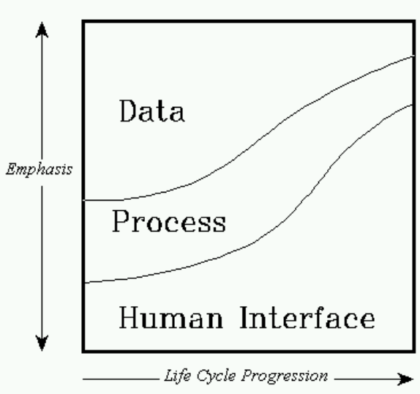
Figure 1. Relative Emphasis on Data, Process, and Human Interface During Life-Cycle Progression
In Zeidon, application development is recognized as an iterative process. The stages in the application development life-cycle are not linear, meaning that you will not necessarily complete one stage before moving on to the next.

Top

[Amber demo]

Analysis
During analysis, the focus is primarily on data. You begin by building a data model that is comprised of entities, attributes, relationships and domains. The data model is a logical representation of data, which means it is independent of any physical implementation considerations. Because data components in the model are not physical programming structures, the model remains valid across technological implementations and throughout the application life-cycle. When the application is running, the physical database structures are defined against the logical data model (or generated from the model), allowing all application development to be defined against the logical model instead of the physical model.
From the data model, you then define Zeidon objects, which extend the logical data model by adding structures and behaviors that facilitate processing.
Zeidon object definitions are comprised of an initial entity from the data model and any number of related entities, determined by following relationship paths from the initial entity. There are no restrictions on the paths followed. They can fold back on an entity already defined through another path in the object (a duplicate entity) or even loop through the same path multiple times (a recursive subobject). The object thus provides a structure for application data, but it is the logical structure of the data model, not a physical structure. This logical structure greatly assists the rest of the application development life-cycle, simplifying the specification of some functionality, while allowing other functionality to occur automatically.

Top

[Amber demo]

Data Prototyping
Although the emphasis at this stage is on data, some attention to process and human interface is necessary in order to test the data analysis. Zeidon supports and encourages data prototyping during analysis. Because it is difficult to evaluate data and behaviors only through diagrams and reports, Zeidon makes it possible for you to autodesign windowing dialogs from your object definitions. These interfaces enable both developers and end users to test their understanding of the analysis data models at an early stage in the development process.

Top

[Amber demo]

Design
As the life-cycle moves from analysis to design, focus shifts from data to process. Unlike other windowing application building tools where the design phase involves mostly programming, Zeidon focuses on the windowing dialog as the basic unit of design. The application developer designs dialogs rather than writing programs.
The Zeidon autodesign and prototyping features can be used to automate the design process and test early the effectiveness of design decisions. For new systems, database designs can be generated from the logical data model. For systems with existing databases, the database characteristics can be defined against the logical data model.
The developer can either paint dialogs or auto-design them from system requirements and Zeidon object definitions. Relationships to data (mapping and editing) are defined through non-procedural windowing forms. Information captured during analysis, such as attribute domains and data constraints, do not have to be redefined or transformed. They can be used exactly as they were defined during analysis.
Testing in Zeidon consists largely of testing design decisions. Designs of data, process and human interface are tested using the Zeidon Object Browser and Zeidon Interpreter/Debugger.

Top

[Amber demo]

Construction
The last life-cycle stage of construction involves the final specification of the physical database and operating system environments, followed by database DDL and C programming generation, compilation, and linking. These functions are implemented and controlled through the Zeidon Application Build Facility. During application maintenance, changes are made against the appropriate analysis or design constructs. Applications are built with almost no programming. Programming is only required to build reusable physical components, such as DB Handlers to new databases and domains requiring complex algorithms.

Top

[Amber demo]

About Zeidon Basics
The Zeidon Basics manual describes concepts and definitions that are fundamental to all Zeidon application development. This manual consists of 5 chapters and an index. Chapter contents include the following:
• Chapter 1, "Introduction," provides a brief overview of Zeidon, its documentation set, and the role of the Zeidon Basics Manual.
• Chapter 2, "Data Modeling," introduces the concepts behind the Entity/Relationship data model.
• Chapter 3, "Zeidon Objects," describes in detail the concepts behind and utilization of the Zeidon object. The Zeidon object is the key component of the Zeidon system. It is strongly recommended that this chapter be read and understood before attempting to use the Zeidon tools.
• Chapter 4, "Dialogs/AutoDesign," provides information that will allow you to rapidly build windowing dialogs from the Zeidon objects you have constructed for your application.
• Chapter 5, "System Overview," provides a more detailed overview of the Zeidon system and its tools. Included in this section is a more detailed description of the configuration management system used to manage Zeidon Application components.
Related Topics:
Intended Audience

Top

[Amber demo]

Intended Audience
Zeidon Basics is designed for new users of Zeidon who are already familiar with Microsoft Windows. Much of the information in this manual is designed to provide a working knowledge of the Zeidon approach to application development and is not repeated in the Zeidon User's Guide.

Top

[Amber demo]

Other Zeidon Documentation
The Zeidon User's Guide is a detailed reference to the Zeidon application development system. It gives step by step instructions for using the Zeidon tools to build applications. Whereas Zeidon Basics provides conceptual information, the Zeidon User's Guide takes a task-oriented approach and provides "how-to" information.
The Zeidon VML Language Reference manual is a detailed reference to the Zeidon View Manipulation Language (VML). It explains the overall structure and functionality of VML, and also lists and describes in detail the individual VML declarations and statements. Information about using C code in conjunction with VML operations is also provided.
Related Topics:
On-line Help

Top

[Amber demo]

On-line Help
Your documentation set is supplemented by on-line help as well. On-line help is available from every Zeidon tool by selecting Help from the menu bar or by pressing the F1 key.

Top

[Amber demo]

Overview
All Zeidon application development must begin with the creation of a logical data model that represents the information that must be stored and maintained by an organization. A Zeidon data model is said to be logical because it represents application data from the perspective of business requirements rather than any particular physical software system requirements. The data model is a representation of business data as it is used by an organization in the "real world". In most cases, the data model provides a global, high-level view of all the data that is used across an organization. This makes it possible for all applications in an organization to be integrated because they are built on top of the same logical data model.
The data model forms the basis against which all application development is defined. This logical representation of data is maintained throughout the life-cycle, and need not be transformed into physical structures for application programming. Instead, the physical database structures used when the application is running are defined against or generated from the logical data model. The same information, in the same logical form, can therefore be used throughout all stages of application development.
This means that an application is not tied to any particular technological environment or physical implementation. Whereas the physical requirements of an application often evolve and change over time, the logical representation of data is usually fairly stable and provides a better foundation for application development.
Data is defined in a data model in the form of entities, relationships, attributes, and domains. A common way of visually representing the data contained in your data model is through an Entity/Relationship diagram (E/R diagram).
Figure 2 shows an example of an E/R diagram for a Video Store:
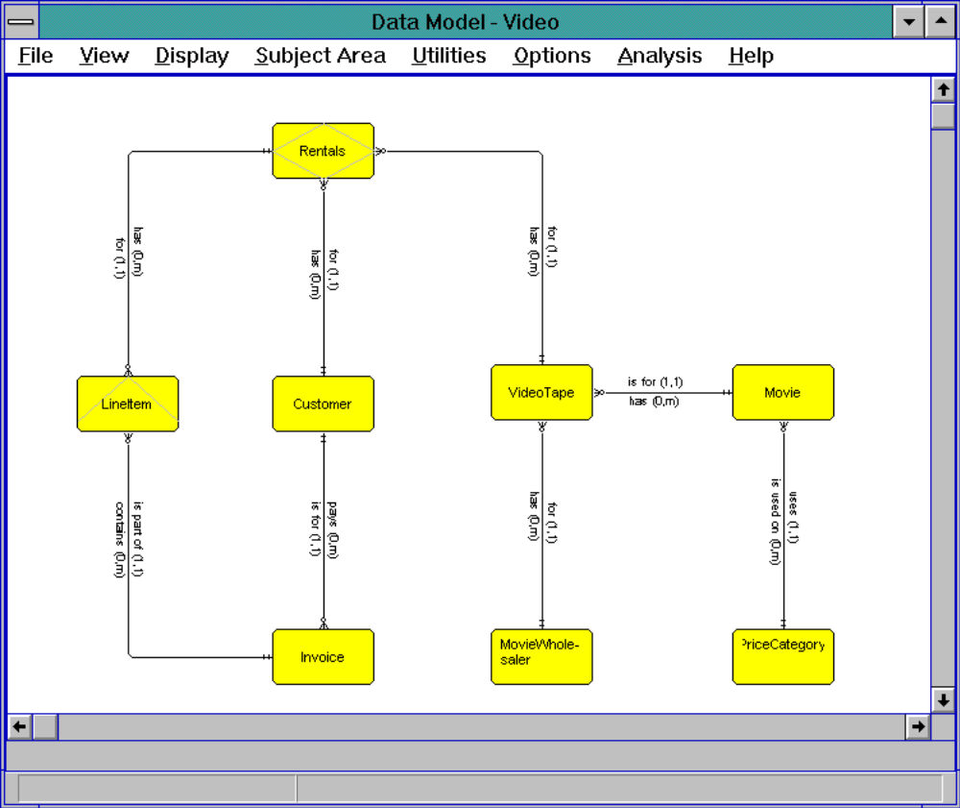
Figure 2. Entity/Relationship Diagram for a Video Store
In the E/R diagram shown above, the entities are represented by rectangles and the relationships are represented by lines. It is important to note that the structure of these entities is merely relational, not hierarchical. This means that no one entity is considered superior or subordinate to any other. Each entity is merely related in some way to other entities: hence the name Entity/Relationship diagram.

Top

[Amber demo]

Entities
An entity can be understood as a discrete class or type of data item about which an organization stores information. In Figure 3, the entities are Movie, Price Category, Customer, Invoice, etc.
Entities in an E/R diagram are classified by the semantic purpose they serve in the data model. The entity types are:
• Fundamental ⎯ an entity that exists and is of interest in its own right. In Figure 3, Movie, Customer, Invoice, MovieWholesaler and PriceCategory are examples of fundamental entities.
• Associative ⎯ an entity that exists primarily to interrelate other entity types. In Figure 3, the entity Rentals does not exists on its own. Each rentals entity only exists as it ties together a LineItem entity with a VideoTape entity.
• Attributive ⎯ an entity that serves to describe another entity. In Figure 3, LineItem is an example of an attributive entity. A LineItem only has meaning as a further description of Invoice..
• Work ⎯ An entity which has no corresponding entity in the data model. At activate time, no instance information for the entity and its children will be activated. Instancing of the entity is the responsibility of the application.
It is important to note that the entities in a Zeidon data model represent more than just diagrams of data components. Rather, the entities in the data model are fully integrated with the database and can be extended directly into Zeidon object definitions. Therefore, when a change is made to the data model, that change can be automatically reflected anywhere else that information is used.

Top

[Amber demo]

Relationships
Entities are linked to other entities via relationships. A relationship can represent either a physical or conceptual connection between two entities. For example, the Movie entity is related to the Price Category entity because every movie has a price category assigned to it. Relationships in an E/R diagram appear as verbs (i.e., Movie has Price Category, Price Category is assigned to Movie), while entities appear as nouns.
Related Topics:
Cardinalities

Top

[Amber demo]

Cardinalities
Cardinalities represent the number of instances that may occur between two related entities in a data model. Each cardinality is constrained by a minimum and a maximum. In an E/R diagram, the cardinality is displayed in parentheses following the relationship name. For example, the relationship between Movie and Price Category has a cardinality of one to one (1, 1). This means that every movie must have a relationship to one and only one price category. On the other hand, the relationship between Movie and Video Tape has a cardinality of one to many (1, m). This means that each movie must be copied onto a minimum of one video tape, but there is no limit to how many video tapes the movie may be copied onto.

Top

[Amber demo]

Attributes
Each entity in a data model is made up of one or more attributes (data items) which describe the entity. For example, the Movie entity might have the attributes Title, Lead Actor/Actress, Supporting Actor/Actress, Director, Producer and Rating.

Top

[Amber demo]

Domains
Each attribute in a data model must be assigned a domain. A domain is used for validation and/or formatting of a given attribute. For example, the BirthDate attribute might be assigned a domain named Date that would allow only numbers in a valid date format to be mapped to the BirthDate attribute. The Date domain might also be used to display the BirthDate attribute in the format mm/dd/yyyy, regardless of how it is stored. Since all data (attributes) are encapsulated, the value of an attribute can be set only by going through its domain, assuring the integrity of data values.

Top

[Amber demo]

Subject Areas
Because data models often contain data that is used by different areas of an organization, Zeidon allows you to divide the information from a data model into subsets called subject areas. A subject area contains a subset of entities and relationships from the data model that pertain directly to a particular application or area of an organization. Subject areas are particularly useful if you have a large model that is stored in the repository. An individual developer can check out only the portion of the data model that is necessary for the current task, leaving the rest of the model accessible to other developers.
Using the data model represented in Figure 2, for example, you might want to create a subject area containing only entities and relationships pertaining to Inventory. The Inventory application would not be concerned with Customers or Invoices so you could define a subject area containing only the entities Movie, Video Tape, Movie Wholesaler, and Rentals. The subject area is still connected to the rest of the data model, but it allows you to see and work with only the portions of the model that are necessary for your current needs.

Top

[Amber demo]

The Data Modeling Tool
Data models and Entity/Relationship diagrams are created and updated using the Zeidon Data Modeling tool. Step-by-step instructions on using the Data Modeling tool are provided in the chapter "Data Model" in the Zeidon User's Guide.

Top

[Amber demo]

Overview
After you have defined a data model, the next step in Zeidon application development is the creation of one or more Zeidon objects. Objects extend the logical data model by adding structures and behaviors that facilitate processing. Zeidon objects provide a way of structuring application data that is optimal for the task of application development.

Top

[Amber demo]

Zeidon Object Structure
A Zeidon object defines a logical structure that will be used in the current application. Zeidon objects are composed of an initial entity from the data model called the root entity, and any number of related entities determined by following relationship paths from the root entity. A Zeidon object represents a particular view into the data model that is most convenient for a specific business purpose in the current application.
Conceptually, creating a Zeidon object from an E/R diagram is like grabbing the entity that will act as the root entity, snipping any unwanted relationships, and pulling the entity to the top of the structure, allowing the desired subordinate entities to dangle beneath it. For example, the E/R diagram in Figure 3 could be converted to a Zeidon object structure by pulling the Customer entity up to the top of the structure:
Figure 3. Video Store Entity/Relationship Diagram
A resulting Zeidon logical object definition would look as follows:
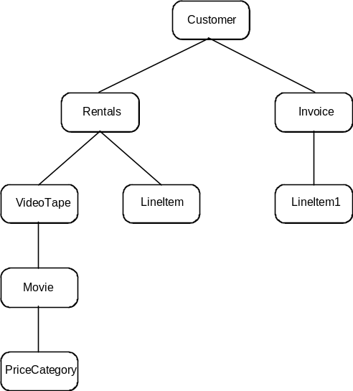
Figure 4. Customer object definition
The structure of Zeidon objects makes navigation easier and more flexible than navigating through the relational structure of the data model. In addition, defining an object allows you to organize the application data in whatever way is most useful for the current business processing need. For example, the object definition shown in Figure 4 is not the only object that can be created from the Video Store data model. In Figure 4, the entity Video Tape is the parent of the entity Movie, representing the relationship "Video Tape is a copy of Movie". While this may be the desired view of the Movie/Video Tape relationship for Customer processing, the Inventory processing view might want the Video Tape entity as a subordinate of the Movie entity. A separate object named Movie can be created to process the Video Tape and Movie data differently, even though it is based on the same logical data model:
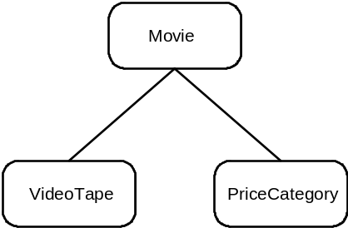
Figure 5. Movie object definition
In fact, any entity can be pulled up to root position of a data structure if it is advantageous for a given application. There are no restrictions on the relationship paths followed. A single E/R entity may occur multiple times in an object representing different relationships (a duplicate entity) or even occur down the same path multiple times (a recursive subobject). Note that the name given an entity in a Zeidon object need not match its corresponding E/R entity in the model so duplicate entities in a Zeidon object can have unique names.
Also note that the use of Video Tape as a parent entity to Movie in one object definition does not preclude its use as a child entity in another, even if both object definitions are to process data from the same database. This flexibility reflects the power and simplicity of an Object Oriented approach to data structure.

Top

[Amber demo]

Entities
As in the data model, an entity in a Zeidon object represents a distinct class or type of data item about which an organization stores information. The entities that make up a Zeidon object can be imported one-to-one from the entities defined in the data model. Unlike entities in the data model, however, the entities in an object are arranged into hierarchical relationships. As previously stated, Zeidon objects are initially composed of an topmost entity called the root entity. Entities that are defined as fundamental entities in the data model most commonly become the root entities of your objects. The root entity for the object definition in Figure 4 is Customer. Because the structure is hierarchical, every other entity type in the object definition has a parent entity defined for it. For example, in Figure 4, the Line Item entity has a parent entity named Invoice, representing the relationship "Invoice has Line Items". The entities that are subordinate to a parent entity in an object definition are called child entities.
There are four types of Zeidon object entities:

Object Entity Type | Description
Root Entity | The topmost entity in the Zeidon object. This entity is generally selected from a fundamental entity in the E/R model.
Model Entity | A model entity is an entity which is included into the Zeidon object from the E/R model including a specific E/R model relationship to its parent entity type.
Derived Entity | A derived entity is an entity which is included into the Zeidon object excluding any relationships to its parent entity type. In many cases, there may be no relationships defined in the E/R model between the derived entity and its parent entity type.
Work Entity | A work entity is an entity which has no corresponding entity in the E/R model.
Derived and work object entities have special behavior when processing object instances. For more information, please refer to the discussion on object instances later in this chapter.

Top

[Amber demo]

Relationships
As discussed previously, the relationships in an object are defined hierarchically. Whereas the data model represents all possible relationships between entities, an object follows one particular relationship path through the entities.

Top

[Amber demo]

Attributes
Attributes in an object are the same as attributes in a data model and can be imported directly from the model along with their associated entities.
There are three types of attributes in a Zeidon object:

Attribute Type | Description
Model Attribute | Model attributes are attributes which exist in the corresponding model entity associated with the object entity. Any or all model attributes can be included in a Zeidon object entity. Model attributes which are not included in an object entity are considered hidden from view in the object entity.
Work Attribute | A work attribute is an attribute which is created for use with its associated object entity only. It has no tie back to the associated E/R entity in the model. Like E/R attributes, when creating a work attribute, a domain must be associated with the attribute.
Derived Attribute | A derived attribute is a special kind of work attribute which has a derivation algorithm associated with it. The derivation algorithm is invoked each time the attribute is set or retrieved. Generally, a derived attribute is used to represent data whose value is calculated from other information in the Zeidon object. For more information on derived attributes, please refer to the discussion on derived attributes later in this chapter.

Top

[Amber demo]

Object Instances
While an object definition defines the structure of the application data and the attributes associated with each entity type, an object instance represents the application data itself. For example, if the Movie object is defined as shown in Figure 5, an instance of the Movie object definition might look as follows:
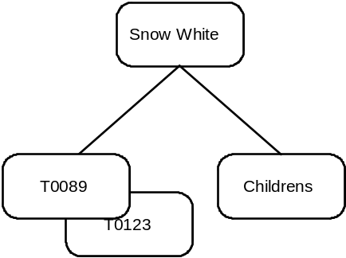
Figure 6. An instance of the Movie object
As depicted above, the instance of the movie 'Snow White' is carried on two video tapes numbered T0089 and T0123 and it is in the Price Category called 'Childrens'. There may be any number of instances of a given object in the application database. Each instance consists of one occurrence of the root entity type in the structure and its related child entity instances.

Top

[Amber demo]

Processing Object Instances
Object instances are processed using views and operations. Views are identifiers to active object instances in memory. A view is created when an object instance is activated and used thereafter to manipulate the object instance. In addition to identifying an active object instance, views maintain a position on entity instances of each object entity type within the object instance. This position for an object entity type is called the cursor position. The current cursor position determines which entity instance is to be processed when referenced in an operation call. Figure 7 depicts a view to the movie instance.
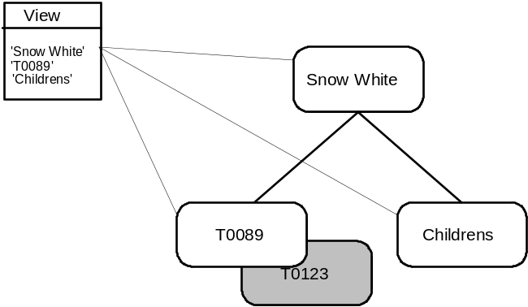
Figure 7. A view to the Movie object instance
In Figure 7, you can see that the cursor positions are on the Movie entity instance 'Snow White', the VideoTape instance 'T0089' and the PriceCategory entity instance 'Childrens'. The VideoTape instance 'T0123' is considered 'out-of-view' because there is no cursor position established.
Operations are used to create and modify application data though views. They can be written in either the Zeidon View Manipulation Language (VML) or the Microsoft C programming language. Operations are used to:
• Activate and Commit object instances from databases and files
• Create and delete entity instances
• Set attribute values
• Accept subobjects
• Navigate the application data by modifying entity cursor positions
Related Topics:
Activating and Committing Object Instances
Empty Object Instances
Creating and Deleting Entity Instances
Setting Entity Instance Attributes
Accepting Subobjects
Modifying a Cursor Position

Top

[Amber demo]

Activating and Committing Object Instances
Activating an object instance is the process of bringing a requested set of application data into memory. For example, to activate the object instance shown in Figure 5 you can specify the VML Statements:
VIEW vMOVIE BASED ON LOD MOVIE
ACTIVATE vMOVIE WHERE MOVIE.Movie.Title = 'Snow White'
The first statement 'VIEW MOVIE BASED ON LOD MOVIE' declares a view identifier vMOVIE which is to be used to reference an instance of the Zeidon object type MOVIE. The second statement 'ACTIVATE vMOVIE...' brings the object instance into memory from the application database and returns the vMOVIE view identifier with cursor positions as shown in figure 8.
Note that in Zeidon, data is cached. This means that when object instance data is processed, changes are not done directly against the database, but against a copy of the data in memory on the workstation. When you activate an object instance, the data is copied into memory on the workstation for processing. When processing is complete, the modified object instance can be either committed to the database or dropped without making any changes to the database.
To commit any changes to the object instance, you can execute the VML statement:
COMMIT vMOVIE
The commit statement applies all changes made to attributes and entity instances to the application database. To preserve the integrity of the data, all changes are applied as part of a single transaction against the application database.

Top

[Amber demo]

Empty Object Instances
To create a new object instance, you can activate an instance as empty with the following VML statement:
ACTIVATE vMOVIE EMPTY
An empty activate returns a view to an object instance with no entity instances in it. From here you can start creating application data by creating entity instances and assigning attribute values.

Top

[Amber demo]

Creating and Deleting Entity Instances
After activating an object instance, entity instances may be created in and deleted from the object instance. Referring back to figure 7, to create a new VideoTape for the movie 'Snow White' with the ID 'T0068', you can execute the VML statement:
CREATE ENTITY vMOVIE.VideoTape BEFORE
Upon execution of the statement a new entity instance of the entity type VideoTape is created with NULL attributes and the view is updated as shown in Figure 8.
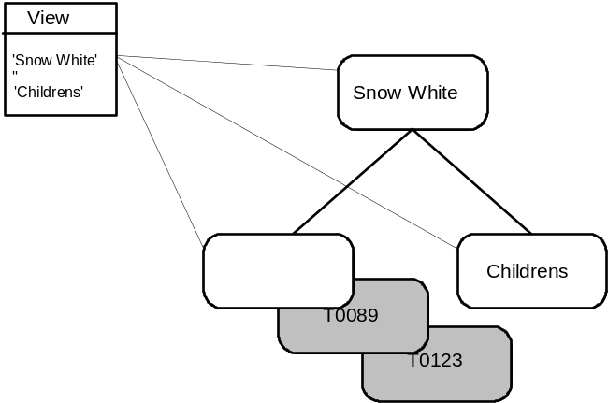
Figure 8. View to instance after creating the VideoTape entity
In addition to creating and deleting entity instances, entity instances may also be included into and excluded from the object instance. There is a subtle but important distinction between creation/inclusion and deletion/exclusion of entity instances. When you create an entity instance, a subsequent commit of the object instance results in two database activities:
1. The entity instance data you created is inserted into the database ( i.e. the VideoTape is created)
2. A relationship is created between the entity instance and its parent ( i.e. a relationship is created between the new VideoTape and the previously existing Movie ).
When you include an entity instance, the include is done from an existing entity instance in a separate object instance or within the same object instance. The key difference between an include and a create is that the entity instance already exists prior to the include and the include process simply creates the relationship to a previously existing entity instance as stated in step 2 above. Returning to our Movie object instance, the entity instance PriceCategory is likely to have been included into this object because price category information is reusable and is generally maintained separately from movie information. The process of including a price category involves activating an instance of an object containing price category information and including the desired PriceCategory entity instance from that object instance under the Movie entity in our Movie object instance.
Deletes and Excludes are the exact opposites of Creates and Includes. The deletion of an entity results in the removal of one or more relationships to an entity instance followed by a delete of the entity instance itself, whereas the exclusion of an entity instance results in simply the removal of the relationship between the entity instance and its parent. In our example above, the price category information can be excluded from the Movie object instance but not deleted since it is likely to be used by other object instances.

Top

[Amber demo]

Setting Entity Instance Attributes
Once an entity instance has been created, the attributes of the entity can be set using VML assignment statements. For example, to set the ID of the VideoTape instance created above, you can execute the following VML statement:
vMOVIE.VideoTape.ID = 'T0068'
The resulting instance after the assignment then looks as follows:
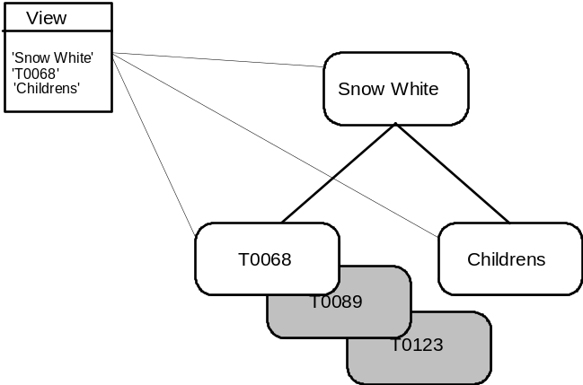
Figure 9. View to instance after assigning VideoTape ID
Note that each entity instance in a Zeidon Object usually have multiple attributes and the above examples show a single attribute for simplicity's sake.

Top

[Amber demo]

Accepting Subobjects
Subobjects by definition are an object entity instance and its children. In our Movie example above, the Movie entity instance along with its VideoTape and PriceCategory instances is considered a subobject. In addition, the PriceCategory instances itself is also considered a subobject even though it contains no child object entity types. Accepting a subobject is the mechanism to validate the completeness of application data. The Accept process validates that all required attributes have been set, checks that any cardinality constraints inherited from the E/R model have not been violated, and invokes any application defined Accept rules for the object entity being accepted.

Top

[Amber demo]

Modifying a Cursor Position
In order to reference entity instances which are out-of-view, you must modify the entity cursor for the entity type to position on the desired entity position. For example, if you want to position on the VideoTape entity instance whose ID is 'T0123' following VML statement:
SET CURSOR FIRST vMOVIE.VideoTape WHERE
vMOVIE.VideoTape.ID = 'T0123'
The resulting view to our movie instance would look as follows:
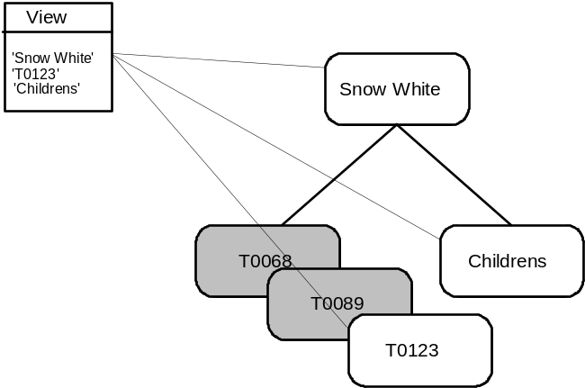
Figure 10. View to instance after modifying the VideoTape entity cursor
At this point, you can query/modify the attributes of VideoTape 'T00123' if you so desire.

Top

[Amber demo]

Object Behaviors
Once the structure and attributes of a Zeidon object has been defined, you can enhance the functionality of the object by adding specific object behaviors to the object. Object behaviors are the addition of business rules to the object which are triggered either manually or automatically when an application processes an instance of the object type.
Related Topics:
Object Rules
Derived Attributes

Top

[Amber demo]

Object Rules
Object rules come in three forms; Static Object Rules, Triggered Object Rules, and Global Object Operations. Static object rules are rules which are defined either through the Zeidon Object tool or inherited from the E/R model. The static rules for a Zeidon object are:

Static Rule | Description
Attribute Not Null | The Attribute Not Null rule constrains whether an object entity attribute can be assigned a NULL value. It is checked each time an attribute assignment is made.
Attribute Updateable | The Attribute Updateable rule constrains whether or not an attribute is updateable in its associated object entity. This rule is ignored if the object entity itself is not updateable.
Domain | Domain rules constrain the values of attributes. They are inherited from the E/R model for E/R based attributes or assigned through the Zeidon Object tool for work attributes. Domain rules are checked each time an object entity attribute is set.
Cardinality | Cardinality rules are inherited from the E/R model for model entities in the Zeidon object. Cardinality rules are checked each time an object entity is accepted as being well-formed.
Object Entity Update Rules | Object entity update rules constrain which type of updates are allowed for an object entity. These rules are create, update (attributes), delete, include, exclude, and source of include.
Parent Delete Restrict | The Parent Delete Restrict rule constrains whether or not a parent entity instance can be deleted when an instance of the restricted Zeidon object entity exists. This rule is set through the parent delete behavior in the Zeidon Object tool and checked when Deletes are attempted in the Zeidon object which would result in the delete of the immediate parent to the entity instance containing the rule.
Triggered object rules are algorithms which are triggered automatically when selected activities are performed on an object instances. Triggered object rules occur at three levels, object instance, entity instance, and entity attribute. The object level triggered rules are:

Object Instance Triggered Rule | Description
Activate | The Activate rule is invoked at completion of an Activate for an instance.
Activate Empty | The Activate Empty rule is invoked at completion of an Activate Empty Object Instance.
Commit | The Commit rule is invoked prior to a Commit of an object instance.
Drop | The Drop rule is invoked prior to a Drop of an object instance from memory.
The Object Entity Triggered rules are:

Entity InstanceTriggered Rule | Description
Accept | The Accept rule is invoked prior to an Accept of an object entity that defines a subobject.
Cancel | The Accept rule is invoked prior to an Cancel of an object entity that defines a subobject. For more information on Cancel, please refer to the section on temporal subobjects later in this section.
Create | The Create rule is invoked after creation of an object entity instance.
Include | The Include rule is invoked after object entity instance is included.
Delete | The Delete rule is invoked prior to the deletion of an object entity instance.
Exclude | The Exclude rule is invoked prior to the exclusion of an object entity instance.
The Entity Attribute triggered rules are:

Entity Attribute Triggered Rule | Description
Domain | Domain rules are algorithms written to validate the data for a domain prior to assigning a value for an attribute. Domain rules are invoked each time an attribute assignment takes place for an attribute using that domain.
Global object operations are algorithms that modify the data in one or more object(s). Much like methods or functions in Object Oriented Programming, global object operations are defined for an object and are invoked by other operations.
For more information on the definition and development of object rules, please refer to the Zeidon User's Guide in the Zeidon Object tool and Operations sections.

Top

[Amber demo]

Derived Attributes
There are two types of attributes: those that contain persistent data that is mapped directly from the database or file (such as the examples above), and derived attributes. A derived attribute contains data that is created dynamically during the execution of the application and is not physically stored on the database or in data files. For example, in the Customer LOD provided in the Video Store sample application, the Invoice object entity contains a derived attribute for the total invoice amount. Derived attributes are implemented as algorithms automatically invoked when the attribute value is set or retrieved.
For more information on the definition and development of derived attributes, please refer to the Zeidon User's Guide in the Zeidon Object tool and Operations sections.

Top

[Amber demo]

Advanced Object Instance Processing
Up to this point, we have covered the basic concepts behind the Zeidon object and the processing of a Zeidon object. If you are not comfortable with the topics covered so far, we recommend that you familiarize yourself with the previous topics before tackling the concepts presented in this section. In this section, we will build on the basic concepts covered in the previous topics and introduce some new concepts which make application building with Zeidon object more productive.
Related Topics:
Multiple Views to an Object Instance
Naming Views
Read-Only Processing
Subobjects
Temporal Subobjects
Temporal Entities
Accepting and Canceling Subobjects

Top

[Amber demo]

Multiple Views to an Object Instance
As previously stated, all processing of active object instances is accomplished from views. Given a view to an active object instance, any number of new views to the same object instance can be created. Since views carry a cursor position on each object entity type, multiple views allow for multiple positions in the active object instance. Figure 11 depicts two separate views into the Movie object instance.
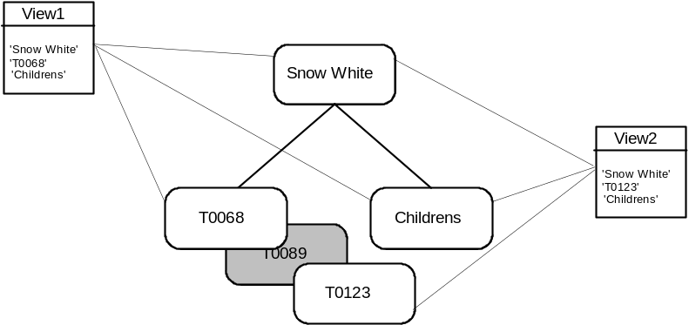
Figure 11. Multiple views into an active object instance
When a new view is created, cursor positioning information is copied from the creating view to the new view created. From that point on, the cursors in each view act independently.

Top

[Amber demo]

Naming Views
In order to save views for later reference by operations and dialogs, names can be created which may be used to retrieve a previously created view. For example, to name the view vMOVIE in our examples above, you can execute the VML Statement:
NAME vMOVIE "MOVIE"
The above statement creates a name for the view which may later be used to retrieve the view in an operation by executing the VML statement:
GET VIEW vMOVIE NAMED "MOVIE"
Though multiple names for a single view are rarely needed, there is no limit to the number of names a single view can have. If a name is in use for another view when a new view is named, the name is redirected to reference the new view and the previous view can no longer be retrieved by that name.
Named views are the mechanism by which Zeidon objects communicate with application dialogs. In dialogs, controls communicate with objects using registered views. Registered views are simply the definition of named views which the controls can retrieve for mapping attributes in a Zeidon object to the User Inteferace. For more information on registered views, please refer to the Dialogs section of this manual.

Top

[Amber demo]

Read-Only Processing
In addition to the update rules defined for a Zeidon object, object instances and views can be designated as read-only. Read-only views and instances prohibit any updates to the application data in an object instance regardless of the rules defined for the entities and attributes in the Zeidon object.
Object instances can be designated as read-only upon activation. When done at activation time, the initial view returned and any views created from the initial view will be marked as read-only to prevent updates to the data.
Views which are not read-only may also be switched to read-only by calling the system operation SetViewReadonly. Once a view has been set to read-only, it can not be reset to updateable and any views created from the read-only view will also be marked as read-only.

Top

[Amber demo]

Subobjects
Subobjects by definition consist of an object entity and all of its descendants. Figure 12 shows an example of a subobject starting with the Rentals object entity.
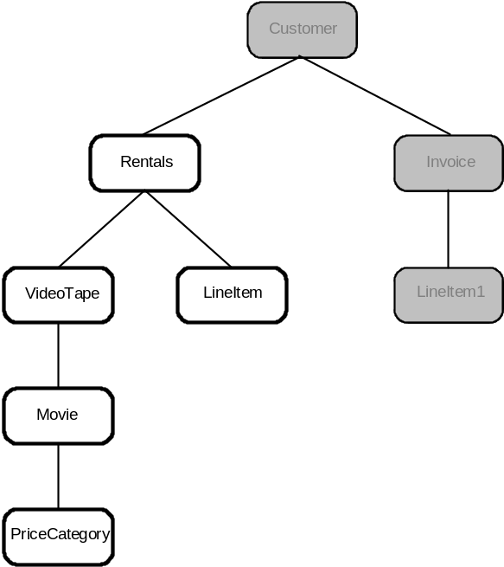
Figure 12. Subobject starting with Rentals object entity
Subobjects are an important concept in that many operations actually involve a subobject as a whole as opposed to a single entity. For example, the system operation AcceptSubobject not only validates that the target object entity is valid, but also validates cardinality rules for the target entity's descendants.

Top

[Amber demo]

Temporal Subobjects
Zeidon caches object instances in memory between Activate and Commit operations. This caching acts as a work-in-progress transaction which may be either committed upon successful completion or dropped to cancel any updates applied to the instance data. Temporal subobjects provide a method of creating nested transactions ( i.e. transaction within a transaction ) within a single object instance. These nested transactions can be either Accepted or Canceled without impacting changes made to other parts of the object instance.
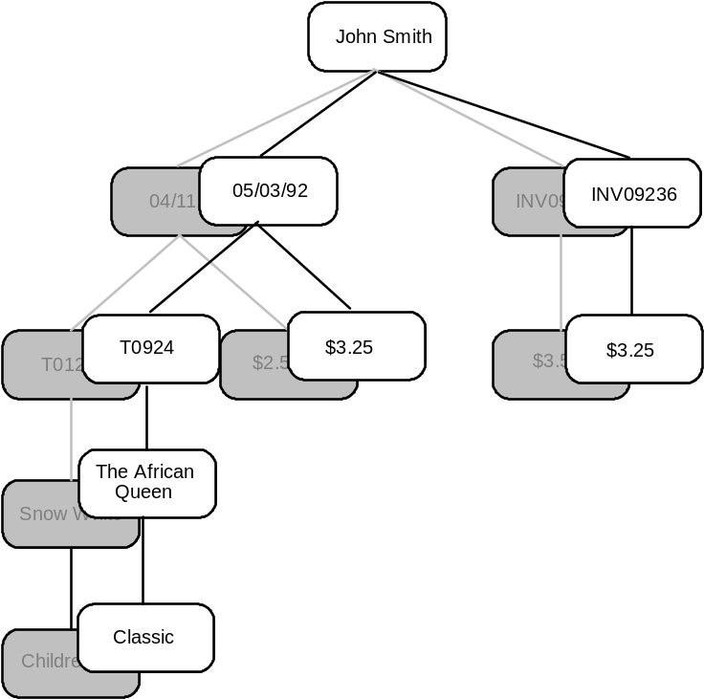
Figure 13. An instance of the Customer object
For example, Figure 13 shows an instance of the customer object. The subobject instance starting with the object entity Rentals consists of:
• A rentals entity instance with a rental date of '05/03/92'
• A VideoTape entity instance with an ID of 'T0924'
• A Movie entity instance with the title 'The African Queen'
• A LineItem entity instance with the Amount '$3.25'
• An Invoice entity instance with the ID 'INV9236'
• A LineItem1 entity instance with the Amount '$3.25'
We can create a nested transaction with the Rentals subobject by issuing the system operation CreateTemporalSubobjectVersion specifying Rentals as the target entity instance for the subobject root. What this does is save the current subobject information and create a work version of the subobject which may then be updated. If we then modify the Customer name to 'John T. Smith', the LineItem Amount to '$4.00' and Exclude the VideoTape entity instance, the object instance would appear as follows:
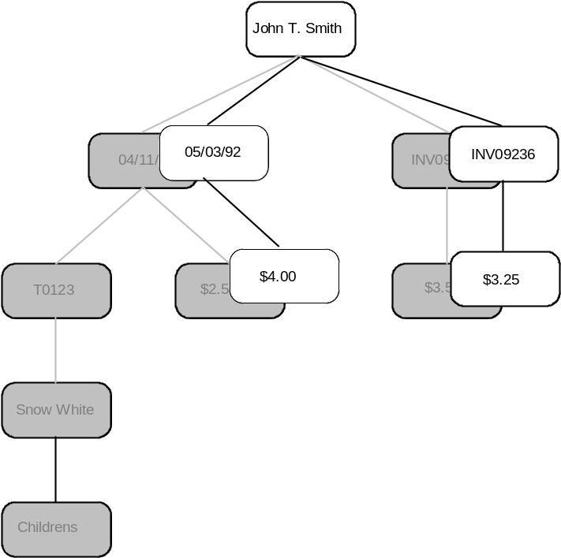
Figure 14. An instance of the Customer object after modifying the Customer Name,
the LineItem Amount ,and excluding the VideoTape entity instance
After applying changes to the object instance, we then either accept the changes by Accepting the Rentals object entity or Cancel the changes by Canceling the Rentals object entity. If we cancel the Rentals subobject, the object instance reverts back to its previous state as shown in Figure 13 except for the Customer Name change, since the Customer entity type is not part of the Rentals subobject.

Top

[Amber demo]

Temporal Entities
In addition to temporal subobjects, Zeidon provides the capability to create temporal entities. For example, a new temporal VideoTape entity instance can be created as part of the initiation of a new video tape rental and a date attribute assigned for the rental. At this point the object instance looks as follows:
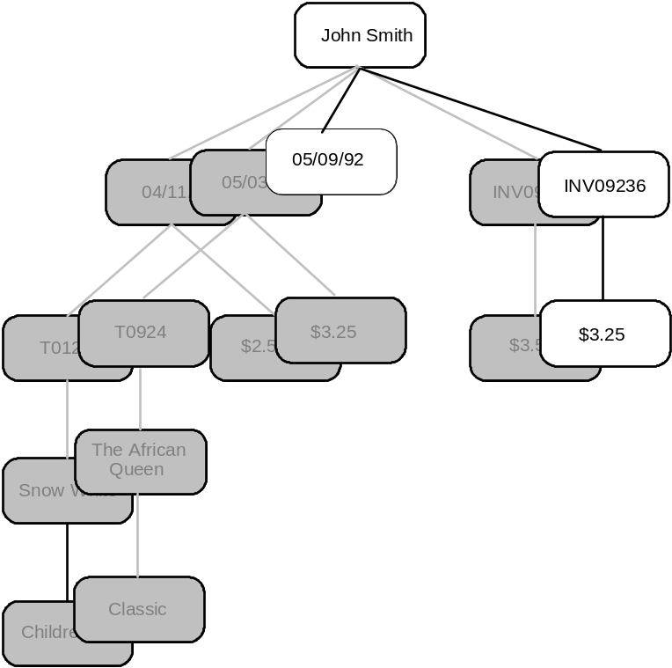
Figure 15. An instance of the Customer object with a temporal Rental entity instance
If the customer than changes his mind and decides not to rent, the rental can be canceled by canceling the rentals object entity and the temporal entity is removed from the object instance. Note that Accepting the entity in this state would most likely result in a cardinality violation because a rental requires a VideoTape in order to be complete.

Top

[Amber demo]

Accepting and Canceling Subobjects
Accepting and Canceling of subobjects can be done on any entity type in a Zeidon object at any time regardless of whether or not the target entity of the accept or cancel is temporal. There is one exception to this rule and that is when a temporal entity or subobject is accepted while one of its descendants is also a temporal entity or subobject. This case results in an error because the descendent must be accepted or canceled prior to accepting the parent entity type. In other words, when creating levels of nested transactions down a hierarchical path of an object instance, the Accepts and Cancels must be issued in the reverse order of the initial CreateTemporal calls.
In addition to temporal subobject processing, Accept processing:
• Validates that all required attributes are defined for the target entity instance
• Validates that all cardinalities are correct for the target entity's children
• Invokes any Accept constraint defined for the target entity type
• Returns the results to the calling operation
In addition to temporal subobject processing, Cancel processing:
• Invokes any Cancel constraint defined for the target entity type
• Returns the results to the calling operation

Top

[Amber demo]

The Objects Tool
Objects are created and updated using the Zeidon Objects tool. Step-by-step instructions on using the Objects tool are provided in Chapter 2, "Building Objects," in the Zeidon User's Guide.

Top

[Amber demo]

Overview
In Zeidon, you group related windows together into sets, called dialogs. In general, the windows that make up a dialog operate primarily on a major Logical Object Definition and interact with each other. There is no restriction, however, on what windows are grouped together to form a dialog and there is no restriction on windows contained in one dialog passing control or communicating with windows from a different dialog. A dialog is simply any logical collection of windows that makes sense to you.
Be aware, however, that when maintaining the specification of a window, you will be checking out the whole dialog that contains that window. That means only one developer can work on a dialog at a time.
Zeidon dialogs are primarily made up of two things.
1. Window definitions, which include the specification of all items necessary for the functioning of a window.
2. Dialog operations, which are programming statements that are necessary to augment the non procedural specifications for window definitions.

Top

[Amber demo]

Window Definitions
Window definitions specify all the information necessary for the function of that window as a part of a Zeidon application. In building a window definition, you are concerned primarily with the following components.
1. Controls
2. Registered Views
3. Menus and Options
4. Control Events
5. Actions
Related Topics:
Window Controls
Control Data Mapping
Registering Views
Menus and Options
Control Events
Window Actions
DIL Messages
Disabling Actions and Graying Controls/Options
Modal and Modeless Windows

Top

[Amber demo]

Window Controls
Window controls are the visible components of a window that display information or allow for operator action. Zeidon controls include the same types as controls in other windowing systems, such as:
• Text
• Edit Boxes
• Buttons (Push, Radio, Check)
• List Boxes
• Combo Boxes
• Group Boxes
As with some other windowing systems, Zeidon controls are not restricted to those that are standard with windowing systems, but include more complex combinations, such as spread sheet and outliner controls. In addition, you can build your own controls and make them a part of the Zeidon system, just like the Zeidon controls.
Though Zeidon controls are similar to those in other windowing systems, they also differ by capturing additional information that cause the controls to perform functions automatically. That information is primarily of two types.
1. Event and action information allows an operator to trigger function by selecting a control through a mouse or keyboard action. This is covered below in the sections, Control Events and Window Actions.
2. Mapping information controls the display of data in a window and the capture of data through the mouse and keyboard. This is covered below in the section, Control Data Mapping.
Beyond events and mapping, there is additional information you can provide for a control, such as control colors, control fonts and DIL messages.
Window controls typically use the default colors you assign to your windowing session. You can override these colors, however, on individual controls. What colors mean and how they affect a control depends on the control itself. Most of the basic controls allow you to select a foreground color and a background color. Other more complex controls allow additional color definitions. To determine the color options for a control, you must go to the documentation for that control or bring up the detail window for that control.
Window fonts are typically treated like colors, and a default is used. You can override font information, however, for individual controls. What font means and how they affect a control depends on the control itself. Most of the basic controls allow you to select a single font. Other more complex controls allow addition font definitions. To determine the font options for a control, you must go to the documentation for that control or bring up the detail window for that control.
The DIL message information for a control allows you to override the default message that will be displayed in the DIL message for a window when that control gains focus. As explained in the section DIL Messages, you can add a DIL message to a window that will present an information message as each control gains focus. You typically use the default DIL message for a control, but you can override that default message by assigning a specific message on the detail window for that control.
You display and enter control information by double clicking on any control in the Zeidon Designer. In response to that action, a window is presented displaying current information settings for that control and allowing you to modify those settings. Though much of the information on these windows is common across control types, the actual information presented is unique for the control you selected.

Top

[Amber demo]

Control Data Mapping
The key concept behind mapping is that most controls display and/or capture data. In Zeidon terms, most controls display attribute values and/or capture attribute values. For example, a list box displays the value of an attribute for several entity instances and an edit box captures an attribute value for a single entity instance. Thus, mapping is the presentation of one or more attribute values in a Zeidon control.
When data (an attribute value) is displayed and captured, its format is often converted from the format internally stored in Zeidon or on a database. For example, a date is usually displayed as MM/DD/YY or DD/MM/YY, even though it is rarely stored that way. For another example, the data represented in a control showing a pie chart are actually numeric attribute values, and in no way resemble a pie chart. Thus, mapping is often the conversion of data, as well as its presentation.
To specify mapping, you must identify three pieces of information:
1. View - Since mapping is from/to an object instance, that object instance and a particular position within it (the view) must be identified. To identify a view, you must have given that view a name, which is called registering the view. This usually occurs automatically, but you can control it as described in the section, Registering Views.
2. Entity Name - Since attribute names are unique only within an entity, the entity containing the attribute must be identified by name. For some controls, there are additional entity names that may be specified. For example, a list box can have three entity names specified: one for the entity containing the attribute being displayed, one for the entity that is being listed (which could be different from the one containing the attribute) and one for the parent entity under which the entities are listed (which doesn't have to be the listed entity's immediate parent).
3. Attribute Name - This is the name of the attribute for which data values are being displayed or captured.
In some cases, you can also specify context information, along with the view, entity and attribute for mapping. This allows you to control the formatting used for that attribute. As explained in the chapter on domains, a domain can have several contexts defined with it, that identify various formats that can be used with that domain. If the domain for an attribute has multiple contexts, you can select one of those contexts for mapping with that attribute. For example, if you were specifying mapping for an edit box to an attribute with domain Date, you could select the context, DD-MM-YYYY, which would cause the date to be displayed and entered in that format. If you do not specify a context, the default context defined with the domain will be used for formatting.
For example, consider a Logical Object Definition, Customer_Orders, containing entities Customer, Order and Order_Item and a view to that an instance of that object type with registered name, Active_Customer. If you wanted an edit box on a window which presented and captured the Date_Ordered from the Order entity, you would paint an edit box control, double click on the control icon to bring up the control information window and select the following mapping names.
View: Active_Customer
Entity: Order
Attribute: Date_Ordered
If you wanted to override the default date context to format the date as DD-MM-YYYY, you would also select the context name as:
Context: DD-MM-YYYY
As a second example, if you wanted a list box displaying the Description attribute from the Order_Item entity for all Order_Item entities under a Customer, you would paint a list box control and a subcontrol on top of it for the list item. To specify the attribute to be displayed in the subcontrol, you would double click on the control and select the following mapping names.
View: Active_Customer
Entity: Order_Item
Attribute: Description
To specify what entity is to be listed under what parent, you would double click on the list box control and select the following mapping names.
View: Active_Customer
Entity: Order_Item
Scope Entity: Customer

Top

[Amber demo]

Registering Views
When you want data from an object instance to be included in a window control, a name must exist to identity which object instance and which view to that object instance is to be used by the control. In other words, all views to active object instances that are referenced within windows must have names assigned to them that can be referenced by each window control. In Zeidon, we call these names, registered view names.
To control name conflicts, all the names you want to assign to views must be specified, or registered, to the application. To use a registered view name on a window control, you must also assign that name to the dialog under which the control is defined. This is done to limit the size of lists for registered view selection and to control what views can be accessed by any dialog. You register these names to the application and assign them to a dialog from the Dialog tool using the menu option, Registered Views. Some view names are registered automatically. When you create a Logical Object Definition, you get a registered name assigned by the same name as the Logical Object Definition.
When you register a view name, you must assign it a Logical Object Definition name. This is to protect you from accidentally using the same view name with object instances of different types, which would cause mapping errors. A view name is thus registered for a particular object.
Registering a view name does not assign that name to an active view. It only declares a name that can then be assigned to an active view and specifies the object type to control what kinds of views can be assigned that name. To assign a registered view name to an active view, you must specify the name in an operation statement. For example, to assign the registered view name, Active_Customer, to a view with VML variable name, customer, include the following statement within a VML operation.
NAME VIEW customer REGISTERED AS "Active_Customer"
You typically assign a registered view name to a view in a dialog operation executed by a window just preceding the window that references that view.
If you assign the same registered view name to another view, it switches the view referenced by that name. In other words, only one view can be assigned the same name at a time.

Top

[Amber demo]

Menus and Options
Zeidon supports two kinds of menus with subordinate options.
• Menu Bars
• Popup Menus
Menu bars and popup menus are logically the same in that both are composed of options that can be selected by the operator. The difference is that menu bars have the first level of options presented on a bar at the top of the window and a window has a maximum of one menu bar, while popup menus only appear in response to a right mouse click and a window can have several popup menus.
A menu bar exists to define the various processing options available to the operator on that window. Usually a window that has a menu bar has no push buttons, as the processing options are defined on the menu bar, instead of the body of the window. A menu bar has at least one first level option, and usually several, that are presented across the bar. If you single click one of the options, its suboptions are presented. There can be a hierarchy of options, so that suboptions can themselves have suboptions. The last tier of a suboption (which can be the option itself on the menu bar), triggers an action when it is selected by a single mouse click.
Popup menus exist to present a unique set of options for different controls. You trigger a popup menu for a control from a dialog operation statement. For that control, you select the event that is to bring up the popup menu and tie it to an action, with a dialog operation. In that operation, specify the statement, ShowPopupMenu in VML or CreateTrackingPopupMenu in C, to present the correct menu at either a default position or a specific position on the window. It may be that the control will present a different popup menu, depending on the state of the control or on other information within the system.
You define what activity an option is to trigger by assigning an action to that option. You can do this by selecting an action that already exists or by specifying a new action for that option. The action selected for an option can be already selected for another option or by an event tied to a control. Thus, the same action can be triggered by several events and/or options. Actions are described under the section Window Actions below. You tie an action to an option by updating the detail information for that option and selecting an existing action or specifying a new action.

Top

[Amber demo]

Control Events
Various window controls have events that you may want to tie to actions. In other words, controls have events that can trigger actions. Each control has a unique set of events. For example, push buttons have a single event, which is the selection of that button. List boxes have several events, including a single click and a double click event.
You tie an event to an action by double clicking on the control in the Zeidon Dialog tool and going to the detail window for control information. On that window you will find a list of valid events for that control. Double click on the desired event and select an existing action or specify a new action.

Top

[Amber demo]

Window Actions
Window actions define the activity that can be assigned to menu options or control events. Since an action can be tied to multiple options or events, the action provides a level of reusability within a window. Since actions are usually unique to a window, that reusability does not extend outside the window, even though the components of an action can be reusable outside the window. This will be explained later in this section, after action components are described.
An action has several components, as follows, which define the various activity that can occur for an action.
• Next Window Activity
• Dialog operation
• Auto object activity
• Auto disabling
The first thing you usually think about for an action is the presentation of the next window to the operator, if the action concludes successfully. There are three major choices, with variations of each.
1. Go to another window, either leaving up the current window or replacing it.
2. Stay of the same window, either refreshing it with new information or leaving the current information displayed.
3. Return back to a parent window or to whatever started this dialog.
You choose the next window activity from a combo box on the action detail window. The full meaning of each option is described in the User's Guide.
You usually think next of any VML statements that must be executed to fully define processing. If such statements are necessary, you specify an existing or new dialog operation to include those statements. Since your objective should be to minimize procedural processing, most of your actions should not require operations. Dialog operations are usually not necessary, as much processing can be defined through auto object activity.
The last activity you think about for an action is the disabling of the action based on the state of active objects. Though it will be necessary sometimes to disable actions through dialog operations, it will simplify maintenance if you can use the auto disabling features of an action. The concept in auto disabling is that an action is usually disabled when an object is in a particular state (ex., a particular entity instance already exists). To specify auto disabling, you thus define an object and the state of that object which will cause the action to be disabled. This is more fully described in the User's Guide.
As mentioned above, an action is not reusable outside a window. At first, this may seem unusual, as there are several things that actions have in common across windows (e.g. they go to the same subwindow; they perform the same functions). However, though the parts may be common across windows, the total usually is not (e.g. it would be unusual for two actions on two separate windows to go to the same subwindow, execute the same processing and disable the same actions).
The component most often reused is the dialog operation. To facilitate dialog operation reuse, they are defined at the dialog level and can be reused by any action within the dialog. Though unusual, you can even request the reuse of an operation in another dialog.

Top

[Amber demo]

DIL Messages
The use of windowing dialogs can be assisted by a form of help, called a DIL message. A DIL message is a bar, usually placed on the bottom of a window, that displays short informational messages for the operator about activity occurring on the current window. That bar can be made up of a single message area or several short message areas. Zeidon allows you to format a DIL message either way. You can program the processing of DIL messages to present them entirely under program control, or you can request that Zeidon present DIL messages automatically based on information about a control.
An example of programming the presentation of DIL messages is the E/R Diagrammer for data modeling in Zeidon. The special control that handles the graphics of E/R modeling sends custom messages to the DIL message area that provide the operator with information about activity on the model, such as the name of the entity on which the cursor is positioned. You can do the same thing from a control or from any dialog operation by issuing the operation, SetDIL_Message.
In addition, you can request Zeidon to automatically present a DIL message based on what control has focus.

Top

[Amber demo]

Disabling Actions and Graying Controls/Options
In windowing dialogs, it is often desirable to gray controls and options when the corresponding action is not valid for the current state of processing. In Zeidon terms, the actions are not valid based on the current state of objects and any controls or actions that trigger those actions should be grayed. You thus do not usually gray controls and options directly, but instead disable actions, which may cause the graying of associated controls and/or options.
One important issue to consider, however, is the impact on controls that have multiple events. Some controls have a single event and the disabling of an action tied to that event will cause the graying of the control. For example, a push button control has only a select event, and the control is designed such that disabling an action tied to that event will gray the push button. However, a list box has multiple events and disabling an action tied to one event should not necessarily gray the control so that other events cannot be triggered. Thus, list boxes are not grayed when actions are disabled. Graying activity for controls based on disabled actions are described with the specific documentation for each control.
You can enable and disable actions under program control using the operation, Enable Action. A parameter in the operation controls whether it is disabling the action, thereby graying associated controls and options, or enabling the action, thereby ungraying associated controls and options.
You can gray and ungray controls and options directly using the operations, SetControlState and SetOptionState.

Top

[Amber demo]

Modal and Modeless Windows
A concept common in windowing systems, but confusing to those new to the windowing paradigm, is that of modal and modeless windows. Modeless windows are the norm in windowing systems and allow the operator to alter focus easily from one window to another. There are times, however, that this flexibility is not desirable and would be confusing to the operator. For example, if the operator has made an error, the system should present an error window and not let the operator continue (i.e. go back to the regular window) without responding to the error. Such windows are termed modal windows.
Any time you want the operator to be forced to respond to a window, before continuing on previous windows, you must make that window modal. If you want to allow the operator to switch back and forth between two windows without completing either, you must make those windows modeless. In general, modal windows are simpler, but less flexible, while modeless windows provide more flexibility to the operator, but can be confusing to that operator and more difficult to define correctly by the developer.
The characteristic of modal versus modeless is not a property of a window in Zeidon, but a property of how that window got control from a previous window. The same window could thus be triggered as modal in one case and modeless in another. This is unusual, however, as windows generally tend to be one type or the other. To specify the modal/modeless characteristic of a window, you select the desired next window activity from the action that caused the window to be presented.
In some cases, you will find modeless windows to be more complex to define that modal windows. This is not based on the modeless characteristic, itself, but on considerations of asynchronous processing. In fact, you can look at modal windows as implementing synchronous activity (only one activity at a time) and modeless windows as implementing asynchronous activity (multiple activities at a time). It is handling the communication and coordination of asynchronous activity that causes the complexity in modeless dialogs.
Most of the complexity in Zeidon occurs in two situations:
• Two modeless windows need to communicate back and forth.
• Two modeless windows are using the same registered view name, but should be processing different views.
Since multiple windows in a Zeidon application can share the same object instances and views, communication problems are minimized in Zeidon. However, if you want activity in one window to be reflected in another, you must request the refreshing of the data in the second window. Since data in object instances is automatically modified during the action of the first window, that activity is reflected in the second window by simply having the controls of that window refreshed from the current values in the object instances.
You can request the refreshing of data in a window at either the window level or the individual control level. Refreshing the whole window is simpler, but somewhat slower. You should initially refresh at the window level, and only alter to the control level if performance is not adequate. The following operations are used for refreshing and are described more fully in the Operations section of the User's Guide.
• RefreshControl
• RefreshWindow
• RefreshAllSubwindows
A more complex problem in dealing with modeless windows occurs when two asynchronous windows reference the same registered view name, but need to refer to different object instances or different views within the same object instance. Note that this situation may or may not be true with asynchronous windows. It is sometimes desirable for two windows to be modifying data in the same view.
For example, consider a case where two modeless windows are modifying different data for the same customer. Both windows would use the same registered view name referencing the same view. On the other hand, consider a case where the same window has been brought up twice, with each of the windows running modeless and modifying data for two separate customers. Both windows would use the same registered view since they come from the same definition, but would need two separate views into two different object instances.
To handle both cases above, we need a way to control whether two windows with the same registered view name are referencing the same view or two different views. This is accomplished by naming views (i.e., assigning registered view names) at either the task level or the subtask (window) level. If a view is named at the task level, then all the windows that use that name will be using the same view. If a view is named at the subtask level, then all the windows that use that name will be using different views.

Top

[Amber demo]

Autodesigning Dialogs and Windows
The Zeidon autodesign feature automatically creates application windowing dialogs based on the structure of a Logical Object Definition (LOD) and the content of the data model. Zeidon can autodesign an entire windowing dialog or autodesign attributes into an existing window. You can autodesign dialogs using mostly default settings that require little design effort, or you can specify detailed information, controlling the order of attributes on each window. literal content and function, creating a dialog that more precisely matches you objectives. Once the dialog has been autodesigned, you can also fine tune the autodesigned windows using the Zeidon Dialog tool.
The autodesign process uses three different Zeidon application components: a Logical Object Definition (LOD), a User Interface Specification (UIS), and a windowing dialog.
• A LOD describes the structure and relationships of the application data. Zeidon uses the LOD to determine the structure for the autodesigned dialog. Therefore, before you autodesign a dialog you must first create a LOD using the Zeidon Objects tool. Note that the LOD inherits the required information from the data model, such as relationships cardinality and entity type.
• From the LOD, you create a UIS. The UIS allows you the flexibility to determine how your application will look and run when it is completed. Although the structure of the UIS and the resulting autodesigned dialog are partly determined from the characteristics of the data model and LOD, you can control attribute content, prompt and button text and some button actions using the UIS.
Note: If you are autodesigning an individual window, you do not have to create a UIS, but you must have an existing LOD.
• When you initiate autodesign from the Dialog tool, Zeidon automatically creates an application windowing dialog using the information in the UIS or adds attribute content to an existing window. Autodesigning a complete dialog requires a UIS, while adding attribute content requires only a LOD.
The structure of a dialog is primarily determined by the characteristics of the data model and LOD. This is reflected in the UIS through autodesign case types. When a UIS is first initialized, the case types are determined from the data model and LOD. You are allowed to make modifications within the case structure (i.e. determine attribute content, eliminate an entity to be autodesigned), but you are always limited to the case types from the data model and LOD.
Related Topics:
Autodesign Case Types
Dialog Structure and Content
User Interface Specification

Top

[Amber demo]

Autodesign Case Types
Each autodesign case type is determined from the data model and LOD and is initialized when you first create a UIS. Each case is determined by the type of entity in the data model (i.e. fundamental, associative, attributive), its relationship cardinality in the data model and its runtime permissions in the LOD, as follows. The case types were defined based on their association with the data model and their impact on the resulting dialog.
Autodesign includes the following case types:
• Case 1 - A case 1 type is primarily for attributive entities under their parent, but is also used for the root entity of a LOD. The key characteristics of case 1 entities in a UIS is that they will always generate a listbox on a parent window, listing all current instances of that entity under its parent (or all instances of the root entity on the initial window of the dialog) and a maintenance/display window of the attribute content for the window.
• Case 2 - A case 2 type is for a fundamental entity under another entity in the LOD, where the maximum cardinality of the fundamental entity under its parent is 1 and the runtime permission for the entity in the LOD is include/exclude. The maximum cardinality means that within an object instance, there will be only one occurrence of the fundamental entity under its parent and thus, instead of a listbox on the parent window as for case 1, a group box is generated, showing enough attributes of the fundamental entity to identify that entity. In addition, a select window is generated that allows the user to go to a list of instances of the fundamental entity and select the one to be included in the object.
• Case 3 - A case 3 type is for a fundamental entity under another entity in the LOD, where the maximum cardinality of the fundamental entity under its parent is greater than 1 and the runtime permission for the entity in the LOD is include/exclude. The maximum cardinality means that within an object instance, there may be multiple occurrences of a fundamental entity under its parent and thus a listbox will be generated on the parent window to list the current instances as for case 1. However, because the runtime permission is include/exclude, a select window is generated that allows the user to go to a list of instances of the fundamental entity and select entries to be included in the object, the same as case 2.
• Case 4 - A case 4 is similar to case 3, except that in this case an associative entity exists between the fundamental entity and what would otherwise be the parent entity. Whereas case 3 identifies an entity under its parent and is involved with two entities, case 4 identities and entity under an associative entity under its parent and is involved with three entities. Like case 3, case 4 generates a listbox of current entity instances on the parent window. Also like case 3, it generates a select window that allows the user to go to a list of instances of the fundamental entity and select entries to be included in the object. If the associative entity has attributes, however, it allows values of those attributes to be entered on the select window and generates an additional maintenance window where those values can be updated.
• Case 5 - A case 5 type is for an additional fundamental entity under a Case 4 associative entity. It will result in a combo box being created on both the case 4 new entity window and on the case 4 update entity window. This combo box will be used both to display the current entity included and also to select a new entity to be included. The case 5 entity must have a maximum cardinality of 1.
• Case 6 - A case 6 type is used for the same object structure as a case 2 type, but generates a different window structure. That is, both a case 2 type and a case 6 type are used for a fundamental entity under another entity in the LOD, where the maximum cardinality of the fundamental entity under its parent is 1 and the runtime permission for the entity in the LOD is include/exclude. But where the case 2 type generates both a group box on the parent window to display the current entity included and a new window to select a new entity to be included, the case 6 type generates only a combo box on the parent window that is used both to display the current entity and also to select the new entity.

Top

[Amber demo]

Dialog Structure and Content
An autodesigned dialog is composed of several interrelated windows. The structure of the dialog is primarily determined by the autodesign case types, as described above. The data content is primarily determined by the attributes you select in the UIS.
The controls on the dialogs are determined by the attributes you select, by the associated domains of those attributes, by the autodesign case structure and by options you select in the UIS. The controls generated are as follows:
• Edit Box - This is the most common way an operator enters data for an attribute. If the attribute is updateable within the LOD and you have requested update functionality for the associated entity in the UIS and the associated domain is not a table, an edit box control for the attribute will be generated.
• Text - This control is generated for all prompts and for any attributes that are not updateable.
• Combo Box - This control is generated if the attribute is updateable within the LOD and you have requested update functionality for the associated entity in the UIS and the associated domain is a table,
• List Box - This control is generated for listing child entities on a parent window when the cardinality of the relationship to the parent is greater than 1. When this control is generated is explained under autodesign case types above.
• Button - All actions on dialog box windows are initiated using buttons. Some buttons are generated automatically base on case type, while others are determined by options you select in the UIS.
• Group Box - The above controls are organized into groups using the group box control. Basically a group box is created for the content and functionality of each entity on its own window or on a parent window.
• Tab - When a LOD has several child entities under a parent entity, there is often not room on the window of the parent entity to hold all the listbox and group box controls for the children. In this case, the tab control can be used to separate the content of each child entity into its own tab area.

Top

[Amber demo]

User Interface Specification
A User Interface Specification (UIS) is defined relative to a LOD and contains information that impacts the design of a dialog. A UIS is required for autodesigning an entire dialog, but is not required when autodesigning attributes into an existing window.
When a UIS is first created, it is initialized according to the entity type and relaitonship cardinality in the data model. The result is an autodesign case type for each entity, as explained above. You must add information for each entity, particularly identifying attribute content for each window. You also specify other information, such as captions and actions to further control the resulting window content. You cannot change an entity from one case type to another, but you can change an entity to "none", meaning no window will be autodesigned for the entity.
When defining UISs, you can also set default values for the LPLR that impact the dialogs generated. These include information such as button sizes and text values. If you do not set the default values yourself, appropriate defaults will be chosen.

Top

[Amber demo]

Overview
This section reviews the Zeidon application components and introduces the tools in the Zeidon development system as well as how application components are managed on the Zeidon repository.

Top

[Amber demo]

Application Components
The application components which make up a Zeidon application and are managed by the Zeidon tools are as follows:
• Domains - Domains constrain the values which may be assigned to an attribute. Domains include algorithms, tables for enumerated lists of valid values, formatting information, and contexts for adding special meaning. Domains are assigned to data model attributes which are then inherited by Zeidon objects using the data model attributes and to work attributes in the Zeidon object. The Zeidon Domain tool is used to create and maintain domains.
• Data Model - The data model is the fundamental design unit in Zeidon. It contains the entities, Relationships, and attributes which exist for the business. A data model is built which is independent of any particular application needs. Its intent is to define what pieces of information a business uses and how it is related to other pieces of the business. It does not describe how any of the pieces are used in any particular application. The Zeidon Data Model tool is used to create and maintain a data model.
• Subject Areas - Over time, as the data model grows, the model itself gets unwieldy. Subject areas are a partitioning mechanism for breaking up a large data model into logical sub components. Subject areas are made up of a subset of entities from the data model. In addition, any relationships whose source and target entity are both part of a subject area are automatically included in the subject area. The Zeidon Data Model tool is used to create and maintain subject areas.
• Physical Data Models - A physical data model describes a physical mapping relationship between a data model and a specific implementation of the data model on a selected database ( or databases ). For example, a physical data model can be created to map a given data model to Microsoft's SQL Server. The Zeidon Physical Data Model tool is used to create and maintain physical data models.
• Zeidon Objects - Zeidon objects, or Logical Object Definitions (LODs), are the key to application development. Objects are assembled from the data model into a hierarchical structure to satisfy particular application needs. Behavior and business rules in the form of operations are then added to the object to enhance productivity and insure data integrity. Execution versions of a Zeidon object are combined with the physical data model information to automate the database access and combine data update into logical 'business transactions'. The Zeidon object tool is used to create and maintain Zeidon objects.
• Dialogs - Dialogs are graphical user interfaces which interact with Zeidon objects for the creation, display, and maintenance of application data. Dialogs consist of windows and controls. Controls contain mapping information for communication with instances of Zeidon objects. The Zeidon Dialog tool is used to create and maintain dialogs.
• Registered Views - Registered views define names which are associated with specific Zeidon objects. These names are used for mapping Zeidon object attributes to dialogs and for operations to process Zeidon object instances. The Zeidon Dialog tool is used to create and maintain registered views.
• User Interface Specifications - User Interface Specifications define information for AutoDesigning Zeidon dialogs and dialog windows. The UIS combines dialog style preferences with selected attributes from Zeidon objects for input into the Zeidon AutoDesign facility of the Zeidon Dialog tool. The Zeidon Dialog tool is used to create and maintain UISs.
• Presentation Environment - The presentation environment defines the window styles, controls, fonts, and colors which can be used to build dialogs. The Zeidon Presentation Environment tool is used to maintain the presentation environment Information.
• Global Operations - Global operations are operations which are not tied to a particular Zeidon object or dialog, but are reusable by any Zeidon object or dialog in the application. The Zeidon Operation tool is used to create and maintain global operations.
• Source File Definitions - Source File definitions contain information about the operations within a source file associated with either a domain, Zeidon object, dialog, presentation environment, or global operation. Source File definitions are created and maintained automatically by the tool associated with each of the application components listed above.

Top

[Amber demo]

Tools
The tools (dialogs) which make up the Zeidon application development system are as follows:
System Administration - The System Administration tool is for the creation of Central Project Libraries(CPL), Central Project Library Releases(CPLR), and the creation and maintenance of Users on the Zeidon Repository. For more information on CPL's and CPLR's, please refer to the section on Configuration Management later in this chapter.
• Workstation Administration - The Workstation Administration tool manages the Zeidon application components on the Zeidon repository. This tool is used to create Local Project Library Releases(LPLR), check-out and check-in application components, and refresh LPLR's. For more information on LPLR's and configuration management functions, please refer to the section on Configuration Management later in this chapter.
• Domain - The Domain tool is for the creation maintenance of the application domains for use by model attributes and Zeidon object attributes.
• Data Model - The Data Model tool is for the creation maintenance of the application data model and subject areas for the data model.
• Technical Environment - The Technical Environment tool is for the creation and maintenance of physical mappings between the application data model and databases such as Microsoft's SQL Server.
• Object - The Object tool is for the creation and maintenance of Zeidon objects and operations for the Zeidon objects.
• Presentation Environment - The Presentation Environment tool is for the creation of dialog window styles, fonts, colors, and controls for use in building dialogs.
• Dialog - The Dialog tool is for the creation of windowing dialogs for maintaining application data. This tool also creates and maintains registered views and dialog operations associated with windowing dialogs.
• Launch - The Launch tool runs windowing dialogs for testing and debugging purposes.
• Operation - The Operation tool is for defining and maintaining global operations associated with an application.
• Object Browser - The Object Browser is a utility for examining and changing Zeidon object instances while a test application is running.

Top

[Amber demo]

Configuration Management
Configuration management is the process of controlling the way application components are created and stored in the Zeidon repository. It involves setting up the configuration of the repository itself, managing the use of the repository by multiple developers, and controlling conversions to new releases of your Zeidon applications.
Related Topics:
The Zeidon Repository
Central Project Libraries
Central Project Library Releases
Local Project Library Releases

Top

[Amber demo]

The Zeidon Repository
The repository is a database that contains all of the components of your Zeidon applications. In addition to storing components, the repository also records how they relate to one another and enforces standard configuration rules (for example, the repository won't allow you to connect to two versions of the same reusable component). For client/server systems, the repository is stored on a network server and can be accessed by multiple local workstations.
Each component that is stored in the Zeidon repository is part of a project. A project can be any group of items that you want to organize and control together. This could be an entire application or a smaller piece of an application that changes independently and is reused by multiple applications (such as an E/R diagram or a set of domains).

Top

[Amber demo]

Central Project Libraries
If a project is to be re-used by multiple applications or by multiple users, it must be stored as a central project library (CPL) in the Zeidon repository. CPL's are similar to directories in that they provide a way to organize your projects into categories. Unlike directories, however, Zeidon CPL's contain only multiple versions, or releases, of the same thing. A CPL consists of one or more central project library releases (CPLR's).

Top

[Amber demo]

Central Project Library Releases
Because projects that are reusable may go through several stages of implementation, the repository allows you to store multiple releases of each project and to control the conversion from one release to another. Every project that is stored in the repository is stored as a central project library release (CPLR). Multiple releases of the same project are stored in a single CPL.
The sample repository shown in Figure 16 contains five CPL's, represented by circles. There is one CPL for each project that is stored on the repository: a CPL for operations that are shared by the entire company (Company Reusable Opers), one for domains shared by the entire company (Company Reusable Domains), and one for each of the Zeidon sample applications (Video Store, Banking, and Education).
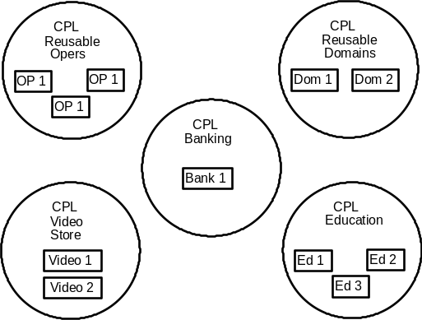
Figure 16. Sample CPL's With CPLR's
Each CPL contains one or more CPLR's, which are represented by rectangles. There is one CPLR for each release of a particular project. The Company Reusable Operations have gone through three releases while there has been only one release of the Banking application.
Related Topics:
Reusing CPLR's
Migrating to New CPLR's

Top

[Amber demo]

Reusing CPLR's
To support the reusability of data and function, it is possible for one CPLR to reuse what is contained in another CPLR. For example, if you have multiple applications that use the same set of domains, you can connect each application CPLR to the CPLR containing the domains. This allows you to avoid the repetition of having to copy the domain set into each application. If you create a new release of an application but do not change the domain set, you can simply connect the new application CPLR to the existing release of the domains. Note that the connection is made between CPLR's, not between CPL's, because each release of the application must decide which release of the domains it should reuse.
Any time one CPLR reuses another, the reused CPLR is included in the CPLR to which it is connected. For example, in Figure 18, CPLR Dom 1 reuses CPLR OP 1. This means that OP 1 is
included in Dom 1. If any other CPLR's reuse Dom 1, the connection to OP 1 is also included. This included connection is represented in Figure 17 by a dashed line.
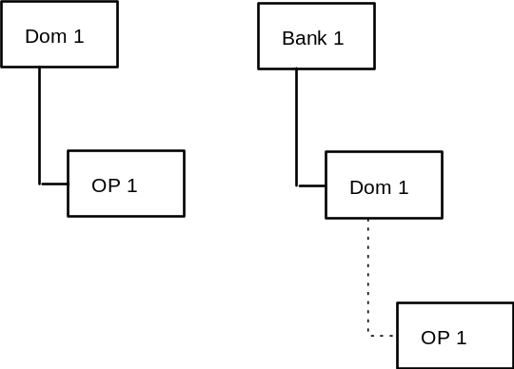
Figure 17. Reusing CPLR's
There are two important considerations to keep in mind when reusing CPLR's:
1. Any time you reuse a CPLR, all relationships in the path of that CPLR are included. For example, in Figure 17, because Bank 1 reuses Dom 1, it has a reusable connection to OP 1 as well.
2. You can only reuse one CPLR within a CPL. In other words, you can only connect to one release of the same project at a time. For example, it would be invalid for Bank 1 to reuse Dom 2 because it is already reusing Dom 1. Note that it would also be invalid for Bank 1 to reuse OP 2 because of its included connection to OP 1.
If you want to connect to a new release of something that is in the same CPL as a release you are currently reusing, you must first exclude the connection to the old CPLR and then include the new connection. This process of moving from one release of a project to another is called migration.

Top

[Amber demo]

Migrating to New CPLRs
When you create a new release of a project, you may have old releases still in production that you do not want to alter while you move over to the new release. Because the Zeidon repository allows you to store multiple releases of each project, you can maintain control over the migration from release to release.
For example, when you have a new release of a Zeidon application, you create a new CPLR within the CPL for that application. The old CPLR remains in the repository with its connections to other reusable CPLR's so that it can function as it always has. You can then make decisions about what relationships you want to make to the new CPLR without affecting the previous release.
Migrating to a new release of a project often requires deleting, or excluding, some old relationships and creating, or including, some new ones. In the example shown in Figure 17, Bank 1 could migrate from reusing the first release of domains (Dom 1) to reusing a second release, Dom 2 (not pictured), by excluding the connection from Dom 1 and then including a connection to Dom 2.
This excluding from components in one reusable CPLR and including to components in another CPLR is handled automatically through Zeidon Migration Services. The process can generate errors, however, that must be handled by the developer. For example, if a component in an application CPLR references a domain in a CPLR and then migrates to a new version of that domain CPLR that does not contain the referenced domain, an error will occur. The developer must then decide whether to change the domain reference or add the domain to one of the CPLR's.

Top

[Amber demo]

Local Project Library Releases
Local Project Library Releases (LPLR's) are not stored in the Zeidon repository but in directories on individual workstations. LPLR's are where changes to projects are made. Rather than directly updating a CPLR, you check out or copy out to your workstation the components of a CPLR that you want to change. One LPLR is created for each CPLR that you check-out or copy-out. Note that an LPLR may contain any component from its associated CPLR and may also reference anything in the reusable path of the CPLR.
Related Topics:
Checking Out
Copying Out
Refresh

Top

[Amber demo]

Checking Out
When you check out something from the repository, it is not available for anyone else to check out until you check it back in. This means that no one can make changes to the things you are working on until you are finished with them.

Top

[Amber demo]

Copying Out
When you copy out a component from the repository, it remains available for others to check out or copy out from the repository. This means that someone else could make changes to what you have copied out that you do not know about. Zeidon allows you to upgrade a copied component to checked-out status, but only if it is not currently checked-out by someone else and has not been modified since you made your copy.

Top

[Amber demo]

Refresh
When one person makes a change to a CPLR and checks it back into the repository, those changes are not immediately reflected on every other local workstation. Instead, the Zeidon refresh option allows you to control when you want to be affected by other people's changes. When you specify that you want an LPLR on your workstation to be refreshed, Zeidon will update it with the latest version of all components of its associated CPLR as well as any reusable CPLR's to which it is connected.

Top

[Amber demo]

Zeidon Runtime Environment
Each application built with Zeidon executes under the Zeidon runtime system. The runtime system is made up of the following runtime components:
• Object Services - Object Services (the Object Engine) is an executable module (ex., a DLL) which manages the activation and modification of Zeidon object instances. This component manages windowing tasks on a workstation, Zeidon object views, object structure information (object entities, object attributes, domains, etc.) , and the application data which makes up an activated object instance. This component runs as a separate task from the application and is called by applications which use Zeidon objects.
• Dialog Driver - The dialog driver is an EXE file and set of DLLs which 'drives' the windowing application. It only exists on a workstation. The dialog driver activates the initial window for an application and manages all the windows for a single application task. This component acts a a task client to object Services on the behalf of a running application.
• Database Handlers - Database handlers are system provided interfaces to database management systems such as Microsoft's SQLServer and IBM's DB2. Handlers can also be developed as part of the application to support other database systems or a combination of multiple database systems for heterogeneous applications.
Figure 19 is a high-level representation of a Zeidon runtime system running on a workstation. In this example, the database handler is triggered by the Object Engine on the workstation and is running itself on the work station. Whether the database is local or remote depends upon the database interface that is called by the database handler. Usually the database is local when the database handler is running on a work station.
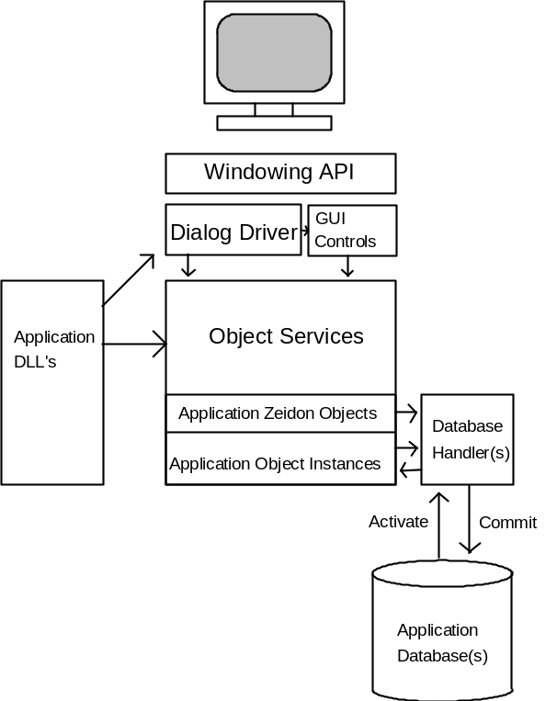
Figure 18. Zeidon RuntimeSystem
Normally the database handler does not run on the workstation. In these cases, there is an Object Engine on the server and the object operation, Activate or Commit is sent from the Object Engine on the workstation to the Object Engine on the server, where the database handler is executed to read or write to the database. Any object instances created on the server are then returned back to the calling Object Engine on the workstation where the application continues.
In addition to the Zeidon runtime system, each application has the following runtime components:
• Executable Zeidon Objects - Each logical Zeidon object defined for an application has a runtime version which describes the structure of the object, the object entity and object attribute names, and all information necessary for mapping the object to the desired database system.
• Executable Domain Definitions - The domain set defined for an application has an executable component containing the underlying data type and any table definitions for each domain in the set. In addition, the Algorithm which implements the domain is also defined for runtime execution.
• Application DLL's - Application execitable modules (ex., DLL's) contain all object operations, domain operations, and dialog operations generated from the VML defined for an application.
When an application is started at a workstation, the Dialog Driver registers with Object Services and passes an application Name for Object Services to use in resolving domains and Zeidon objects to process. A view to an application subtask is returned which can be used for activating Zeidon objects by the application DLL's. This view is then used by the driver to communicate with dialog operations while the application is running.

Top

