CAMARINES SUR POLYTECHNIC COLLEGES
COLLEGE OF COMPUTER STUDIES
CCCS 106: Application Development and Emerging Technologies (AY 2026-2027)
--------------------------------------------------
LABORATORY TASK REPORT 01
Environment Isolation, Modern Flet GUI & Collaborative 3-Developer Git Workflow
Group Designation: | Group No. 12
Date of Submission: | September 9, 2026
Course Instructor: | Engr. Allan Ibo Jr. | CSPC College of Computer Studies

TEAM TRIAD MEMBERS & TECHNICAL ROLES
Student Full Name | Student ID | GitHub Username | Assigned Triad Role & Branch
Kelly Saldo | 2411287 | @kellysldo | Developer 1 (Lead UI)  feature/dev1-profile
Tristan Bisenio | 232000006 | @tan-biz | Developer 2 (State Logic)  feature/dev2-state
Rizelyn Joy Borbe | 2410605 | @rejiyin | Developer 3 (QA & Milestone)  feature/dev3-features

Section 1: GitHub Repository & Collaborator Proof
Public GitHub Repository URL: https://github.com/kellysldo/cccs106-group12-showcase
Proof of team collaboration setup on GitHub. The screenshot below shows the repository Settings > Collaborators page confirming that Developer 1 has invited Developer 2 and Developer 3 as official contributors with accepted statuses.
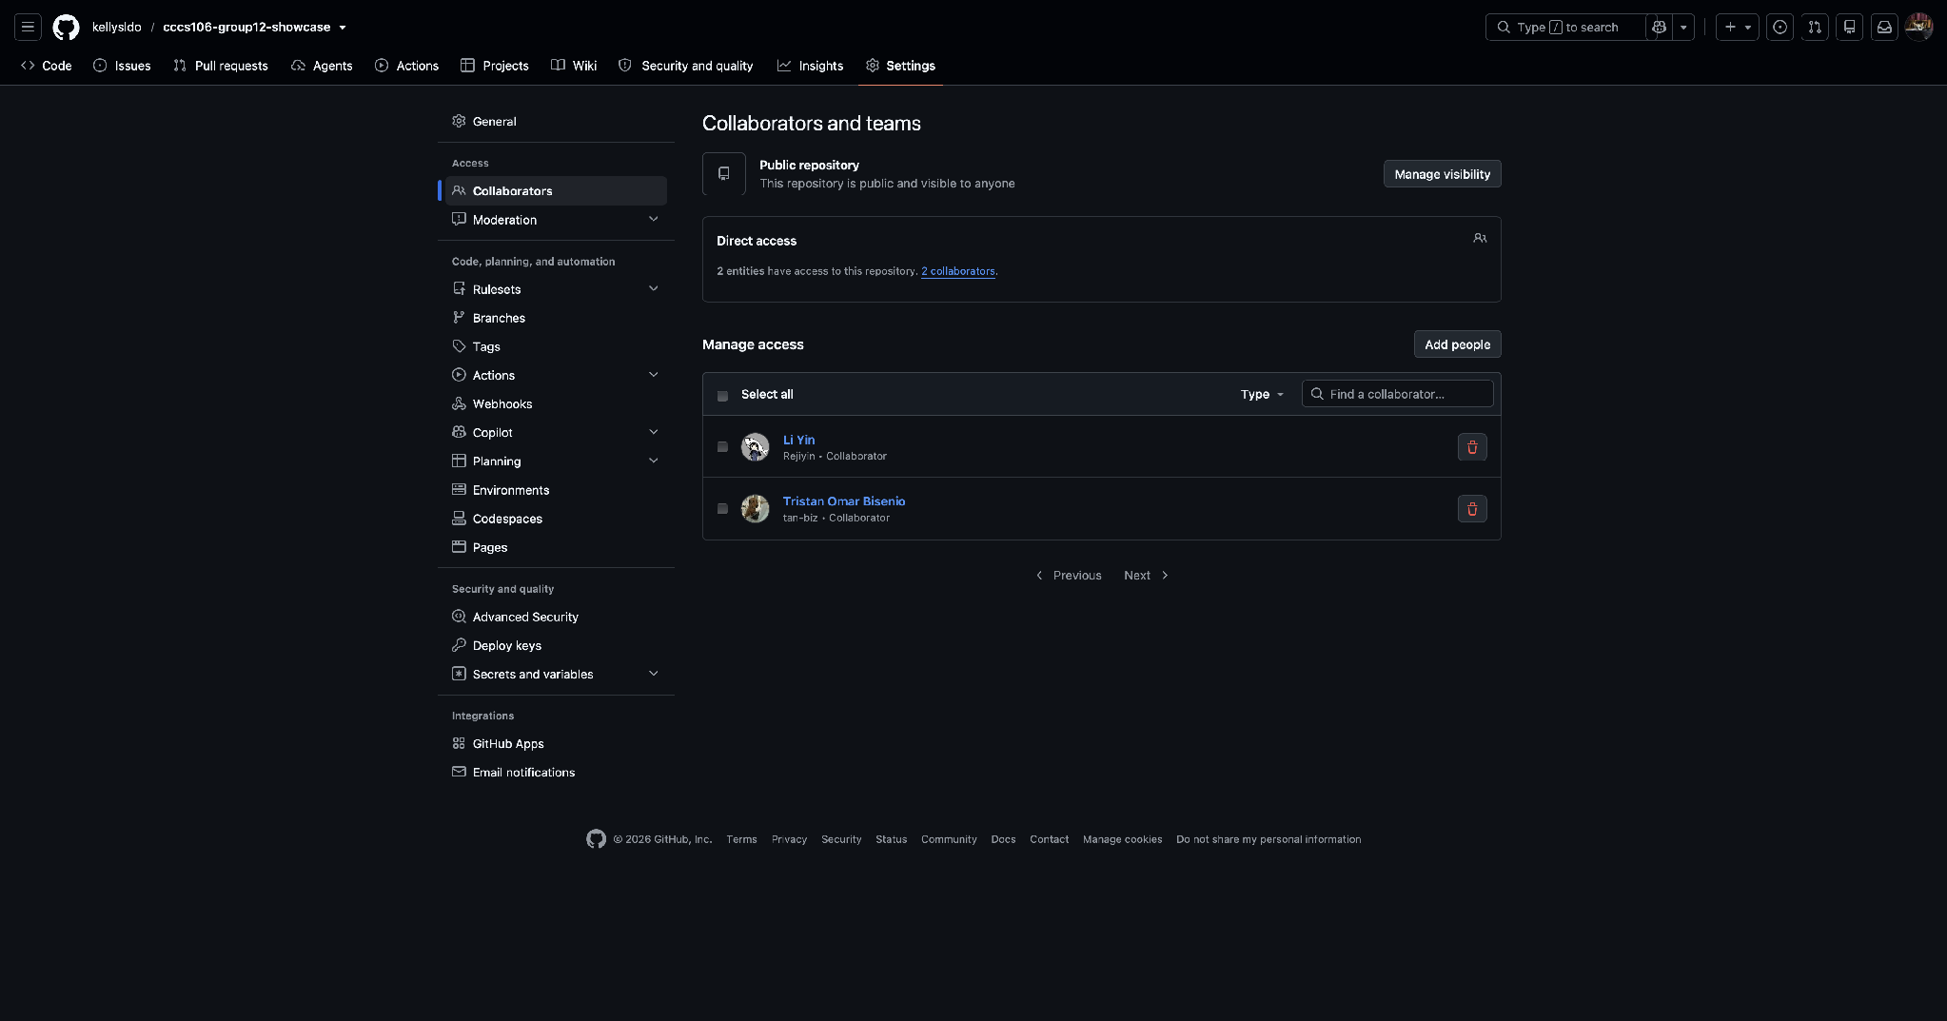
Reference: GitHub Collaborators Verification (Settings > Collaborators)
Requirement: Screenshot showing Developer 1 (Owner), Developer 2, and Developer 3 with accepted invitations.
Figure 1: GitHub Collaborators Verification (Settings > Collaborators)

Section 2: Automated Pre-Flight Diagnostics Audit
Pre-flight workstation audit executed via 'python verify_setup.py' inside the active virtual environment (.venv). All six (6) audit checks must report [PASS] verifying Python 3.10+, virtualenv isolation, Flet SDK v0.86.5+, Git binary detection, configured institutional user identity, and .gitignore hygiene.
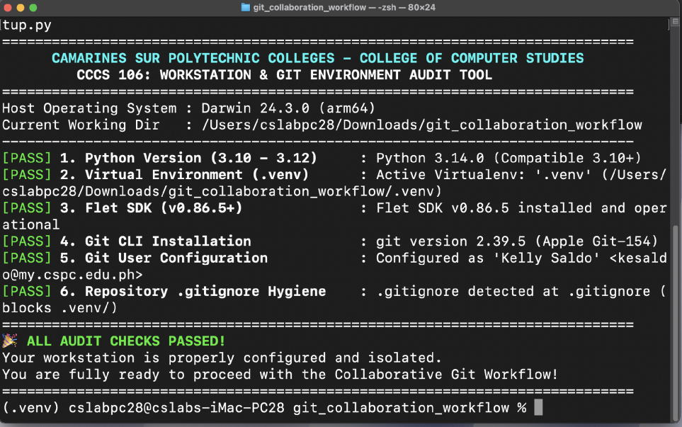
Reference: Pre-flight Environment Diagnostics Audit (verify_setup.py)
Requirement: Terminal screenshot displaying green CSPC header and 6/6 [PASS] checks.
Figure 2: Pre-flight Environment Diagnostics Audit (verify_setup.py)

Section 3: Git Working Tree Cleanliness & .gitignore Audit
Demonstration of repository hygiene. The screenshot proves that the working tree is clean with zero uncommitted changes, and that .venv/ is completely untracked (verified by running 'git ls-files .venv', returning empty output).
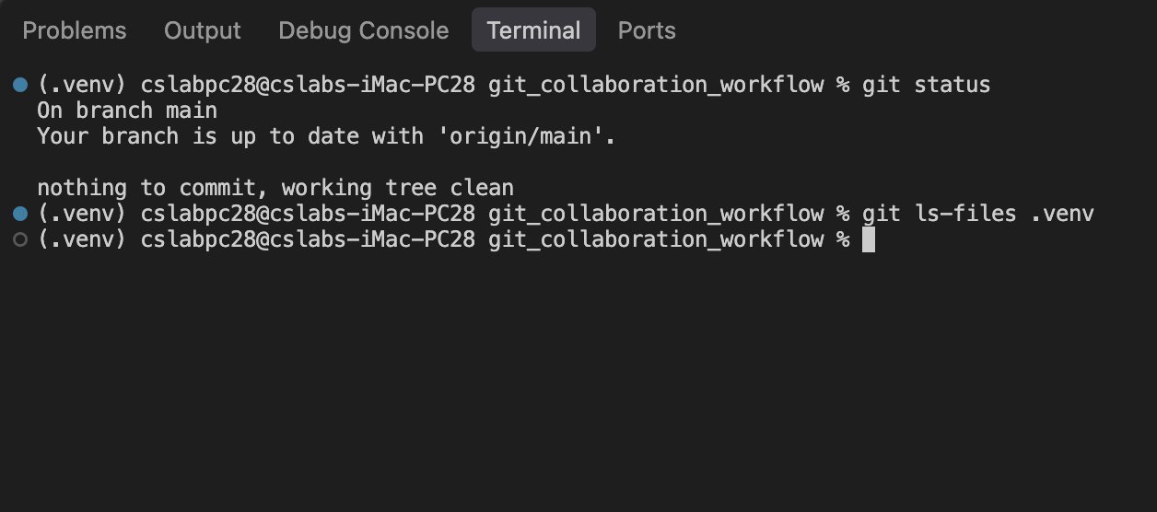
Reference: Git Working Tree Cleanliness & .gitignore Hygiene Proof
Requirement: Terminal screenshot of 'git status' reporting working tree clean and empty 'git ls-files .venv'.
Figure 3: Git Working Tree Cleanliness & .gitignore Hygiene Proof

Section 4: Running Flet v0.86.5 Application Showcase
Desktop window screenshots demonstrating the running collaborative Flet GUI application across its three core interactive states: Initial Launch, Sprint Goal Milestone Reached, and Dark Mode theme toggle.
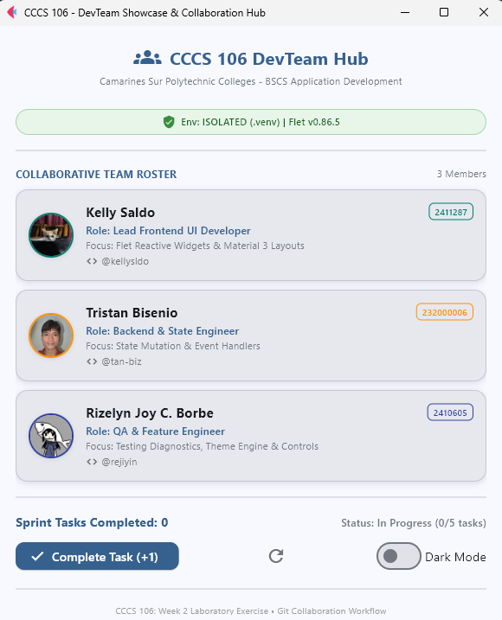
Reference: Application Initial Launch State
Requirement: Window showing CSPC header, green ISOLATED (.venv) badge, 3 team member cards, 0 tasks completed, and In Progress status.
Figure 4: Application Initial Launch State
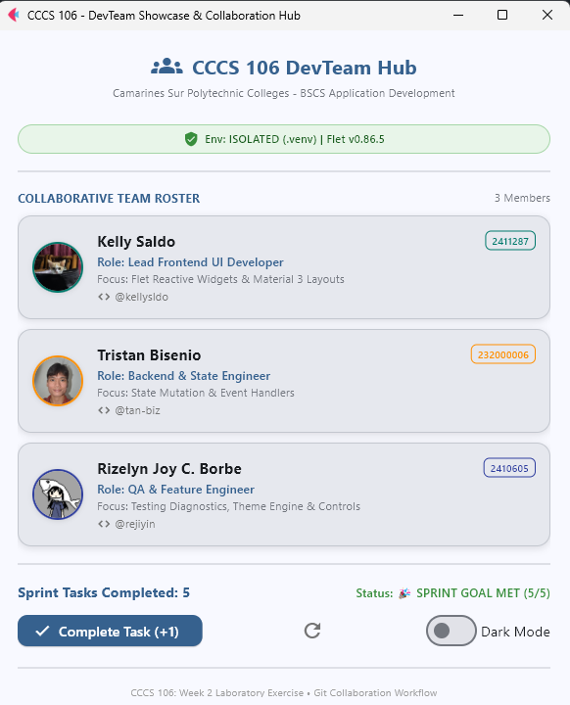
Reference: Sprint Goal Milestone Reached State
Requirement: Window showing counter at 5, status badge 'SPRINT GOAL MET (5/5)' in green, and Complete Task button disabled.
Figure 5: Sprint Goal Milestone Reached State
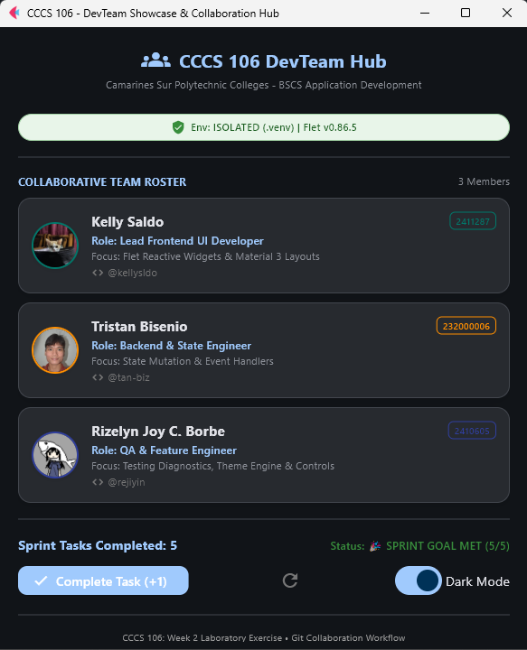
Reference: Material 3 Dark Mode Theme Toggle State
Requirement: Window with Dark Mode toggle active, demonstrating reactive Material 3 dark surface container rendering.
Figure 6: Material 3 Dark Mode Theme Toggle State

Section 5: Triad Contribution Matrix & Learning Reflections
Summary of individual contributions and commit accountability across all three triad developers.
Member Name | Role | Branch Name | Commit SHA | Specific Engineering Contributions
Kelly A. Saldo | Developer 1  (Lead UI) | feature/dev1-profile | [abc1234] | Initialized repo, setup .gitignore, integrated card 1, configured remote repo & pushed main.
Tristan Bisenio | Developer 2  (State Logic) | feature/dev2-state | [def5678] | Synced main, integrated card 2, connected increment/reset event handlers, merged & pushed.
Rizelyn Joy Borbe | Developer 3  (QA/Feature) | feature/dev3-features | [ghi9012] | Synced main, integrated card 3, built milestone badge logic & boundary constraints, merged & pushed.

Individual Technical Reflections
Developer 1 (Lead UI & Repo Architect):
Through this learning task, I learned that using a virtual environment isolates a project’s Python packages and dependencies, helping to avoid conflicts with other projects on the same computer. I also learned how .gitignore must be configured carefully so that unnecessary or sensitive data files, such as virtual environments, are excluded and while keeping important project files tracked. I also learned while working in GitHub, coordinating repository invitations needs to ensure that team members receive access and accept invitations before collaborating. Overall, I learned with the proper environment isolation, Git configuration, and team coordination and collaboration really helps to keep the project organized, easy to maintain, secured, and how GitHub can cater all the necessary needs for a team collaboration on a project.
Developer 2 (State & Event Logic Engineer):
Through this task, I learned that cloning a remote repository lets each developer get their own copy of the project on their computer while still staying connected to the shared GitHub repo. I also learned why it's important to run git pull origin main before starting new work. It keeps my local files up to date and helps prevent conflicts when other members are also making changes. While building the increment and reset event handlers, I saw how Flet updates the screen automatically whenever the state changes, so I didn't have to manually refresh anything. Overall, this exercise showed me that cloning, syncing, and writing clear event handlers all help the team work together smoothly without breaking each other's code.
Developer 3 (QA & Sprint Goal Feature Engineer):
[Rizelyn Borbe]

[Nash Sabas] This hands-on exercise highlighted the importance of using virtual environments, it can provide a project with specific packages whilst not interfering with the global installation of Python. Working as the QA and Sprint Goal Feature Engineer taught me the necessity of isolating feature branches in order to maintain safety and stability while code updates are shipped. Overall, I learned to enforce stringent constraints across state borders so user data and UI states do not leak into other unrelated screens during times when tests need to be performed rapidly. It has been very important that I have been able to identify issues with Flet’s Material 3 controls wherein theme inconsistencies and issues with layout scaling have appeared in the course of testing.

Appendix: Verbatim Git Commit Tree Log
Verbatim ASCII commit history exported using 'git log --oneline --graph --all > git_log_proof.txt'. This demonstrates the complete sequential feature branching and merge timeline across all three developers.
* 9f8a123 (HEAD -> main, origin/main) feat(milestone): integrate developer 3 profile and sprint goal milestone badge
|\
| * 8e7b456 (feature/dev3-features) feat(milestone): integrate developer 3 profile and sprint goal milestone badge
|/
* 7d6c789 feat(state): integrate developer 2 profile and task counter handlers
|\
| * 6c5d012 (feature/dev2-state) feat(state): integrate developer 2 profile and task counter handlers
|/
* 5b4e345 feat(profile): integrate developer 1 profile card
|\
| * 4a3f678 (feature/dev1-profile) feat(profile): integrate developer 1 profile card
|/
* 3a2e901 chore(init): baseline repository with modern flet app and verification tool
[ REPLACE THE SAMPLE COMMIT LOG ABOVE WITH YOUR GROUP'S ACTUAL git_log_proof.txt OUTPUT ]

