HOW TO REQUEST GOODS FROM



Document Information: 1
PRISM Requesting Overview: 1
Requesting items 1
Stock vs. Purchased 2
Tracking your Order 3
Shopping List 3
PRISM-Step By Step 4
Requesting Items From Catalog 4
Requesting Non-Catalog Items 4
Delivery Instructions 5
Checking the Status of Your Orders 6
PRISM with Microsoft’s Internet Explorer 6
Initial log-in screen – note the message 6
Search List Results: 7
Drop Down lists: 7
PRISM Log-in accounts (adapted from an email response): 7

Document Information:

Created by Mike Ring 9/28/05
Modified by Anna Becker 2/2/06
Last modified on 2/3/06

PRISM Requesting Overview:

Requesting items
Once you have logged in, click the Request Goods and Services on the top menu bar.
We have what we call a “catalog” stored in the system. The PRISM catalog is simply a list of all stock items and frequently purchased non-stock items. You will be able to submit a free-form ‘write-in’ request, but you should only do this if the item you need is not in the catalog.

There are several ways that you can choose an item to request.
First, you can search for it. The keyword search will look through all of the possible fields for what you enter. For example, if you type in “Dell,” it will find all of the Dell computers and monitors, everything that is manufactured by Dell, and everything where Dell is listed as a vendor. If you don’t have success with the basic search, you can try the Advanced Search, where you can specify more of the fields. Once you find the item that you want, you can choose to add it to your cart or add it to your list. (more discussion of the list and the next steps later)

Second, you can browse the catalog by figuring out what category an item might be under. For instance, if someone from the Lab needs some more phosphoric acid, they would look under chemicals and scroll down until they found the phosphoric acid. You can choose to add it to your cart or to a shopping list. (as above, more discussion of lists and next steps later)

Finally, if you can’t find the item anywhere in the catalog, you can choose Add Non-Catalog Item to Cart. When you need to do this, BE SPECIFIC. The better you can describe exactly what you want, the more likely it is that purchasing will be able to fulfill your request. If you have spec sheets or something similar, you will be able to upload them and attach them to the requests. You need to provide funding sources to pay for the entire estimated cost, and if you want, you can suggest a vendor. Purchasing will not guarantee use of this vendor if it is something that can be bought from multiple places, but you are welcome to suggest one. Finally, you choose Add to Cart to add it to your cart, or if this is going to be a part of a frequently purchased list of items, you can choose to add it to your shopping list. (more discussion of shopping lists later) Once you choose one of these options, you come back to the main screen, and you have the message You have 1 item in your cart

Stock vs. Purchased
If you searched for or browsed and found an item, you will notice that there is a column labeled Type. When you select a stock item, you are asking for it from our stockroom. These are a whole range of things: chemicals, office supplies, printed materials, and miscellaneous other things. The request will go directly to the stockroom. A purchased item is something that the purchasing branch orders for you. On some stock items, you simply have to put in the quantity of the item that you want and then add it to your cart or list. However, if the stock item is not funded by an indirect account you will need to specify an org budget. For a purchased item, you have to specify an org budget and you have the opportunity to suggest a vendor. Once you have done that, you simply add it to your cart or list.

Again, this will take you back to the main Request Goods and Services screen.
Once you are done shopping, you can view your cart by choosing View Cart from the navigation bar. You can make any final changes to your cart at this point, and if you like, you can add the entire cart to a shopping list (once again, more discussion later). If you’re done, then you just hit the Checkout button.

The final information that you need to enter is the ship-to location and the need-by date. You have three delivery options available for the shipment of your requested items. You may choose to have your requested items delivered to an MDH Employee, a Private Citizen, or an External Organization. If you are shipping to an MDH employee, you can simply select their name and work location from the provided drop down lists. If you are shipping to someone other than a MDH employee you would select Private Citizen option and select the recipient and their correct delivery address from the dropdown list. If the person you wish to have your items delivered to is not on the list you have the option of entering a new private citizen and their address. Your newly entered private citizen will show up in the drop down list once entered. If you are delivering to an external organization (such as a local public health agency), you can simply select the organization from the dropdown list. You may also enter a contact’s name for this delivery option. If the organization you wish to have your items delivered to is not listed you have the option of entering a new organization into the list.

Enter the date when you need to have the order by. Then choose your priority. NOTE: If you choose high priority, purchasing will do everything they can to get this order to you by your need-by date. You will be responsible for whatever shipping costs are incurred, regardless of how high they are, or if the shipping cost is greater than the item cost. Most orders are normal or low priority. If you don’t choose high priority, purchasing will make every reasonable attempt to get your items to you by your need-by date, but they will choose less expensive options at the risk of missing your need-by date by a few days.

Once you’ve finished filling that out and are satisfied with your order, simply hit Submit Request, and you’re done!

Tracking your Order
If you want to see what the status of an already-placed order is, choose Request Goods & Services and then choose My Requests. From here, you can see every request that you’ve placed (with the newest requests on top), and you can check the status of any individual item. Just find the request that the item was in, and click the arrow on the left side of the screen. This will show you the details of any individual request, with the status of each item shown. Some items require approval, purchased items will have to be ordered and purchased, and stock items will need to be dispersed by the stockroom.

Shopping List
When you have an order that you make often, such as ordering materials for a conference, and you know that you’ll need a certain amount of the same items, you can create what is called a Shopping List. As you’re working on a request, you can simply hit Add to Shopping List on each item that you want added, or when you’re finished with your request, you can go to the View Cart screen, and choose Add Cart to Shopping List. Once you have a shopping list created, you can choose My Shopping Lists from the navigation bar to view your lists. You can then select an entire list, or just parts of a list to add to a request.

PRISM-Step By Step

Requesting Items From Catalog
- Log in to PRISM
- Click on Request Goods & Services along the top navigation bar
- If you know what type of item you are requesting, choose its subcategory from the current catalog.
- If you do not know what subcategory the item would fall under, you can search for it using the search box.
- Look for the item in the list that pops up. If you do not find the item that you are looking for, scroll back to the top of the current page and search for your item again either using the search box or a different subcategory.
- Once you have found your item, check to see if its Type says Stock Item or Purchased Item. If the item is a purchased item you will need to have an Org number(s) to fund the purchase.
Note: Some of the stocked items will also require an Org number if they are not funded by an indirect account.
- Click on Add to Cart.
- Enter the quantity of the item that you are purchasing.
- If applicable select the ORG Budget that will be funding this purchase, and the amount in dollars that they will be funding. If multiple org budgets will be funding this purchase, click Add Another Funding Source.
- Click Add to Cart.
- If you are adding more items to this request, go back to step 3. Once you have added all of the items that you want into your cart, click View Cart on the top navigation bar.
- Here you can make any last minute changes to funding sources and quantity. If you decide to make any changes, after you make the change, click Update Shopping Cart.
- If you need to, you can remove an item by checking the box on the right side next to the item that is marked Remove and clicking Update Shopping Cart.
- Once you are done making modifications, click Checkout.
- Now you choose your delivery options. Please see Delivery Instructions below.

Requesting Non-Catalog Items
The following steps are for if you are unable to find the item that you would like to request in the current catalog.
- If you are unable to find the item that you are looking for in our catalog, click on Add Non-Catalog Item to Cart on the top navigation bar.
- Fill in all of the requested information, including a description of the item (BE SPECIFIC), what category you think it would fit in, how many you want, what units they come in (boxes, cases, bottles, etc), and an estimated cost.
- In the future, you may be able to upload a spec sheet in the space provided to give purchasing more detailed information
- You must choose a funding source and the amount that they will be paying, in dollars. If you have more than one funding source, click Add Another Funding Source, and repeat this step
- You may suggest a vendor if you choose. Purchasing does not guarantee that they will buy from this vendor, but they will take your suggestion into consideration
- Once you are done, click Add to Cart
- If you are adding more items to this request see Requesting Items from Catalog above or repeat the above process to add more non-catalog items.
- Once you have added all of the items that you want to your cart, click View Cart on the top navigation bar
- Here you can make any last minute changes to funding sources and quantity. If you decide to make any changes, after you make the change, click Update Shopping Cart.
- If you need to, you can remove an item by checking the box on the right side next to the item that is marked Remove and clicking Update Shopping Cart
- Once you are done making modifications, click Checkout.
- Now you choose your delivery options. Please see Delivery Instructions below.

Delivery Instructions
- A Recipient/Organization and Mailing Address must be present for the order to be submitted. If this information is not present or is incorrect click on Change Delivery Info.
- You may choose to have your requested items delivered to an MDH Employee, a Private Citizen, or an External Organization.
- If delivering to an MDH Employee select the employees name from the recipient drop down list. You also need to select the work location of that employee from the facilities drop down list.
- If delivering to a private citizen, click on Private Citizen and select a recipient from the recipient drop down list and then select the correct address.
- If the person you wish to have your items delivered to is not in the dropdown list, click on the Click Here link at the bottom of the screen to add a new person. Select No org – add private citizen data. Then click on Add New Person and submit their name and address. Once the new person has been entered they will be listed in the dropdown list of private citizens and available for selection.
- If delivering to an external organization, click on External Organization and select that organization from the dropdown list. You may also enter a Contact name for the delivery.
- If the organization you wish to have your items delivered to is not listed in the dropdown list click on the Click Here link at the bottom of the screen to add a new organization. Select Add NEW external org – Enter org name. Enter the organizations name and click Next to enter the organizations address. Select Done Save My Work and your new organization should now appear in the dropdown list.
- Once the delivery information is correct you must specify a need-by date for your order and choose a priority. High priority means that you would be willing to pay any amount of extra shipping charges to get the item by your need-by date. Normal means that orders are processed normally.
- When you are done, click Done - Submit Request.
- You will get a tracking number that you can write down for future reference.

Checking the Status of Your Orders
- Click on My Requests on the top navigation bar.
- Scroll down the list until you find the request that you are looking for (it is sorted by date placed).
- Click on the arrow on the left side of the request that you are interested in
- This will give you detailed information on each item that you requested, and you can see the status of each item (waiting for approval, waiting for purchase, shipped, etc).

PRISM with Microsoft’s Internet Explorer
We recommend using FireFox or Netscape 7 or higher to work with PRISM. If you use Internet Explorer here are a few of the known problems.

Initial log-in screen – note the message
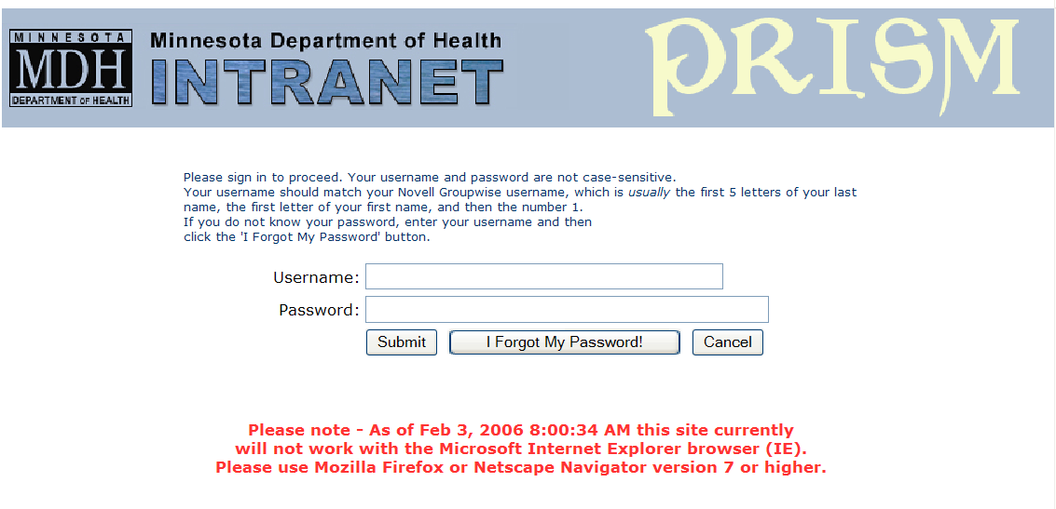

Search List Results:
Sometimes the “Add to List” or “Add to Cart” icons do not display properly in Internet Explorer 6. Instead you get a document icon with a red x in it. That icon will still work, but there is no way to know what it does without prior knowledge of the program. Here is a screen with the part of the search results looking for catalog items with “pencil” in it. The icons are working properly in this screen.
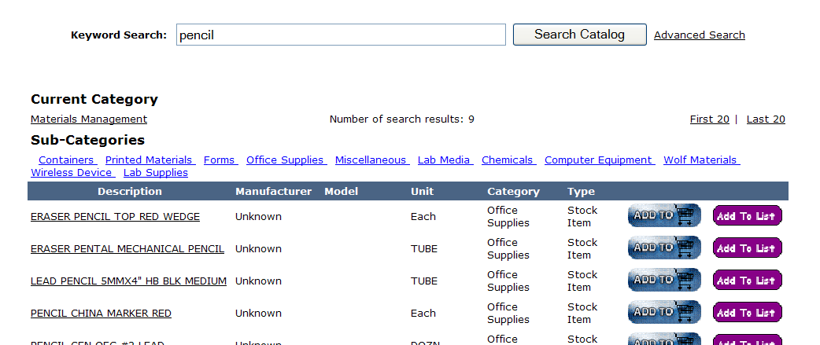

Drop Down lists:

In IE 6, you cannot select an item from a drop-down list using more than one letter. For instance, if you are looking for ORG # 1601 on a list, in a mozilla based browser, you can quickly type “160” and it will take you to the place in the list with 1600, 1601, 1602, 1603, 1604 …. In IE 6, you can only select based on one letter, so typing “160” will take you to the position in the list starting with “0” – the last letter you typed.

PRISM Log-in accounts (adapted from an email response):

The login name should be the same as their Novell ID (i.e., mine is flahas1). The password would be the same one they use for the other Administrative applications, such as iPhone. If they don't know their password, they should first attempt to access it by clicking 'I Forgot My Password'. The system will present them with a challenge question. They will have to provide the correct answer and then they'll be able to reset their password. If they have never logged into an admin app before and have never set up their challenge question, the default challenge question should be "what is your childhood pet's name" and the default answer is "fluffy".

