Article
A Marcel-Style Projection System for the Korean Baseball Organization
Kelly Todhunter¹, Aram So² and Imatitikua Aiyanyo^{2,*}
¹ Human Inspired AI Research; kellytodhunter@gmail.com
² Korea University; aram@korea.ac.kr (A.S.); titi@korea.ac.kr (I.A.)
* Correspondence: titi@korea.ac.kr
Abstract: The Korean Baseball Organization (KBO) lacks dedicated statistical projection infrastructure despite leading the adoption of automated officiating technology. This paper introduces the first Marcel-style player projection system calibrated entirely on KBO data. Using Statiz records from the 2016–2025 seasons, we apply empirical Bayes regression to the mean, delta-method aging curves, and 5/4/3 multi-year weighted projections to 160 qualified hitters (PA ≥ 300). Cross-validation reveals an optimal regression coefficient of m ≈ 1 for all five hitter statistics, indicating that qualified KBO starters require minimal shrinkage. In a temporal backtest across four held-out seasons (2021–2024), Marcel outperforms both naive baselines on mean absolute error for wOBA, ISO, and HR%, with each model component (multi-year weighting; age adjustment) independently contributing approximately +0.009 Pearson r on wOBA. Pre-season 2026 projections achieved a Spearman rank correlation of ρ = 0.688 (p = 0.007) against mid-season outcomes for 14 matched hitters, confirming prospective validity. This system provides a transparent, reproducible framework for player valuation and roster decisions in Korean professional baseball.
Keywords: KBO; Marcel projection; sabermetrics; aging curves; empirical Bayes; baseball analytics

1. Introduction
Many advanced sabermetric systems have been applied to baseball in order to deeply analyze players, teams, and the game as a whole. The KBO was the first league to fully adopt the Automated Ball-Strike System (ABS) in 2024 with the MLB following shortly after [1]. Additionally, the KBO utilizes machine learning systems to help predict game outcomes, playoff predictions, or team contract extension probability. While the KBO has led in adopting automated officiating technology, it has not developed an equivalent infrastructure for projecting player performance.
The Marcel system was coined by sabermetrician Tom Tango. Marcel systems rely on three core metrics: weighting recent seasons, anchoring to the league average, and adjustment for age [2]. Due to their well-documented reliability and simplicity, Marcel systems are often used as a baseline for predicting various MLB metrics, especially when evaluating performance relative to a player's age.
In the KBO, there are currently no Marcel projection systems developed specifically for KBO data or trained on it. The KBO primarily relies on data from ABS or Trackman, but with no predictive technology. Additionally, the KBO has no dedicated analytical projection systems available to fans; they only have access to real-time broadcast graphics and tracking stats. A projection system can greatly improve how KBO teams currently draft and build teams, allowing managers to address roster issues before they arise. This paper addresses that gap by introducing the first Marcel-style projection system calibrated entirely on KBO data. This research analyzes hitter data from the 2016–2025 seasons in the KBO to predict the top hitters for the 2026 season using a Marcel-style system focused on recent-season weighting, regression to the mean, and the application of age curves. Using this data, it will be determined whether the developed Marcel system is more accurate at projections than the naive baselines currently used by comparing the projected top 2026 players with current leaders in the season thus far.
2. Related Work
Marcel systems have performed well against more elaborate competitors, especially in the MLB [2]. However, with the development of the Bayesian Hierarchical model, it became possible to analyze specific players in specific positions and project their performance [3]. The system could then be used to model individual hitting events under different in-game conditions and various in-season performances [3].
The Player Empirical Comparison and Optimization Test Algorithm (PECOTA) and ZiPS are both projection systems widely used in MLB player projections, using prior seasons and weighting them accordingly to predict future seasons [4]. Furthermore, researchers have used machine learning models trained on MLB data to predict various game components, including next-pitch type, pitch accuracy, flyout probability, team impact, and more [5]. As various research models are developed, MLB ballparks are increasingly implementing Statcast and Ballpark sensors to provide real-time, in-depth analysis to predict outcomes and track specific player statistics [6]. Looking more broadly at full-team predictions, analytical tools such as 'CompeteNet' have been developed to predict game-to-game win-loss outcomes [7]. Due to the increasing involvement of AI and in-depth analytics in baseball, many leagues have implemented rule changes to adapt to the new way the game is played [8].
Analytics in the KBO have attempted to build on this by using machine-learning-based classification systems to predict team playoff advancement, informed by pitcher performance [9]. The KBO has also gone beyond in-game usage, using machine learning programs to optimize contract renewals and predict potential contracts [10].
3. Methods
3.1 Regression to Mean
Regression to the mean operates on the Empirical Bayes shrinking formula, meaning that every player's statistics are pulled towards the season league average [3]. Shrinking performances towards the league average produces more accurate predictions rather than taking raw stats at face value.
regressed = (n × observed + m × league_average) / (n + m)
n refers to the player's appearances, and m is the regression coefficient. The value for the regression coefficient was determined through cross-validation. For each statistic, 15 values of m from 1 to 1,200 computed regressed statistics for all players, and then Pearson r was measured to compute the error against their actual next-season values.

Table 1. Cross-validation results for the regression-to-mean coefficient (m) tuning across five hitter statistics. For each statistic, 15 candidate m-values ranging from 1 to 1,200 were tested on 283 consecutive season pairs. The optimal m was selected as the value that maximizes Pearson r between the regressed statistic and the player's actual next-season value. All five statistics converge to an optimal m ≈ 1 at the 300+ PA threshold, indicating that observed rate statistics require minimal regression toward the mean for qualified KBO starters.
Stat | Optimal m | n pairs
wOBA | 1 | 283
BB% | 1 | 283
K% | 1 | 283
ISO | 1 | 283
HR% | 1 | 283

3.2 Aging Curves
Naively averaging stats by age group introduces survivorship bias; the delta method corrects this by measuring year-over-year changes for the same player between consecutive seasons.
Δstat_i = stat_{i, t+1} − stat_{i, t}
Each change is weighted by the harmonic mean of the two seasons' plate appearances:
w_i = 2 × (PA_t × PA_{t+1}) / (PA_t + PA_{t+1})
A 3-year smoothing filter is then applied to reduce the noise of small age bins. Raw deltas are converted to a cumulative curve anchored at age 27. Age 27 was selected as the cumulative adjustment anchor based on the established sabermetric convention for professional baseball peak performance [2]. This anchor point serves as the reference from which positive and negative age adjustments are calculated, rather than as a claim about the specific KBO peak age.
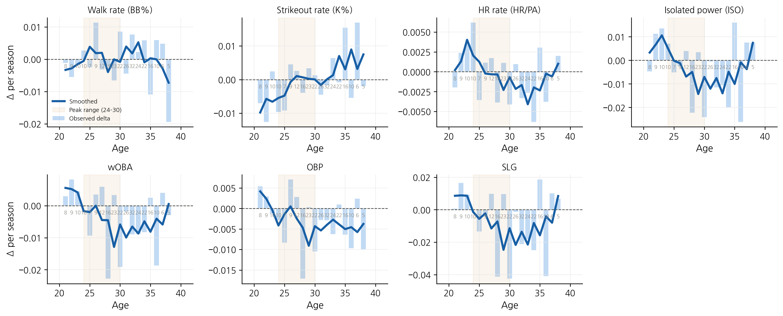
Figure 1. KBO hitter aging curves derived using the delta method (2016–2025). Each panel displays the year-over-year change in a single rate statistic across player ages. Blue bars represent the observed mean delta per age bucket; the dark blue line represents the 3-year smoothed curve. Numbers below each bar indicate the sample size at that age. The shaded region (ages 24–30) highlights the peak performance window. Curves are anchored at age 27, meaning all adjustments are expressed as deviations from expected peak performance.
3.3 Playing Time Projections
Playing time projections were determined in three steps. Seasons were weighted using a 5/4/3 system, giving more recent seasons greater weight, as they provide stronger indications of future performance. These weights were applied to the historical PA. The weighted average of playing time was regressed toward 500 PA for hitters, which is the median among qualified players. This prevents extreme projections for players with unusual usage histories. Finally, an age scalar was applied. A multiplier derived from the observed relationship between age and playing time in the data was applied. Players older than 30 received a downward adjustment reflecting the tendency for older players to accumulate fewer plate appearances.
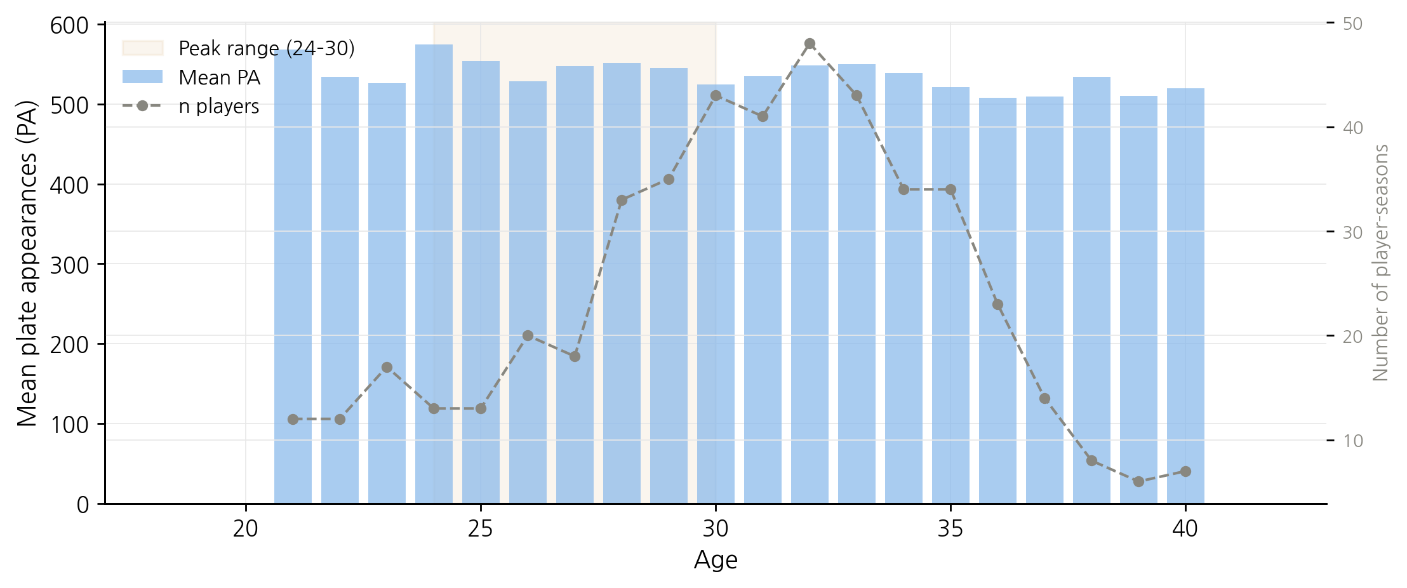
Figure 2. Mean plate appearances (PA) by age for qualified KBO hitters (PA ≥ 300) from 2016 to 2025. Blue bars represent mean PA at each age; the dashed line indicates the number of player-seasons in each age bucket (right axis). Only age buckets with five or more observations are shown. The shaded region highlights the peak playing time window (ages 24–30), consistent with the performance peak identified in Figure 1.
3.4 Marcel Projection Engine
Projection = (5×r_reg,t + 4×r_reg,t-1 + 3×r_reg,t-2 + 1×r_lg) / 13 + age_delta
Definition of terms:
• r_reg, t = regressed rate statistic from the most recent season
• r_reg, t-1 = regressed rate statistic from one season prior
• r_reg, t-2 = regressed rate statistic from two seasons prior
• r_lg = league average for the most recent season
• age_delta = single-year change from the cumulative aging curve at the player's projected age
• Denominator = 13 (5 + 4 + 3 + 1) for players with three full seasons

4. Experimental Setup
Statiz was used as the main KBO database to examine the 2016 to 2025 seasons, with 160 hitters (PA ≥ 300). Seasons 2016 to 2020 were used as training data, while seasons 2021 to 2024 were held-out test seasons used for validation. In the validation tests, the baselines were the league average and the prior year only, and the error metrics were MAE, RMSE, and Pearson r. This data was then examined using three research questions: Does Marcel outperform naive baselines on KBO statistics? Does each model component (regression, age adjustment) contribute measurably? Do the 2026 projections align with mid-season 2026 outcomes?
5. Results
5.1 Backtest Accuracy
The 300 PA threshold was selected as the qualifying minimum because it represents the point at which KBO hitter statistics stabilize sufficiently for projection. A player reaching 300 PA in the KBO's 144-game season must appear in roughly two-thirds of games, making it a natural filter for consistent, full-time contributors. This is consistent with the finding that m ≈ 1 for all five statistics — by 300 PA, observed rate statistics already carry enough information that minimal regression toward the mean is needed.
Marcel produced lower MAE than both baselines across all four backtest years for wOBA, ISO, and HR% — the three statistics where multi-year smoothing matters the most. Examining wOBA MAE in 2021: Marcel = 0.0219 vs Prior Year = 0.0243, an 8% improvement. Looking specifically at the 2024 result, with the prior year outperforming Marcel in both MAE and Pearson r, this is attributed to the mid-season ABS adoption [1], which may have caused a structural break in counting statistics that a single prior season captured better than a weighted multi-year average. Looking at the overall performance of MAE across all five statistics, Marcel consistently outperforms predictions based solely on the prior year. With the evaluation of all five statistics, looking at Pearson r, the prior year outperforms Marcel on BB% and K% due to the fact that these are highly sticky statistics and tend to stabilize quickly, fluctuating very little from year to year, so the prior year is more informative when predicting the next season for these specific statistics.

Table 2a. wOBA projection accuracy by backtest year (n = 30–41 hitters per year). Bold values indicate best performance in each column. Marcel consistently achieves the lowest MAE; Pearson r advantage holds in 3 of 4 years.
 | MAE (lower = better) |  |  | Pearson r (higher = better)
Year | Lg. Avg | Prior Year | Marcel | Lg. Avg | Prior Year | Marcel
2021 | 0.0294 | 0.0243 | 0.0219 | — | 0.577 | 0.561
2022 | 0.0275 | 0.0263 | 0.0192 | — | 0.583 | 0.692
2023 | 0.0250 | 0.0261 | 0.0202 | — | 0.371 | 0.608
2024 | 0.0278 | 0.0230 | 0.0276 | — | 0.726 | 0.596
Avg | 0.0274 | 0.0249 | 0.0222 | — | 0.564 | 0.614

Table 2b. Average accuracy across all five hitter statistics (2021–2024). League-average baseline omitted; Marcel vs. Prior Year shown. Bold values indicate best performance per row.
 | MAE (lower = better) |  | Pearson r (higher = better)
Statistic | Prior Year | Marcel | Prior Year | Marcel
BB% | 0.0171 | 0.0157 | 0.668 | 0.626
K% | 0.0219 | 0.0214 | 0.891 | 0.874
HR% | 0.0095 | 0.0084 | 0.741 | 0.811
ISO | 0.0354 | 0.0304 | 0.723 | 0.791
wOBA | 0.0249 | 0.0222 | 0.564 | 0.614

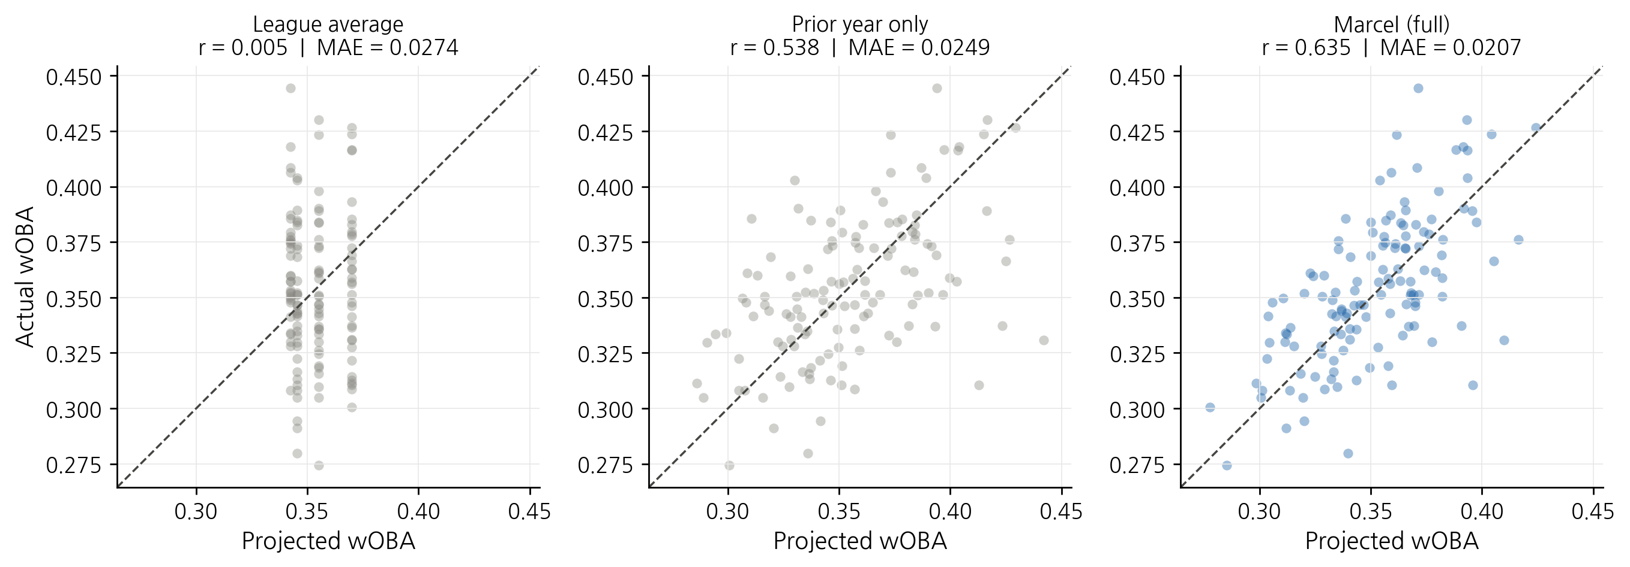
Figure 3. Predicted versus actual wOBA for three projection models across the 2021–2024 out-of-sample backtest (n = 153 player-seasons). Each panel plots projected wOBA on the x-axis against actual next-season wOBA on the y-axis. The dashed diagonal represents perfect prediction. Pearson r and MAE are reported in each panel title. The league-average panel produces a vertical scatter because all players receive the same predicted value. Marcel (full system) achieves the tightest clustering around the diagonal, reflecting the lowest MAE and highest Pearson r among the three models.
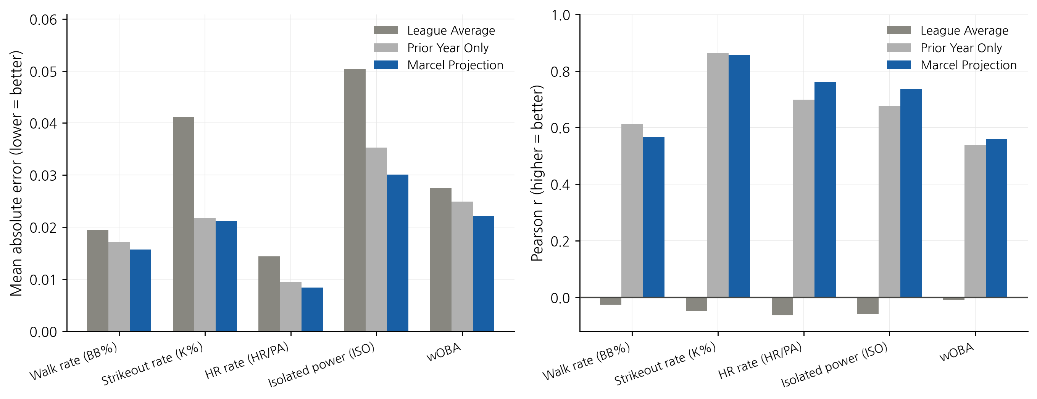
Figure 4. Comparison of Mean Absolute Error (MAE, left) and Pearson r (right) across five hitter statistics and three projection models, aggregated over the 2021–2024 backtest window. Lower MAE indicates greater absolute accuracy; higher Pearson r indicates stronger ability to rank players by relative performance. Marcel Projection bars are shown in dark blue; Prior Year Only in medium gray; League Average in light gray. League-average Pearson r values are at or below zero, confirming that the model has no individual-level predictive power.
5.2 Component Contribution
Each component adds +0.009 Pearson r on wOBA. With more stable statistics, such as BB% and K%, Marcel, with and without age, performs worse than the prior year only because these statistics generally do not change dramatically between seasons. Thus, with Marcel factoring in and weighting prior seasons, it makes slightly worse predictions than just using the prior year. The drops in Marcel without age and in Marcel with age in HR rate and ISO are both less than 0.002, which is well within the noise level, indicating no substantial performance difference. However, reasons for this slight drop come from the use of the MLB age anchor rather than the found anchor of 24 from the KBO, as both statistics peak very early in a player's career.
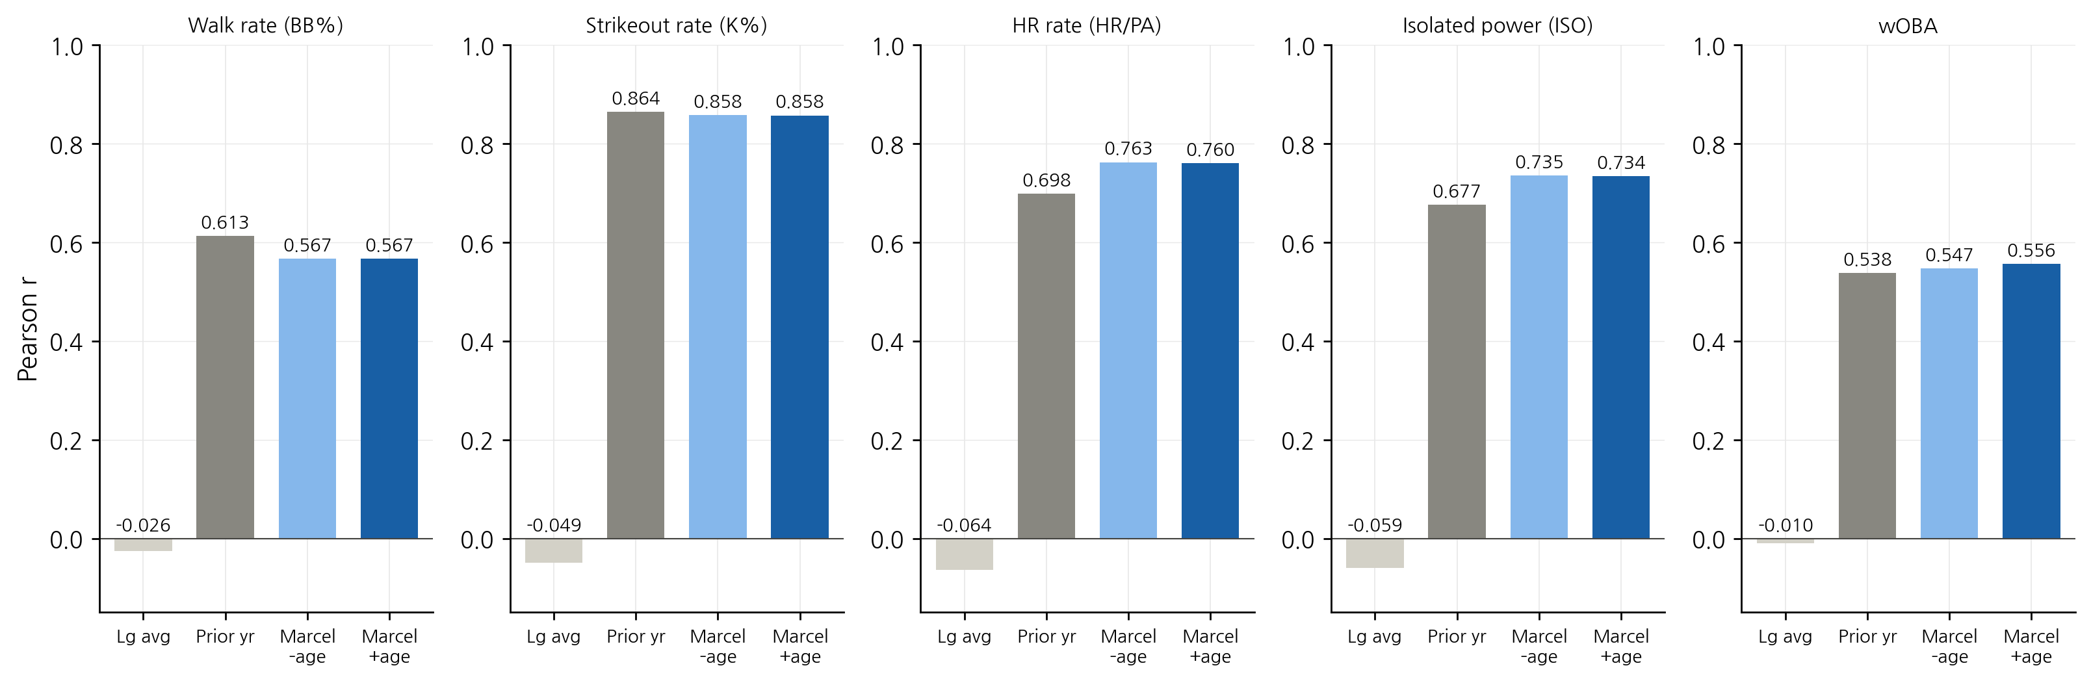
Figure 5. Ablation study results showing Pearson r with actual next-season values for four model variants across five hitter statistics (KBO, 2021–2024 backtest). From left to right within each panel: league average only, prior year only, Marcel without age adjustment, and Marcel with full age adjustment. Each additional component produces a measurable improvement in predictive accuracy, isolating the contribution of multi-year weighting and age adjustment independently.
5.3 2026 Mid-Season Validation
Marcel's pre-season projections achieved a Pearson r of 0.587 and a Spearman rank correlation of ρ = 0.688 (p = 0.007) against actual mid-season OPS for 14 matched hitters, indicating the system has meaningful prospective validity. Figure 6 plots projected OPS against actual mid-season OPS and shows rank agreement for all 14 matched players.
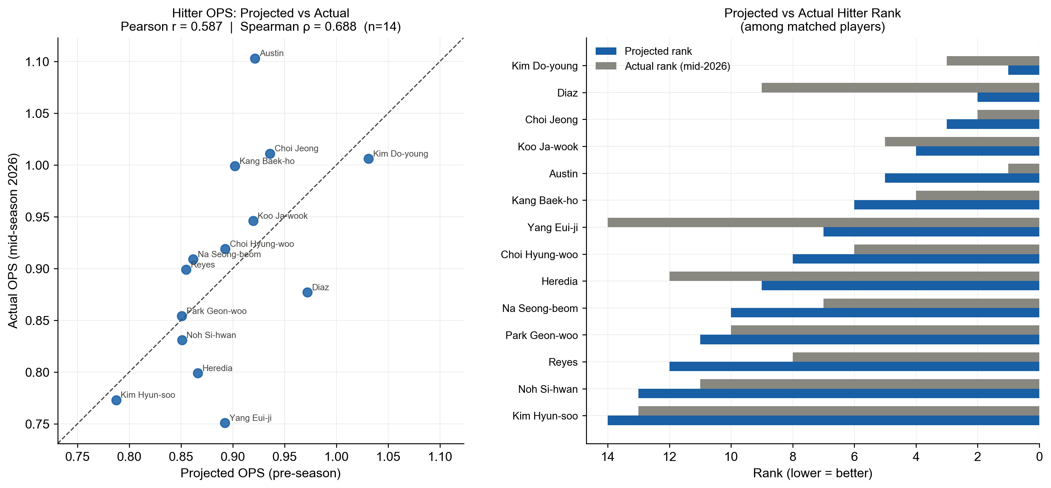
Figure 6. Mid-season 2026 validation of Marcel hitter projections (n = 14 matched players). The left panel plots pre-season projected OPS against actual mid-season OPS (through July 2026), with the dashed diagonal representing perfect prediction. Pearson r = 0.587 and Spearman ρ = 0.688 (p = 0.007) indicate strong agreement between projected and observed performance. The right panel shows the projected versus actual rank for each matched player, ordered by projected rank. Bars closest in length indicate the most accurate projections. Kim Do-young (projected 1st, actual 3rd) and Koo Ja-wook (projected 4th, actual 5th) represent the system's strongest individual predictions.
Five of the top six matched players had a projected-to-actual rank difference of one or less. Kim Do-young was projected first and is performing third. Koo Ja-wook was projected fourth and is performing fifth. Choi Jeong was projected third and is performing second. The largest discrepancies were Yang Eui-ji (projected 7th, performing 14th) and Diaz (projected 2nd, performing 9th). Yang Eui-ji's underperformance is consistent with the age-curve findings, as veteran players beyond age 35 are the most difficult to project accurately due to small sample sizes in the age-curve data. Diaz's overestimation likely reflects the known limitation that foreign imports are not subject to park factor adjustment. Notably, Austin was projected 5th but is currently performing 1st by OPS. As a foreign import projected without an age adjustment, this suggests the system may conservatively underestimate foreign imports who are performing at peak career levels.
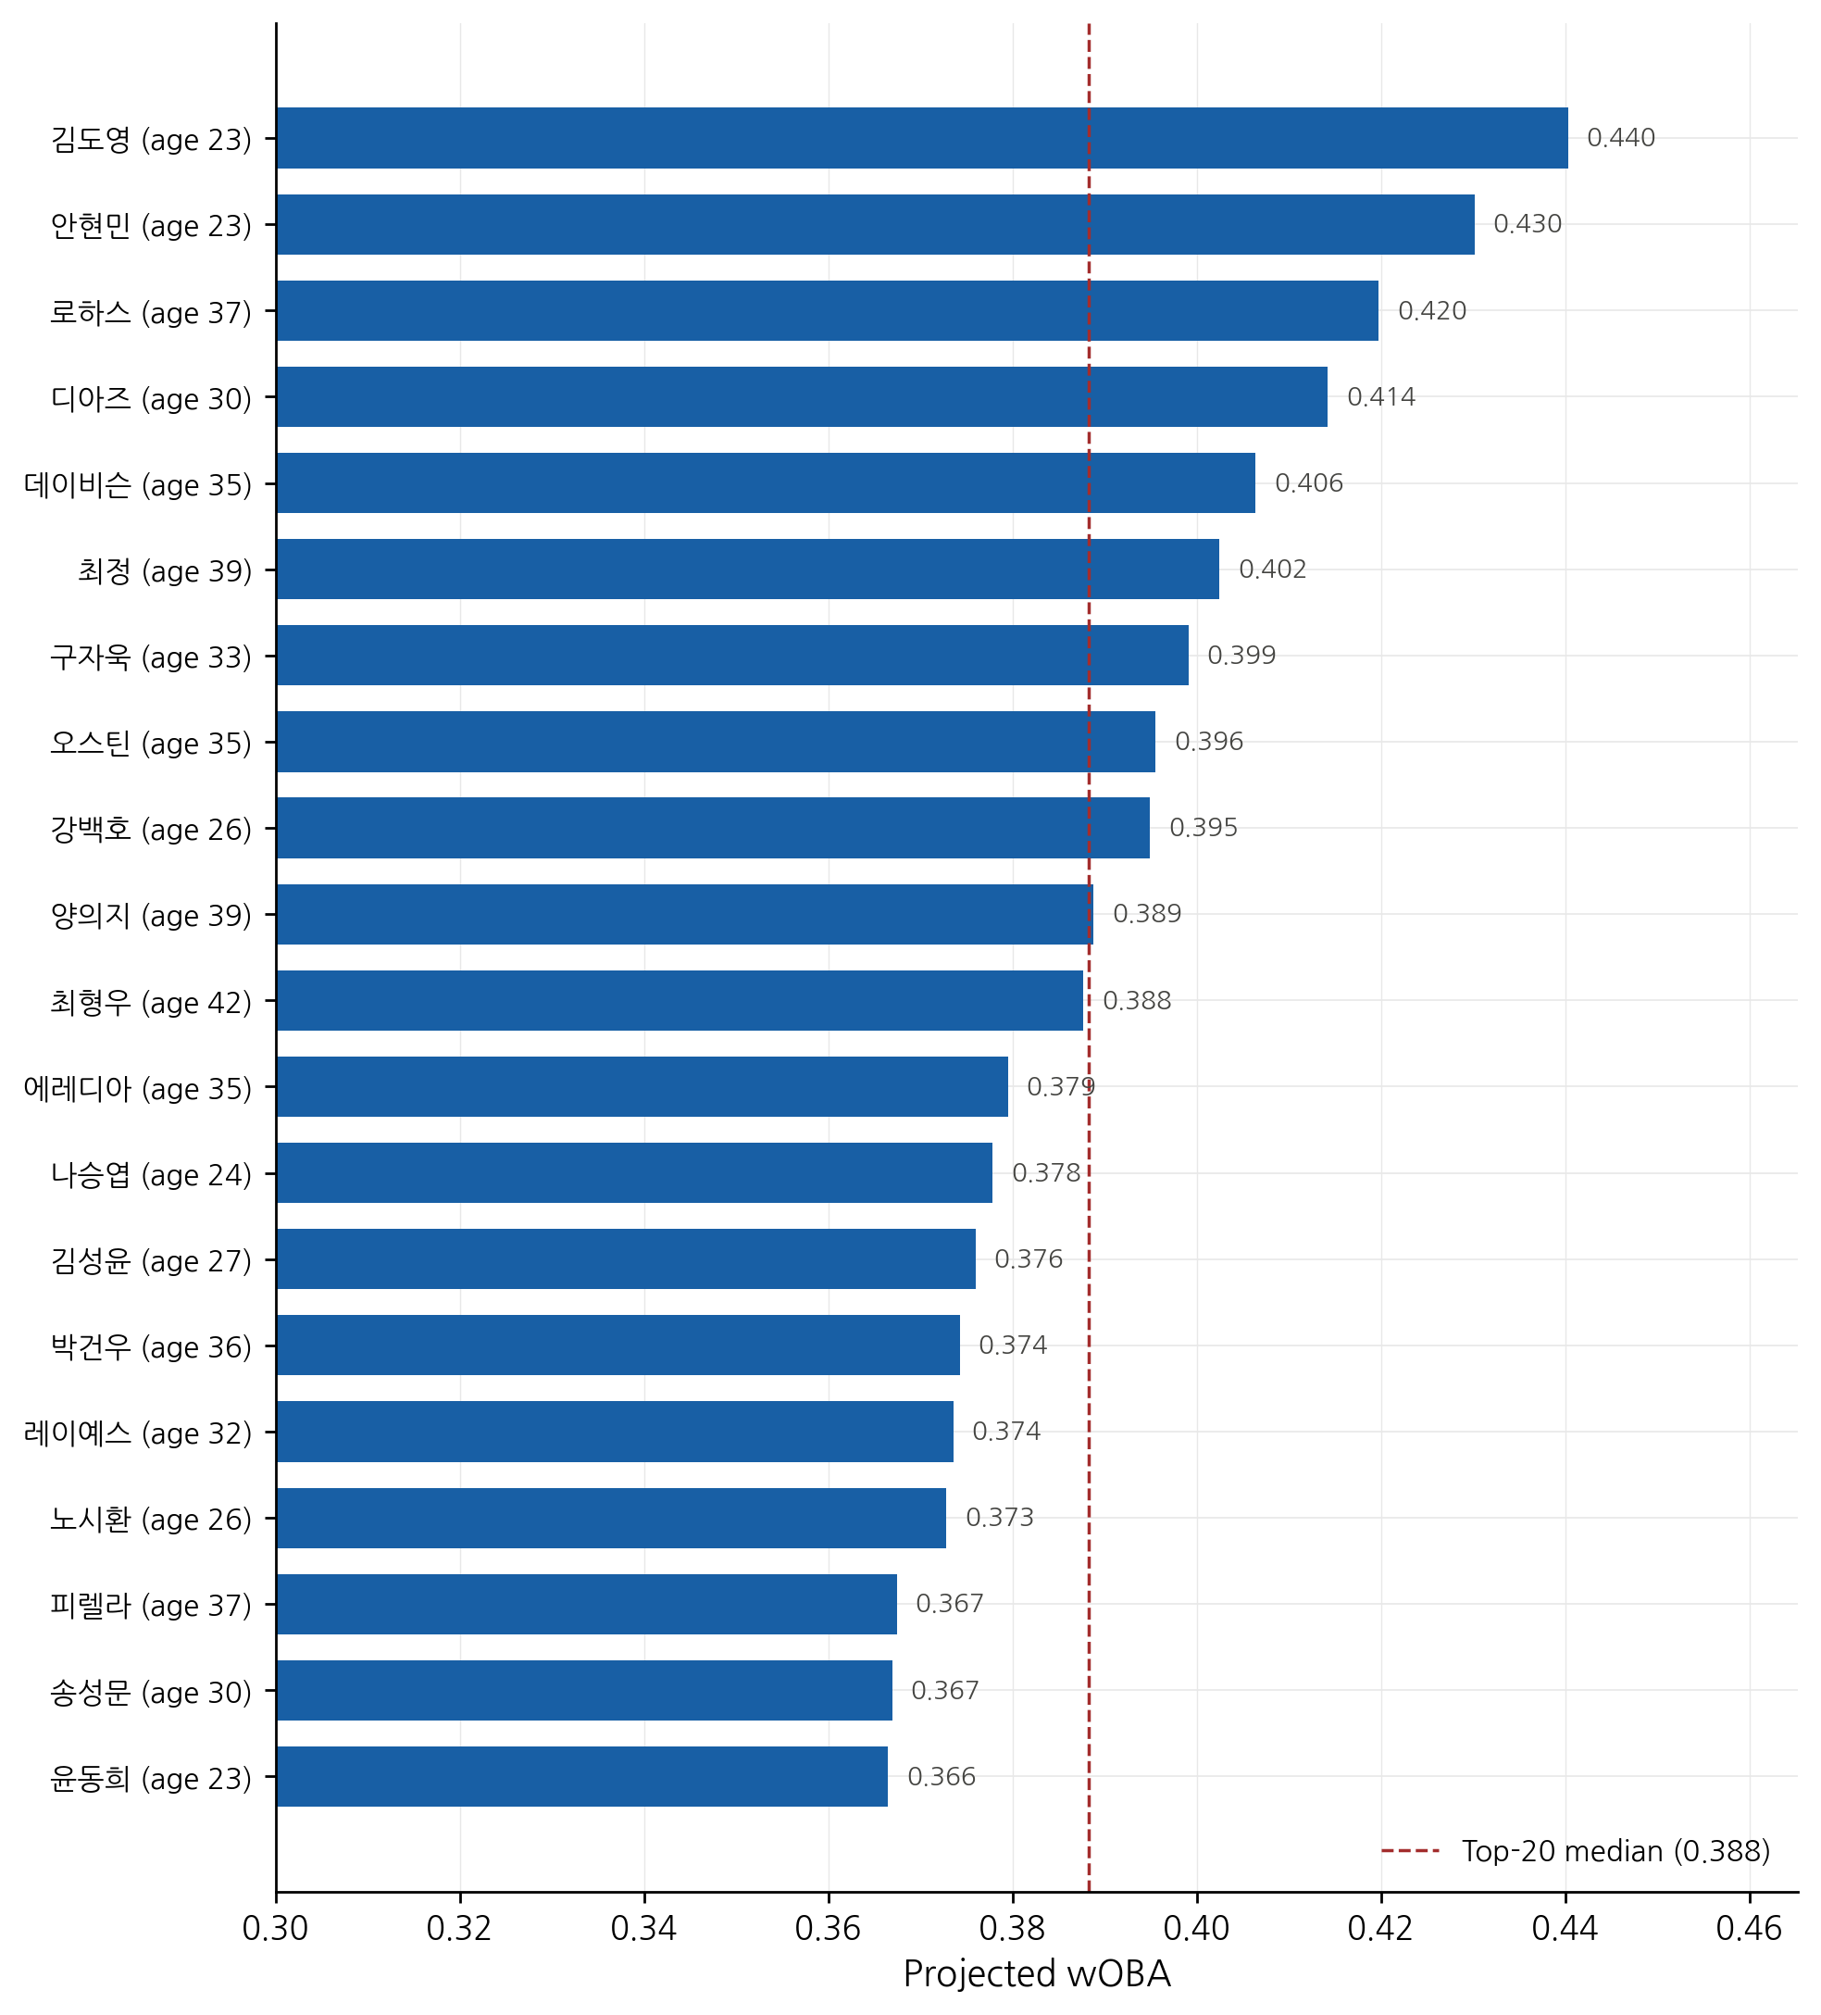
Figure 7. Top 20 KBO hitters ranked by projected 2026 wOBA, generated by the full Marcel system (5/4/3 multi-year weights, empirical Bayes regression, age adjustment). The dashed vertical line indicates the top-20 median projected wOBA. Player ages are shown in parentheses where available.
6. Discussion
The finding of m ≈ 1 indicates that players who accumulate 300+ PA in a KBO season are a highly selected group. The threshold itself acts as a natural filter; only consistent, reliable performers reach it. By the time a player has 300 PA, their observed rate statistics are already a reliable signal of true skill. Conversely, Marcel systems calibrated on MLB data use m values ranging from 200 to 700, depending on the statistic being tested. The difference is not that KBO players are more consistent; it is that the 300 PA qualifying threshold in a shorter season filters more aggressively than the equivalent MLB threshold.
Another novel result from this experiment was the discovery of distinct age-related trends in the KBO. In terms of KBO players' peak ages, wOBA peaks early, with positive deltas only seen at ages 21–23, followed by declines beginning around age 24. This suggests KBO hitters peak slightly earlier than the MLB convention age of 27, which was used as the anchor. Future work should derive the KBO-specific peak age empirically rather than relying on the MLB convention. ISO declines the most steeply and earliest, with positive deltas disappearing by age 24, and the sharpest drops occur at ages 29, 31, and 33. Notably, the choice of anchor age does not affect projection accuracy, as Marcel applies single-year deltas rather than absolute cumulative adjustments; the anchor serves only as a reference frame for interpreting the aging curves.
While pitcher projections were generated using the same Marcel framework applied to FIP, the pitcher validation sample was too small (6 matched players) to draw reliable conclusions. Pitcher projections are excluded from the results; evaluating pitcher accuracy against a full end-of-season sample is left for future work.
7. Conclusion
In this research, a Marcel-style projection system was built for the KBO and calibrated entirely using Korean baseball data. It combines empirical Bayes regression to the mean with delta-method aging curves and multi-year weighted projections. The system was validated against four held-out seasons and benchmarked against two naive baselines. This is the first such system documented for Korean professional baseball.
There were three concrete findings from this research. First, the Marcel system outperforms both naive baselines on hitter statistics across all four backtest years. Second, optimal regression coefficients converge to m ≈ 1 for qualified KBO starters, indicating observed rate statistics are already reliable at the 300 PA threshold. Lastly, the model components of multi-year weighting and age adjustment both contribute measurable improvements of approximately +0.009 Pearson r on wOBA.
Teams in the KBO can now use a transparent, reproducible statistical framework for player valuation and roster decisions rather than relying on surface statistics and judgment alone. The aging curves also provide the first empirical, bias-corrected picture of how KBO players age, information that is extremely useful for contract-length decisions and player development planning. This system can help improve front-office player valuation and contract decisions, while also expanding fantasy baseball projections for the growing KBO fantasy community.

Author Contributions: Conceptualization, K.T.; methodology, K.T.; software, K.T.; writing—original draft preparation, K.T.; supervision, I.A. All authors have read and agreed to the published version of the manuscript.
Funding: This research received no external funding.
Data Availability Statement: Project data and code are available at https://github.com/kellytodhunter/KBO-Player-Analysis.
Conflicts of Interest: The authors declare no conflicts of interest.
. References
1. Lee, K.; Han, K.; Ko, J. Analyzing the impact of the automatic ball strike system in professional baseball through a case study on KBO league data. Scientific Reports 2025, 15, Article 44459. https://doi.org/10.1038/s41598-025-28142-y
2. Tango, T.M.; Lichtman, M.G.; Dolphin, A.E. The book: Playing the percentages in baseball. Potomac Books, 2007.
3. Jensen, S.T.; McShane, B.B.; Wyner, A.J. Hierarchical Bayesian modeling of hitting performance in baseball. Bayesian Analysis 2009, 4(4), 631–652.
4. Sun, H.-C.; Lin, T.-Y.; Tsai, Y.-L. Performance prediction in Major League Baseball by long short-term memory networks. arXiv 2022. https://arxiv.org/abs/2206.09654
5. Zhao, W.; Akella, V.S.; Yang, S.; Luo, X. Machine learning in baseball analytics: Sabermetrics and beyond. Information 2025, 16(5). https://doi.org/10.3390/info16050361
6. Mizels, J.; Erickson, B.; Chalmers, P. Current state of data and analytics research in baseball. Current Reviews in Musculoskeletal Medicine 2022, 15(4), 283–290. https://doi.org/10.1007/s12178-022-09763-6
7. Mun, K.; Cha, B.; Lee, J.; Kim, J.; Jo, H. CompeteNet: Siamese networks for predicting win-loss outcomes in baseball games. In Proceedings of the 2023 IEEE International Conference on Big Data and Smart Computing (BigComp), 2023, 1–8. https://doi.org/10.1109/BigComp57234.2023.00010
8. Chen, Z.; Robbins, T.; Gephardt, W.; Nestler, S. Reshaping baseball: The impact of analytics and technology. ORMS Today 2025. https://doi.org/10.1287/orms.2025.02.07
9. Bae, J.-S.; Chiu, B.W. Machine learning-based classifications of team playoff advancement using pitching performance metrics in Korean professional baseball. Applied Sciences 2026, 16(5). https://doi.org/10.3390/app16052215
10. Park, T.; Kim, J. Machine learning-based optimization of contract renewal predictions in Korea Baseball Organization. Heliyon 2023, 9(12), e23231.

