Habitude: Fishbowl
The FISHBOWL habitude reminds us of the difference between being religious vs. having a relationship with God. Religion constricts us by making us feel like all we’re doing is trying to keep a bunch of rules. God wants a relationship with us where his love and forgiveness free us to pursue a friendship with Him. He wants our authentic heart not a performance. He wants to change us from the inside; for that is the only way we will be free.
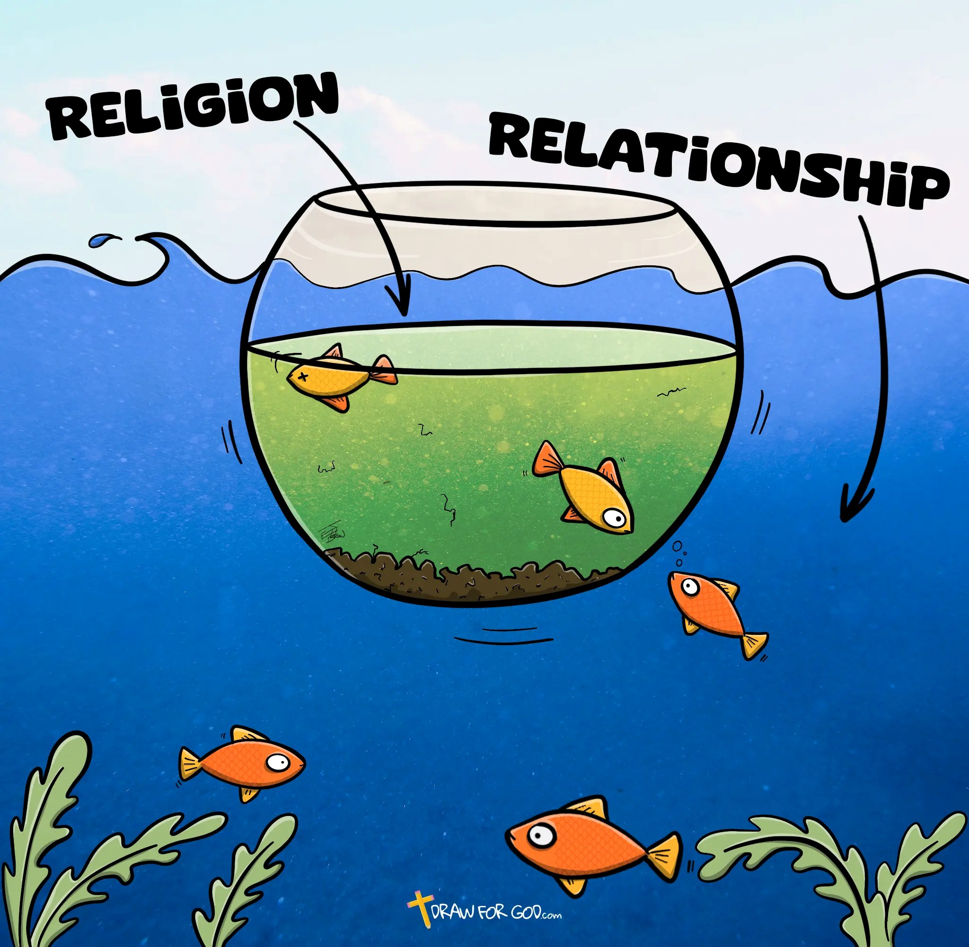

Religion: Trying to look right on the outside through rule-keeping and performance, without ever letting God change what’s underneath.
Relationship: Pursuing a trusting, loving, authentic friendship with God free from fear.

Self-Assessment
Take a minute and think honestly about your relationship with God right now. On a scale of 1 to 10 (10 being strongest), rate yourself in the following areas:
Attention (how much time and focus I give to my relationship with God)
1 2 3 4 5 6 7 8 9 10
Trust (how much I actually rely on God instead of just myself)
1 2 3 4 5 6 7 8 9 10
Communication (how honest and real my prayer life is)
1 2 3 4 5 6 7 8 9 10
Honesty (how willing I am to let God see — and clean out — what’s really inside)
1 2 3 4 5 6 7 8 9 10

Take Action! Write down one specific thing you will do this week to grow your relationship with God — not just your religious performance.

