Habitude – The Fishbowl
The Point: Having a healthy relationship with God is about letting Him change you from the inside out. It’s not about religion — trying to look good on the outside — it’s about relationship.
Game: insert an active intro game…

Welcome Back! Intro…
Show students a variety of road signs (print copies from the handout page, or hold up the images).
- Which road sign would you use to describe your relationship with God right now? Why?
- What do you think about the statement, “Christianity isn’t about religion; it’s about relationship”?
- What is the true difference between religion and relationship?
Religion is all about how you look on the outside. It’s about giving the appearance of doing the right things and trying to look good. Relationship is all about loving God and allowing Him to change you from the inside out. Religion is outside – in. Relationship is inside – out.

Digging In
Give the Religion vs. Relationship handout to everyone.
Read the point on the handout or let the kids try to explain the picture before reading the box!
The FISHBOWL habitude reminds us of the difference between being religious vs. having a relationship with God. Religion constricts us by making us feel like all we’re doing is trying to keep a bunch of rules. God wants a relationship with us where his love and forgiveness free us to pursue a friendship with Him. He wants our authentic heart not a performance. He wants to change us from the inside; for that is the only way we will be free.

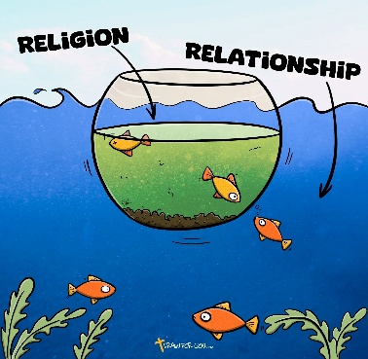
Break into small groups for Bible study.
Read Matthew 12:9-14.
- What were the Pharisees concerned about? (keeping rules, particularly the “no work on the Sabbath” rule)
The Pharisees had created 39 different categories of “work” — things you couldn’t do on the Sabbath. They were afraid God might be angry with them if they didn’t keep these rules.
- What was Jesus concerned about in this story? (a person who needed help)
- Did Jesus break the rules? (yes!)
- Do you think God cares more about your friendship with Him, or what you do for Him?
- Does God love a person more if they are a “good” person? Why? (no, God’s love is constant and we are secure in his grace, saved by Jesus’s sacrifice and sealed by his Spirit – God will still discipline us in love but he will not condemn, all that he does is in love for our benefit, to make us more like Jesus)
Read Ephesians 2:8-9. Is our salvation based on our good works? How do you know?
- What do you think God really desires in a relationship with you? (attention, trust, communication, love, friendship, honesty, etc.)
- What do you need more of in your relationship with God right now — and what would make it healthier?
- What can you do this week to make that improvement?
- How would a healthier relationship with God grow your influence as a leader?
- Do you think the people in your small group or lunch club group understand that God wants a relationship more than religion?
Take a few minutes to let students evaluate themselves on the self-assessment section of the handout. Then, answer the last section on what they will do in response.
Allow 5 minutes or so for students to share their thoughts, impressions, self-assessments, or action steps regarding their relationship with God…

Conclusion
Restate the main point!
Having a healthy relationship with God is about letting Him change you from the inside out. It’s not about religion — it’s about relationship.
God is crazy about you, and He wants a personal friendship with you that starts the moment you put your trust in Him. It’s all about the relationship.
The deeper your relationship with God is, the more impact you’ll have as a student leader — because in your heart, you’ll be on the same page with Him. Your motivation will be bursting, your courage stronger, and your wisdom growing.
Close in prayer. Ask God to help each person move from religion to relationship — to let Him change them from the inside out.

