Habitude: Half-Hearted Kamikaze
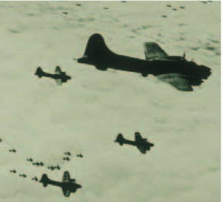
Join organization to add value
Kamikaze pilots are only useful if they are committed to their mission. Leaders are the same way. You cannot have involvement without commitment and be effective.

Here are the phases we usually experience as we build commitment in our lives. It starts with an idea and ends as a conviction:
Phase Description
- Ideas We perceive an issue by the way we think about it. This involves our minds.
- Opinions We begin to express our preferences on that issue. This involves our emotions.
- Beliefs We conclude where we stand on the issue. This involves both mind and emotion.
- Commitments We begin to act on our belief. This involves our minds, emotions, and will.
- Convictions We are ready to die for our commitment (give our total lives to it). It now is a passion in
our lives.

Your commitment will mean something when you act on it for an extended period of time. When you become committed, you will notice something wonderful. The moment you make a commitment, you will find all kinds of wisdom, energy, and resources at your disposal that weren’t necessarily there before you made the commitment. Commitment opens up the floodgates to the resources you need, but they won’t show up a moment too soon. Many people want to see everything in place before they get committed. Unfortunately, they will never act if they are waiting for perfect conditions. They are half-hearted kamikazes. Others wait for a feeling before they act. They want to “feel” led to do something. Once again, they may be waiting for a while. We are much more likely to act our way into a feeling than we are to feel our way into action. Get committed long enough, and eventually that commitment will become a conviction you’ll be willing to die for.

David Salyers, Vice President of Marketing for Chic-Fil-A, says most students graduate from college and its all about making good grades, building a resume, and then selling themselves to the highest bidder. This leads to disaster over the long haul. Instead, he suggests that those graduates should approach it in this way: develop their strengths, discover their passion, then locate an organization in order to add value to it. The money will follow the mission. Check out the diagrams below and compare the two approaches to life:

Sell yourself to highest bidder
Good grades
Build a resume
Discover passions
Develop strengths

