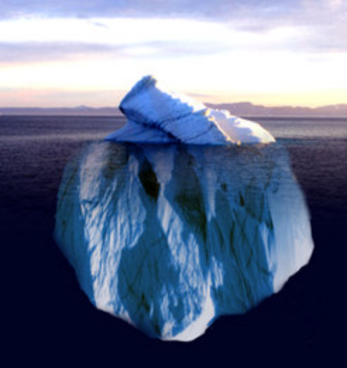
The iceberg represents your leadership. The 10% above the water is your skill. The 90% below the water is your character. It’s what’s below the surface that sinks the ship.
Habitudes: Habits & Attitudes of Leadership
THE ICEBERG

The iceberg is a great picture of leadership because so much of our influence comes from qualities we can’t see on the outside. It’s the stuff below the surface. 90% of our leadership is made up of our character. Our character is comprised of these 4 things:

- Self-discipline: The ability to do what’s right even if you don’t feel like it. Leaders with strong character are disciplined to do what must be done and do it on time.

- Core values: Principles you live by that enable you to take a moral stand. Leaders with strong character have developed a moral compass to guide their decisions.

- Sense of identity: A realistic self-image based on who God made you to be. Leaders with strong character know themselves and embrace their strengths and weaknesses.

- Emotional security: The capacity to be emotionally stable and consistent. Leaders with strong character deal with others well and don’t get defensive at criticism.

Self-Assessment
Take a minute and think about your own character. Do you have strong character? Where are your weak spots? On a scale of 1 to 10 (10 being strongest), rate yourself in the following areas:

- Self discipline (the ability to do what’s right even if you don’t feel like it)
1 2 3 4 5 6 7 8 9 10

- Core values (principles you live by that enable you to take a moral stand)
1 2 3 4 5 6 7 8 9 10

- Sense of identity (a healthy, realistic self-image based on who God made you to be)
1 2 3 4 5 6 7 8 9 10

- Emotional security (your emotional health that enables you to be stable and consistent)
1 2 3 4 5 6 7 8 9 10

Take Action! Write down one specific thing that you will do that will help you improve a weakness in your character.

