Paper Tiger
A 20-Minute High School Devotion
Scripture: "For God has not given us a spirit of fear and timidity, but of power, love, and self-discipline." — 2 Timothy 1:7 (NLT)

Opening
Quick question to start us off: what’s something that scares you way more than it probably should? Not a real danger — just something that feels a lot bigger and scarier than it actually is.
Today we’re talking about fear — and how a lot of what scares us is more bluff than reality. But first, let’s play a game.
Up-Front Game: Stare Down Showdown
Group size: any size, split into 3–4 teams of 4–5 Space needed: two chairs up front facing each other
Split the class into 3–4 teams and have each team sit together. Two chairs go up front, facing each other about two feet apart. Each round, one rep per team sits down and goes face-to-face with an opposing rep in a straight-up staring contest — first to blink, laugh, or look away loses the point for their team. The twist: teammates can’t touch their rep or leave their seats, but they can cheer, chant, and try to crack the other team’s rep from where they’re sitting. It puts a handful of brave volunteers on the spot while every other student is fully in the game from their seat.
Setup
Split the class into 3–4 teams and have them sit together in clusters. Set two chairs up front, facing each other.
How to Play
1. Send up reps. Each team sends one rep to the front. Two reps sit down, facing each other.
2. Stare it out. On “go,” both reps lock eyes — no smiling on purpose, no blinking on purpose, no touching. First to laugh, blink, or look away loses the round; the other rep’s team scores a point.
3. Teams get loud. Seated teammates can cheer for their own rep or try to distract the opponent — voices only, no getting up, no touching. A team that touches a rep forfeits the point for that round.
4. Rotate reps. A new rep comes up from each team every round, so everyone who wants a turn gets one. Play 4–5 rounds.
5. Crown a champion. Tally the points — highest-scoring team wins.
Between-Round Twist (adds conversation)
While the next reps get seated, ask the team that just went to answer one quick question below out loud — one sentence — before the next stare-down starts.
- On a scale of 1–10, how easily do you spook?
- A time you acted brave even though you were nervous.
- Something you used to be afraid of but aren’t anymore.
- One thing that “looks” scary but really isn’t that big a deal.
The Teaching
There’s a butterfly that doesn’t have any real weapons. No sting, no bite, no claws — nothing physical that could actually hurt a bird trying to eat it. Its whole defense system is a bluff. When the owl butterfly opens its wings, two enormous circles stare back at whatever’s hunting it — dead ringers for the eyes of a much bigger, much more dangerous owl. (show picture) A bird that was about to have lunch suddenly thinks it’s about to become lunch, and it takes off. But those “eyes” aren’t eyes. They’re just patterns on a wing. Up close, in good light, you can tell in about half a second that it’s not a predator at all — it’s paper-thin and harmless. The bluff only works from a distance, in a flash, before anyone has time to look closely.
Here’s the flip side: that same butterfly family has cousins that survive by doing the opposite — folding their wings until they look exactly like a dead leaf, veins and all, and just disappearing into the background. One kind scares danger away by looking bigger than it is. The other kind survives by staying still and unnoticed. Different strategy, same goal: don’t let the thing that could hurt you get the upper hand. (show picture of open and closed leaf butterfly)
Most of what scares us works exactly like that owl butterfly’s eyes — real for a second, powerful from a distance, and completely fake the moment you actually look at it closely. The presentation you’ve been dreading. The conversation you’ve been avoiding. The “what if” that keeps circling your head at 11 p.m. It puffs itself up right when you’re not looking closely, and it works — right up until you actually turn and face it.
Paul wrote 2 Timothy to a young guy named Timothy who was, by every account, scared — scared of leading, scared of being taken seriously, maybe scared of failing in front of people who were watching him closely. And Paul doesn’t tell him fear isn’t real. He tells him where it’s not from: “God has not given us a spirit of fear and timidity, but of power, love, and self-discipline” (2 Timothy 1:7). Fear shows up loud and convincing, like a pair of giant fake eyes flashing open right in front of you. But it’s not what God handed you. Power, love, and self-discipline are what He handed you. That’s the real thing behind the bluff.

Owl Butterfly
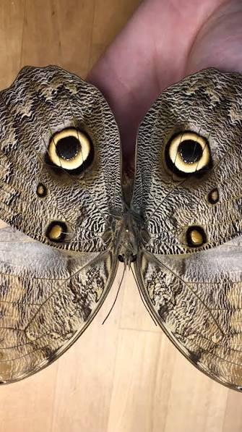

Leaf Butterfly — Wings Closed


Leaf Butterfly — Wings Open


Discussion Questions (talk in desk groups or with a partner)
1. What’s something that scares you way more than it probably should?
2. On a scale of 1 to 10, how much does fear usually decide what you do or don’t do? Explain.
3. God has not given you a spirit of fear, but of power, love and self-discipline. How could you apply that truth the next time fear raises its head?
Object Lesson: The Heavy-Looking Box
What you need: a large box (a moving box works great), packing tape, one light object to put inside (a single pillow or a few crumpled plastic bags), and a marker. Ahead of time, seal the box up with just the light object inside, and write something on the outside that sells it as serious — “HEAVY,” “FRAGILE,” “DO NOT DROP,” whatever works.
In front of the group, call up a volunteer and tell them — seriously — that you need help lifting something heavy. Let them get ready for it: bend their knees, brace themselves, maybe even wave over a second volunteer to help carry it. Then have them lift it. It’ll fly up off the ground, way lighter than everyone in the room — including them — was bracing for.
Here’s the point. Everyone in the room, including the volunteer, built its weight entirely out of a label and a warning, and it turned out to weigh almost nothing. That’s what fear does every time. It doesn’t have to be true to make you brace yourself — it just has to look serious enough that you never actually step up and lift it to check. God didn’t hand you a spirit that braces for a box that might be heavy. He handed you power, love, and a clear mind — so you can go ahead and pick it up.
Closing Prayer
Lord, You know what scares us — even the stuff that isn’t as big as it looks. Thank You that You didn’t give us a spirit of fear, but power, love, and a clear mind. Help us walk toward what scares us instead of running from a bluff, and help us trust that You’re bigger than anything that only looks big. Amen.

