 Application

Specification

TimeTracker 1.0 DB

GITHUB:

Kelmorrison/CSE2102project_30_deg_N

30⁰N Travel Taxi and Service

Group: Genesis

Kelvin Morrison 1028679

Noel Farley 1027234

Ryan Wilson 1028654

Zhi Cheng Su 1028141

Valon Madramootoo 1028391

Date: October 15th, 2018

Revision Sheet

|  |  |  |
| --- | --- | --- |
| **Release No.** | **Date** | **Revision Description** |
|  |  |  |
|  |  |  |
| Rev .0 | 09/12/18 | Content adhere to relevant parts of the template |
| Rev .1 | 10/15th/18 | E-R and Relationship Diagram was added |
| Rev.2 | 11/02nd/18 | Functional Specification was added, and some design features was modified |
|  |  |  |
|  |  |  |
|  |  |  |



We have carefully assessed the Database Specifications for the 30Degrees North. This document has been completed in accordance with the requirements of the Time Tracker System specifications for Development Methodology.

MANAGEMENT CERTIFICATION - Please check the appropriate statement.

______ The document is accepted.

______ The document is accepted pending the changes noted.

______ The document is not accepted.

We fully accept the changes as needed improvements and authorize initiation of work to proceed. Based on our authority and judgment, the continued operation of this system is authorized.

_____________ ____________________

Kelvin Morrison 2018/09/12th

Project Leader

_________________ _______________________

Valon Madramootoo 2018/09/12th

UI Development

___________________ ________________________

Noel Farley 2018/09/12th

QA leader

____________________ ____________________

Zhi Cheng Su 2018/09/12th

UI developer

______________ ____________________

Ryan Wilson 2018/09/12th

Back End Developer

**Introduction**

This document defines the normative content of the software requirements specification. Organization of the information items in the document such as the order and section structure may be selected in accordance with the project's documentation policies.

* **1.1 Problem Statement**

30 ⁰N is a taxi service that estimates its charges base on the time it takes to travelled from one point to another.

However sometimes the drivers of the company vehicles forget to log the time they start the journey, and this causes some problems since a customer cannot be charged fairly.

Furthermore, customers are also complaining that some drivers are taking the longest route and wasting their time. So, Mr. Zod the owner and CEO of the company will like the implementation of a system to keep track of time while managing the route of travelled.

* **1.2 Purpose**

The goal of this document is to give detail description of the Time Tracker 1.0 database and all other components that are required for its optimal performance it also describe all functional and nonfunctional requirements of the time tracker 1.0 application for 30 ⁰N.

* **1.3 INTENDED AUDIENCE AND READING SUGGESTIONS**

This Project is a prototype for the Time Tracker 1.0 and is therefore restricted within 30˚N and the developing team.

* **1.4 Scope**

The “Time Tracker 1.0” (TT 1.0) database is intended to interact with a mobile base GPS application and other mobile time keeping hardware. It will automate the time keeping process. This function will intercorporate with a GPS road mapping application that will help drivers find the closest possible route to their destination. The TT 1.0 will also calculate the charge for the service delivered and print out an invoice for the corresponding service while keeping a digital log of all transactions.

**System overview**

The TimeTracker 1.0 database is intended to interface with three level of users. Owner, Management and the drivers of the company vehicles.

All data related to customers travelled will be capture and recorded on a web base server, management is required to set and adjust their hourly rates.

A mobile GPS-Navigator (maybe just a phone app?) software application will interact with the database about vehicle location and route of travel, it is required that the necessary hardware be installed onboard the company vehicles that is intended to log data in the Database.

The mobile application requires both Internet and GPS connection to fetch and receive information about time of travelled and closest possible route. Between drivers and the database.

|  |  |
| --- | --- |
| **System Overview** | **Details** |
| Developing Company Name | Genesis Inc. |
| Client Name | 30Degrees North |
| Database Name | TimeTracker |
| System Type | Database/Web Application |
| System Code | 1.0 |
| Operation Status | Under development |

**Acronyms and Abbreviations**

|  |  |
| --- | --- |
| **Acronym** | **Meaning** |
| GPS | Global Positioning System |
| TT | TimeTracker |
| DESC | Description |
| DBMS | Database Management System |
| Acronym | Meaning |
| UI | User Interface |
| QI | Quality Assurance |

**Points of Contact**

Genesis computing Inc.

|  |  |  |  |
| --- | --- | --- | --- |
| Designation | Name | Email | Phone# |
| Project leader | Kelvin Morrison | kelvin_morrison97@yahoo.com | +5926888913 |
| UI Developer | Zhi Cheng Su | Rivailleheichou414@gmail.com | +5926486694 |
| UI Developer | Valon Madramootoo |  |  |
| Back-end Developer | Ryan Wilson | ryanwilsoni@yahoo.com | +5926118906 |
| QA | Noel Farley | vest.946@gmail.com | +5926471401 |

**DATABASE ADMINISTRATIVE INFORMATION**

The major features of the Time Tracker 1.0 Database system are shown in the entity relationship model below. (logical diagram) this diagram gives a high-level view of how entities are related to each other and there path of communication.

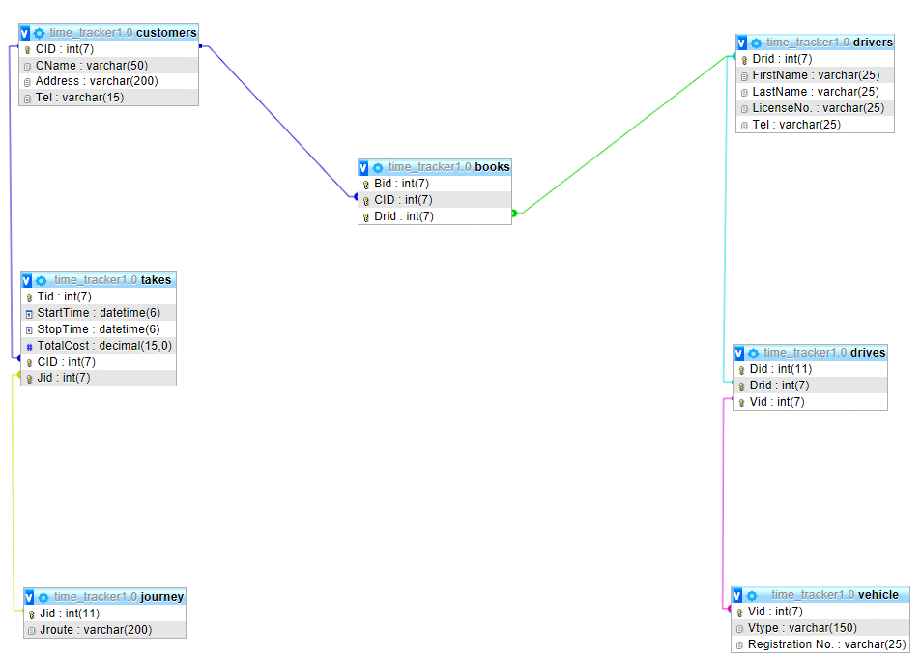

* **Responsibility**

The Owner of 30 ⁰ N will be responsible for the management and overlooking the database. All administrative functions will be carried out by staff or any organization specified by the owner of the entity.

* **User class and Characteristics**

A first-time user of the system must be giving login privilege by an upper level staff. While these privileges are not granted, if a user is continuously trying to log in, the system will flag the unauthorized use while alerting management about the security breach and make a log of the time and devices IP that attempt to gain entry.

Every user that interact with the system will have access to different functions base on the level of privilege granted to them, User can set the mobile application to his/her preferred language.

Instruction about route of travel and time will displayed base on mopping data stored in the data base.

The System will interact with three level of users:

* User Class 1- Owner of Entity
* User Class 2 - Entity Owner and administrators
* User Class 3 – Drivers

Users at each level of the system will have access to different user functionality specific to their job requirements. (Not Bad)

**User Class 1 – Owner**

* Functional requirement
* Set Access level of other users.
* Has the authority to add or remove user from the system.
* Manage and regulate the entire database.
* The rights to permanently delete any users.

**Users Class 2- Owners and Administrators**

* Functional requirement
* Have the responsibility for regulating the hourly rates in the database.
* Creating logging for level three users.
* Keep track of the location of vehicles.

**Users Class 3- Drivers**

* **Functional requirement**
* Log in to the mobile device that interface with the database set destination.
* **Operating Environment**

The operating environment for the Time Tracker 1.0 is listed below.

Web base server: Apache

Operating system: Windows/Android/IOS

Database: MYSQL database

Platform: PHP/ MYSQL:

Backup: Cloud and local server

* **Storage Requirement**

It is estimated that the database will require a terabyte (1024 GB) of data storage space on start up. More storage space may be required due to maintenance, update and storage of mopping and travelling data.

**Implementation**

The system will function on MYSQL and be deployed in three phases

* **Phase one**
* **Installing and integrating of mobile devices on all vehicles**

During this process the GPS navigation system, time tracking hardware and the mobile broadband devices will be placed onboard the vehicles also sample street mapping data will be collected.

* **Phase 2**
* **Implementation of a time management system**

The clocking system for the time tracking hardware will be integrated to work along with the GPS Navigator. Testing will be done during this phase to ensure the clocking system function at it was intended.

* **Phase 3**
* **Capturing and Billing**

The prices are set and coordination with the clocking system to generate charges. Recording of GPS data and generating invoices base on time of travel.

**Error Handling**

* **Data loss**

The database will be systematically backup to reduce loss of data. It will require an independent server to run on.

* **Accidental Data Deletion (Don't delete data just hide)**

All Deleted Data will remain in a recycle bin for twenty 20 days before permeant deletion

* **Power failure**

A backup system along with a generator will be employed.

* **Hardware failure**

In the event of fire, flood or any other disaster all data could be recovered from an offsite server

**Functional Requirements**

* **Purpose**

This part of the document will give details to how the software will operate in its environment and describe all other components that are require for its full performance.

* **Distributed Database:**

A single application should be able to operate transparently on data that is spread across a variety of different databases and connected by a communication network this is necessary for future Expansion.

* **Client/Server System**

The architecture design of the Time Tracker 1.0 will feature both a client and Server application.

* **User Interface**

Both Client and Server will have separate means by which they are access

* **Required Hardware /software**

|  |  |
| --- | --- |
| Mobile Broadband Modem | This is for the internet connection for the mobile devices onboard the vehicles, every vehicle will be required to have one. |
| GPS Navigation software and hardware | Require for fetching data about a vehicle location to the database and give detail about best possible route to a destination. |
| Time Tracker and invoice printing hardware | It is required to start and stop the timing process and printing of the invoices it will also display the time in rear time in the vehicle. |
| Web Server | “Apache” this will deliver the web interface to log into the database and allow for all front-end functionality. |
| MySQL database | Use for storage and retrieval data by all connecting components |

* **User Views**

Each user will have a different view of the database when log into the web application. These views will depend on the user privilege available to that user class:

* **Class 1: Owner/ Administrator**

When this class of user log into the web application they will be given the privilege to add, update or delete any account. Also, all administrative function is available to this class of user. Only user with the rights to add or delete data.

* **Class 2: Managers/ dispatchers**

When log in they will have access to vehicle location and all drivers’ activities also they will have the privilege of setting and suspending login session for lower level staffs.

* **Class 3: Drivers**

These class of users only privileges are to login and out of the system, making searches, logging time and requesting invoices for services delivered.

**Operational processes**

Driver are required to log into the mobile interface before starting his/her tour of duty,

When a customer call to book a driver, the dispatcher will send the assignment to the closest possible vehicle to the customer location this will be don’t via the mobile interface aboard the vehicle.

When the customer board the vehicle and instruct the driver of their intended destination the driver will enter a search, to locate the closest possible route and start the time tracking application.

When the customer arrived at their destination the driver stops the time tracker and request a printout of an invoice (invoice is calculated based on some formula times the time it takes to travel from point a to b)

This entire process is capture and recorded in a database.

**Application Functionalities**

For Owner/Administrator

* Login/ register
* User information
* Able to trace vehicle location
* Adjust charges formula
* Able to check if a driver is on or off duty
* Add or delete any user

For Manager/ Dispatchers

* Login/ register
* Create login for lower level user
* Able to check if a driver is on or off duty
* Send out dispatch

For drivers

* Login/register
* Start and stop the timer

**NON-FUNCTIONAL REQUIREMENTS**

* **Performance requirements**

These are the steps involved to perform the implementation of TT 1.0 database

* **E R Diagram**

The E-R Diagram constitutes a technique for representing the logical structure of the database in a pictorial manner. The analysis is used to organize the data as a relation, normalizing relation and obtaining a relation database.

* **Entities:** Specify distinct real-world items in an application.
* **Attributes:** Specify properties of an entity and relationships.
* **Relationship:** Which connect entities and represent meaningful dependencies between them.

ER Diagram Timetracker1.0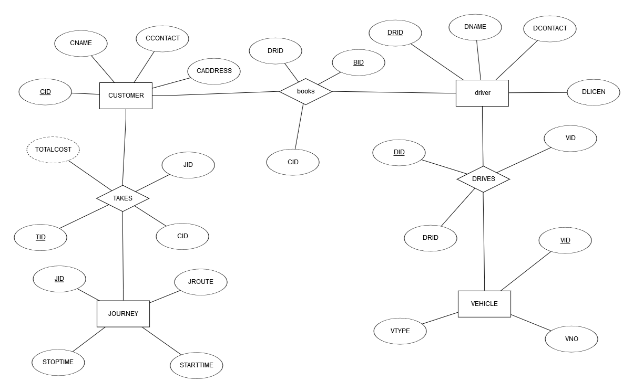

* **Normalization**

The means of ensuring that information is only stored once. Storing the same information several times will leads to wastage of storage space and increase in the total size of the data stored.

* **Safety Requirements**

Are the means of putting systems in place to back up and recover system data to be use in the event of extensive damage to the database due to catastrophic failure.(These will be the means to bring the database back to the state it was before any failure due to sabotage, fire or flood or any natural disaster)

* **Security Requirements**

Involves all actions taken to ensure safety and integrity of the database. (This involves the implementation of the necessary procedures to zero tampering or malicious deletion of data from the database or any other action that will corrupt or otherwise hinder the normal function of the database)

* **Software Quality Attributes**
* **AVAILABILITY:**

Information regarding access rout should be readily available on request.

* **CORRECTNESS:**

All data regarding to route and charges should be accurate

* **MAINTAINABILITY:**

The administrators or manager in chargers should be able to easily maintain or correct charge data.

* **USABILITY**

The mobile interface should be easy to navigate.

Application process flowchart



**Mockup-diagram**

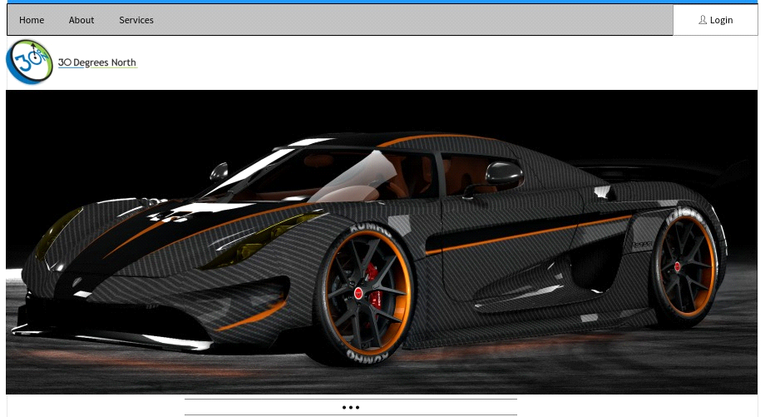

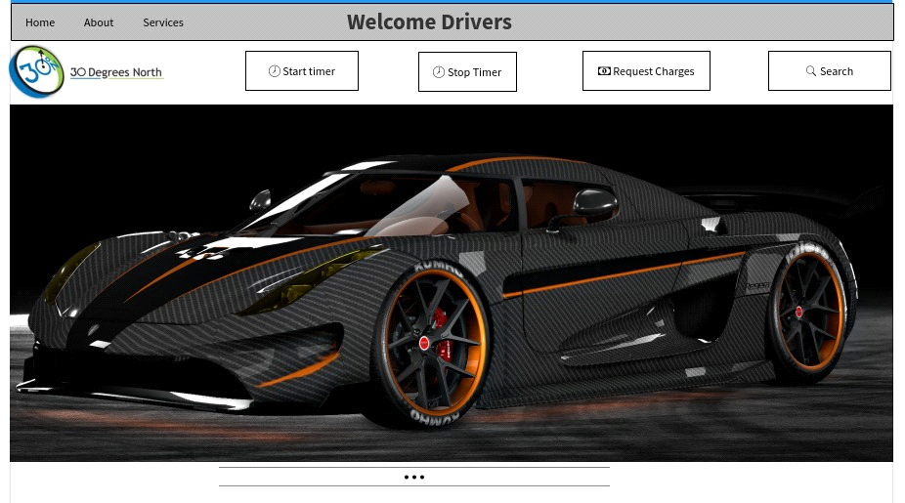

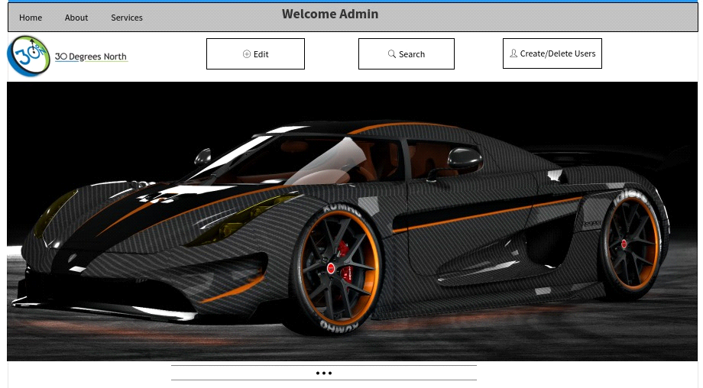

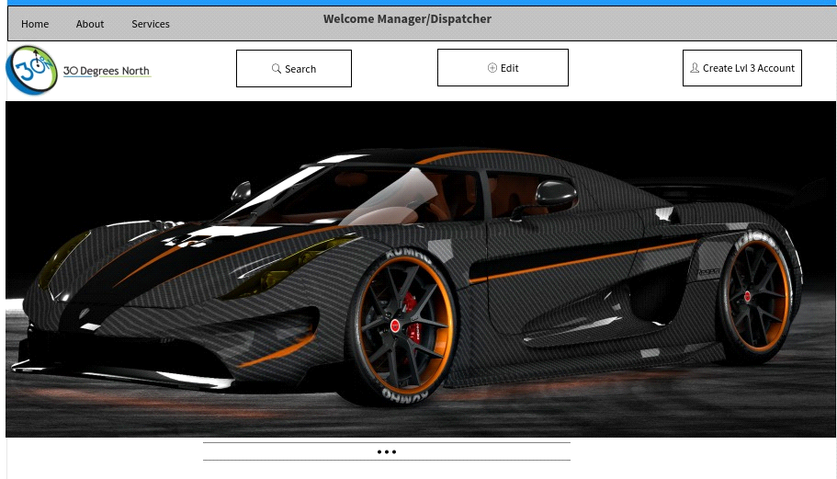

Group Leader's Report

|  |  |  |
| --- | --- | --- |
| NAME | CONTRIBUTION | GRADE |
| ZHI CHENG SU | Diagrams | Excellent |
| RYAN WILSON | Database | Excellent |
| NOEL FARLEY | Mockup/Create | Excellent |
| VALON MADRAMOOTOO | Mockup/Create | Excellent |