Kelp Time

A web application to better visualize massive collections of

data regarding kelp over decades of experiments

Nathaniel Namenyi

Jason Griffith

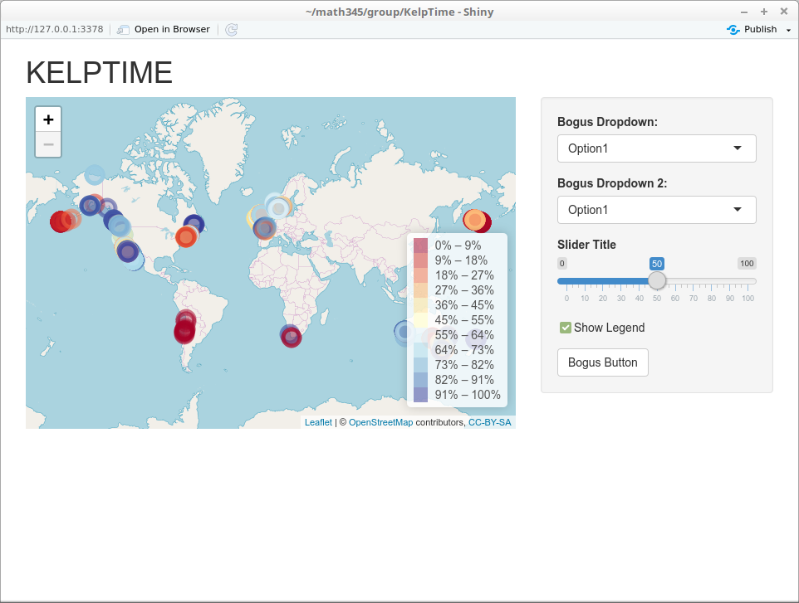

Introduction

Our project’s goal is to develop a web application in Shiny, leaflet, and R. This is being made in conjunction with Dr. Byrnes and uses his data gathered regarding his research in marine biology. The goal is to create a user interactive way to view the expansive dataset that may lead to new insights on data interpretation. The primary window will be a map displaying the location the data points were taken, and potentially a heat map and allow the user to choose what what parameters create the heat densities. There will also be an optional secondary window that will graph the data as either, points, lines, bar, etc based on what points the user has selected in the map window.

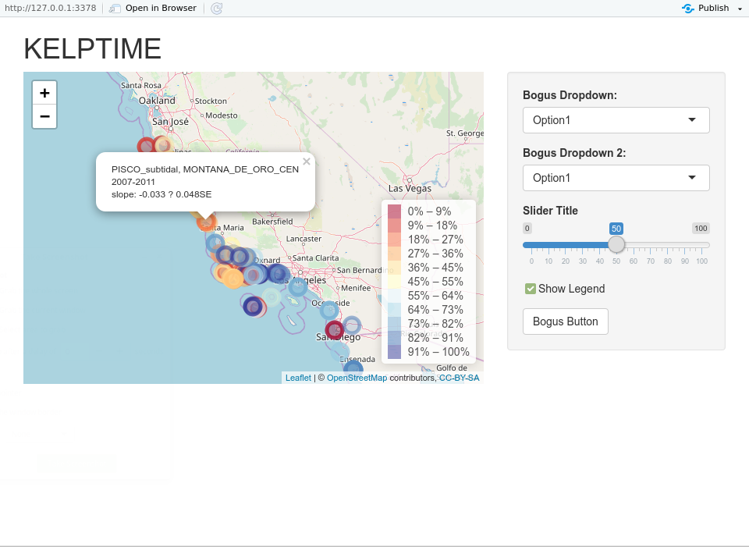

Current Progress

We have an application up and running. It currently displays the location of all of the points from Dr. Byrnes data and colors them based on his calculated slope. The darker blue indicating a greater slope, and darker red indicating the converse. The map can scroll over the the entire world as well as zoom in and out to view the entire map or down to a single point on the map. Clicking on the points displays their name, date range, slope and standard error of the slope. There are a few options we have added without tying to anything as of yet. They are more of a proof of concept as seen in the above picture. The show legend tick-box can display or remove the legend, the two drop-downs can easily be configured to a number of data points to change what data is displayed on the map, as well as the slider.

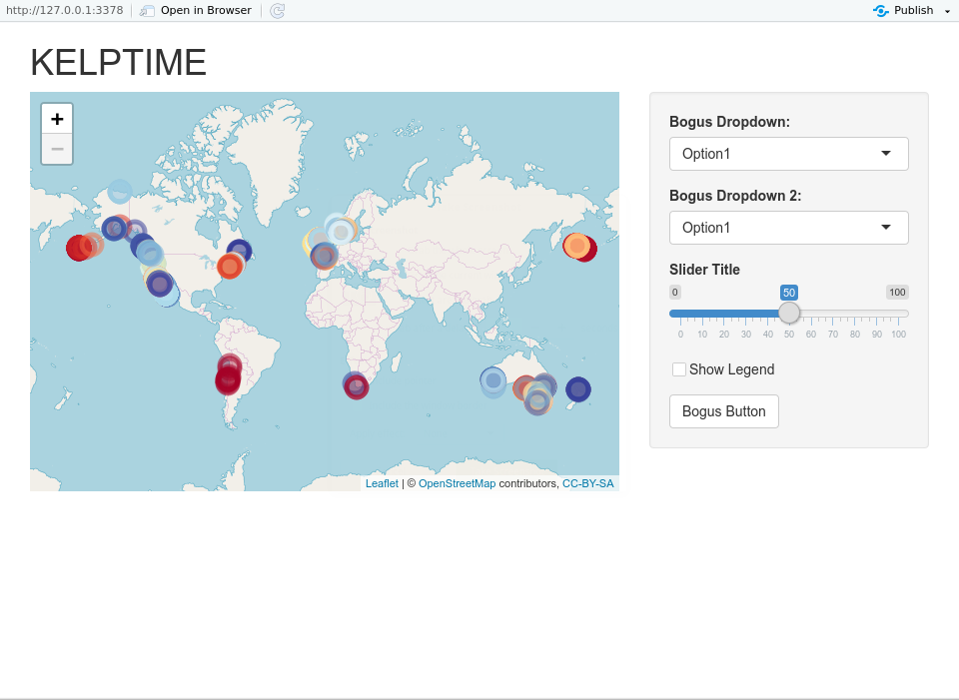

Data

The dataset we are using in the project are taken from Dr. Byrnes and his collaboration with other marine biologists and their studies on kelp over the course of many years. They have also incorporated many open source datasets into theirs giving us a wide range of data from as far back as the 19th century. The data can be found on Github:

<https://github.com/kelpecosystems/global_kelp_time_series>

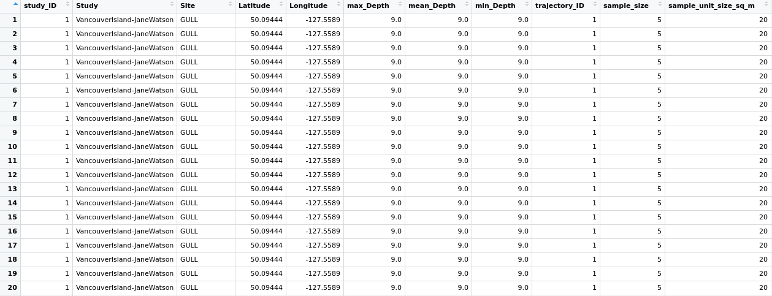

From this data, we are considering a few different datasets, particularly the [CleanDataWithRegions.csv](https://github.com/kelpecosystems/global_kelp_time_series/blob/master/03_derived_data/CleanDataWithRegions.csv) which has the data nicely formatted making it easier to work with for our purposes. Plus, the addition of regions gives us another method to partition the data which Dr. Byrnes has suggested would be useful.

Our codebase is also open source, which can be viewed at <https://github.com/nnamenyi10/KelpTime>.

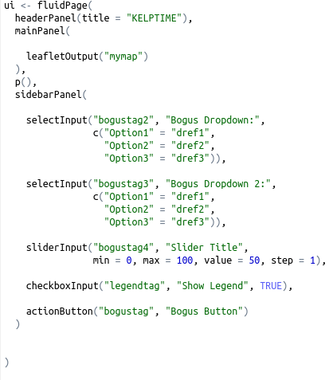

Planned Features

After meeting with Dr. Byrnes, it has been established that we are working in the right direction with our current prototypes. A few ideas we are entertaining are:

* Changing the way the data is displayed on the map, from the current slope oriented dots, to larger groups that split once zoomed on, to changing the data that determines the color of the dot.
* A second window that displays different types of graphs based on x and y axes that the user can select.
* Filtering data displayed on the map by date or region.
* Clicking on a point can display a graph with all of the point from that map, a line of best fit would be generated, and a dotted line of best fit for the region would be overlain to compare (suggested by Dr. Byrnes)
* Select multiple points on the map to be displayed overlain on the same graph for comparisons.
* A filter based on which measurement was used.

