Kelp Ecosystem Ecology Handbook

# Foreword

Welcome to the Kelp Ecosystem Ecology Network. What you have before you is a handbook containing background information on the network and protocols for our current field activities. These protocols have been worked over by network scientists over the past two years, and a full how-to for all of our activities. By following these protocols and working with your regional coordinator, you should be able to get up and running with a full kelp forest monitoring program and/or a removal experiment that will be part of the larger network effort.

This handbook represents the combined efforts of many of the scientists within the network. Special acknowledgement goes to Dan Reed at the SBC LTER for much of the observational sampling protocols. Many of the protocols and accompanying materials are taken straight from the SBC LTER handbook, modified only for non-canopy kelp systems. Second, we wish to acknowledge the first cohort of regional coordinators for extensive edits. Version 1 of the Protocols were finalized at the KEEN-ONE meeting at the Cat Cove Marine Lab in June of 2014. If you have any questions, edits, etc., to this handbook, please do not hesitate to contact the current network coordinator at [jarrett.byrnes@umb.edu](mailto:jarrett.byrnes@umb.edu).

Table of Contents

Foreword 1

What is KEEN? 4

Overview 4

Specific Aims 4

How Do I Become Involved? 4

Data and Authorship Policies 5

Data 5

Authorship 5

FAQ 5

Kelp Forest Observational Sampling 7

Acknowledgements 7

Overview 7

Specific Aims 7

Datasheets and Data Management 7

Materials Needed 7

Site and Transect Placement 9

Site Selection & Overview 9

Transect Placement 9

Quadrat Sampling Protocol 10

Swath Sampling Protocol 12

Fish Count Protocol 13

Subsurface Kelp Morphometrics Protocol 14

Canopy Kelp Sampling Protocol 15

Sample Dive Plan for Observational Sampling 16

Temperature Logging Protocol 17

Regional Adaptations of General Protocols 18

Species Lists & Guides 18

Lists 18

Guide 18

Northwest Atlantic (New England, Eastern Canada) 19

What follows are modifications to the general KEEN sampling protocols for the Gulf of Maine and Northwest Atlantic. If you feel protocols need to be modified further, please contact your regional coordinator (jarrett.byrnes@umb.edu). 19

Removal Experiment 19

Kelp Forest Observational Sampling 19

Southern California and Baja 20

Alaska 20

Chile 20

Northern California and the Pacific Northwest 20

Large-Scale Kelp Removal Experiment 21

Overview 21

Datasheets and Data Management 21

Materials Needed 21

Site Selection 23

Site Layout 24

Pre- and Post-Removal Sampling Protocol 25

Removal Protocol 26

Temperature Logging Protocol 27

Timing of Resampling Removal Experiment 28

Sample Dive Plan for Removal Experiment 28

Data Management 30

General Notes 30

In the Field 30

After the Field 30

Data Entry Workflow 31

Quality Control 31

Post-Submission Data Management 31

# What is KEEN?

## Overview

The Kelp Ecosystem Ecology Network (KEEN) is a collection of marine scientists around the globe interested in assessing the impacts of global change on kelp forests. Kelp forests are ubiquitous along temperate coasts, covering 25% of the world’s coastline. Kelps themselves are a critically important species, forming the foundation of many temperate and boreal coastal ecosystems. Different aspects of global change that affect kelps can therefore have a large impact on the goods and services those ecosystems provide by rippling through the entire ecosystem. We seek to understand how these critical ecosystems may therefore be changed in the future, and to what extent they will be resistant and resilient to changes in our oceans.

## Specific Aims

In particular, we seek to answer three questions using KEEN:

1)  How will increases in mean temperature affect the ability of kelp forest communities to recover from disturbance?

2)  How will average temperature interact with a disturbance common to all areas (waves) to affect kelps and their associated communities?

3)  Are these effects system specific, or are they general across all global temperate rocky reefs?

## How Do I Become Involved?

If you’re interested in becoming part of KEEN, all we ask is that you either perform the manipulation and follow up at one site in one year, or, you include one site in our long-term community monitoring. That’s it. One site, one method. We’re trying to embrace the crowdsourcing philosophy – that many hands will make light work. More removals or adding more sites over time to your observational sampling would be great, but we understand even one is already quite a bit!

To become a member, contact our network coordinator at [jarrett.byrnes@umb.edu](mailto:jarrett.byrnes@umb.edu), and also cc your regional coordinator, whose address can be found at [http://www.kelpecosystems.org/about/regional-coordinators/](http://www.kelpecosystems.org/about/regional-co-ordinators/)

## Data and Authorship Policies

### Data

Once contributed and quality controlled, all data (both experimental and observational) is fully open within the network. The experimental data stays private within the network until it is used in a publication for the first time. At this point, that data becomes fully open to the public via the Australian Ocean Data Network and the Knowledge Network for Biocomplexity.

Observational data becomes publically available *upon being quality controlled*. Until the first publication, the data include explicit use restrictions to request collaboration with the data collectors. The reason for this difference is the broad general utility of observational data beyond the narrow scientific analyses that we will conduct as part of the network. Members are invited to publish their data sets as data papers so that they have individual DOIs and can be cited as such.

### Authorship

For any first publication arising from data collected by KEEN, data contribution guarantees authorship on the manuscript unless the contributing member decides otherwise.

For subsequent publications using the already used network data, we require that lead authors solicit collaboration from the members who collected the data. However, collaboration entails more than just data contribution. Collaborators are expected to be active intellectual participants in the development of the manuscript, and respond to requests for text, comments, analyses, etc. in a timely manner. If a member is not able to live up to this obligation, they are asked to be honest about it and remove themselves from the author list for submitted manuscripts.

## FAQ

Along the way, we’ve encountered many common questions about each of the elements of KEEN. Here are some answers to common questions.

**I already have an observational sampling program in place. Can I just give you that data?** Sure! As long as your sampling program is analogous to or exceeds what we ask of in our protocols, that’s great. We can always drop some extra samples (say, if you work along 100m transects) or find other ways to cross-calibrate or convert your data. We’ll take care of the conversion.

There are cases where your data are at too coarse of a scale, or miss something crucial, and in that case, we may not be able to utilize it, though. In those cases, we’re happy to add it to the catalogue, but preserve it for use in only specific targeted instances where it can be useful.

**I have an observational sampling program in place that does almost all of what you’re asking. Is that enough for you?** Not quite. Again, if there are crucial measurements missing, while we may be able to use some of the data some of the time, we won’t make it part of our larger data catalogue. However, if you’re open to adding one more set of measurements to your activities, that would be great! We’d love to add your data to the larger effort!

**My system doesn’t have any huge expanses of super-dense kelp. It’s all fairly patchy. Does that disqualify my system from being part of the experiment?** No. Not at all. Indeed, this is a feature, not a bug, for your system. Many systems – particularly at the southern range limit of kelps – become more patchy and variable.

**Do I need a permit for the clearings? Who should I contact?** Ask your regional coordinator. They should have a list. Policies vary by nation and state.

# Kelp Forest Observational Sampling

### Acknowledgements

Much of the protocols below come verbatim from the Santa Barbara Coastal Long Term Ecological Research (SBC LTER) site’s Kelp Forest Monitoring Handbook. We are indebted to Dan Reed, Shannon Harrer, Clint Nelson, and others for refining many of the techniques herein. Additional modifications are drawn from the Partnership for Interdisciplinary Study of Coastal Oceans (PISCO) protocols and the Tasmanian MPA monitoring program.

### Overview

The broad goal of the kelp forest observational sampling is to characterize variation in the community structure of temperate reefs along gradients of temperature and wave exposure. By building up a large body of samples of full community structure within a biogeographic region, we can begin to ask questions about how local influences combine to create regional patterns.

### Specific Aims

In the observational sample, we aim to create a rich data set to build models that examine the interaction of temperature and wave exposure derived from regional models on kelp abundance and community structure.

### Datasheets and Data Management

Datasheets for each protocol below are supplied along with this handbook. Datasheets have been customized for each region. Consult your regional coordinator if you need to add or delete species to ensure that all species codes are synched up for your region. Electronic files should be stored in redundant electronic file systems or online cloud file systems such as Dropbox.com before being sent to the KEEN data coordinator. See Data Management for more.

## Materials Needed

#### Survey Materials

* Waterproof paper for data sheets
* Data sheet carriers/holders *(dive slates) (One for each survey team member)*
* 1m2 open PVC quadrat
* 1m2 strung 3x3 PVC quadrat
* 1m bar/stick *(1 required – minimum of 2 recommended)*
* ~10cm to 30cm rulers *(or equivalent) (minimum of 2 recommended)*
* 50m Transect tapes *(1 required – minimum of 2 recommended)*
* Marker floats *(2 required)*
  + (Recommend: “Pelican Float – Marker Recovery System” #100-Float)
* ~3 to 5 lbs. dive weight *(one for each float/temporary anchor points)*

#### Temperature Sensors

* UW logging Temperature sensor
  + (Onset Computer Corporation: HOBO Pendant Temperature/Alarm Data Logger 64K   
    (Model – UA-001-64) (-20°C to +70°C). See full product description at:  
    <http://www.onsetcomp.com/products/data-loggers/ua-001-64>
* Secondary housing (if required for location)
  + 1/4” Stainless Steel eye-bolt with washer and nut(or equivalent) (for anchoring)
  + 1 1/2 “ PVC Threaded male adapter
  + 1 1/2 “ PVC cleanout adapter with threaded plug
  + 1 1/2 “ PVC threaded cap
* Floating Polypropylene line “ to 3/8” dia.
  + *(braided line recommend as it’s easy to splice directly on to the eye-bolt)*

## Site and Transect Placement

### Site Selection & Overview

Sites are chosen in any area that is composed of primarily rock between 8-12m. All sites selected by a group are sampled annually during early-mid summer to monitor the local subtidal marine communities at peak community diversity and abundance. For example, in New England, this corresponds to mid-July to mid-August. Each site has four transects sampled to ensure a good site-level description of the community.

General site descriptions and GPS coordinates in decimal degrees should be recorded and detailed for each site on your group’s site information datasheet.

All sites must have two temperature loggers placed within the site.

### Transect Placement

Transects start points at each of the sites are selected using stratified random sampling from maps before sampling to ensure good spatial coverage (i.e., at least 100m apart). Transects should run roughly parallel to shore following a depth contour line between 8-12m.

Before sampling is begun, a surveyors transect tape is attached to a weight on a float line (such as a pelican buoy) placed at the pre-selected start point for a transect. Transects may be moved if they are in an unsuitable location (e.g., a sudden 30m canyon, or a wide sand-flat with no rocky substrate). Otherwise, transects should run across any features found to provide an accurate description of a site.

Run the transect tape 40m out from this point following the depth contour along a straight path as best as possible parallel to shore. Attach the end of the transect tape to another weight and float line. After sampling, use floats to obtain GPS locations of the start and end of each transect line and record on the site data sheet.

## Quadrat Sampling Protocol

*Adapted from Reed, D. C. . 2013. SBC LTER: Reef: Kelp Forest Community Dynamics: Invertebrate and algal density. Santa Barbara Coastal LTER. knb-lter-sbc.19.20 (*[*http://metacat.lternet.edu/knb/metacat/knb-lter-sbc.19.20/lter*](http://metacat.lternet.edu/knb/metacat/knb-lter-sbc.19.20/lter)*).*

The purpose of Quadrat sampling is to determine the abundance of abundant common invertebrates, algae, and small cryptic fish for sampled sites along a randomly placed transect line. Along each transect a diver places a 1 square meter PVC frame on the bottom such that one side the PVC frame overlays the transect tape. The diver records the number of all target species within the 1m2 area defined by the PVC frame. Substrate beneath understory algae is searched, however, neither the substrate nor the organisms attached to it are removed (i.e., torn off of the substrate) to facilitate sampling of organisms hidden from view.

For a 40m transect line, there are 6 sample points 8m apart. Points are: 0m, 8m, 16m, 24m, 32m & 40m. Quadrats are oriented along the transect line in the following manner: Starting at 0m and then again at the 16m and 32m marks, the frame is placed on the *OFFSHORE* side of the transect line. The alternating sample areas are started at the 8m, 24m and 40m marks and the PVC frame is placed on the *ONSHORE* side of the transect line.

To begin the sampling, the PVC frame is positioned such that sample area is recorded by placing the bottom corner of the PVC frame starting at the 0m mark on the *OFFSHORE* side of the transect line with the top edge of the frame aligned to the 1m mark. Quadrat sample areas then alternate each side of the transect line using the bottom corner of the PVC frame at each point with the last sample point of 40m using the top edge of the PVC frame. (Figure 1) Thus the 0m quadrat samples the 1m2 area between 0m and 1m on the offshore side of the transect line, while the 40m quadrat samples the 1m2 area between 39m and 40m onshore of the transect line.

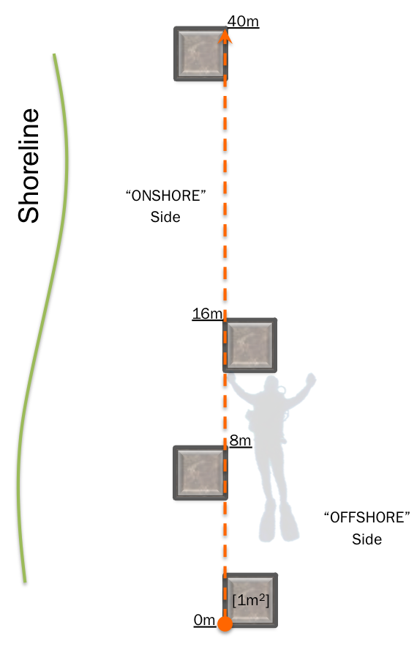

Figure 1. Diagram of quadrat orientation on transect tape.Uniform Point Count Protocol

*Adapted from Reed, D. C. . 2013. SBC LTER: Reef: Kelp Forest Community Dynamics: Cover of sessile organisms, Uniform Point Contact. Santa Barbara Coastal LTER. knb-lter-sbc.15.22 (*[*http://metacat.lternet.edu/knb/metacat/knb-lter-sbc.15.22/lter*](http://metacat.lternet.edu/knb/metacat/knb-lter-sbc.15.22/lter)*).*

The purpose of the Uniform Point Contact sampling is to determine the percentage cover of algae and sessile invertebrates for sampled sites along a randomly placed transect line. Some species may be sampled in UPCs and Quads or Swaths to provide different measures of their abundance.

The diver swims the length of the 40m transect centering a meter stick perpendicular to the transect tape at each meter interval. The diver then records the species that intersect an imaginary vertical line (operationally defined as a distinct “point” ~2mm in diameter) positioned at each end of the meter stick (n = 80 points per transect)  
(Figure 1).

Additionally, the substrate type under each point is noted. If there are multiple species encountered under the point (e.g., algae on top of a tunicate), then all species of plant/animal should be recorded. The total percentage cover of biota recorded on the transect may exceed 100% using this method; however the percentage cover for any single species per transect is always less than or equal to 100%.

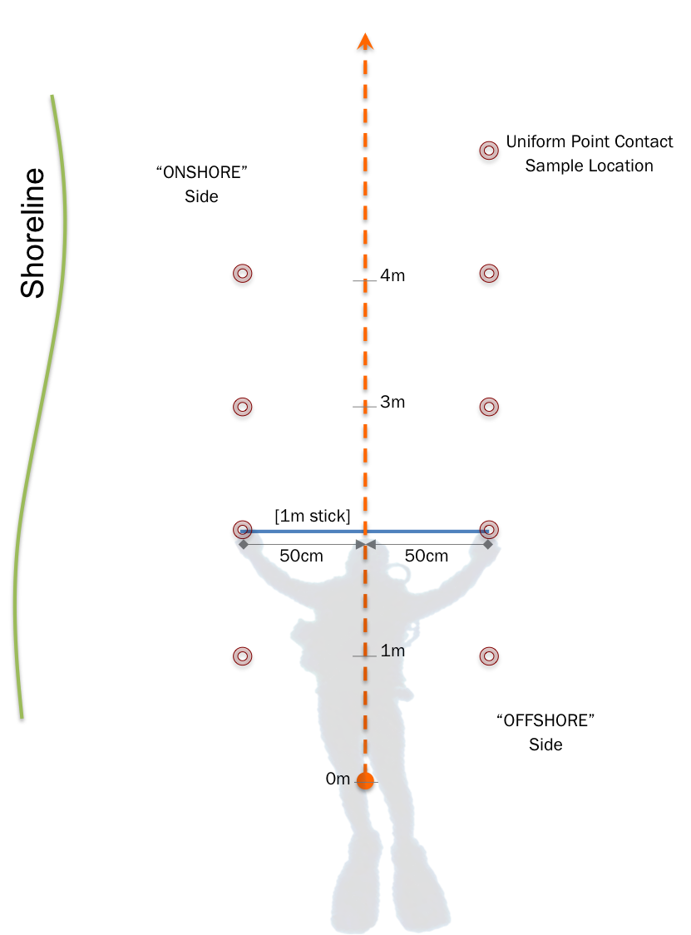

Figure 2. Diagram of Uniform Contact Points on transect line for meters 1 thru 4.

## Swath Sampling Protocol

*Adapted from Reed, D. C. . 2013. SBC LTER: Reef: Kelp Forest Community Dynamics: Invertebrate and algal density. Santa Barbara Coastal LTER. knb-lter-sbc.19.20 (*[*http://metacat.lternet.edu/knb/metacat/knb-lter-sbc.19.20/lter*](http://metacat.lternet.edu/knb/metacat/knb-lter-sbc.19.20/lter)*).*

The purpose of the swath sampling is to determine the abundance of common algae, invertebrates, and demersal cryptic fish that can easily be counted in a 1 m-wide area on each side of the 40m transect. Swath sampling is performed by a diver swimming the length of the 40m transect twice, once each on the onshore and offshore sides of the transect.

As the diver swims, they use a 1m long bar perpendicular to the transect tape (& approximately 25cm off bottom) and records the abundance of all targeted species encountered in each 40m x 1m area. The total area sampled is 80 m2 (Figure 1). To facilitate sampling, the abundance of each target species is recorded in each of four subsections: 0-20m Onshore, 21-40m Onshore, 0-20m Offshore, and 21-40m Offshore.

The substrate beneath understory algae is searched for target species, as are the undersides of ledges and crevices. No substrates or organisms are removed to expose targeted species hidden from view.

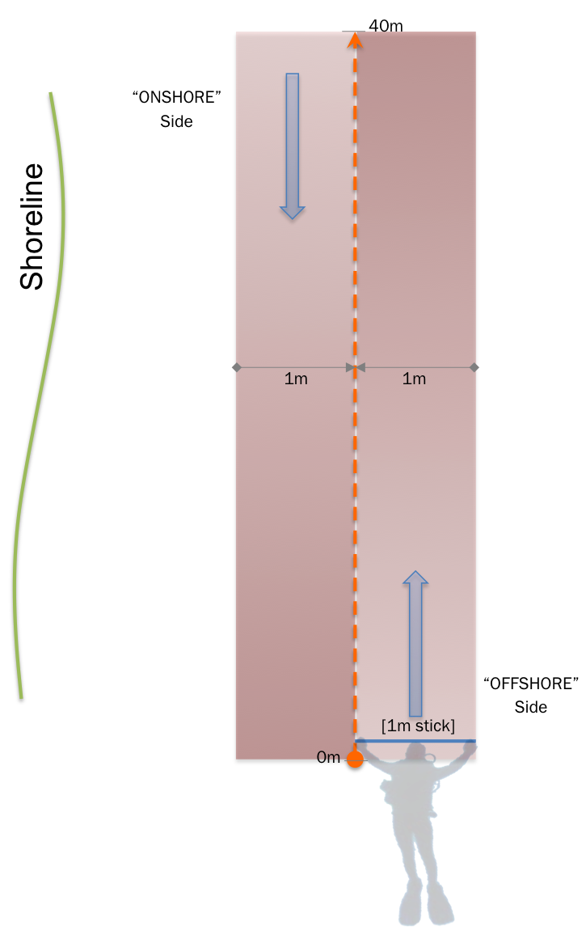

Figure 3. Diagram of swath sampling layout on transect tape.

## Fish Count Protocol

*Adapted from Reed, D. C. . 2013. SBC LTER: Reef: Kelp Forest Community Dynamics: Fish abundance. Santa Barbara Coastal LTER. knb-lter-sbc.17.27 (*[*http://metacat.lternet.edu/knb/metacat/knb-lter-sbc.17.27/lter*](http://metacat.lternet.edu/knb/metacat/knb-lter-sbc.17.27/lter)*).*

The purpose of the Fish sampling is to determine the abundance of common fish that can be counted in a 2-8m (depending on regions– see your regional protocols, as visibility conditions differ between regions) wide area along the 40m transect. Fish sampling is performed by a diver slowly swimming the length of the 40m transect about 1m above the transect line recording the abundance and size of all fish individuals encountered within a predefined imaginary “cube”. This “cube” extends 1-4m on either side of the transect tape (2-8m across) and 2m up from the substrate (2m high) (Fig. 1). Total area sampled varies by region.

As the diver swims, they sample by scanning ahead frequently to record any transient species that pass through the “cube” while also searching beneath understory algae. Every fish sighted within the sampling area during the survey is recorded in pre-defined size bins.

Care is taken by the diver to count only fish that enter the “cube”. Some fish species are attracted to divers and will follow the diver, re-entering the sampling “cube” several times. Therefore, fish that enter the sampling “cube” from behind the observer are not counted.

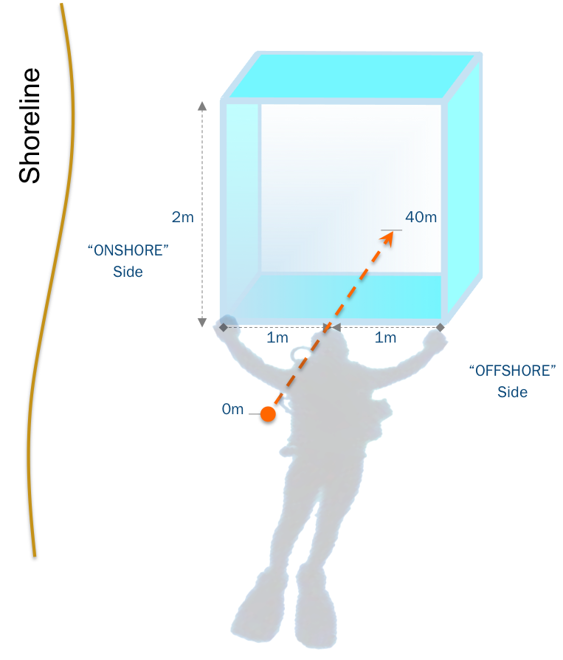

Figure 4. Diagram of quadrat orientation on transect line with 2m width.

## Subsurface Kelp Morphometrics Protocol

The purpose of the kelp morphometrics protocol is to assess the size distribution and biomass of subsurface (e.g., not *Macrocystis, Nereoystis, Ecklonia maxima,* or other canopy forming kelps – see Canopy Kelp Sampling Protocol) kelps along a transect. This is the only destructive sampling technique involved in sampling. It should be completed after all other protocols are carried out to avoid biasing any other results.

Along the transect, divers should swim and collect 1 adult individual of each species of subsurface kelp every 4 meters (n=10 individuals per transect). If kelps are rare enough that one is not present every four meters, haphazardly chose enough individuals so n=10. If there is no kelp, record that none was available. Back on the boat, measure and record the relevant dimensions of the kelp to determine its biomass (e.g., for *Saccharina latissima* and many others, record blade length and width, and record stipe length). The specifics of this protocol will vary by region. See descriptions in the **Regional Protocols**section of the handbook and/or talk to your regional coordinator.

## Canopy Kelp Sampling Protocol

*Adapted from Reed, D. C. . 2013. SBC LTER: Reef: Kelp Forest Community Dynamics: Abundance and size of Giant Kelp (Macrocystis Pyrifera), ongoing since 2000. Santa Barbara Coastal LTER. knb-lter-sbc.18.17 (*[*http://metacat.lternet.edu/knb/metacat/knb-lter-sbc.18.17/lter*](http://metacat.lternet.edu/knb/metacat/knb-lter-sbc.18.17/lter)*).*

The purpose of kelp monitoring is to monitor the abundance and size of adult canopy forming kelps, such as *Macrocystis pyrifera*, *Ecklonia maxima*, *Nereocystis leutkeana,* at sites through time. Adult canopy forming kelps are defined differently for different species. Refer to your regional protocols. In general, they are kelpswith fronts standing upright >1m above the surface, but, again, see the appropriate regional protocol or ask your regional coordinator for guidance. Canopy kelp sampling is performed by an observer swimming the length of the 40m transect twice, once each on the onshore and offshore sides of the transect tape. The total sampling area is 80m2

As the observer swims, he/she holds a 1m long bar perpendicular to the transect tape and records data for all adult canopy kelps encountered in the 1m wide area on both sides of the transect tape. Kelp data is recorded in four subsections for each transect, 0-20m Inshore, 21-40m Inshore, 0-20m Offshore and 21-40m Offshore. For each plant encountered, the number of fronds measured 1m above the holdfast and the largest dimension of the holdfast diameter is recorded.

## Sample Dive Plan for Observational Sampling

We have found that one transect can be easily sampled by two buddy pairs in a single dive. A transect can be sampled by a single three-person trio, but it can be difficult to keep buddies in sight, so recommend against it. Below is a sample dive plan for one four-person team on a single transect. In this sample, divers are optimized to minimize disturbance of mobile organisms to ensure an accurate count.

1. Drop the anchor at the chosen transect lat/long. If the point is to shallow, move offshore until an appropriate depth is reached and correct the lat/long on the site data sheet for this transect.
2. Buddy team one goes down the anchor and begins the transect adjacent to it. The first diver swims parallel to shore performing the fish protocol. The second diver reels out the transect line, and tells their buddy to stop when they have reached 40 m.
3. Buddy team one pops a float at the end of the transect so that it can be marked via GPS at the end of the dive.
4. Buddy team one splits the swath count between them, swimming back to the beginning of the transect.
5. If this is a system where kelps are removed for morphometrics, buddy team one turns around, and removes kelps according to the appropriate regional protocol.
6. Buddy team two enters the water and swims to the end of the transect.
7. Diver one of buddy team two begins with the point count protocol.
8. Once diver one of buddy team two is on their third meter, diver two of buddy team one begins the quadrat protocol.
9. Whichever buddy team finishes their work last reels up the transect before returning to the boat.

## Temperature Logging Protocol

To record temperature data, deploy two continuous temperature loggers at each survey site. We suggest Onset 64K Pendant Loggers (UA-001-64). These loggers are inexpensive and field serviceable. Off the shelf batteries can be used and all housing parts can be field replaced if damaged.

Place loggers in a “toughened housing” (a 1 ½“ capped PVC pipe fitting – see Figure 2 below) drilled with holes. Attach the housed sensor to stainless steel eyebolts or re-bar firmly secured to the substrate with marine epoxy (Z-Spar). Attach a ~0.5m length of polypropylene line to the housing or the eyebolt to facilitate finding it on subsequent dives.

While Individual site bottom characteristics vary, a depth of 10.0m is the target for logger deployment at sites. Recorded actual depth for each sensor placement as well as a GPS position in decimal degrees using a float line from the sensor anchor point to the surface to get latitude/longitude coordinates. The beginning or end of a transect would be ideal.

Each logger should sample the ambient water temperature at thirty-minute intervals. Offset the paired loggers by fifteen minutes so that temperature data is recorded at the site every fifteen minutes. At 30-minute intervals, the loggers can collect data for up to 2 years. But battery life may be limited to just over a year in cold water.

Retrieved and replace loggers annually during the benthic monitoring season.

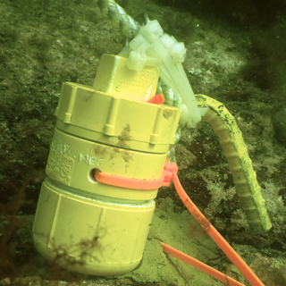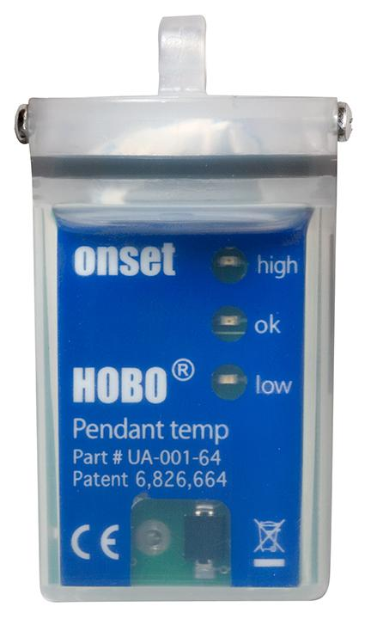

Figure 1 –Onset “Hobo” Pendant Temp Logger

Figure 2 –PVC housing for temperature sensor

# Regional Adaptations of Observational Protocols

## Species Lists & Guides

### Lists

For each region, regional coordinators will maintain a species list. For every species sampled as part of a regions activities, the species list will contain the species code, Latin name, common name (if available), a brief description suitable to fit onto a data sheet, and which protocols sample a particular species in the observational survey.

Here are the first few lines of the New England list, for example:

|  |  |  |  |  |  |  |  |
| --- | --- | --- | --- | --- | --- | --- | --- |
| **Species Code** | ***Species*** | **Distinctive trait** | **Common name** | **Quads** | **UPC** | **Swath** | **Fish** |
| **ABAB** | *Abietinaria abietina* | coarse corticated, unbranched main stem | sea fir |  | ✔ |  |  |
| **AGCL** | *Agarum clathratum* | many regular holes | Shotgun Kelp | ✔ | ✔ |  |  |
| **AGJ** | *Agarum clathratum* | <10cm, many holes | juvenile Shotgun kelp | **✔** |  |  |  |
| **ALDI** | *Alcyonium digitatum* | white fingers, irregular masses | Dead man's fingers |  |  | ✔ |  |
| **ALES** | *Alaria esculenta* | distinctive midrib | Winged Kelp | ✔ | **✔** | ✔ |  |
| **ALJ** | *Alaria esculenta* | <10cm, distinctive midrib | Juvenile winged kelp | ✔ |  |  |  |

### Guide

Regions should also construct a photographic ID guide for all species sampled. This guide should be sorted taxonomically, and provide more detailed descriptions to aid divers in identification of similar taxa.

## Northwest Atlantic (New England, Eastern Canada)

What follows are modifications to the general KEEN sampling protocols for the Gulf of Maine and Northwest Atlantic. If you feel protocols need to be modified further, please contact your regional coordinator ([jarrett.byrnes@umb.edu](mailto:jarrett.byrnes@umb.edu)).

#### Quadrat Sampling Protocol

Multiple species codes are used for several species to aid in distinguishing size/age categories for the purpose of estimating the young-of-year class. The following species size classifications used in quadrat sampling are:

*Agarum clathratum –* juvenile = individual < 5cm tall

*Alaria esculenta* *–* juvenile = individual < 10cm tall

*Laminaria digitata* *–* juvenile = individual < 10cm tall

*Saccorhiza dermatodea* *–* juvenile = individual < 10cm tall

*Saccharina latissima* *–* juvenile = individual < 10cm tall

*Saccharina longicruris* *–* juvenile = individual < 10cm tall

*Strongylocentrotus droebachiensis –* juvenile = individual< 20mm in diameter.

Species code BLD refers to the small single blade stage of a kelp that cannot be identified to species.

Also, crabs <5cm in carapace width are counted in quads (and have a corresponding code for being small) while crabs >5cm are counted in swaths.

#### Fish Sampling Protocol

In the Northwest Atlantic, fish transects count all fish 1m to either side of the transect (2m total width). Fish are binned into the following size classes: YOY, 0-10cm, 10-50cm, 50-100cm, >100cm.

#### Subsurface Kelp Morphometrics Protocol

For subsurface kelp morphometrics, collect individuals of *Saccharina latissima, Saccharina longicuris, Agarum clathratum, Alaria exculenta,* and *Laminaria digitata* where available. Measure stipe length, maximum blade length, and maximum width.

## Southern California and Baja

## Alaska

## Chile

## Northern California and the Pacific Northwest

# Large-Scale Kelp Removal Experiment

### Overview

### Datasheets and Data Management

Datasheets for each protocol below are supplied along with this handbook. Datasheets have been customized for each region. Consult your regional coordinator if you need to add or delete species to ensure that all species codes are synched up for your region. Electronic files should be stored in redundant electronic file systems or online cloud file systems such as Dropbox.com before being sent to the KEEN data coordinator. See Data Management for more.

## Materials Needed

#### Survey Materials

* Waterproof paper for data sheets
* Data sheet carriers/holders *(dive slates) (One for each survey team member)*
* 1m2 open PVC quadrat
* 1m2 strung 3x3 PVC quadrat
* 100m Transect tapes *(1 required)*
* 50m Transect tapes *(1 required – minimum of 2 recommended)*
* Marker floats *(2 required)*
  + (Recommend: “Pelican Float – Marker Recovery System” #100-Float)
* ~3 to 5 lbs. dive weight *(one for each float/temporary anchor points)*

#### Anchor Materials

Substrate Cleaning

* Putty knife *(or similar stiff bladed scraping tool)*
* Wire brushes
  + (Large & Small recommended)

Substrate Anchors

* 5/16”or 3/8” stainless steel eye bolts *(with large ~ 1” eye)*
  + (Nuts and washers as needed to aid anchoring)

*OR*

* Steel re-bar stakes ~ 12” (30cm)
  + (Recommend bending for hooked end )
* Z-Spar marine epoxy compound *(or equivalent)*
  + An amount about the size of a “tennis ball” for each bolt
  + Sometimes known as A-788 Splash Zone Compound
* Electrical tape *(or equivalent)* in the following colors:
  + Yellow, Red, White & Blue
* Plastic “Zip-ties” (aka - electrical or wire ties)
  + Preferably in matched colors to above

#### Temperature Sensors

* UW logging Temperature sensor
  + (Onset Computer Corporation: HOBO Pendant Temperature/Alarm Data Logger 64K   
    (Model – UA-001-64) (-20°C to +70°C). See full product description at:  
    <http://www.onsetcomp.com/products/data-loggers/ua-001-64>
* Secondary housing (if required for location)
  + 1/4” Stainless Steel eye-bolt with washer and nut(or equivalent) (for anchoring)
  + 1 1/2 “ PVC Threaded male adapter
  + 1 1/2 “ PVC cleanout adapter with threaded plug
  + 1 1/2 “ PVC threaded cap
* Floating Polypropylene line “ to 3/8” dia.
  + *(braided line recommend as it’s easy to splice directly on to the eye-bolt)*

#### Kelp Removal Materials

* Snips, scissors, shears, or hedgeclippers (for canopy forming kelps) *(or equivalent)* for each diver
* 8m line
  + *a line with “eye” or “looped” ends preferred*

*OR*

* Transect tape (20m – 50m)
* Mesh Bags for removal of clipped kelp
  + (May be needed for removal of larger species of kelp)

## Site Selection

Sites should be selected to be of moderate wave exposure relative to the region (i.e., not in a no-wave embayment, but not at a fully exposed coast). Sites should have a bench of kelp habitat between roughly 5-12m (region dependent). Sites should have relatively good initial kelp densities, although initial density will be used as a covariate (i.e., no sites in urchin barrens or turf beds – we need kelp to be present in order to have an effect). We are using these standardization choices in order to make our results broadly comparable between regions without having to incorporate an excessive number of covariates.

Note, some regions or areas within a region may not have extremely high kelp abundances. This reflects biogeographic variability, and should not be avoided. For further discussion, see the project FAQ.

**Figure 1:** Example island with available area in the intersection of the proper depth, kelp availability, and moderate wave exposure. Note location of chosen random point.

**5 -12m**

**Kelp**

**Moderate**

**Waves**

## Site Layout

At a single site, we will locate four plots along a 60m transect (e.g., centered at 0m, 20m, 40m, and 60m). One of these plots will be chosen at random as the removal plot. The other three will serve as controls. The transect should run alongshore, with depth held relatively constant (i.e., no large depth gradients).

**Figure 2:** Sample island with transect line and plots marked. The chosen removal is in pink.

0m

20m

40m

60m

## Pre- and Post-Removal Sampling Protocol

Within each plot, we will sample all sessile species, mobile invertebrates, and cryptic fish in twelve 1m2 quadrats centered in the plot. To do so, we will count the abundances of all large conspicuous solitary organisms in 1m2 quadrats, as in the kelp forest observational sampling experiment (see below). This will be followed by point-contact counts with 9 points spaced evenly in a grid in the same 1m2 quadrats. Under each point, divers will record the identity of all species present.



**Figure 3:** Sample point count quadrat with 3x3 grid. The 9 points in the center are sampled. Note, over the entire plot, this adds up to 108 points. All species under the grid can be enumerated. In the open quadats, the large block species, not easily identifiable as solitary, would not be recorded.

**Figure 4:** Sample layout of a plot. Note that the ordering of quadrats is designed to optimize diver movement as they flip quadrats from one area to the next. Colors of markers are described in the sample dive plan below and facilitate finding and resampling plots.

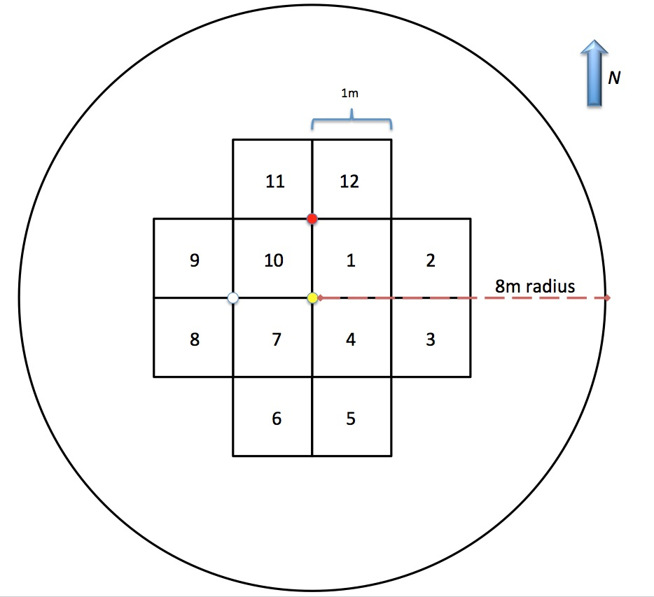

## Removal Protocol

In experimental plots, remove all kelps in a circle 8m in radius (roughly 200m2) by clipping them just above their holdfast. Kelp meristems are located just beneath their blades, and this removal at the base of the holdfast will ensure die-back of all cut kelps without leading to disturbance of other sessile species. As the experiment is meant evaluate the ability of the system to rebound after losing all kelps, juvenile kelps should also be removed.

## Temperature Logging Protocol

To record temperature data, deploy two continuous temperature loggers at each removal site. One should be affixed to the center of the removal plot and the other to the center of the first control plot. We suggest Onset 64K Pendant Loggers (UA-001-64). These loggers are inexpensive and field serviceable. Off the shelf batteries can be used and all housing parts can be field replaced if damaged.

Place loggers in a “toughened housing” (a 1 ½“ capped PVC pipe fitting – see Figure 2 below) drilled with holes. Attach the housed sensor to stainless steel eyebolts or re-bar firmly secured to the substrate with marine epoxy (Z-Spar). Attach a ~0.5m length of polypropylene line to the housing or the eyebolt to facilitate finding it on subsequent dives.

While Individual site bottom characteristics vary, a depth of 10.0m is the target for logger deployment at sites. Recorded actual depth for each sensor placement as well as a GPS position in decimal degrees using a float line from the sensor anchor point to the surface to get latitude/longitude coordinates. The beginning or end of a transect would be ideal.

Each logger should sample the ambient water temperature at thirty-minute intervals. Offset the paired loggers by fifteen minutes so that temperature data is recorded at the site every fifteen minutes. At 30-minute intervals, the loggers can collect data for up to 2 years. But battery life may be limited to just over a year in cold water.

Retrieved and replace loggers annually during the benthic monitoring season.

## Timing of Resampling Removal Experiment

Sites should be visited at the height (e.g., July for Northern Hemisphere summer) of the summer field season and resampled as before. This timing should be specified by your regional co-coordinator.

## Sample Dive Plan for Removal Experiment

1. Before diving, preselect a removal plot randomly from 0m, 20m, 40m, and 60m.
2. Two divers (team A) go down with quadrats, clippers, data boards, and a float & weight.
3. After locating the start of a line of plots, divers install a bolt to mark the center of the 0m plot. They embed a label (0m) in the Z-spar blob.
4. After team A installs bolts at all three points (center, N, and W) of the 0m plot, they mark the north bolt red, center bolt yellow, and West bolt orange to aid in finding the center of the plot during resampling. All bolts have polypro line attached to them floating up 1m.
5. Team A divers pop a float, indicating that the sampling team should enter the water.
6. Team A lays out 60m transect tape along pre-selected alongshore heading. At the end (60m) they pop a second float.
7. Team B enters the water. They both note the heading of the transect tape on their data sheets.
8. The quadrat sampler begins in plot 1. After finishing, they move to plot 2, and the UPC sampler begins.
9. After marking, team locates the removal plot, and begins to sample. If completed, move to the first control plot, and sample it.
10. Bolt team marks the rest of the plots (at 20m, 40m, and 60m) with the same bolt pattern as before. They install temperature sensors in removal and first control plot.
11. Team B continues sampling all plots until they are finished. They then assist in kelp removal.
12. After putting in all plot marking bolts, team A returns to the kelp removal plot. They lay out 8m line tied to a weight at the center of the plot to visualize the radius of the clearing.
13. If team B has not completed sampling the removal plot, team A begins removing all kelp between 4-8m away from center bolt, creating a donut with a 4m hole in the center. After team B leaves, team A can clear the center.
14. To remove kelp, snip individuals at base of their holdfast, wafting it away. If kelp will not be washed away in the next few days, it may need to be bagged and taken away from the plot.
15. Once sampling finished, team A can move in and assist in the removal until it is done.

# Data Management

## General Notes

Below is a general protocol for data management, going from the end of data collection to submission to KEEN. It may seem like a bit much, but rest assured it is designed to make sure that the quality of data at all sites is the same. If we all follow the same protocol, there will be no doubts as to variable quality of data coming from different sites due to poor data management. We encourage you all to incorporate these protocols into other projects in your labs, as they have been tested by many organizations and shown tp produce reliable results.

We also recommend that, while going through the data entry process, your data is stored on more than just a single local computer! Get a Dropbox (<http://dropbox.com>) or similar account, perform regular backups to external hard-drives or off-site backup locations. This data is extremely valuable, both to you and the network, and you should always employ the best practices to make sure it is not lost or corrupted.

## In the Field

After a dive, all observers should check their own data sheets for legibility. Tally all hash-marks for counts and write circled roman numerals to indicate final numbers. After being satisfied by all data sheets, exchange data sheets with your dive buddy and make sure that they, too, understand each and every entry on your data sheet. Store sheets in a common folder to bring back to the lab.

Do not lose this folder.

## After the Field

Sheets should be rinsed and hung to dry. As soon as sheets are dry, place them in a “To be scanned” folder. Scan them into a computer at the earliest opportunity. Print the scan. The printout of the scan should be as legible as the original. If it is not, re-scan and print, using a higher resolution or alternate settings if necessary.

Once the printout of the scan is deemed equally legible, note the date scanned and who scanned it on the original, and archive it away in a binder or folder of original data sheets. Note the scan and date in the master data chain of custody file for the site. Place the print-out in a “To be entered” folder.

## Data Entry Workflow

Open the appropriate template from the **Data Templates for Entry** folder of the appropriate type (Removal Experiment v. Observational Sampling). Immediately save it in the **Data Entry in Progress** folder with a filename *site_protocol_date_in_progress.xls.* Date should be in the YYYMMDD format. Enter data from scanned copy, saving regularly. Highlight questionable entries in yellow. Note any questions and highlight these as well.

If you cannot complete entering a sheet, save and close the file. Put the sheet you are working on into the a “In Progress” folder.

When data entry is complete, save and close the file. Move the file to the **Data to be Verified** folder, removing _in_progress from its name. Note your name and date on the *original* data sheet in the “Data entered” fields at the bottom. Add the same information to the data chain of custody spreadsheet. Place the scanned sheet in the “To be checked” folder.

## Quality Control

For quality control, we recommend the two-person read-back method. One person reads from the scanned data sheet while the other checks lines in the file. This can be done with two people, or you can record yourself reading from the datasheet.

Along the way, stop at any highlighted entries. If it is a transcription problem from the scan, check the original data sheet for confirmation of the original value. Contact the observer where necessary for clarification. Remove highlights as questions are answered.

Once completed, save the QC-ed file and move it to the Verified Data folder. Note on the data chain of custody log and on the original data sheet your name and when the data was completed being QC-ed. Notify the site manager. Archive the scanned copy in a binder.

## Post-Submission Data Management

Once all data from a site is quality controlled, zip up the verified data and scans of data sheets and share them with the KEEN data coordinator (currently, email [jarrett.byrnes@umb.edu](mailto:jarrett.byrnes@umb.edu)). This can be via email, if file sizes are small, shared dropbox links, FTP, or otherwise.

Once the coordinator acquires the data, they will first add all data sheet scans to a permanent archive. They will then perform an additional later of data Quality Assurance. They will first compare all species codes used in your data to those used within your region, and flag any mis-matches and potential typos. Second, they will scan the data for any outliers or extreme values. These will be flagged and checked against the scans. They will check for consistency in lat/long entries, and verify that they fall within the geographic area you are sampling (e.g., to catch using an incorrect lat/long format). Last, they will merge your data with the rest of the network, checking for any errors thrown.

You may receive further contact from the coordinator about any data QA issues. Hopefully these can be resolved quickly by checking with original data sheets or observer.