CSI Genome
Project 07 - The Contamination Detective
Introduction to Bioinformatics - Course Project Report
Astana IT University
Programme: Big Data Analytics, Bachelor level
Students: Abylaikhan Torekhan and Kuanysh Bakizhan
Group: BDA-2405
Astana, 2026

1. Introduction
Public DNA databases are used to study organisms and compare genomes. However, a submitted genome can contain DNA from another organism or short technical sequences left over from sequencing. If these errors are reused, they can lead to wrong biological conclusions.
Our question: Can a small, understandable screening tool find suspicious sequences in a defined part of GenBank, and which records have enough evidence to request a closer review?
We analysed 3,006 Mollicutes assemblies and seven real sequencing runs. The screen flagged 246 assemblies (8.18%): 243 with known adapter motifs and three with strong foreign-DNA matches. This is the rate found by our screen. It does not mean that exactly 8.18% of the archive is contaminated.

2. Background

2.1 Where unwanted sequences come from
- Foreign organism: DNA from a host, another microbe or laboratory reagents enters the sample or is included during assembly.
- Vector: DNA from a cloning plasmid remains in a sample. A vector match can also be an intended part of an engineered strain.
- Adapter: a short sequence added during library preparation remains in reads or in the final assembly. Read-through happens when sequencing continues past the sample fragment into the adapter.
- Index hopping: a read receives the index of another sample in a pooled sequencing run, so it is assigned to the wrong library.
- Sample swap or mislabel: a sample, species name or database link is mixed up during laboratory work or submission.

2.2 Foreign DNA is not always an error
Bacteria can acquire genes from other organisms through horizontal gene transfer (HGT). An unusual sequence inside a long bacterial contig may therefore be real biology. A deliberately inserted construct is another explanation. We treat these cases separately instead of calling every foreign match contamination.
Our small reference panel was chosen before interpreting the results. It covers E. coli, Ralstonia pickettii, mouse mitochondrial DNA and an Arabidopsis chloroplast. These represent possible laboratory, reagent, animal-host and plant-host sources. The panel is quick to search, but it cannot detect every possible contaminant.

3. Data
The archive slice contains every versioned GenBank assembly returned for Mollicutes (NCBI taxid 31969) in the saved snapshot from 29 September 2026. These bacteria have relatively small genomes, making thousands of assemblies manageable on one computer. Many also live with animal or plant hosts.
The dataset contains 3,006 assemblies, 317,568 contigs and 3,674,465,179 bases. The study snapshot was retrieved on 29 September 2026 and the original BLAST checks were run on 30 September. The complete notebook analysis was rerun on 1 October using the same versioned records and cached BLAST responses.
Resource | What we use it for
GenBank / NCBI Datasets | Assembly FASTA files and BioSample / BioProject metadata. Every accession is in config/assemblies.csv.
ENA | Metadata and raw reads for seven archived sequencing runs. URLs and run IDs are in config/reads.csv.
RefSeq / Nucleotide | Four foreign references: GCF_000005845.2, GCF_902374465.2, NC_005089.1 and NC_000932.1.
UniVec_Core | Known vector and related technical sequences. The saved file has a checksum.
NCBI BLAST | Identification of three suspicious 1 kb sequences. The request used nt; the server returned core_nt.
Table 1. Data sources and saved identifiers.
Run | Platform | Assembly
ERR14335636 | NextSeq 500 | GCA_965212735.1
ERR14335635 | NextSeq 500 | GCA_965212725.1
DRR504716 | MinION | GCA_040369795.1
SRR6082028 | MinION | GCA_002441935.1
SRR33330896 | NovaSeq X Plus | GCA_041276565.1
SRR9681681 | MiSeq | GCA_007859615.1
SRR28122442 | Sequel IIe | GCA_038024965.1
Table 2. Raw sequencing runs used in the read checks.
Direct matching of BioSample IDs linked 212 assemblies to ENA runs. Some metagenome assemblies use a parent sample ID, which this simple join misses. Missing links do not mean that no reads exist. Platform names were missing or unrecognised for 173 assemblies.
Seven records had a failed NCBI ANI taxonomy check. These are candidates for taxonomic review, not proven sample swaps. The two NextSeq runs share a study and release date, but there is no confirmed shared sequencing lane.

4. Methods

4.1 Finding adapter and reference matches
We search every contig in both directions for four known adapter motifs: TruSeq R1, TruSeq R2, Nextera and BGI. Matches must be exact and are 19-21 bases long. This rule is easy to inspect, but it misses damaged or incomplete adapters.
Contigs of at least 1 kb are also aligned to the foreign panel and UniVec_Core with minimap2 through mappy, using the asm5 preset. A match must contain at least 200 matching bases, at least 95% identity and mapping quality (MAPQ) of at least 20. Minimap2 finds short shared seeds, joins them into longer chains and extends promising matches into alignments.
For each reference, overlapping aligned intervals are counted only once. This also combines the two pieces of a circular mitochondrial sequence when it starts at a different position from the reference.

4.2 A simple score for foreign DNA
Evidence | Points
The reference covers at least 80% of the contig | +2
Sequence identity is at least 98% | +1
Contig GC differs from the whole assembly by at least 12 percentage points | +1
The foreign match has at least 500 bases of flanking sequence on both sides | -3
Table 3. Score used to prioritise foreign-sequence candidates.
A score of 3 or more flags a possible foreign contaminant. A foreign block with long flanks is kept as an HGT or construct candidate. Flanks support a different interpretation, but do not prove HGT. Vector matches are also kept separate because vectors can include normal bacterial DNA.

4.3 Checking the organism with BLAST
We submitted one 1 kb window from each of the three strongest foreign candidates to NCBI BLAST. We used megablast, an expectation threshold of 1e-10 and up to 20 hits, excluding hits to the query record itself. A BLAST window checks the identity of that piece; the panel alignment provides support across the contig. Exact queries and raw responses are saved.

4.4 A small detector test
The adapter screen returned no flags in 100 real native 1 kb windows. After inserting an exact Nextera motif, it detected 100 out of 100 windows. With one changed base in the motif, it detected 0 out of 100. This shows the main weakness of exact matching. These artificial spikes test the detector; the archive audit itself uses real data.

5. Results

5.1 How many assemblies were flagged
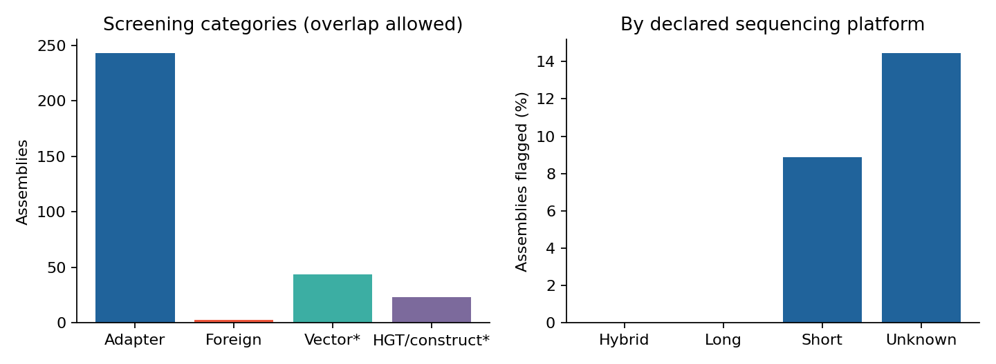
Figure 1. Screening categories and flag rates by declared platform. Vector and HGT / construct matches are counted separately; categories can overlap.
The main screen flagged 246 / 3,006 = 8.18% of assemblies: 243 had an adapter motif and three had foreign-DNA evidence. There were also 44 vector-match assemblies and 23 HGT or construct candidates. These separate categories are not added to the main total.
The 95% Wilson interval for the main rate is 7.26-9.22%. It describes counting uncertainty, but does not correct for missed contaminants, related samples or the choice of archive slice.

5.2 Platform and year patterns
Release era | Assemblies | Flagged | Rate
<=2015 | 113 | 3 | 2.65%
2016-2019 | 303 | 8 | 2.64%
2020-2022 | 634 | 44 | 6.94%
2023-2026 | 1956 | 191 | 9.76%
Table 4. Flag rates by assembly release era.
The rate was higher in recent release groups and in assemblies labelled as short-read data. Adapters come from library preparation, and fragmented assemblies have more contig ends where technical sequence can remain. However, species, laboratories and project types also differ between groups. The result does not show that a platform alone caused contamination.
All rates by year, taxon and platform, including their denominators, are in results/rates.csv. A release year is not necessarily the year when sequencing took place. Small early-year groups also make individual yearly percentages unstable.

5.3 Short reads and technical sequence
We used the first 10,000 read pairs from each of four Illumina runs. For each run we measured quality by cycle, GC distribution, exact adapter matches, repeated sequences, low complexity and poly-G tails. These are small prefixes of real runs, not random samples.
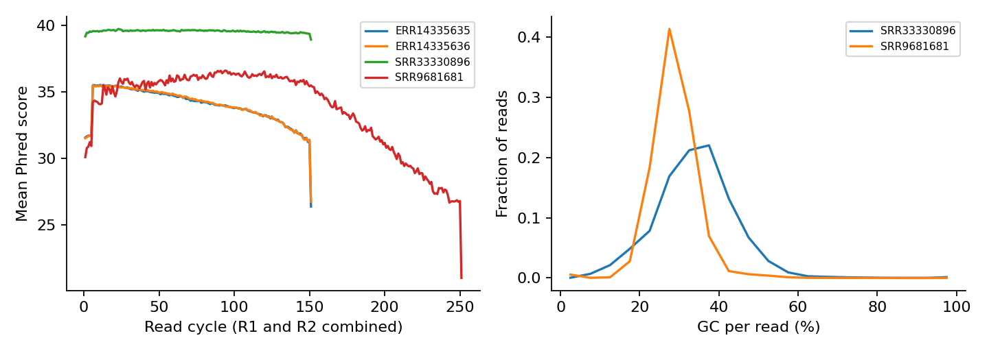
Figure 2. Mean raw quality by cycle and GC distributions for two example runs. R1 and R2 contribute to the same cycle average.
Run | Adapter reads | Trimmed | Discarded
ERR14335636 | 0.00% | 22.91% | 0.27%
ERR14335635 | 0.00% | 23.50% | 0.51%
SRR33330896 | 0.00% | 1.78% | 1.21%
SRR9681681 | 50.60% | 75.31% | 14.42%
Table 5. Short-read checks and trimming results.
The MiSeq run SRR9681681 had exact adapter sequence in 50.60% of reads. It was the clearest read-through example. Before mapping, the pipeline removes the first exact adapter, trims trailing bases below Phred 20 and discards reads shorter than 50 bases. Q20 means a nominal base-error probability of 1%.
Low complexity means trinucleotide entropy below 3 bits: the read uses a small variety of three-base patterns. This is a warning, because AT-rich bacteria can naturally have simple sequences. Poly-G means at least ten G bases at the end of a read. Duplicate counts use repeated sequences, not optical duplicate positions.
The plant-associated NovaSeq run mapped poorly to the bacterial assembly and our small panel. Plant nuclear DNA is a possible explanation, but unmapped reads cannot be assigned to a species from this result alone. An extra GC peak is also not enough to prove contamination.

5.4 Long reads and chimeras
We checked the first 2,000 reads from each of two Oxford Nanopore runs and one PacBio run. A chimera is a read that joins pieces which should not belong together. The search looks for a read with one alignment to its native assembly and another to the foreign panel.
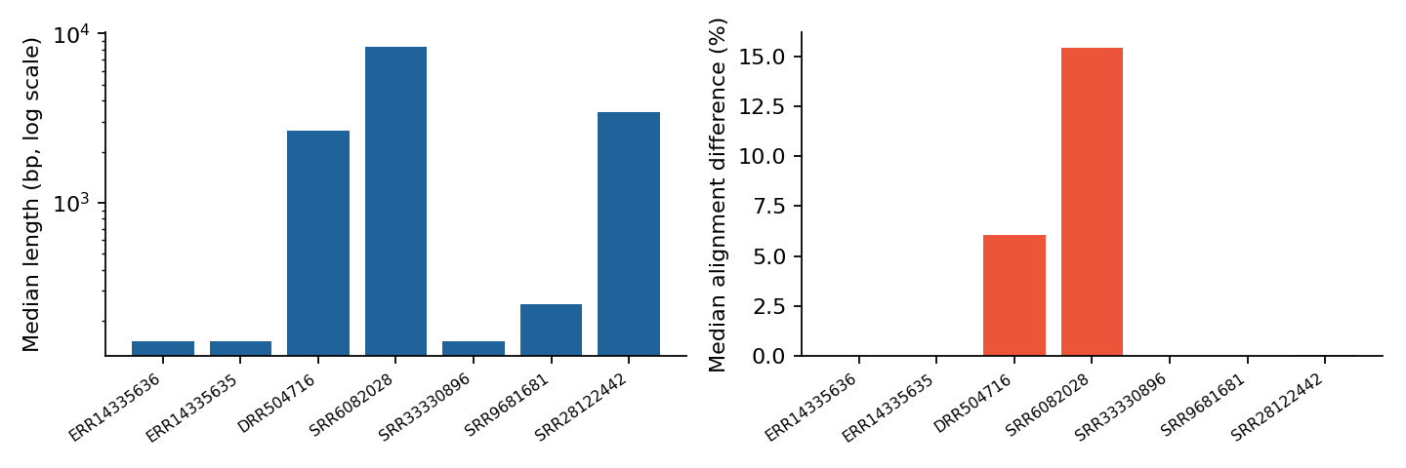
Figure 3. Read lengths and differences from the selected reference. Runs contain different organisms and sequencing generations, so this is not a controlled platform comparison.
Run / platform | Median length | Identity | Split reads
DRR504716 / ONT | 2,662 bp | 93.97% | 0/2000
SRR6082028 / ONT | 8,370 bp | 84.56% | 0/2000
SRR28122442 / PacBio | 3,419 bp | 99.95% | 0/2000
Table 6. Long-read alignment results.
ONT uses map-ont; the PacBio Sequel IIe run uses map-hifi. A chimera candidate needs two alignments with MAPQ at least 20, at least 300 query bases each and no more than 50 bases of overlap. We found zero native-plus-foreign splits. The upper 95% Wilson bound is about 0.19% per run, conditional on this screen and sampling scheme.
Alignment differences include real strain differences as well as sequencing errors. Rearrangements within the same organism and contaminants absent from the panel are not tested by this chimera rule.

5.5 The index-hopping check
For ERR14335635 and ERR14335636, we mapped 10,000 pairs per run against both assemblies. Both mates had to uniquely favour the other sample, with MAPQ at least 30, identity at least 98% and at least 90% query coverage. Neither run had a cross-assigned pair; the upper Wilson bound was about 0.038% per run.
This checks for cross-sample sequence. Without index reads, lane information and the original sample sheet, it cannot prove or rule out index hopping. Laboratory mixing and shared biological sequences can produce similar signals.

6. Error analysis

6.1 Reviewing a sample of flags
A fixed random seed selected one representative hit from each of 20 adapter assemblies and 10 vector assemblies. We also examined all three foreign candidates. The saved review records use contig position, nearby sequence, BioSample descriptions and non-self BLAST hits. Each decision and its reason is recorded in results/review_decisions.csv.
Screen | Reviewed | Supported | False label | Unresolved
Adapter | 20 | 19 | 0 | 1
Foreign | 3 | 3 | 0 | 0
Vector | 10 | 0 | 6 | 4
Table 7. Evidence review. A false label means that calling the match contamination would be misleading.
For adapters, 19 cases had supporting context: a longer adapter sequence, a contig end or a position next to an assembly gap. One short internal Nextera match remained uncertain. Among resolved cases, the false-discovery fraction was 0 / 19, but its 95% Wilson upper bound was 16.8%. If the unresolved case were false, the fraction across all 20 cases would be 5%.
All three foreign candidates had whole-contig support and a non-self BLAST match. However, three cases are too few to claim almost perfect accuracy: zero rejected cases out of three still gives an upper Wilson bound of 56.2%.
Six of ten vector cases were GM12 strains described as engineered or deletion-mutant strains. Their E. coli lac-operon segments fit intentional constructs. Calling all vector matches contamination would therefore give at least 6 / 10 false labels in this sample. Four other vector cases remained unresolved.

6.2 What this error estimate means
A false-discovery fraction asks: among the flags we checked, how many were wrong? A conventional false-positive rate asks: among truly clean records, how many were flagged? The second measure needs a representative set of known clean genomes, which we do not have. The 100-window baseline is useful, but does not replace that set.
The review is documented evidence checking. It is not an independent, blinded human validation or laboratory confirmation. Its sample size and unresolved cases limit what we can say about accuracy across the whole archive.

6.3 Changing the score
A foreign-call threshold of 2 or 3 retains all three foreign candidates. Raising it to 4 retains one. These numbers show that the threshold matters. They only retest saved alignments; they do not measure the effect of changing the mapping filters or expanding the reference panel.

7. Ten records for curator review
The following list gives versioned records and 1-based, inclusive coordinates. The three foreign sequences have BLAST evidence. For the seven adapter-rich assemblies, the coordinate is one example; the count is the total number of exact adapter matches in that assembly.

1 GCA_937885255.1
CALAAF010000019.1:1-16354
mouse mitochondrial DNA; 100.00% identity and 100% contig coverage.

2 GCA_013389495.1
JACAOE010000004.1:1-2885
E. coli; 99.24% identity and 100% contig coverage.

3 GCA_949083825.1
CARVPV010000123.1:1-2163
mouse mitochondrial DNA; 100.00% identity and 100% contig coverage.

4 GCA_900556265.1
USOI01000001.1:1-19
568 exact adapter matches; motif: Nextera.

5 GCA_900553385.1
USDR01000001.1:33626-33644
445 exact adapter matches; motif: Nextera.

6 GCA_937983315.1
CALKAH010000001.1:23-43
337 exact adapter matches; motif: TruSeq_R2.

7 GCA_947064695.1
CAMSWF010000001.1:26-46
224 exact adapter matches; motif: TruSeq.

8 GCA_948820955.1
CAQKIL010000001.1:384-404
203 exact adapter matches; motif: TruSeq.

9 GCA_949019015.1
CARLZX010000001.1:17038-17058
196 exact adapter matches; motif: TruSeq_R2.

10 GCA_948996125.1
CARIPT010000002.1:16896-16916
174 exact adapter matches; motif: TruSeq_R2.
Suggested action for records 1-3: inspect BLAST results, raw-read support and assembly context; remove the sequence only after confirmation. For records 4-10: inspect all listed coordinates, trim confirmed terminal adapters and examine internal joins before editing.
Evidence files: results/curator_top10.csv, adapter_hits.csv and alignment_hits.csv; BLAST identifications are in nt_hits.csv, with saved queries and responses. No sample swap or index-hopping event was demonstrated by this analysis.

8. Limitations
- Small reference panel. Four foreign references cannot cover every contaminant. Nuclear host DNA, distant organisms and short foreign fragments may be missed.
- Exact adapters only. One changed base caused all 100 mutated test motifs to be missed. A negative result does not mean that an assembly is clean.
- Ambiguous biology. GC content can vary naturally. A foreign block may be HGT, an engineered construct or an assembly error. Sequence context alone cannot prove which explanation is correct.
- Small read samples. We used the first reads from seven runs, not random samples from the whole archive. Read-level percentages should not be applied to all 3,006 assemblies.
- Platform comparisons are observational. Organisms, laboratories, assembly methods and release years differ between groups. The data do not isolate the effect of the sequencing instrument.
- Incomplete metadata. Direct BioSample matching misses some parent-sample links. Missing platform names and release dates also limit comparisons.
- Limited BLAST scope. The server returned core_nt rather than the requested nt database. Some large eukaryotic chromosomes are absent from core_nt.
- Limited validation. The case review was small and not independently blinded. Unresolved flags and unknown false negatives prevent a precise estimate of total contamination prevalence.

9. Recommendation and conclusion
A database curator should use these results as a list of records to inspect. Known adapters at contig ends are strong technical clues. Whole-contig matches to an unrelated organism also deserve attention, but should be checked against raw reads and submission context before removal. Vector matches should be reviewed separately, especially in engineered strains.
Our screen found 246 flagged assemblies out of 3,006 (8.18%). Most flags were adapter motifs. The strongest foreign cases matched E. coli DNA and mouse mitochondrial DNA. The seven raw-read examples also showed clear adapter read-through in one MiSeq run, while the tested long-read and pooled-run checks found no positive candidates.
The answer to our question is yes: a small screening tool can find useful, traceable candidates at archive scale. Its output is a starting point for review, not a final diagnosis. The main practical lesson is to combine sequence matches with biological context and to report what the screen can miss.

10. Reproducibility
The repository contains one executable Jupyter notebook with all analysis code, a Snakemake workflow that runs the same notebook, pinned dependencies and a small real test dataset. Its eight tasks follow the handbook in order. All assembly and read accessions are saved in the config files.
- Quick offline check: after installing the locked environment, run snakemake --cores 2. The bundled test contains 13 assemblies and small read samples. It gives five assembly flags: two adapter and three foreign candidates.
- Full result: run snakemake --cores 2 --config mode=full. This retrieves the fixed archive inputs and reproduces the main analysis. Exact-query BLAST responses are cached and can be replayed offline.
- Environment: requirements.lock.txt records package versions. A Dockerfile is also supplied; the Docker image was not tested. The tested workflow used the local Python environment.
On the macOS notebook rerun, adapter scanning took 117.9 s, panel and vector alignment 80.2 s, and read checks 34.4 s. The notebook process peak memory recorded after alignment was 1188 MiB, including earlier stages. These component times exclude downloads, environment setup and NCBI waiting time. Input sequences total 3.67 billion bases; the intermediate query FASTA is about 3.4 GiB.
Assemblies are processed one at a time. At similar throughput, ten times more sequence would take roughly ten times the scan and alignment time. This is an estimate, not a measured tenfold run. Main costs are CPU time, downloading and storage; monetary sequencing costs cannot be reconstructed from these records.

11. Team responsibilities
Abylaikhan Torekhan and Kuanysh Bakizhan both worked on the code and checked the results. The work was shared rather than divided into separate coding and checking roles. Both partners are responsible for the final report and for explaining the full analysis at the defence.

References
Li, H. (2018). Minimap2: pairwise alignment for nucleotide sequences. Bioinformatics. doi:10.1093/bioinformatics/bty191.
Salter et al. (2014). Reagent and laboratory contamination can critically impact sequence-based microbiome analyses. BMC Biology. doi:10.1186/s12915-014-0087-z.
NCBI. VecScreen interpretation guidelines.
NCBI. BLAST nucleotide database documentation.
Illumina. Nextera adapter sequences.
Illumina. Index hopping in multiplex sequencing.

Appendix A. AI usage disclosure
Tool: Claude (Anthropic), used through Claude Code.
Purpose: to help plan the analysis step by step, to implement the engineering and programming part of the project, and to choose suitable technical solutions.
Use: Claude helped break the project into stages (metadata reconciliation, adapter and vector screening, composition and alignment screens, nt BLAST identification, the contamination-versus-HGT rule, read-level analysis, false-positive review).

