**Comparison of Tech Support Services Between Age Groups**

Kelseyann Wright

Student ID: 00565814

College of Information Technology, Western Governors University

Data Acquisition - D205

Dr. William Sewell

March 5, 2023

**Comparison of Tech Support Services Between Age Groups**

1. **Research Question**

Do older customers purchase tech support services more often than younger customers? Answering this question will help sales teams better understand customer demand for tech support services and adjust their marketing and sales strategies accordingly.

**A1. Identifying Data**

Customer age from the “customer” table and tech support data from the add-on “services” table will be used. Customer age will be grouped into 6 categories: 25 and under, 26 to 35, 36 to 45, 46 to 55, 56 to 65, and 66 and over. Then, the percent of customers in each age group with tech support services will be calculated to answer the research question.

1. A picture containing chart

   Description automatically generated**Logical Data Model**

Figure 1: Entity Relationship Diagram (ERD) exported from PostgreSQL

As shown in the entity relationship diagram (ERD, Figure 1), the add-on services table contains the field “customer_id”, which directly relates to the “customer_id” field in the customer table (PostgreSQL, 2022a).

**B1. Code for the Physical Data Model**

The code for creating the add-on “services” table is shown in Figure 2. The code creates an empty table with the 8 fields in the services table and sets the primary key to the “customer_id” column. It also includes code to add constraints to the customer table for the associated foreign key (Figure 2). This allowed the relation to show in the ERD (Figure 1).

*Figure 2: SQL code for creating add-on "services" table.*

**B2. Loading CSV Data**

The “services.csv” file was imported using the import/export dialog (PostgreSQL, 2022b). Using the import/export dialog tool, PostgreSQL runs the code below.

|  |
| --- |
| \copy public.services (customer_id, internetservice, phone, multiple, onlinesecurity, onlinebackup, deviceprotection, techsupport) FROM '/Users/kelseyannwright/Desktop/WGU/D205/Data_Original/Services.csv' DELIMITER ',' CSV HEADER; |

This code cannot be run directly in the PostgreSQL query tool. However, it can be used in the PSQL tool (PostgreSQL, 2022c).

1. **SQL Query**

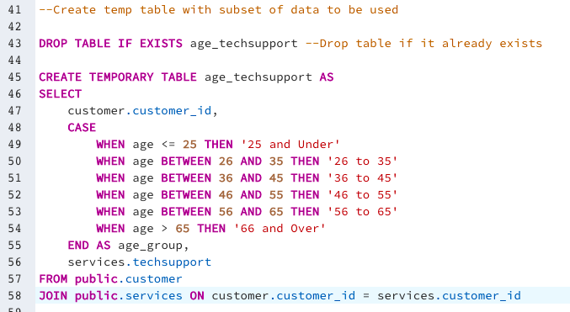A temporary table was created using a SELECT query to join the customer table and services table and add the age groups for the analysis (Figure 3). A temporary table was chosen so that multiple queries could be run against a smaller subset of data to increase processing speed during the analysis.

Figure 3: SQL query to create a temporary table with the subset of data to be used for the analysis.

A query was then run on the temporary table to count the number of customers in each age group who have tech support services, as well as the total number of customers in each age group and the percent with tech support services (Figure 4). This query resulted in a data table summarizing the number and percent of customers with tech support services in each age group (Table 1).

*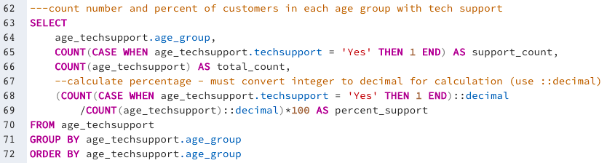Figure 4: SQL query to determine counts for analysis.*

Table 1: Summary of tech support services for each age group.

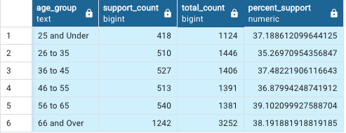

**C1. CSV File(s)**

A file called “queryoutput.csv” was attached and submitted with the performance task.

1. **Add-on File**

The add-on file should be acquired and refreshed in the database quarterly. Based on the results of the analysis, older and younger customers purchase tech support services about evenly. This relationship is unlikely to change drastically weekly or monthly. Therefore, reassessing this relationship quarterly should be sufficient to inform sales teams of any changes in trends that may impact marketing and sales strategies moving forward. In addition to refreshing the information quarterly, the file should be acquired and refreshed after deployment of any new technology to determine if there was a change in tech support demand from customers coinciding with the release of the new technologies.

1. **SQL Script**

The PSQL tool (PostgreSQL, 2022c) and the code below can be used to import the data.

|  |
| --- |
| \copy public.services (customer_id, internetservice, phone, multiple, onlinesecurity, onlinebackup, deviceprotection, techsupport) FROM '/Users/kelseyannwright/Desktop/WGU/D205/Data_Original/Services.csv' DELIMITER ',' CSV HEADER; |

1. **Panopto Video**

A Panopto video was attached and submitted with the performance task. The link can also be accessed here: <https://wgu.hosted.panopto.com/Panopto/Pages/Viewer.aspx?id=7bb9634f-6b21-4005-8231-afbc00a83d89>

1. **Web Sources**

Sewell, W. (2021). Churn Tables [CSV files]. Western Governors University.

<https://westerngovernorsuniversity-my.sharepoint.com/personal/william_sewell_wgu_edu/_layouts/15/onedrive.aspx?id=%2Fpersonal%2Fwilliam%5Fsewell%5Fwgu%5Fedu%2FDocuments%2FDocuments%2FD205%2FChurn%20Tables&ga=1>

1. **Sources**

PostgreSQL. (2022a). Entity relationship diagram (ERD) tool documentation. <https://www.pgadmin.org/docs/pgadmin4/development/erd_tool.html>

PostgreSQL. (2022b). Import/export data dialog documentation. <https://www.pgadmin.org/docs/pgadmin4/development/import_export_data.html>

PostgreSQL. (2022c). PSQL tool documentation. <https://www.pgadmin.org/docs/pgadmin4/6.18/psql_tool.html>