**Analyzing Website Traffic**

Kelsey Thompson

Colorado State University Global

MIS370: Web Analytics

March 24, 2024

Dr. Justin Bateh

Here is a 1-6 list of my conversions for clarity:

I conducted the following analysis in Excel on the dataset [BounceRates.xlxs](https://csuglobal.instructure.com/courses/88504/files/6218721?wrap=1):

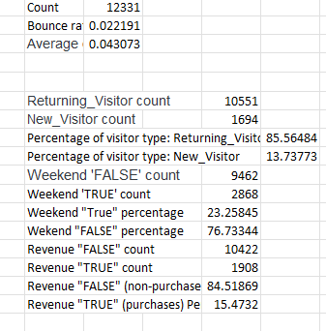

1. For the average bounce rate I received the following from =AVERAGE(G2:G12331):

.022191

1. For the average exit rate, I utilized =AVERAGE(H2:H12331) and received the following:

.043073

1. Using a pivot table and leveraging Excel for the best analysis of this data, I found the percentage of revenue based on a Special Day. See the last collum, which is highlighted.

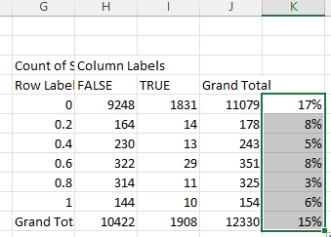

1. The percentage of purchases vs. non-purchases was found by, first the COUNTIF function. Then the percentage of each.

|  |  |
| --- | --- |
| Revenue "FALSE" Percentage | 84.51869% |
| Revenue "TRUE" Percentage | 15.4732% |

1. The percentage of visitor type was found by, first the COUNTIF function. Then the percentage of each.

Returning_Visitor: 85.56484%

New_Visitor: 13.73773%

1. The percentage of weekend visits was found by, first the COUNTIF function. Then the percentage of each.

|  |  |
| --- | --- |
| Weekend "TRUE" percentage | 23.25845% |
| Wekend "FALSE" percentage | 76.73344% |

Summery:

I analyzed the dataset in Excel, named BounceRates.xlxs. Several insights have emerged. This dataset encompasses variables like Administrative, Informational, and ProductRelated pages visited, along with BounceRates, ExitRates, PageValues, and SpecialDay proximit. The average bounce rate across our website stands at approximately 2.22%, indicating a small percentage of visitors leave without further engagement. Additionally, the average exit rate is around 4.31%, suggesting a slightly higher rate of visitors exiting the website from specific pages after visiting them.

Using the COUNTIF function in Excel, I calculated the percentage of purchases versus non-purchases. The analysis revealed that 84.52% of visits resulted in no revenue, while 15.47% led to revenue-generating transactions. Further segmentation based on visitor types showed that returning visitors constitute approximately 85.56% of all visits, with new visitors accounting for around 13.74% of the total.

Regarding visitation patterns, 23.26% of visits occur on weekends was founded, while the majority, 76.73%, take place on weekdays. Furthermore, I calculated the percentage of revenue based on a Special Day, which can be seen in the last column of the table, highlighted for clarity.

Based on these findings, several recommendations can be made to optimize our business and digital marketing strategies. Firstly, efforts should focus on reducing bounce and exit rates by enhancing website usability, content relevance, and page load times. Secondly, targeted marketing campaigns could be tailored towards returning visitors, leveraging their loyalty and familiarity with our brand to drive repeat engagement and conversions, specifically on weekdays (which had higher activity than weekends). Leveraging data-driven insights, personalized offers and recommendations can be presented to visitors based on their browsing behavior, preferences, and previous interactions with our website.

Furthermore, ongoing monitoring and analysis of key performance indicators (KPIs) such as bounce rates, exit rates, and revenue conversion rates are essential to track the effectiveness of implemented strategies and identify areas for further optimization. Analyzing correlations could also facilitate more informed decision-making. For example, we could explore whether there's a correlation between the number of product-related pages visited and the bounce rate, or between the time spent on informational pages and the likelihood of making a purchase. By continually refining updates and marketing campaigns, based on data-driven insights, we can enhance the overall user experience, increase conversion rates, and drive sustained revenue growth.