Data Distribution Analysis
Kelsey Thompson
Colorado State University Global
MIS 445: Statistics in Business Analytics
Professor Mark Bateh
January 7, 2023 (turned in)

Data Distribution Analysis
For this assignment, I will conduct summary statistics and z-score tests on the dataset SASHHELP.BASEBALL, narrowing down to the variable, Salary.
- Here are all of the Basic Statistics in my Summary Statistics, after selecting instructed percentiles and creating a Plots, Histogram and Box Plots:
- Here is the simple, Summary statistics on the variable ‘Salary’ only.

- Here is the Summary Statistics with the specified Percentiles, the Histogram and Box Plot:
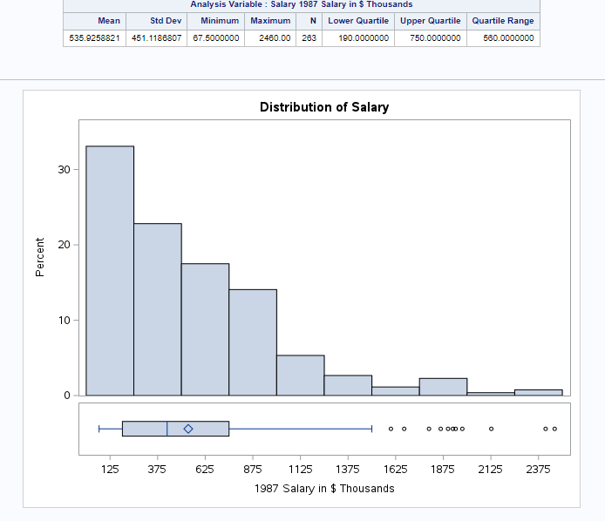
- I used the the ‘proc sql’ to calculate the z-scores for the Salary variable. Here is my ‘proc sql’ code followed by a screenshot of the z-scores output (on page 4).
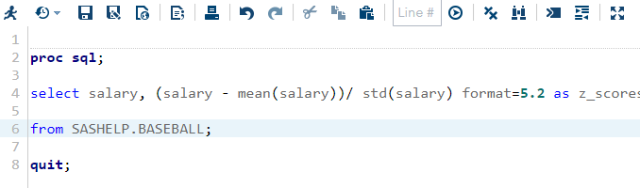

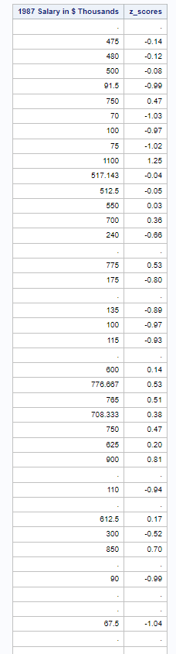
- To interpret the results from the Summary Statistics tests, I included an ordered summary of the Z-scores results, the numbers, Box Plot, Histogram and Summery Statistics. Here is an analysis on my integrated findings from steps 1 and 2:
The z-scores test identifies outliers in baseball players' earnings, with specific individuals earning significantly more than the average. The dataset reveals both missing data and a prevalent trend of high earnings in the baseball industry. Visual analysis through a box plot and histogram highlights a rightward skew, indicating a concentration of players with relatively lower earnings and a tail of outliers earning substantially higher. Summary statistics provide additional insights, revealing that 25% of players earn below 190, 75% below 750, and the majority below 1.500.000, as shown in the box plot. Key statistics include a Mean of 535.9258821, Standard Deviation of 451.1186807, Minimum of 67.5000000, Maximum of 2460.000, and N of 263.

