**Portfolio Project: Relational Database Development**

Kelsey Thompson

Colorado State University Global

MIS407: Database Concepts

Dr. Mario Missakian

June 8, 2024

# **Project Goals**

The Johnson Video Store is transitioning to a relational database for efficient record-keeping. Understanding their operations reveals that videos and DVDs represent copies of movies rented out separately, sourced wholesale from various distributors. Pricing varies based on shipment quantity and past transactions. Each video, DVD, and movie has unique identifiers. The database will track rental transactions, customer charges, and rental preferences, including actors, genres, and awards. It will also store basic customer information. The system must accommodate unlimited movie rentals (on the sale order) and personnel involved in movie production. Excluded are equipment rentals and sales. The database aims to streamline operations and enhance customer service.

# **Business Questions**

By expanding the retail establishment’s data, analytics empowers them towards invaluable insights for refining strategies, optimizing marketing initiatives, aligning with overarching goals and vision, and fostering continuous product development. This data-driven approach not only enhances customer engagement and satisfaction but also maximizes sale rates.

All considering, here are a few Business questions that can be answered using data analytics:

1. Relevant to management (who tailors the inventory) which genres exhibit the highest rental rates, and how can we adjust inventory to capitalize on these trends?

* The answer is Historical, Adventure, and Horror. This insight can guide marketing promotions to target these best sellers.

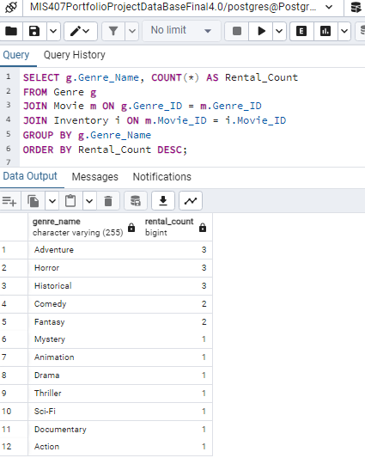

1. Relevant to ownership and marketing, what movie titles have the top rental frequency?

* In this sample database, all movies have been rented once. However, in a real database, this query would provide more insightful data.

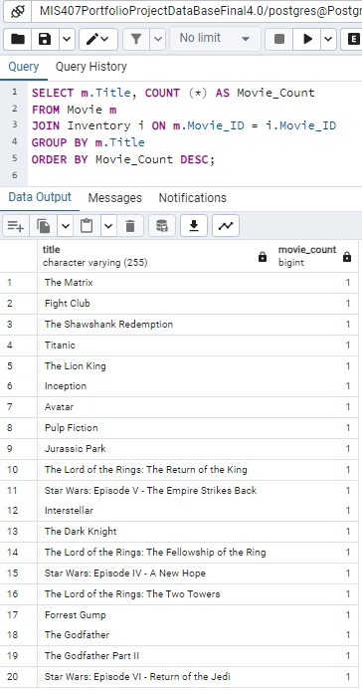

1. Relevant to ownership and marketing, who are the actors or actresses frequently associated with high-revenue movies, and how can we leverage their popularity?

* The first five actors listed can be selected for targeted marketing campaigns.

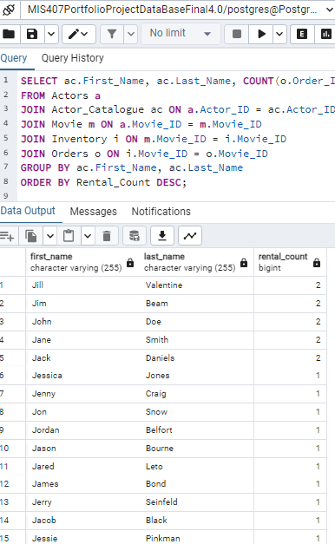

1. Relevant to ownership and marketing, how do customer demographics influence movie preferences?

* In this sample database, all movies have been rented once. However, with a real database, this query would yield more detailed insights.

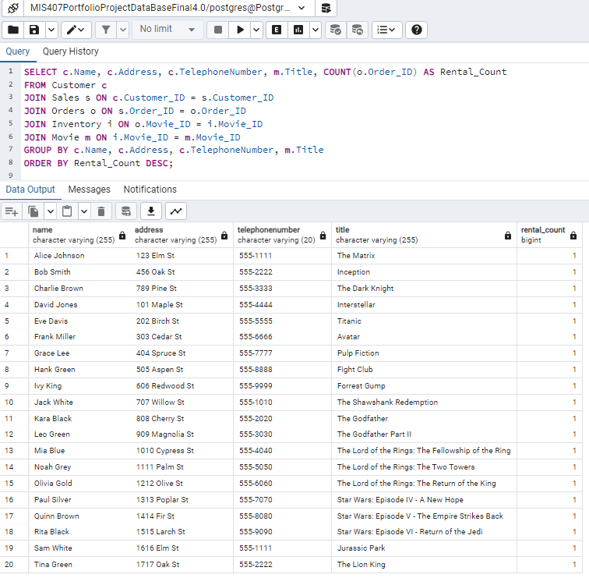

1. Relevant to marketing, complete a customer Retention Analysis by identifying customers who rented at least five times in the last year, indicating potential loyal customers.

* In this sample database, there are no customers who have rented five times in the past year, indicating a need for improved marketing efforts.

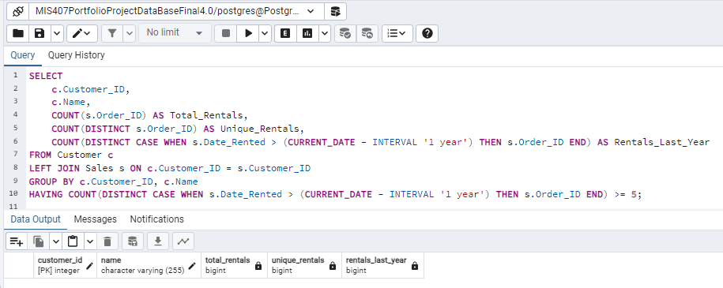

6. Relevant to ownership, which genres exhibit the highest rental rates, and how can we adjust inventory to capitalize on these trends?

* The answer is Historical, Adventure, and Horror. This insight can guide marketing promotions to target these best sellers.

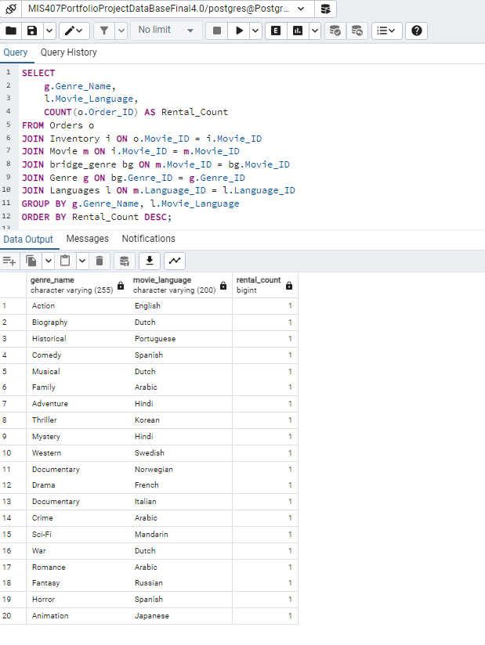

7. Relevant to marketing and management, identify peak rental times by the hour, helping optimize staffing and inventory management during busy periods.

* In this sample database, all movies have been rented once. However, with a real video store, especially in the 1990s, detectable patterns would emerge.

# 

8. Relevant to ownership and management, how many and which movies are in stock that are rated 'G'? Keeping an inventory can provide insights into product opportunities for expanding the client base.

* The Lion King is the only movie (out of 20) that is rated 'G'.

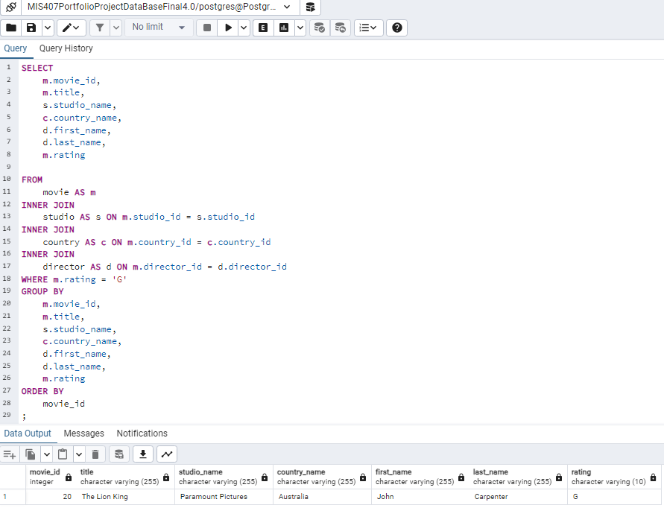

9. Relevant to the business accounting, analyze the sales report to project future profit goals.

* Analyzing 20 sales shows rental sales equating to $413.30 over one month. This sample data suggests higher figures in a real-world scenario.

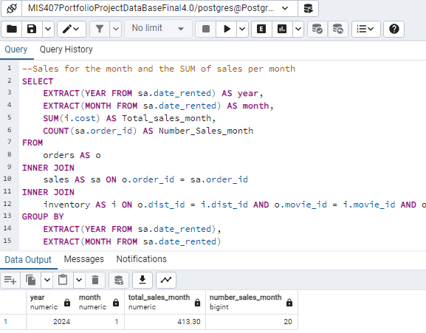

10. Relevant to the business accounting, produce a tax invoice for an order, including cost and taxes.

* The total amount for the sample order is $43.978.

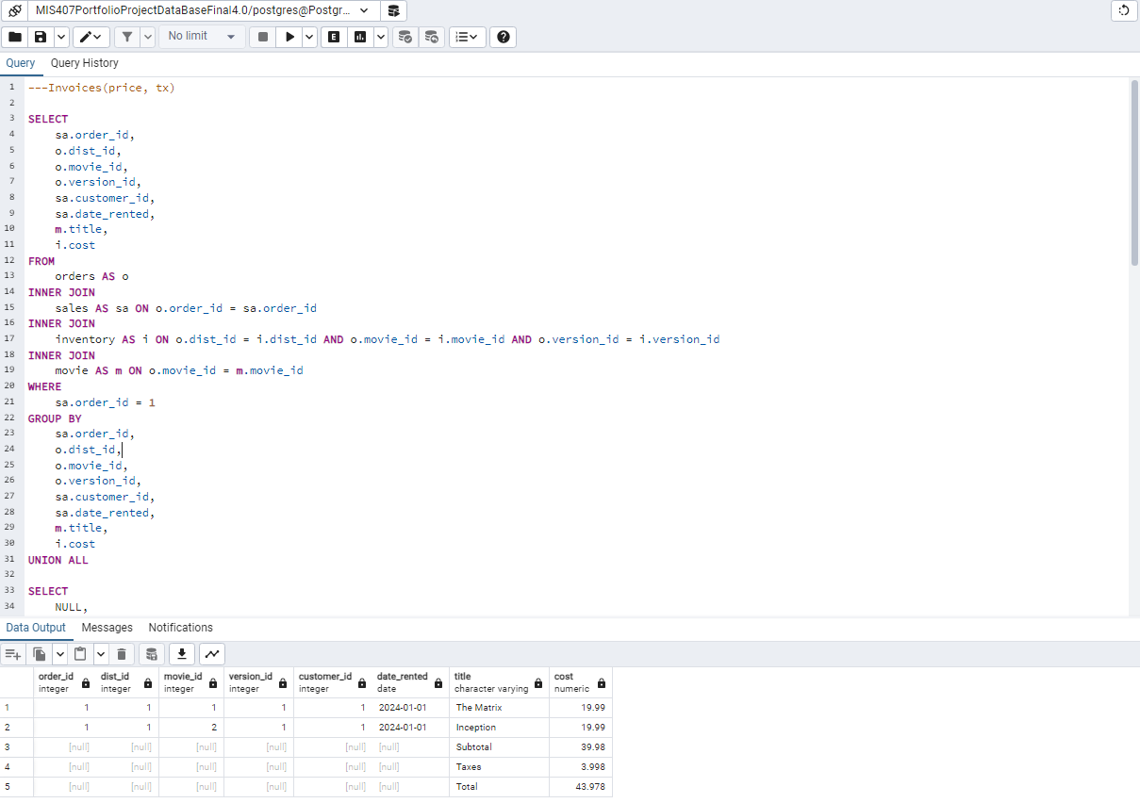

Also, here is the full code:

---Invoices(price, tx)

SELECT

sa.order_id,

o.dist_id,

o.movie_id,

o.version_id,

sa.customer_id,

sa.date_rented,

m.title,

i.cost

FROM

orders AS o

INNER JOIN

sales AS sa ON o.order_id = sa.order_id

INNER JOIN

inventory AS i ON o.dist_id = i.dist_id AND o.movie_id = i.movie_id AND o.version_id = i.version_id

INNER JOIN

movie AS m ON o.movie_id = m.movie_id

WHERE

sa.order_id = 1

GROUP BY

sa.order_id,

o.dist_id,

o.movie_id,

o.version_id,

sa.customer_id,

sa.date_rented,

m.title,

i.cost

UNION ALL

SELECT

NULL,

NULL,

NULL,

NULL,

NULL,

NULL,

'Subtotal',

SUM(i.cost) AS Total

FROM

orders AS o

INNER JOIN

sales AS sa ON o.order_id = sa.order_id

INNER JOIN

inventory AS i ON o.dist_id = i.dist_id AND o.movie_id = i.movie_id AND o.version_id = i.version_id

WHERE

sa.order_id = 1

GROUP BY

sa.order_id

UNION ALL

SELECT

NULL,

NULL,

NULL,

NULL,

NULL,

NULL,

'Taxes',

SUM(i.cost) * 0.1 AS Taxes

FROM

orders AS o

INNER JOIN

sales AS sa ON o.order_id = sa.order_id

INNER JOIN

inventory AS i ON o.dist_id = i.dist_id AND o.movie_id = i.movie_id AND o.version_id = i.version_id

WHERE

sa.order_id = 1

GROUP BY

sa.order_id

UNION ALL

SELECT

NULL,

NULL,

NULL,

NULL,

NULL,

NULL,

'Total',

SUM(i.cost) * 0.1 + SUM(i.cost) AS Taxes

FROM

orders AS o

INNER JOIN

sales AS sa ON o.order_id = sa.order_id

INNER JOIN

inventory AS i ON o.dist_id = i.dist_id AND o.movie_id = i.movie_id AND o.version_id = i.version_id

WHERE

sa.order_id = 1

GROUP BY

sa.order_id

;

# **ERD**

Below is my ERD representing 19 tables for a movie store database. All tables share proper relationships.

A data dictionary from the ERD, is documented in an Excel spreadsheet.

# 

# **Metadata**

Every table was carefully created and selected to meet business requirements and support relationships within the database. For example, the M relationships were supported by bridge tables, such as awards, languages, actors, and genres. I also created simple relationships (1:M or M:1). For example, as the studio, director, and country are all connected to the movie table. the customer and dist(tributor) tables also have a 1: M.

* Version - Stores different versions of movies, such as DVD, Blu-ray, or digital, to track inventory variations.
* Studio - Contains information about movie studios, which produce and distribute the movies.
* Country - Lists countries, useful for categorizing movies by their country of origin that funded the production.
* Languages - Holds data about the languages available for movies, allowing customers to choose movies in their preferred language.
* Genre - Categorizes movies into genres like Action, Comedy, Drama, etc., facilitating customer inquiries and inventory organization.
* Director - Stores information about movie directors, providing content details.
* Awards - Contains award information, which can be used to highlight critically acclaimed movies in the store.
* Actor_Catalogue - Lists actors and actresses, aiding employees with customer searches for movies, featuring favorite performers.
* Dist - Distributor details, important for managing the sources and logistics of movie inventory.
* Customer - Stores customer information, essential for handling rentals, purchases, and customer service.
* Movie - One central table, holding detailed information about each movie created.
* Inventory - Tracks the stock of the Video store of different movie versions, ensuring accurate and available inventory management.
* Catalog - Provides details from the distributors’ catalogues representing available movie products for the store to purchase.
* bridge_genre - Connects movies to their genre(s), supporting multi-genre categorization.
* bridge_language - Links movies to available languages, accommodating multilingual movie offerings.
* Bridge_Awards - Associates movies with awards they've won, enhancing the store's marketing and customer recommendations.
* Actors - Connects movies to their cast members, assisting customers locate movies featuring favorite actors.
* Sales - Records rental transactions, tracking rental history, and managing revenue.
* Orders - Manages the details of orders, including any issues such as failure to rewind,

# **SQL Code for Table Creation (DONE)**

View code in the separate, Notepad document. Now, to address considerations like owner preferences, staffing levels and training:

In implementing a new information system for a family-owned video rental store, it's beneficial to tailor the process to the owners' preferences while subtly integrating Agile methodologies and considering the database life cycle. The store is smaller in stature and employee count, providing an opportunity for personalized, one-on-one training. Acknowledging the familial dynamics, my implementation team would introduce Agile principles gently, emphasizing collaboration and adaptability. This aligns with the owners' appreciation for personal engagement and flexibility, allowing adjustments based on the owners' evolving needs and preferences. My goal is fostering a sense of involvement throughout the process.

Training sessions are fundamental for ensuring a smooth system adoption. Customizing sessions to suit the family's schedule and emphasizing personal interaction can enhance engagement and understanding. By providing hands-on learning experiences and encouraging open communication, my team can ensure that family members and employees feel confident about the new system.

Considering the database life cycle, my team will direct the owners through each stage, highlighting the importance of data integrity and security. By involving the owners in the decision-making processes and by clearly communicating the benefits of each phase, we will build trust and confidence in the system's capabilities, laying a solid foundation for future growth. An incremental approach to data migration and training allows the owners to oversee the process and address concerns as they arise, minimizing disruptions.

System integration focuses on aligning the new system with existing processes and technologies, respecting the owners' preferences and unique requirements. Emphasizing flexibility and adaptability ensures that the new system enhances operational efficiency without imposing unnecessary changes, cultivating a positive experience for the owners and their customers.

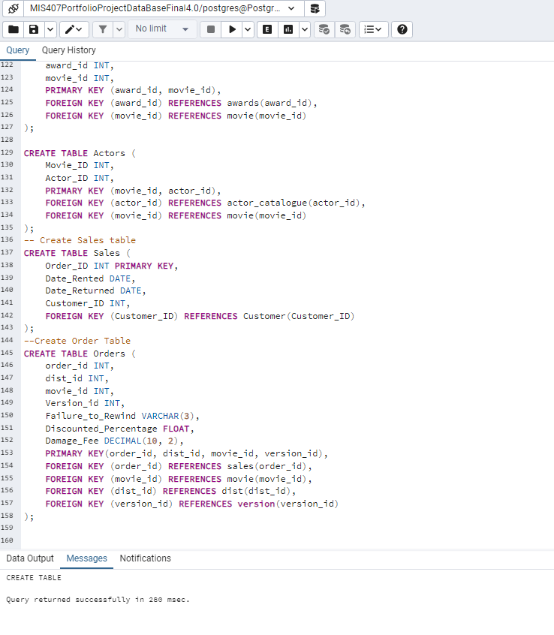

# **SQL Code for Database Seeding**

Here is proof of my INSERT statements, which (the code) can be viewed in full, in a separate Notepad. As well as the Excel workbook containing the information (for good measure). However, you can view that the query was run successful, here:

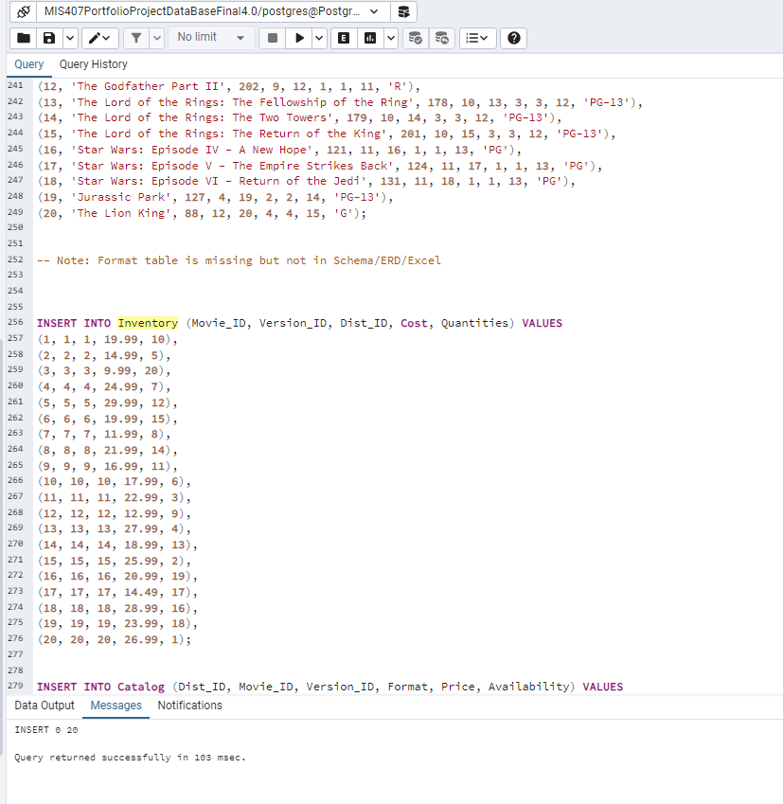

# 

# **Lessons Learned**

As a database consultant, I embarked on a project to develop a database for the Johnson Video Store, which offered invaluable lessons in SQL and database management. Throughout the assignment, I learned the importance of understanding database structuring principles and cardinality relationships. By carefully analyzing the business requirements, I was able to design tables representing various entities such as Version, Studio, and Country, ensuring the database accurately reflected the business's needs.

Moreover, the process of developing the schema and data dictionary from the ERD provided practical experience in translating conceptual designs into concrete database structures. This step involved identifying entity attributes, defining keys, and establishing relationships between tables, all fundamental concepts in SQL database design.

Executing SQL scripts for database creation (DDL SQL) and data population (DML SQL) further enhanced my SQL skills. Creating tables, defining constraints, and inserting data required meticulous attention to detail to ensure data integrity and consistency. Additionally, crafting SQL queries to answer business questions allowed me to apply my understanding of SQL syntax, including SELECT statements, JOIN operations, and aggregate functions, to extract meaningful insights from the database.

Reflecting on the entire process, a strong understanding of how to improve future database development emerged from the lessons learned. It became clear that continuous evaluation and refinement of the database are necessary to adapt to changing business needs. In a real-world scenario, regularly reviewing and optimizing queries can enhance performance and efficiency. Incorporating feedback from users can lead to improvements in database design and functionality. Additionally, staying updated with the latest advancements in database technology can provide new opportunities for optimization and innovation.

Overall, this assignment served as a comprehensive learning experience in SQL, covering database design, implementation, and query optimization. It highlighted the critical role of SQL in managing relational databases effectively and leveraging data to support decision-making processes. The insights gained will undoubtedly inform and improve future database development projects, ensuring they are even more aligned with business needs and technological advancements.

**References**

GeeksforGeeks. (2024, April 30). *How to Design Database Inventory Management Systems.* GeeksforGeeks. [https://www.geeksforgeeks.org/how-to-design-database-inventory- management-systems/](https://www.geeksforgeeks.org/how-to-design-database-inventory-%09management-systems/)

Mannino, M. (2022). *Database design: Design, query, formulation, and administration using Oracle and PostgreSQL*. SAGE Publications. ISBN: 978-1948426954

Valacich, J. S., & George, J. F. (2020). *Modern Systems Analysis and Design (9th ed.)* Pearson Education

# Appendix

MIS307CT5PortfolioCode.txt

MIS407CT5Metadata14.xlsx

MIS407PortfolioINSERTcode.txt

MIS407CT5MetadataDataDictionary.xlsx