Data Replication Assignment

Kelton Sheridan

4/16/2020

The purpose of this paper is to determine where the ceramic sherds(pieces) originated in Ecuador by using Neutron Activation Analysis (NAA). NAA is an chemical analysis that determines the elemental compositions of clay in ceramic sherds. By using this analytical method, it is possible to determine the production centers of these samples of sherds.   
  
In my github repo, I have included the scraped table data from the article (data-reanalysis1.xlsx) as well as the two figures I have replicated (Figure4_ADA & Figure6_ADA).

## Neutron Activation Analysis of Inca and Colonial Ceramics

## from Central Highland Ecuador

library(readxl)  
library(ggplot2)  
library(tidyselect)  
library(dplyr)  
#Reading in the data from table 1 in order to make table 2  
f <- "data-reanalysis1.xlsx"  
ceramic <- read_excel(f, sheet = 1, col_names = TRUE)  
head(ceramic)

## # A tibble: 6 x 31  
## Site No. Al Ca Dy Mn Ti V K Na As U La  
## <chr> <chr> <dbl> <dbl> <dbl> <dbl> <dbl> <dbl> <dbl> <dbl> <dbl> <dbl> <dbl>  
## 1 Spain HUM … 7.7 9.5 4 750 3030 126 1.2 0.95 4.3 1.67 31.6  
## 2 Inca QUI … 11.3 1.3 1.1 271 3670 115 0.6 1.34 5.4 1.86 13.6  
## 3 Panama LAM … 8.8 4.6 1.2 878 3370 160 1.3 1.65 4.4 1.43 25.2  
## 4 Panama LAM … 10 1.9 4.2 1250 2570 111 1.3 1.32 10.7 1.58 28.4  
## 5 Panama QUI … 9.1 1.4 3.5 737 2810 85 1.6 1.49 16.4 2.86 25.5  
## 6 Cuenca IGL … 9.2 0.9 3.1 327 4030 106 0.8 0.99 17.6 1.81 17.7  
## # … with 18 more variables: Yb <dbl>, Sb <dbl>, Sm <dbl>, Ba <dbl>, Ce <dbl>,  
## # Co <dbl>, Cr <dbl>, Cs <dbl>, Eu <dbl>, Fe <dbl>, Tb <dbl>, Nd <dbl>,  
## # Ni <dbl>, Sc <dbl>, Sr <dbl>, Ta <dbl>, Th <dbl>, Hf <dbl>

summary(ceramic)

## Site No. Al Ca   
## Length:53 Length:53 Min. : 7.40 Min. :0.400   
## Class :character Class :character 1st Qu.: 9.20 1st Qu.:2.200   
## Mode :character Mode :character Median : 9.50 Median :2.600   
## Mean : 9.56 Mean :2.687   
## 3rd Qu.:10.00 3rd Qu.:3.400   
## Max. :12.00 Max. :9.500   
## Dy Mn Ti V   
## Min. :1.000 Min. : 271.0 Min. :2380 Min. : 64.0   
## 1st Qu.:1.500 1st Qu.: 653.0 1st Qu.:3020 1st Qu.:103.0   
## Median :2.600 Median : 776.0 Median :3510 Median :127.0   
## Mean :2.487 Mean : 797.3 Mean :3552 Mean :128.5   
## 3rd Qu.:3.100 3rd Qu.: 934.0 3rd Qu.:4000 3rd Qu.:157.0   
## Max. :4.700 Max. :1250.0 Max. :5420 Max. :204.0   
## K Na As U   
## Min. :0.3000 Min. :0.420 Min. : 1.300 Min. :0.430   
## 1st Qu.:0.6000 1st Qu.:1.580 1st Qu.: 2.000 1st Qu.:0.850   
## Median :0.7000 Median :1.850 Median : 3.500 Median :1.300   
## Mean :0.7283 Mean :1.716 Mean : 5.908 Mean :1.325   
## 3rd Qu.:0.8000 3rd Qu.:2.010 3rd Qu.: 6.300 3rd Qu.:1.690   
## Max. :1.6000 Max. :2.310 Max. :22.300 Max. :2.890   
## La Yb Sb Sm   
## Min. :13.60 Min. :0.780 Min. :0.1100 Min. :2.610   
## 1st Qu.:18.00 1st Qu.:1.080 1st Qu.:0.3100 1st Qu.:3.740   
## Median :22.60 Median :1.260 Median :0.4500 Median :4.220   
## Mean :23.43 Mean :1.447 Mean :0.9658 Mean :4.356   
## 3rd Qu.:26.50 3rd Qu.:1.610 3rd Qu.:1.4600 3rd Qu.:4.900   
## Max. :37.40 Max. :3.090 Max. :4.5900 Max. :6.610   
## Ba Ce Co Cr   
## Min. : 410.0 Min. :24.40 Min. : 4.70 Min. : 18.00   
## 1st Qu.: 660.0 1st Qu.:37.10 1st Qu.:10.70 1st Qu.: 34.00   
## Median : 721.0 Median :44.60 Median :15.20 Median : 41.00   
## Mean : 743.7 Mean :46.84 Mean :15.34 Mean : 57.49   
## 3rd Qu.: 828.0 3rd Qu.:55.10 3rd Qu.:19.50 3rd Qu.: 89.00   
## Max. :1360.0 Max. :77.10 Max. :27.30 Max. :115.00   
## Cs Eu Fe Tb   
## Min. : 1.070 Min. :0.700 Min. :2.96 Min. :0.2100   
## 1st Qu.: 2.420 1st Qu.:1.000 1st Qu.:3.85 1st Qu.:0.4800   
## Median : 2.800 Median :1.200 Median :4.33 Median :0.5500   
## Mean : 4.381 Mean :1.147 Mean :4.28 Mean :0.5857   
## 3rd Qu.: 4.160 3rd Qu.:1.300 3rd Qu.:4.75 3rd Qu.:0.6900   
## Max. :18.900 Max. :1.600 Max. :6.13 Max. :1.0200   
## Nd Ni Sc Sr   
## Min. : 5.00 Min. :38.00 Min. : 8.74 Min. : 64.0   
## 1st Qu.:16.00 1st Qu.:43.00 1st Qu.:10.30 1st Qu.:270.0   
## Median :22.00 Median :46.00 Median :13.30 Median :326.0   
## Mean :21.49 Mean :47.32 Mean :13.03 Mean :325.7   
## 3rd Qu.:27.00 3rd Qu.:50.00 3rd Qu.:15.10 3rd Qu.:408.0   
## Max. :37.00 Max. :60.00 Max. :22.80 Max. :731.0   
## Ta Th Hf   
## Min. :0.2300 Min. : 4.100 Min. :3.500   
## 1st Qu.:0.4900 1st Qu.: 5.700 1st Qu.:4.300   
## Median :0.6300 Median : 7.300 Median :5.000   
## Mean :0.6587 Mean : 7.508 Mean :5.183   
## 3rd Qu.:0.8600 3rd Qu.: 8.900 3rd Qu.:5.500   
## Max. :1.2700 Max. :14.400 Max. :9.000

#For all of the cells that has a less than symbol, I made them equal to instead,  
#which may end up changing the results a tiny bit.  
#In order to create Table 2 from the article, I used group_by and summarize to find  
#the means.  
s <- group_by(ceramic, Site) %>%  
 summarize(  
 meanAL = mean(Al),  
 meanCA = mean(Ca),  
 meanDy = mean(Dy),  
 meanMn = mean(Mn),  
 meanTi = mean(Ti),  
 meanV = mean(V),  
 meanK = mean(K),  
 meanNa = mean(Na),  
 meanAs = mean(As),   
 meanU = mean(U),  
 meanLa = mean(La),  
 meanYb = mean(Yb),  
 meanSb = mean(Sb),   
 meanSm = mean(Sm),   
 meanBa = mean(Ba),  
 meanCe = mean(Ce),  
 meanCo = mean(Co),  
 meanCr = mean(Cr),  
 meanCs = mean(Cs),  
 meanEu = mean(Eu),  
 meanFe = mean(Fe),  
 meanTb = mean(Tb),  
 meanNd = mean(Nd),  
 meanNi = mean(Ni),  
 meanSc = mean(Sc),  
 meanSr = mean(Sr),  
 meanTa = mean(Ta),  
 meanTh = mean(Th),  
 meanHf = mean(Hf)  
 )  
 s

## # A tibble: 6 x 30  
## Site meanAL meanCA meanDy meanMn meanTi meanV meanK meanNa meanAs meanU  
## <chr> <dbl> <dbl> <dbl> <dbl> <dbl> <dbl> <dbl> <dbl> <dbl> <dbl>  
## 1 Cuen… 8.17 0.771 3.13 672. 4389. 101. 0.743 0.791 17.0 2.16   
## 2 Inca 11.3 1.3 1.1 271 3670 115 0.6 1.34 5.4 1.86   
## 3 Pana… 9.3 2.63 2.97 955 2917. 119. 1.4 1.49 10.5 1.96   
## 4 Quito 9.71 2.50 2.19 732. 3091. 110. 0.724 1.97 5.39 1.28   
## 5 Riob… 9.93 3.28 2.50 915. 3860. 160. 0.61 1.87 1.98 0.937  
## 6 Spain 7.7 9.5 4 750 3030 126 1.2 0.95 4.3 1.67   
## # … with 19 more variables: meanLa <dbl>, meanYb <dbl>, meanSb <dbl>,  
## # meanSm <dbl>, meanBa <dbl>, meanCe <dbl>, meanCo <dbl>, meanCr <dbl>,  
## # meanCs <dbl>, meanEu <dbl>, meanFe <dbl>, meanTb <dbl>, meanNd <dbl>,  
## # meanNi <dbl>, meanSc <dbl>, meanSr <dbl>, meanTa <dbl>, meanTh <dbl>,  
## # meanHf <dbl>

## Figure 4

## [1] "Site" "No." "Al" "Ca" "Dy" "Mn" "Ti" "V" "K" "Na"   
## [11] "As" "U" "La" "Yb" "Sb" "Sm" "Ba" "Ce" "Co" "Cr"   
## [21] "Cs" "Eu" "Fe" "Tb" "Nd" "Ni" "Sc" "Sr" "Ta" "Th"   
## [31] "Hf"

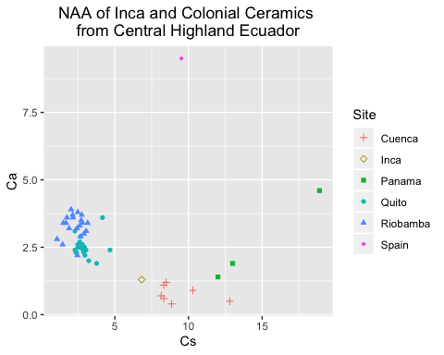

## Figure 6

## [1] "Site" "No." "Al" "Ca" "Dy" "Mn" "Ti" "V" "K" "Na"   
## [11] "As" "U" "La" "Yb" "Sb" "Sm" "Ba" "Ce" "Co" "Cr"   
## [21] "Cs" "Eu" "Fe" "Tb" "Nd" "Ni" "Sc" "Sr" "Ta" "Th"   
## [31] "Hf"

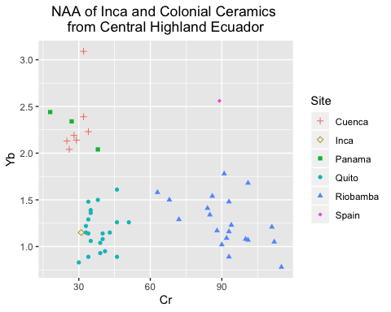

Note that the echo = FALSE parameter was added to the code chunk to prevent printing of the R code that generated the plot.