Automated detection and classification of hollow forms in the Marburg University Forest.
A non-machine learning approach by means of multivariate statistical methods.

Abstract (the end) few lines

1. Introduction

Automation has recently become a buzz-word in Sciences dealing with geographical data (OPITZ – HERRMANN 2018; COWLEY 2012; BENETT – COWLEY – DE LAET 2014). Despite the prejudice against automation (the human eye can see more freely and less restricted, every data is unique in it’s own way) alone in Archaeology and Remote Sensing have seen hundreds of studies published between 2000 and 2015, dealing with automation (LAMBERS – TRAVIGLIA 2016, MAAK – PATERSON 2018). This methodological explosion has unfading relevance, because with the ever renewing data acquisition technologies our data is only becoming bigger and bigger day by day and we need methods which can deal with a huge amount of data.
The main directions of automation are today supervised and unsupervised (data extraction and analysis) in which machine learning or “classical” statistical methods can be applied. Moreover we can also distinguish between pixel- and object based image analysis (SEVARA – PREGESBAUER – DONEUS – VEHOEVEN – TRINKS 2016) which treats the (raster) data either on pixel or segment basis.
In our study we are using semi-automated segmentation to detect hollow forms and classifiy craters, pingen and sinkholes in the Marburg Open Forest (MOF).

Our hypothesis is, that we can automatically detect hollow shapes by segmentation on a sinks only model (SOM). Further we estimate that we can classify the hollow shapes by similarities using multivariate statistics (ordination and cluster analysis) on data of several artificially layers generated from a LiDAR-based DEM. Our remote sensing approach is based only on derivates of a single DEM.

2. Methods

2.1 Remote sensing approach

2.1.1 Data preprocessing

To generate data for the multivariate Statistic approach we need extracted pixel-values of different parameters for each hollow shape. To extract the values we first we need to detect and segment the hollow shapes and generate several artificially layers as parameters.
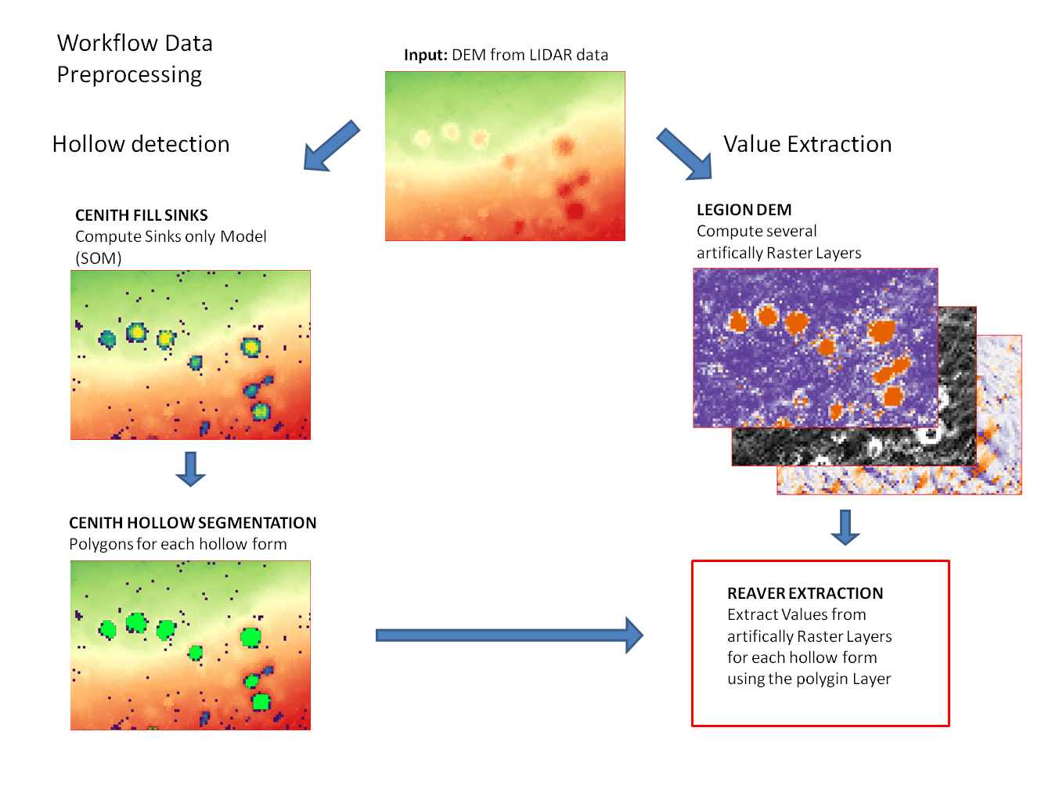
Fig. 1: Remote sensing workflow “data preprocessing”

For the data preprocessing workflow (see fig X) a DEM for the target area is generated from LiDAR data (Hessisches Landesamt 20xx) with a resolution of 0.5 meters. Following we calculate a ‘sinks only elevation model’ (SOM) by subtracting a filled DEM from the DEM using the ‘CENITH fillsinks’ function (Schönberg 2019). Further we perform a segmentation on the SOM using the ‘CENITH hollow segmentation’ function (Schönberg 2019) to generate polygons representing the hollow shapes. The function requires parameters for the moving window and is able to erase polygons by size of the area. To improve the results of the segmentation we created validation points (supervised hollow shape position) for each hollow shape and used the ‘CENITH hollow validation’ function to get information about the hit-rate (correct detected), over- and under-segmentation and receive the best parameters for ‘CENITH hollow segmentation’. We set the minimum and maximum area size according to the typical area size of desired objects in the input DEM. In the next step we compute several artificial raster-layers from the DEM by using the ‘LEGION dem’ function containing geomorphometrics (slope, aspect, curvature) and Skyview-factor (visible sky svf and related parameters).
Finally we extract the values from the artificial-layers for the polygons using the ‘Reaver extraction’ function (Schönberg 2019). Because the ordination requires single values for each parameter the function calculates the standard deviation, mean, sum, minimum and maximum for every artificial layer per polygon.

2.1.2 Multivariant Statistics approach

For the classification of hollow shapes by similarities we need training-datasets for each hollow shape class (crater, pingen and sinkholes) as well as test-datasets to verify the performance. Finally we need a dataset of the Mof for the prediction.
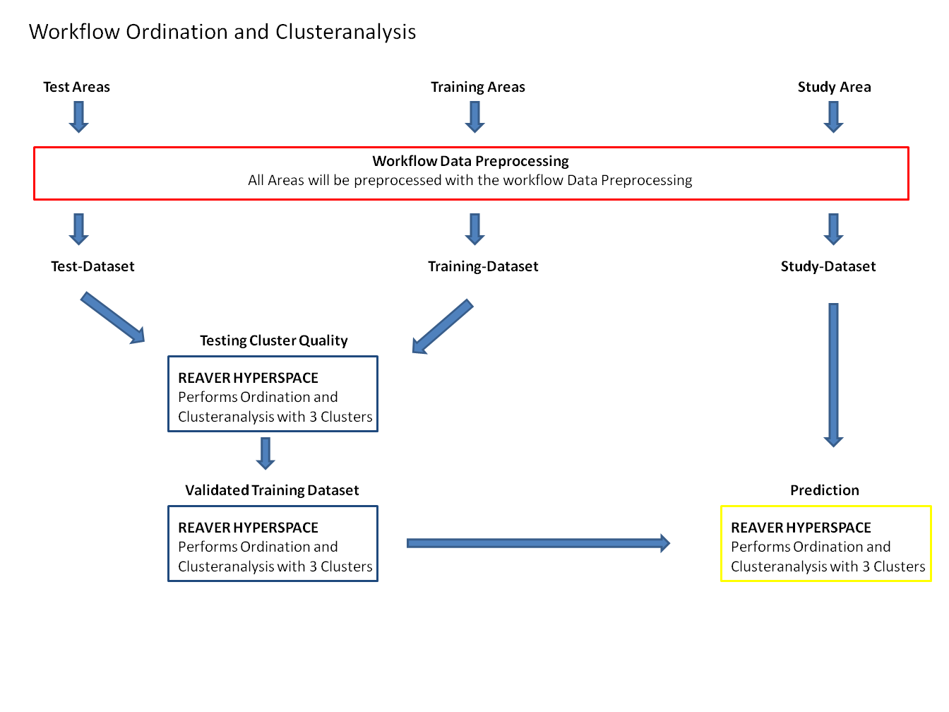
Fig. X: Workflow “ordination and cluster-analysis approach”

First we need areas where the hollow shape classes occur and can be separated to ensure that the extracted values represent the defined class. For the crater class we choose the Lahnberge because here we estimate hollow shapes to be explosion craters from the bombardment of the Marburg train-station in World War Two. For sinkholes we choose an area in Bad Driburg due to the vast occurrence of limestone. To extract pingen we choose Neu Anspach where plenty well documented historic mining activities took place. The test-areas where selected near the training-areas for each class.

The areas of each class run through the data preprocessing to generate the datasets. In the following we perform an ordination and cluster-analysis using the ‘Reaver hyperspace’ function (Schönberg 2019) to assign the objects into three clusters using hierarchic clustering (HC) and K-means clustering. To further visualize the similarities of the Objects the function computes a nmds and dca ordination. We estimate that the three classes are sorted in the three clusters due to similarities of the extracted vales. To check the quality of the clusters we investigate how many objects of a single class are assigned to a cluster. When most objects of a class are assigned to one cluster we estimate it to be the classes representing cluster. We estimate that objects from other datasets (where the class is unknown) which are more similar to the objects of a representing cluster can be assumed as this class. For testing the cluster-quality we combined the training-dataset with each test-dataset and descriptively verified how well the known class of the test-dataset is assigned to the correct cluster.

Finally we generate a dataset for the area of interest (Mof) and perform ‘Reaver hyperspace’ to predict the class of the hollow shapes detected in the area. Statements about the precision of the prediction are based on the test results.

2.2 Field Methods
To validate the outcome of the remote sensing approach, ground truth is required by field investigation. First it had to be understood how these hollow forms can be described and what specific features and attributes have to be expected. According to these specific characteristics, the field methods have been chosen.

2.2.1 Distinction of hollow forms
2.2.1.1 Crater
This specific hollow form is created by bomb detonation, which results in an artificially dense layer beneath, produced by high compression (NAGY 2015, RAJU – GUDEHUS 1994, AMBROSINI – LUCCIONI 2007). NAGY defines various crater-zones (Figure X, after NAGY 2015, Fig. 1.). The original crater boundary (1) ist overlayed by a fall-back zone (2), which is consisted by the material which trickled back into the hollow form after the explosion. Under the fall-back zone lies the rupture region (3), damaged by the explosion. The closing area of the hollow form is the plastic zone (4), compressed by the detonation. This constitutes the most characteristic attribute of a bomb crater. Another descriptive feature is the ejecta (5), lumbing annularly around the hollow form. Zone 2, 3 and 4 are missing under a pinge (depression resulting from mining) or sinkhole.
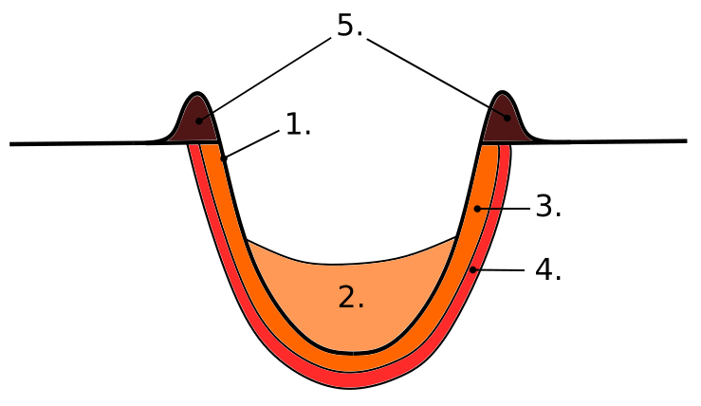
Figure X. The anatomy of a bomb crater.

2.2.1.2 Pingen
Pingen are wedge-, ditch- or funnel-shaped depressions in the terrain caused by mining activity, which can be traced back even to neolithic times (HUSKE 2006). Their layout is caused by the collapse of an underground depletion or quarrying area, which is near to the surface (BISCHOFF – BRAMANN 1988).
Pingen are extrinsicly hard to differentiate from bomb crater, because they can also depict an annular lumbing-area, as crater do. Furthermore, pingen can have steep or shallow embankment and their fill can be loose (ZEILER – GOLZE 2015, 368, Abb. 4.). On the other hand usually multiple pingen appear in a smaller area, sometimes even hundreds (KEMPA 2014, 212). What really differentiates pingen is, that anthropocentric traces can be found in their vicinity, like cart track or any traces of transportation from the pinge.

2.2.1.3 Sinkholes (Doline)
Such as pingen, sinkholes are also depressions in the ground, caused by the collapse of the karstic surface layer. This said, sinkholes are the result of karst processes (ZEPP 2014 ), that is the solution of carbonate rocks or suffusion processes and appear only in karstic regions (LARD – PAULL – HOBSON 1995). Sinkholes can be extremely variable in size, reaching from 1 to multiple hundred meters and also in form, being of natural origin. The lack of an annular lumb around the struture is a clearly distinguishing feature from crater and pingen.
According to the geological map hollow forms ID15 & ID19 are located in an area where slab-lime (Plattenkalk) is mapped. Therefore also sinkholes have been taken into consideration for possible hollow forms in the MOF.

2.2.2 Used field methods
To manually classify hollow forms in the field, two methods have been selected, which were found to be the most adapt to assess the geomorphological specificity of the outcome of the hollow detection (see 2.1.1) in the MOF).
The first method consisted of a 1 m core drill (“Pürckhauer”) to produce core profiles. For the second method, a DPL-5 Dynamic Probe Light (”Künzelstab”) was used to measure the density of the soil. Additionally general attributes (like form or features) of the hollow forms were described.
In our FOI (Field of Interest) the geological map shows limestone for certain hollow forms, so their substrate has been tested on chalk by a solution of 90 % water and 10 % hydrochloric acid.
The Dynamic Probe Light was chosen specifically for detecting the different horizons of crater. And the 1 m core drill allowed a more detailed examination of the underground in up to one meter depth.

Other methods (e.g. nivellement of the hollow forms) have been excluded on the basis that geomorpholocial information of the hollow forms like Slope, Aspect and Curvature were possible to extract from the DEM generated from the LiDAR data. Furthermore, pingen and sinkholes cannot be distinguished on the basis of the inclination of their embankment.

2.2.3 Workflow in the field
Therefore, we set a catena of four profiles through the hollow form. One, to get default values of the surrounding area, was taken some meters outside the hollow form. The second one was taken on the rim of the structure, the third in the embankment (half way down) and the last one in lowest point of the hollow form. In certain cases this workflow was adopted to the circumstances.

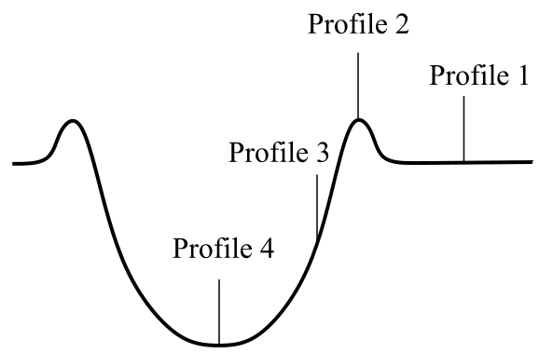
Figure X. Scheme of field workflow.
On each profile, the DPL-5 and the core drill was used. Once in every hollow form, the ground material was tested with HCl for existing limestone.

3. Restults 2 pages
3.1 Automation (Andi, Jan) end-results (quadruple map with tests)

We hypnotized that we can detect hollow shapes by using a SOM. With validation points and tuned parameters for ‘CENITH hollow segmentation’ we reach 100% hit-rates for hollow shapes in each area. Further we hypnotized that we can classify the hollow shapes by an ordination and cluster-analysis.

As seen in Fig X hierarchic clustering (HC) returns clear results by assigning most craters in the first cluster, most pingen in the second cluster and all sinkholes in the third cluster. The K-means clustering does not return clear results. The craters and pingen are assigned together in one cluster while the sinkholes are devided into two cluster.

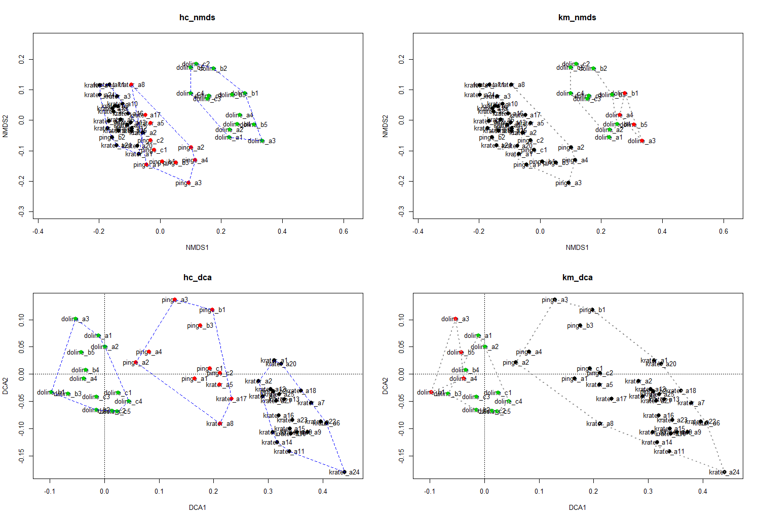

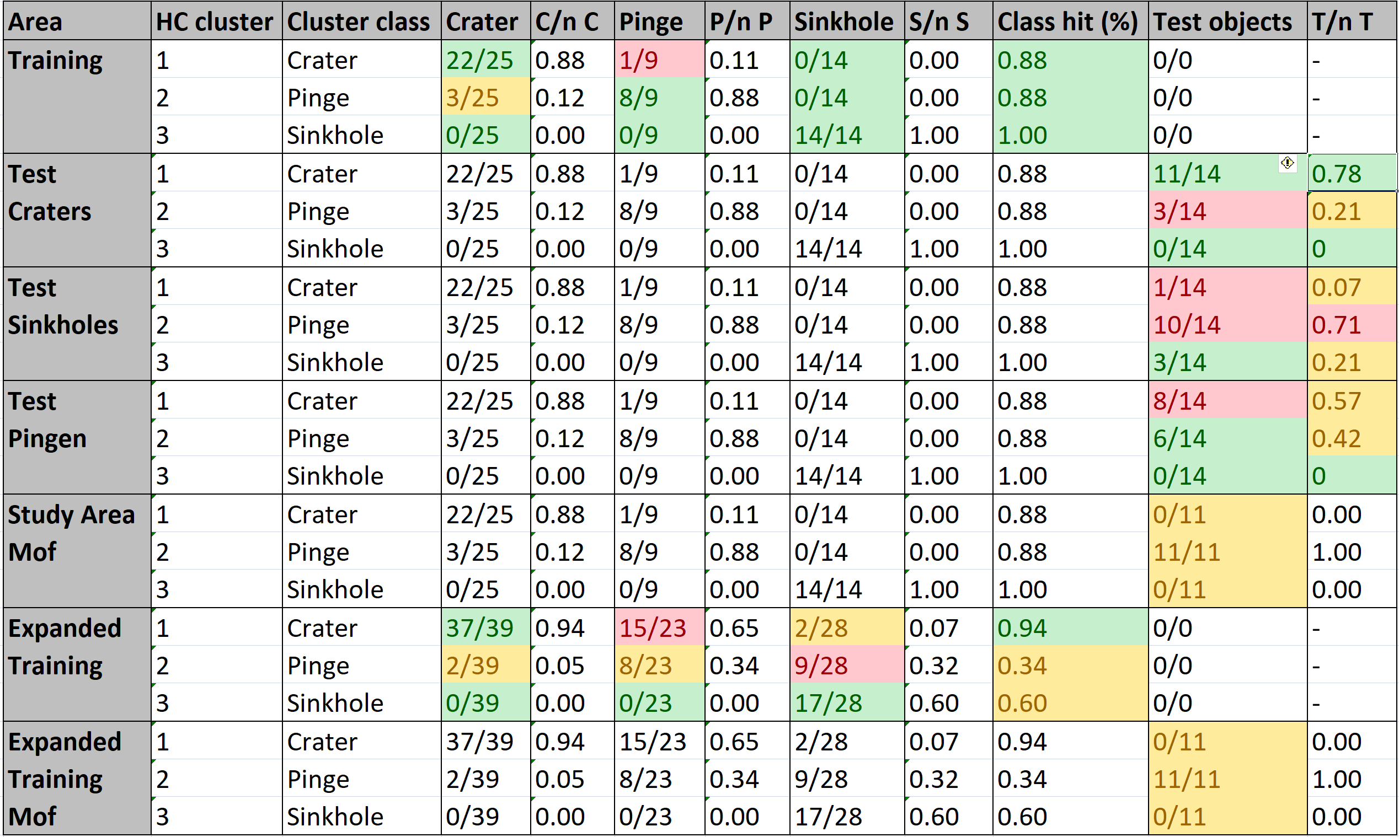

Result Ordinatetion cluster analy – eine 4er grafik km vs hc
Result test als tabelle
Result final prediction als bild + werte

3.2 Field methods
3.2.1 Results of Field campaign
We were equipped with the core drill (“Pürkhauer”) and the DPL-5 (“Künzelstab”) and HCl (10% solution). In total, seven hollow forms have been examined.

3.2.2 Expected vs. Experienced – a critical approach
3.2.2.1 Results
Conclusively we can say the following about the hollow forms detected in the MOF.
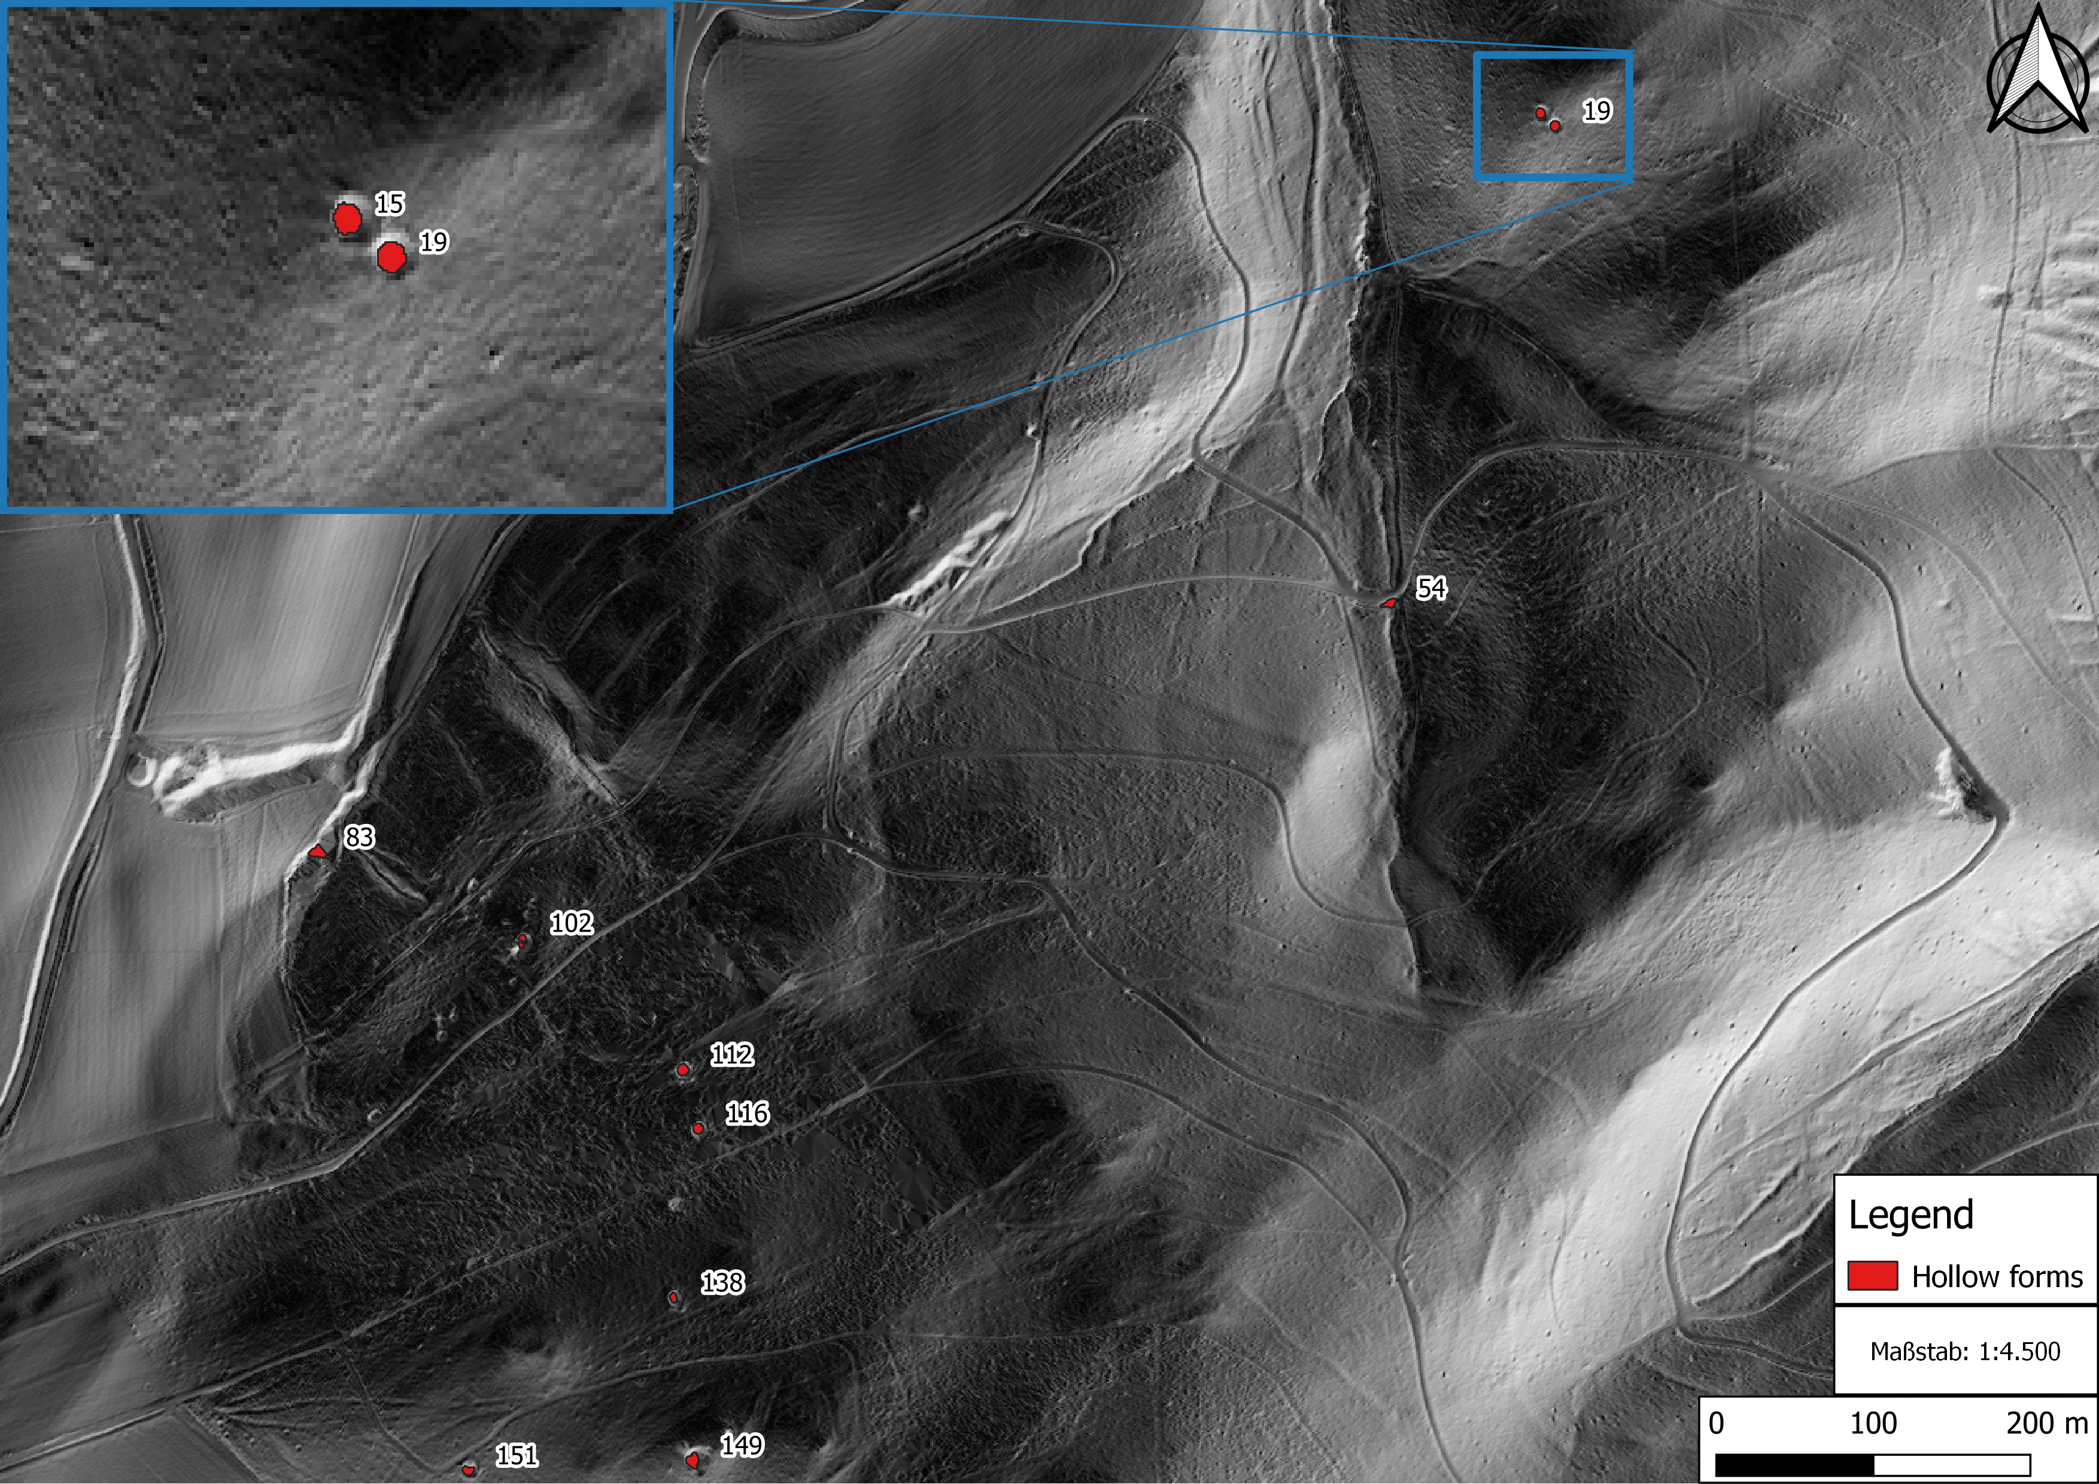
Figure X. The position of the examined hollow forms in the MOF. Data basis: Hillshade from LiDAR.

On the basis of the results of the DPL-5 and the 1 m core drill it was possible to identify 4 craters. As expected in most cases the 4th profile brought the best result regarding the structure of the hollow forms. For our case study the supposed crater have been selected for discussion (Figure X.).
In the case of Hollow Form ID 112.4 the plastic zone can be discerned very clearly around 60-70 cm depth. Hollow Form ID 116 shows two possible plastic zone areas, around 20 - 30 cm and 110 to 140 cm. ID112 and ID 116 lie respectively next to each other, still they present different profiles. In case of ID116 the question can be posed if the plastic zone is situated at already 20 to 30 cm or as we suppose in 110 to 140 cm depth and in the region between 20 to 30 cm the DPL-5 pushed through a stony area or a smaller stone and that is why the results are like this.
ID 138 can be interpreted as crater structures, but the results are less clear as in the previous cases. ID 138.3 shows between 100 and 140 the supposed plastic zone.
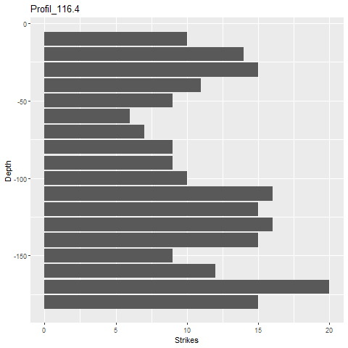
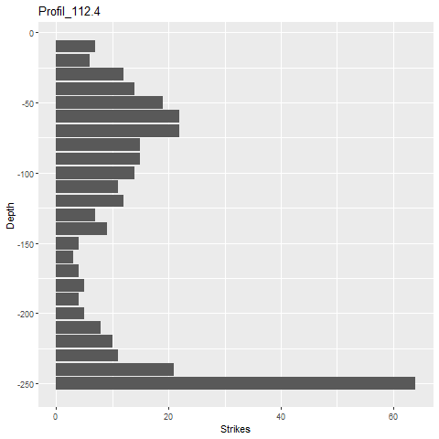
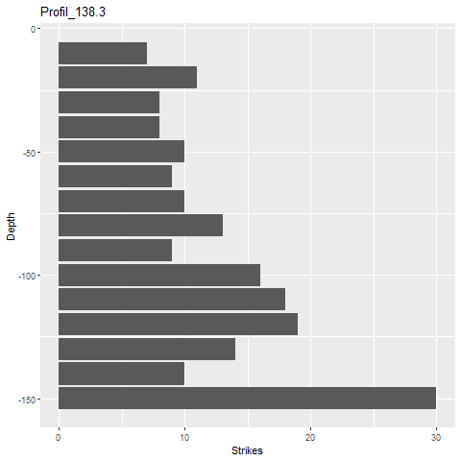
Figure X. DPL-5 profiles of the supposed crater.

ID151 on the other hand can be excluded as crater, because there is no trace of an extensive and dense zone through the profiles (Figure X). Additionally the annular lumb is incomplete. Thus we postulate that in this case we are dealing with a sinkhole.
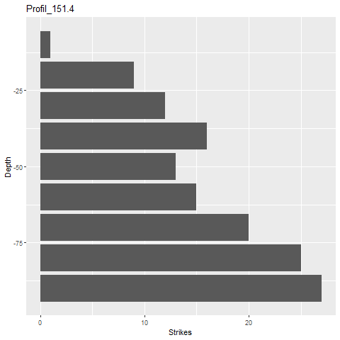
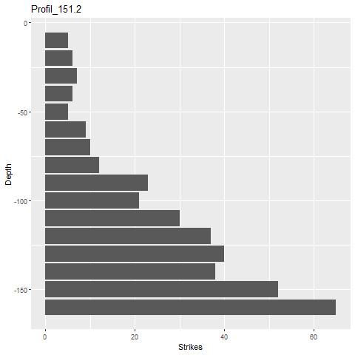
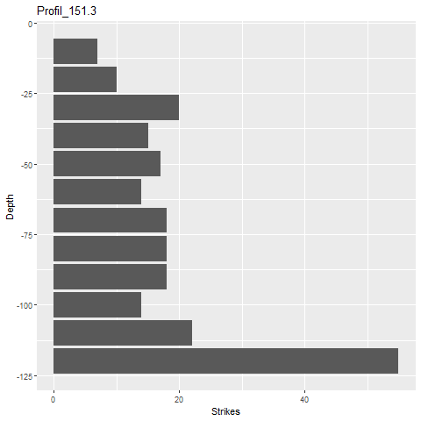
Figure X. DPL-5 profiles of the supposed sinkhole with ID 151.

The hollow forms with ID 15 & ID 19 have been tested with HCl and has been found non-calcareous, thus there are no dolines in the MOF.

4. Discussion 0,5 pages

4.1 Automation

4.2 Field Method
On account of the field work it has been understood, that different crater zones (classification taken from NAGY 2014) appear in different depth of the structures, because these different zones have different dimensions, e.g. thickness, because of the topographic position of the hollow forms. This means, that e.g. near to a summit the dimensions of the zones will be smaller.
Concerning the definition of the different hollow forms in the accessible literature, these are often not clearly set. It is often assumed that the reader clearly knows how a certain hollow form looks like, but if one would like to gather the scientific definition, attributes and specification of those structures, there is not much to find (exception are the crater). This makes it difficult to find appropriate field approaches which deliver clear data for the classification of hollow forms.

The 1 m core drill proved not to be as effective as estimated. From the 23 drill profiles 60 horizons have been documented, 31 were empty. The present horizons were often only 2-3cm thick in the drill. There was no drill profile which was complete. 8 drill profiles were completely empty.
In the case of the supposed craters (fall-back zone) it is understandable, but it is a phenomenon which occurred in all documented hollow forms.
The DPL-5 was the method which delivered the best results, but in certain cases it was not applicable, e.g. in the case of ID149, which was full of stones. Additionally in the summit area it was difficult to reach deep(er), because the shallow soil thickness.

5. Outlook 0,5 pages
Possible solution approaches to detected problems
- age of trees

Supporting Information/Appendix (extra document)
Fact Sheet Hollow Form ID112, Hollow Form ID113,
Tabelle mit Künzelstabergebnissen & Abbildungen
Foto: Agnes mit Equipment

6. References
AMBROSINI – LUCCIONI 2007
Ambrosini, D., – Luccinoi, B., Craters produced by explosionas above the soil surface. In: Elaskar, S. A., – Pilotta, E. A., – Torres, G. A., (Eds.) Mecánica Computactional, Vol XXVI, 2253-2266.

BENETT – COWLEY – DE LAET 2014
Bennett R., – Cowley D., – De Laet V., 2014. The data explosion: tackling the taboo of automatic
feature recognition in airborne survey data. Antiquity 88: 896–905. DOI:
10.1017/S0003598X00050766

BISCHOFF – BRAMANN 1988
Bischoff, W., Bramann, H., Westfälische Berggewerkschaftskasse Bochum. In: Das kleine Bergbaulexikon. Essen, 1988.

COWLEY 2012
Cowley D, C., In with the new, out with the old? Auto-extraction for remote sensing archaeology. In: Bostater C.R, – Mertikas S.P., – Neyt X., – Nichol C., – Cowley D.C., – Bruyant, J.B., (Eds.) Remote Sensing of the Ocean, Sea Ice, Coastal Waters, and Large Water Regions 2012. Proceedings of SPIE 8532 Edinburgh: SPIE; 853206-1. DOI: 10.1117/12.981758

HUSKE 2006
Huske, J., Die Steinkohlenzechen im Ruhrrevier. Deutsches Bergbaumuseum. Bochum, 2006.
KEMPA 2014
Kempa, M., Albvorland-Eisenland. Mittelalterliche Eisenhütten zwischen Reutlingen und Nürtingen. Stuttart, 1988.

LAMBERS – TRAVIGLIA 2016
Lambers, K., – Traviglia, A., Automated detection in remote sensing archaeology: a reading list. AARGnews 53 (September 2016) 25-29. https://a-a-r-g.eu/ Publications tab

LARD – PAULL – HOBSON 1995
Lard, L., – Paull, C., – Hobson, B. "Genesis of a submarine sinkhole without subaerial exposure". Geology. 23, 10 (1995) 949–951.

MAAK – PATERSON 2018
Maack, K. H. R., – Paterson, D., Systematic literature review on automated monument detection: A remote investigation on patterns within the field of automated monument detection. In: Matsumoto, M., – Uleberg, E., (Eds.) Oceans of Data. Proceedings of the 44th Conference on Computer Applications and Quantitative Methods in Archaeology 2016. Oxford, 2018.

NAGY 2015
Nagy, N. M., Numerical Evaluation of Craters Produced by Explosions on the soil Surface. Special Issue of the International Conference on Computational and Experimental Science and Engineeering (ICCESEN 2014). ACTA PHYSICA POLONICA A 128 (2015) 2-B, B260-B266.

OPITZ – HERRMANN 2018
Opitz, R – Herrmann, J. 2018. Recent Trends and Long-standing Problems in Archaeological Remote Sensing. Journal of Computer Applications in Archaeology, 1(1) 19–41, DOI: https://doi.org/10.5334/jcaa.11

RAJU – GUDEHUS 1994
Raju, V. R., – Gudehus, G., Compaction of loose sand depositsusing blasting. In: Proceeding of the 13th International Conference on Soil Mechanics and Foundation Engineering, New Delhi, 1994, 1145–1150.

SEVARA – PREGESBAUER – DONEUS – VEHOEVEN – TRINKS 2016
Sevara C., – Pregesbauer M., – Doneus M., – Verhoeven G., – Trinks I., Pixel versus object – a
comparison of strategies for the semi-automated mapping of archaeological features using
airborne laser scanning data. Journal of Archaeological Science. Reports 5, 485–498. DOI:
10.1016/j.jasrep.2015.12.023

ZEPP 2014
Zepp, H., Geomorphologie. Eine Einführung. Grundriss Allgemeine Geographie. UTB Band 2164. Stuttgart, 2014.

ZEILER – GOLZE 2015
Zeiler, M., – Golze, R., Montanarchäologische Untersuchungen an der Grube Gottessegen am Kindelsberg, Kreis Siegen-Wittgenstein. Ausgrabungen und Funde in Westfalen-Lippe 12 (2015).
https://www.academia.edu/22384357/Zeiler_and_Golze_2015_-_Montanarch%C3%A4ologische_Untersuchungen_an_der_Grube_Gottessegen_am_Kindelsberg_Kreis_Siegen-Wittgenstein_-_AFWL

