Automated detection and classification of hollow forms in the Marburg University Forest.
A non-machine learning approach by means of multivariate statistical methods.

Max. 5 pages

Abstract (the end) few lines

1. Introduction (Agnes) max. 0,5 page

Relevanz in Archäologie neuer ansatz feld und

Was und wo wird Untersucht - Untersuchungsgebiet

Hypothesis formulated at the end of the Introduction
Interne Validierung und Feldvalidierung durch ground thruth, feldmethode

DEM, SOM,

2. Methods 2 pages
2.1 Automation (Andi, Jan)
Figure Flowchart of Workflow. IMPORTANT!!!!!
2.1.1 Detection of hollow forms (quadruple map)
2.1.2 Choice of Variables
2.1.3 MVS (plots in results)
2.1.4 Description of training dataset (from where, what, why that data?)

2.2 Field Methods (Chris, Agnes)

To validate the outcome of remote sensing approach, ground truth is required by field investigation.
First it had to be understood how these hollow forms can be described and what specific features and attributes have to be expected. According to these specific characteristics, the field methods have been chosen.

2.2.1 Distinction of hollow forms (what to expect)
2.2.1.1 Crater
This specific hollow form is created by bomb detonation, which results in an artificially dense layer beneath, produced by high compression (NAGY, 2014, RAJU – GUDEHUS 1994, AMBROSINI – LUCCIONI 2007). NAGY defines various crater-zones (Figure X). The original crater boundary (1) ist overlayed by a fall-back zone (2), which is consisted by the material which trickled back into the hollow form after the explosion. Under the fall-back zone lies the rupture region (3), damaged by the explosion. The closing area of the hollow form is the plastic zone (4), compressed by the detonation. This constitutes the most characteristic attribute of a bomb crater. Another descriptive feature is the ejecta (5), lumbing annularly around the hollow form. Zone 2, 3 and 4 are missing under a sinkhole/depression resulting from mining (“pinge”) or dolina.
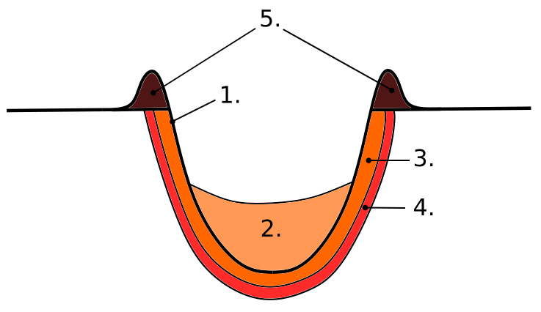
Figure x. The anatomy of a bomb crater.

Asdgh,

In the case of bomb crater the “Künzelstab” was used, to detect the high dense horizon. The “Pürckhauer” allowed a more detailed examination of the underground in up to one meter depth.

2.2.1.2 Pinge

2.2.1.3 Doline

2.2.2 Used field methods (why)
*”Pürckhauer” = 1 m core drill
*”Künzelstab” = Leichte Rammsonde (DPL-5, Dynamic Probe Light)

To manually classify hollow forms in the field, two methods have been selected, which were found to be the most adapt to assess the geomorphological specificity of the outcome of the hollow detection (see 2.1.1) in the Marburg University Forest.
The first method consisted of a 1 m core drill to produce core profiles. For the second method, a DPL-5 Dynamic Probe Light was used to measure the density of the soil. Additionally general attributes (like form or features) of the hollow forms were described.
In our FOI (Field of Interest) the geological map shows limestone for certain hollow forms, so their substrate has been tested on chalk by a solution of 90 % water and 10 % hydrochloric acid.

Why did we not use other methods? Nivellement e.g.

3. Restults 2 pages
3.1 Automation (Andi, Jan) Endresults (quadruple map with tests)
3.1.1 Test with Crater
3.1.2 Test with Pingen
3.1.3 Test with Doline
3.1.4 Prediction MUF

3.2 Field methods (Chris, Agnes)
3.2.1Results of Field campaign
3.2.2 Expected vs. Experienced – a critical approach
3.2.2.1 Results
Why do we have these results?
3.2.2.2 Problems with Pürkhauser
3.2.2.3 Problems with Künzelstab

4. Discussion 0,5 pages
4.1 Automation
4.2 Field Method

5. Outlook 0,5 pages
Possible solution approaches to detected problems
- age of trees
- ...

Supporting Information/Appendix (extra document)
Fact sheet Hollow Form (HF) 1, Hollow Form (HF) 2,

6. References

Nagy 2014,

