Title Goes Here

Agnes Schneider1,✉

16 December, 2020

Text of abstract

1 University of Marburg

✉ Correspondence: [Agnes Schneider <[euboia@gmail.com](mailto:euboia@gmail.com)>](mailto:euboia@gmail.com)

Keywords: keyword 1; keyword 2; keyword 3

Highlights: These are the highlights.

# 1 Introduction

Here is a citation (Marwick, 2017)

# 2 Background

# 3 Methods

# 4 Results

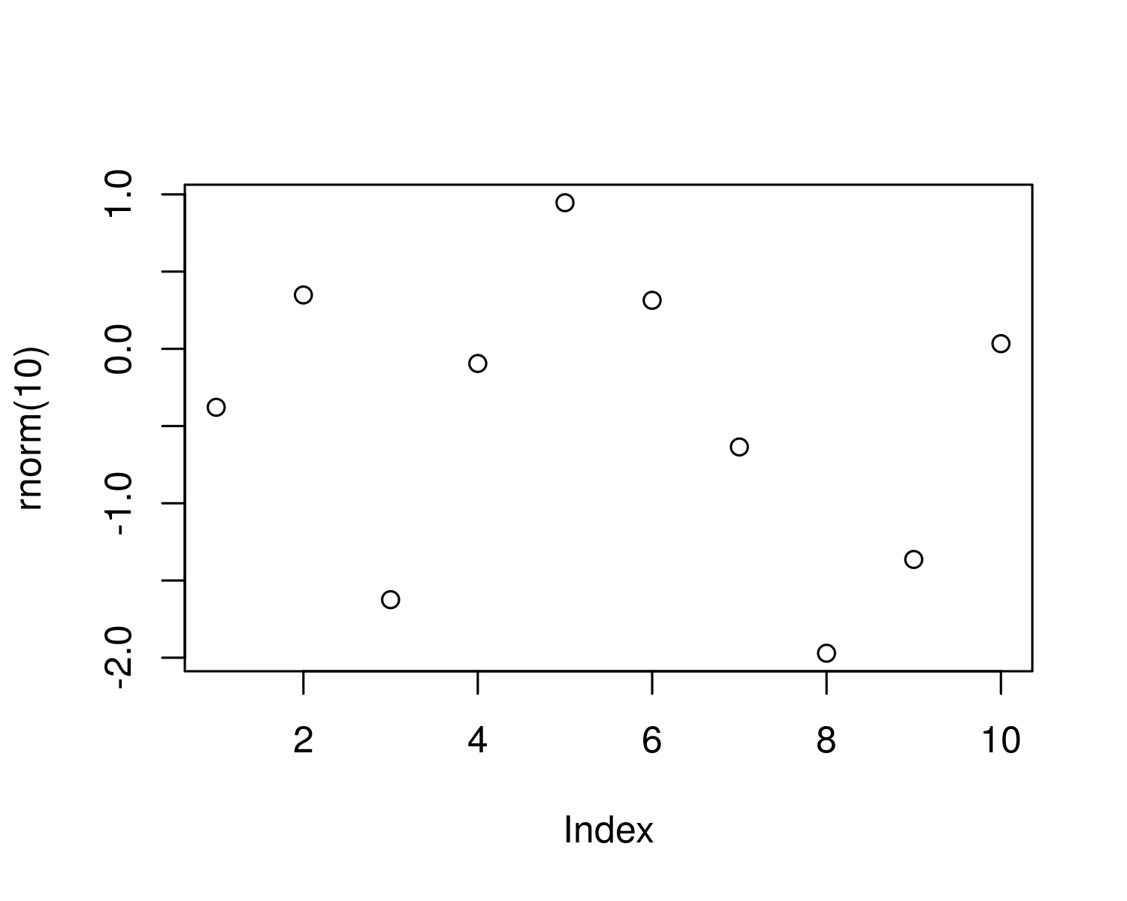

Figure 4.1: A plot of random numbers

Figure 4.1 shows how we can have a caption and cross-reference for a plot

Here is an example of inline code 3.14 in the middle of a sentence.

# 5 Discussion

# 6 Conclusion

# 7 Acknowledgements

# 8 References

Marwick, B., 2017. Computational reproducibility in archaeological research: Basic principles and a case study of their implementation. Journal of Archaeological Method and Theory 24, 424–450. <https://doi.org/10.1007/s10816-015-9272-9>

### 8.0.1 Colophon

This report was generated on 2020-12-16 20:45:40 using the following computational environment and dependencies:

#> ─ Session info ───────────────────────────────────────────────────────────────  
#> setting value   
#> version R version 4.0.3 (2020-10-10)  
#> os Ubuntu 18.04.5 LTS   
#> system x86_64, linux-gnu   
#> ui X11   
#> language en_GB:en   
#> collate en_GB.UTF-8   
#> ctype en_GB.UTF-8   
#> tz Europe/Paris   
#> date 2020-12-16   
#>   
#> ─ Packages ───────────────────────────────────────────────────────────────────  
#> package * version date lib source   
#> assertthat 0.2.1 2019-03-21 [1] CRAN (R 4.0.2)  
#> bookdown 0.21 2020-10-13 [1] CRAN (R 4.0.3)  
#> callr 3.5.1 2020-10-13 [1] CRAN (R 4.0.3)  
#> cli 2.2.0 2020-11-20 [1] CRAN (R 4.0.3)  
#> crayon 1.3.4 2017-09-16 [1] CRAN (R 4.0.2)  
#> desc 1.2.0 2018-05-01 [1] CRAN (R 4.0.2)  
#> devtools 2.3.2 2020-09-18 [1] CRAN (R 4.0.2)  
#> digest 0.6.27 2020-10-24 [1] CRAN (R 4.0.3)  
#> ellipsis 0.3.1 2020-05-15 [1] CRAN (R 4.0.2)  
#> evaluate 0.14 2019-05-28 [1] CRAN (R 4.0.2)  
#> fansi 0.4.1 2020-01-08 [1] CRAN (R 4.0.2)  
#> fs 1.5.0 2020-07-31 [1] CRAN (R 4.0.2)  
#> glue 1.4.2 2020-08-27 [1] CRAN (R 4.0.2)  
#> highr 0.8 2019-03-20 [1] CRAN (R 4.0.2)  
#> htmltools 0.5.0 2020-06-16 [1] CRAN (R 4.0.2)  
#> knitr 1.30 2020-09-22 [1] CRAN (R 4.0.2)  
#> lifecycle 0.2.0 2020-03-06 [1] CRAN (R 4.0.2)  
#> magrittr 2.0.1 2020-11-17 [1] CRAN (R 4.0.3)  
#> memoise 1.1.0 2017-04-21 [1] CRAN (R 4.0.2)  
#> pkgbuild 1.2.0 2020-12-15 [1] CRAN (R 4.0.3)  
#> pkgload 1.1.0 2020-05-29 [1] CRAN (R 4.0.2)  
#> prettyunits 1.1.1 2020-01-24 [1] CRAN (R 4.0.2)  
#> processx 3.4.5 2020-11-30 [1] CRAN (R 4.0.3)  
#> ps 1.5.0 2020-12-05 [1] CRAN (R 4.0.3)  
#> purrr 0.3.4 2020-04-17 [1] CRAN (R 4.0.2)  
#> R6 2.5.0 2020-10-28 [1] CRAN (R 4.0.3)  
#> remotes 2.2.0 2020-07-21 [1] CRAN (R 4.0.2)  
#> rlang 0.4.9 2020-11-26 [1] CRAN (R 4.0.3)  
#> rmarkdown 2.6 2020-12-14 [1] CRAN (R 4.0.3)  
#> rprojroot 2.0.2 2020-11-15 [1] CRAN (R 4.0.3)  
#> sessioninfo 1.1.1 2018-11-05 [1] CRAN (R 4.0.2)  
#> stringi 1.5.3 2020-09-09 [1] CRAN (R 4.0.2)  
#> stringr 1.4.0 2019-02-10 [1] CRAN (R 4.0.2)  
#> testthat 3.0.0 2020-10-31 [1] CRAN (R 4.0.3)  
#> usethis 2.0.0 2020-12-10 [1] CRAN (R 4.0.3)  
#> withr 2.3.0 2020-09-22 [1] CRAN (R 4.0.2)  
#> xfun 0.19 2020-10-30 [1] CRAN (R 4.0.3)  
#> yaml 2.2.1 2020-02-01 [1] CRAN (R 4.0.2)  
#>   
#> [1] /home/keltoskytoi/R/x86_64-pc-linux-gnu-library/4.0  
#> [2] /usr/local/lib/R/site-library  
#> [3] /usr/lib/R/site-library  
#> [4] /usr/lib/R/library

The current Git commit details are:

#> Local: main /home/keltoskytoi/repRCHrs  
#> Remote: main @ origin (https://github.com/keltoskytoi/repRCHrs)  
#> Head: [bd83727] 2020-12-16: settnup