**Applied Machine Learning**

**Assignment 1**

|  |  |
| --- | --- |
| **Name** | YAP LI XEN |
| **Student ID** | P7414389 |
| **Lecturer** | MR. PAUL |

**PART B: REGRESSION**

1. **How is your prediction task defined? And what is the meaning of the output variable?**

* The prediction task is to predict numerical data “price” (house price)
* The output variables “price” is continuous numerical data

1. **How do you represent your data as features?**

* Target: price
* Features: All columns except price



1. **Did you process the features in any way?**

* Feature Selection

1. **Did you bring in any additional sources of data?**

* Nope. Not necessary at this stage

1. **How did you select which learning algorithms to use?**

* Referring to scikit-learn algorithm cheat-sheet recommendation

1. **Did you try to tune the hyperparameters of the learning algorithm, and in that case how?**

* Hyperparameter Tuning: GridSearchCV
* To include a range of values in chosen parameter and assign to param grid
* To set cv to 5 (split the train-validation data into 5 folds)

* Then it will generate the best param and best score

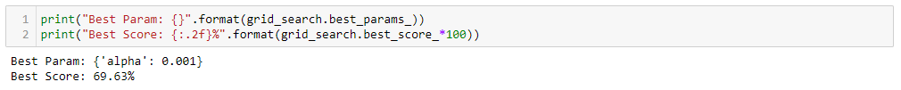

1. **How do you evaluate the quality of your system?**

* Score the trained model using both train data and test data, then compare the result
* We can see how well the trained model can predict the test data
* The comparison can also help us to determine if this is under-fitting, appropriate-fitting or over-fitting

1. **How well does your system compare to a stupid baseline?**
2. **Can you say anything about the errors that the system makes?**

* Using R2 score, it computes the coefficient of determination
* Using Mean squared error

1. **Is it possible to say something about which features the model considers important?**

* Information below shows which features are correlation to the target.

