Multi-Stage AI Workflow Across UX Types
BROOD DataOps - chaining chat, IDE and CLI outputs into one ETL
Applied AI and Prompt Engineering
github.com/kelvee21/lab-multistage-ai-etl

1. The problem
B BROOD Bakery keeps daily operations in hand maintained Excel workbooks, one tab per day, with tab names typed by a person. Across the June files the tabs are named things like "3RD JUNE", "11th june", "12th", and one is called "1OTH JUNE" with the letter o where the digit zero belongs. Headers move between tabs. Some columns hold a per row total, a price or a money value rather than a branch. One dispatch tab has a number sitting above the header row. One waste tab types a branch header with the letters transposed. Many cells are simply empty.
To answer any question about the month somebody copies those tabs into another sheet by hand, lining up branch columns and retyping every number. That is the problem this workflow solves.
The brief asks for a workflow that chains outputs between at least two different AI UX types. This one chains three.

2. The workflow
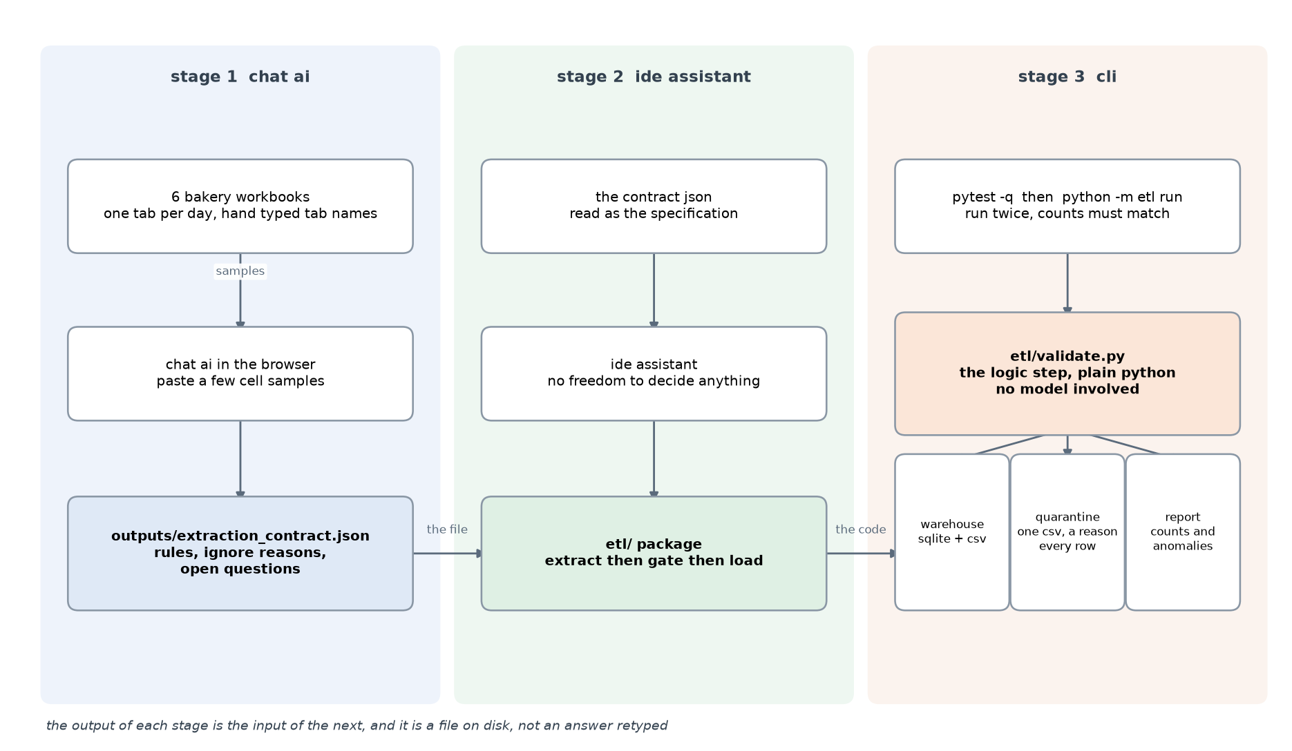
Each stage takes the file the stage before it produced. Stage 1 is a chat AI in the browser. Stage 2 is an assistant in an IDE. Stage 3 is a terminal. Between stage 2 and stage 3 sits a deterministic gate written in plain Python, so no number reaches the warehouse without passing code rather than a model's judgement.
The full diagram in both mermaid and plain text form is in docs/diagram.md in the repo.

3. The three stages, step by step

Stage 1 - a chat AI writes the extraction contract
Input: a short pasted sample of the sheets, never the whole file. Output: outputs/extraction_contract.json.
The contract holds every rule the pipeline needs: conventions for blank cells and for numbers, the branch headers, one entry per source file, which columns to ignore each with a written reason, the rule for the aggregate TOTAL row, a row total cross check, and a list of open questions the model refused to guess about.
The reason this is a file and not just a prompt is that these workbooks contain hundreds of small decisions. Which row is the header, whether a blank cell means zero, whether the bottom TOTAL row is a product. If a model settles those while writing code, the decision is invisible afterwards and can never be checked. In a JSON file every decision is written down, reviewable, and the code simply follows it.

Stage 2 - an IDE assistant builds the ETL from the contract
Input: the contract JSON. Output: the etl/ package. The rule given to the assistant was that the contract is the specification and the code must not decide anything on its own. Where code and contract disagreed, the contract was treated as the bug report.
The package is six modules: contract.py loads and checks the JSON and fails fast, normalize.py does the text, number and date cleaning, extract.py holds the two readers, validate.py is the gate, load.py builds the SQLite star schema and the CSV exports, and __main__.py is the command line entry point.

Stage 3 - a terminal runs it and checks it
Input: the code plus the real workbooks. Output: the run evidence in runs/RUN-LOG.md.
The sequence was: run the test suite, run the pipeline, run it again to prove the second run produces identical counts, read the validation report, then write three independent checks from scratch with no imports from the pipeline itself, so the checks are not the code agreeing with itself.

4. The logic step between the AI stages
A chain of AI calls with nothing in the middle is just a longer prompt. The gate is what makes the numbers trustworthy. It is plain Python in etl/validate.py, with no model and no network.
- Nothing is silently dropped. Every row that cannot be read lands in a quarantine CSV with a machine readable reason and the file and tab it came from.
- Nothing is invented. A blank cell means not recorded. It is never coerced to zero.
- An empty header sitting above real numbers is not loaded, because no header means no column meaning. It is counted as an anomaly so it is not invisible.
- Duplicates are handled differently per fact type, because they mean different things. In a day grid a second row for the same date, product and branch is a data problem and is quarantined. In a sales grid the same bread sold twice at the same branch on the same day is normal, so the rows are summed and a transaction count is kept.
- The warehouse is deleted and rebuilt on every run, so idempotency is a real test rather than a no-op.

5. Results
Numbers below were read from data/processed/validation_report.json.
table | rows
fact_production | 8,616
fact_dispatch | 10,147
fact_waste | 1,232
fact_returns | 0
fact_sales | 689
dim_branch | 16
dim_product | 161
fact rows in total | 20,684

- 20,684 fact rows, rebuilt from scratch on every run.
- 16 branches, being the 14 that appear as column headers plus 2 point of sale locations that only ever appear in the sales files.
- 161 distinct product labels, stored exactly as recorded.
- 4 rows quarantined in total, each with its reason and its source tab.
- 370 informational notes and 95 anomalies recorded in the report.
- Runtime: 6.4 s for this run. Extraction dominates; the gate and the load together are under a second.

6. How the numbers were verified
The test suite builds its own small workbooks in a temporary folder, so it runs on any machine with no bakery data, no network and no key. All 26 tests pass.
Three checks were then written a second time from scratch against the raw files, importing nothing from the pipeline.
- One production day tab was recounted directly from the sheet. The recount and the database agree on the number of observations and on the quantity total.
- Every product row on every day tab of the production workbook was compared against the total the sheet already carries for that row: 1973 rows agree, 0 disagree. Running the same check carelessly, without the branch alias and against the wrong total column, produces hundreds of false alarms, which is what proved the contract needs to pin those choices down.
- For both weekly sales files the recount of the raw grid, the warehouse totals and the workbook's own footer total all agree on quantity and on amount.

7. Adaptability
The chain's state lives in artifacts, not inside any tool. The contract is plain JSON, the pipeline is plain Python, the evidence is markdown and logs. Any tool that can read and write those files can take over any stage, so swapping the chat model, the IDE assistant or the terminal agent changes nothing structural.
More importantly the pipeline never calls a model at runtime. AI is used to build it; the execution is deterministic, which is why running it twice gives the same answer and why it still works in six months with no network.
Adding next month is copying the workbooks in and adding contract entries. The readers key off the contract rather than off file names in the code, so a new branch name or a new column is a one line reviewable change. A new branch that the contract does not know lands loudly in a quarantine rather than being silently mangled.

8. What is still unknown
These were not guessed, and the pipeline does not guess them either. They are recorded as open questions in the contract and counted in the validation report.
- The unit of the day grid quantities is not stated anywhere in the source files. The values are stored exactly as recorded.
- The same bread appears in production without a prefix and in sales with one. This cannot be proven from the data, so both spellings are kept as separate products rather than merged on a guess.
- One source workbook loads zero rows. Every day tab in it is blank with a typed zero in its total column. Whether nothing came back, or returns are recorded somewhere else, is a business question. The source is kept in the run so the gap keeps appearing.
- The day grid files cover only part of the month. There is no tab for the last five days, so the report shows the gap instead of inventing them.
- The two weekly sales files carry a different year from the June files. The values are recorded as the files state them, and the mismatch is reported rather than corrected.

9. Running it
Python 3.12 or newer. Two dependencies, openpyxl and pytest.
python -m venv .venv
.\.venv\Scripts\python.exe -m pip install -r requirements.txt
.\.venv\Scripts\python.exe -m pytest -q
.\.venv\Scripts\python.exe -m etl run
The real bakery workbooks are not in the repository. They are a client's business data, so the raw and processed folders are excluded and the committed documentation carries counts, timings and column names only.

10. How this answers the brief
brief requirement | weight | where it is answered
Workflow chains outputs between at least two AI UX types | core | section 2 and 3, chat to IDE to CLI, three stages
Implemented and tested end to end | 40% functionality | section 5 and 6, pipeline runs on the real files, 26 tests green, running twice gives identical counts
Workflow diagram | 20% documentation | section 2
Clear step by step notes | 20% documentation | section 3, plus the README in the repo
Adaptable to other tools and models | 20% adaptability | section 7, no model at runtime, contract is tool agnostic
Reduces manual effort | 20% efficiency | section 5, a month of hand typed tabs becomes the warehouse in seconds

