TMDB Movie Data Analysis using Pandas and APIs
18 films from the TMDB api, cleaned, ranked and charted

1. Objective
I asked TMDB for 19 movie ids, cleaned what came back into a single analysis table, worked out profit and roi, ranked the set ten ways, ran two cast searches, compared franchises against standalones, and drew 5 charts. Everything below is produced by the code in this repo.

2. Where the data came from
GET /movie/{id} gives budget, revenue, genres, release date and votes. GET /movie/{id}/credits gives the cast list and the crew list, which is where cast, cast_size, director and crew_size come from. I loop the cast list picking name, and the crew list picking the entry whose job is Director.
The brief lists 19 ids. Id 0 is not a real film and the api answers 404, so it is skipped and 18 rows come back. I wait 0.25s between calls to stay under the rate limit. A 429 sleeps 1.5s and retries once. The key lives in .env and is never committed. If there is no key the fetch falls back to a local backup json.

3. Methodology
- Dropped adult, imdb_id, original_title, video and homepage.
- Pulled the collection name out of its dict and joined genres, languages, companies and countries into pipe separated text with a loop.
- Ran value_counts on each joined column before trusting it. On genres it showed that 8 films share the same 3 genres, but the api wrote them in 4 different orders, for example Action|Adventure|Science Fiction and Adventure|Action|Science Fiction. They are one group, not two, so anything comparing genre as whole text would be comparing spelling rather than content. That is why the search and the chart both split on the pipe.
- Turned budget, revenue, id, popularity and votes into numbers and the release date into a date, with errors coerced so bad text becomes empty instead of crashing.
- Treated 0 in budget, revenue and runtime as unknown rather than real, so those become empty. A film with a budget of 0 is a film nobody typed a budget for.
- Where vote_count is 0 the vote_average is meaningless, so it becomes empty. I write this with df.loc on a mask, not df[col].iloc[i], because chained assignment is silently dropped by pandas 3 and the rating would stay put. No film in this set has 0 votes, so a fake record in the test suite covers it.
- Converted budget and revenue to millions of dollars.
- Kept only Released films, then dropped the status column, removed duplicates by id and title, dropped rows with no id or title, and kept rows with at least 10 populated values.
- Reordered to the 22 columns in the order the brief lists and reset the index.
- Added profit and roi, then ranked ten ways, searched twice, grouped franchise against standalone, and drew the charts.

4. Key insights
- Avengers: Endgame is the biggest earner at 2,927.4M, but Avatar makes the most profit at 2,686.7M because its budget is a fraction of the size. Gross and profit are not the same ranking.
- Avatar also has the best return, roi of 12.34 against a budget of 237.0M. The roi column is badly skewed: mean 8.20 against median 7.94 and a maximum of 12.34. One big film drags the mean up, which is exactly why the franchise table below reports the median and not the mean.
- 16 of the 18 films belong to a collection and only 2 are standalones. This is a franchise-heavy set, which limits what any franchise against standalone comparison can prove.
- On that split the standalones show a higher median roi (9.62 against 7.84) but they are two films. 2 against 16 is not a comparison worth drawing a conclusion from.
- The most successful franchise by total revenue is The Avengers Collection with 4 films and 7,904.1M. The top director is James Cameron on 5,187.9M across 2 films.
- Both cast searches return nothing. The Willis search wants Science Fiction and Action with Bruce Willis, the Thurman search wants Uma Thurman directed by Quentin Tarantino, and this set is 18 top grossing films with no Willis film and no Tarantino film among them. That is a property of the sample, not a bug in the search. Widen the id list and both would return rows.
- TMDB popularity and rating do not move together in this set, so popularity is not a usable stand-in for quality. Worth knowing before anyone builds a recommendation list on it.

5. Rankings
The brief asks for ten. roi is filtered to films with a budget of at least 10M and rating to films with at least 10 votes, because small budgets and thin vote counts make both numbers jump around. The top three of each are shown, the notebook has the full list.
ranking | filter | 1st | 2nd | 3rd
1. highest revenue | none | Avengers: Endgame | Avatar | Titanic
2. highest budget | none | Avengers: Endgame | Avengers: Infinity War | Star Wars: The Last Jedi
3. highest profit | none | Avatar | Avengers: Endgame | Titanic
4. lowest profit | none | Star Wars: The Last Jedi | Incredibles 2 | Beauty and the Beast
5. highest roi | budget >= 10M | Avatar | Titanic | Jurassic World
6. lowest roi | budget >= 10M | Star Wars: The Last Jedi | Avengers: Age of Ultron | Incredibles 2
7. most voted | none | The Avengers | Avatar | Avengers: Infinity War
8. highest rated | votes >= 10 | Avengers: Endgame | Avengers: Infinity War | Harry Potter and the Death
9. lowest rated | votes >= 10 | Jurassic World: Fallen Kin | Jurassic World | Star Wars: The Last Jedi
10. most popular | none | Avengers: Infinity War | Avengers: Endgame | Avengers: Age of Ultron

Willis, science fiction and action: 0 matches.
Uma Thurman directed by Quentin Tarantino: 0 matches.
Both are empty for the reason given in the insights. The search logic is exercised by the test suite against fake records that do contain a match, so an empty result here is the data and not the code.

6. Franchise against standalone
Mean revenue, mean budget, median roi, mean popularity and mean rating for the two groups.
group | films | mean revenue | mean budget | median roi | mean popularity | mean rating
franchise | 16 | 1,690.8 | 218.0 | 7.84 | 49.3 | 7.39
standalone | 2 | 1,765.1 | 180.0 | 9.62 | 40.9 | 7.44
roi is the median on purpose. With one large film in a group the mean moves and the median does not, and here the two groups differ by less than the spread inside each of them.

Most successful franchises, by total revenue
franchise | films | total revenue | mean revenue | mean rating
The Avengers Collection | 4 | 7,904.1 | 1,976.0 | 7.96
Star Wars Collection | 2 | 3,402.6 | 1,701.3 | 6.99
Jurassic Park Collection | 2 | 2,982.0 | 1,491.0 | 6.61
Avatar Collection | 1 | 2,923.7 | 2,923.7 | 7.61
Frozen Collection | 2 | 2,727.9 | 1,364.0 | 7.22

Most successful directors, by total revenue
director | films | total revenue | mean rating
James Cameron | 2 | 5,187.9 | 7.76
Joe Russo | 2 | 4,979.9 | 8.25
Joss Whedon | 2 | 2,924.2 | 7.68
Jennifer Lee | 2 | 2,727.9 | 7.22
J.J. Abrams | 1 | 2,068.2 | 7.24

7. Visualizations
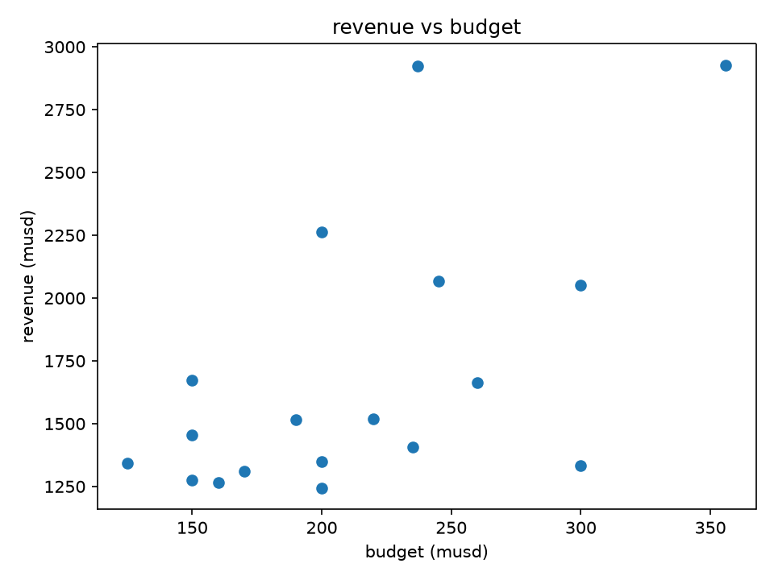
Chart 1. Revenue against budget for the 18 films. The two sit off a diagonal, so bigger budget buys more revenue, but the spread at any budget is wide.
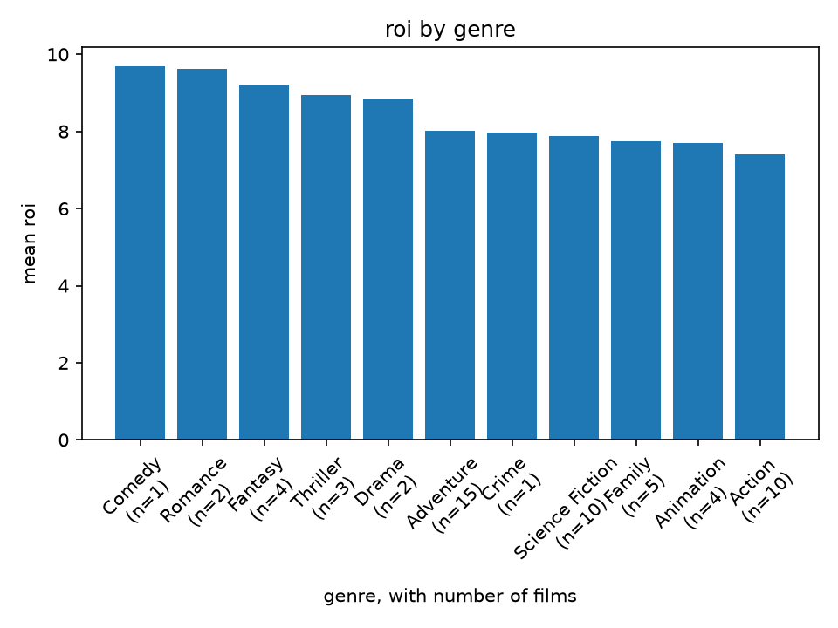
Chart 2. Mean roi by genre, sorted, with the film count on each label. Read the n= first: Comedy and Crime rest on a single film, so those two bars are not a finding. Adventure, Science Fiction and Action are the only genres with a sample worth reading.
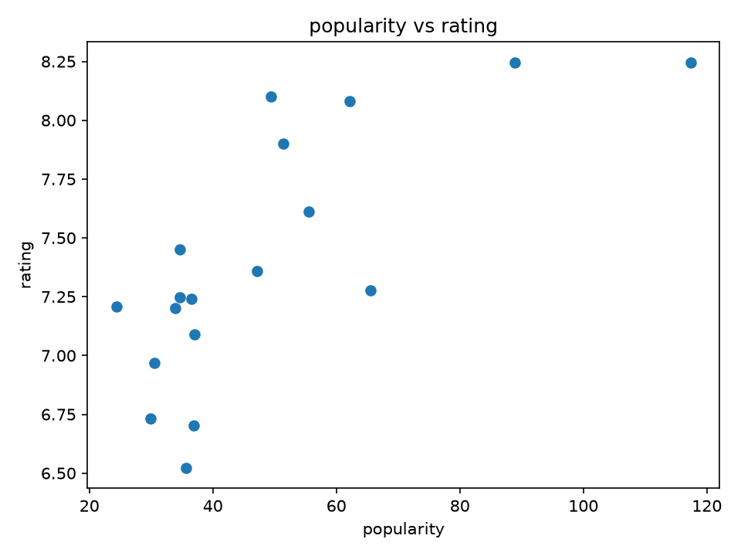
Chart 3. Popularity against rating. The two barely move together, so TMDB popularity is not a proxy for quality.
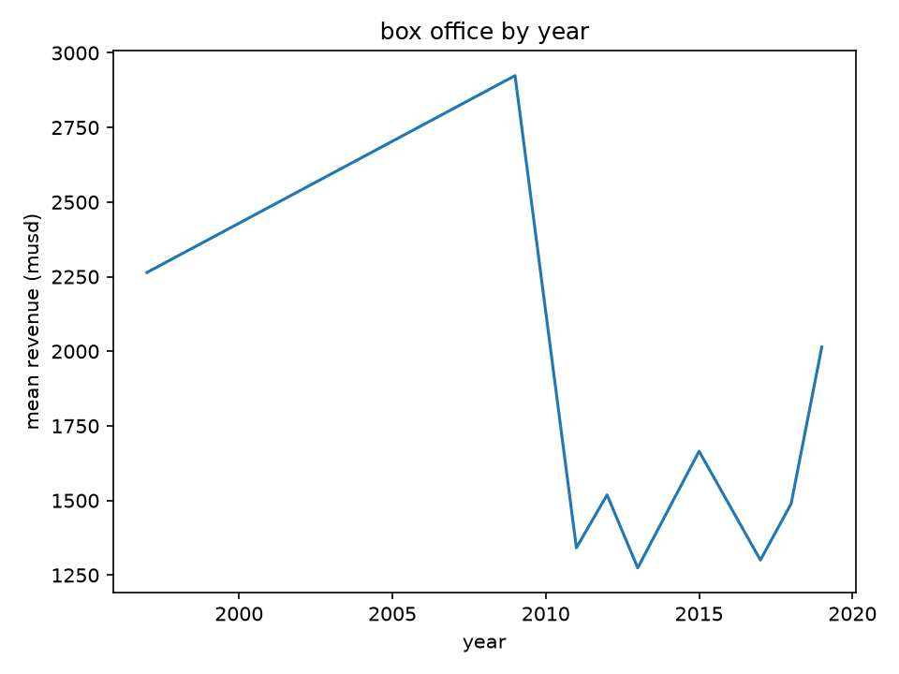
Chart 4. Mean revenue per release year. The set is chosen by box office, so later years look stronger purely because of selection.
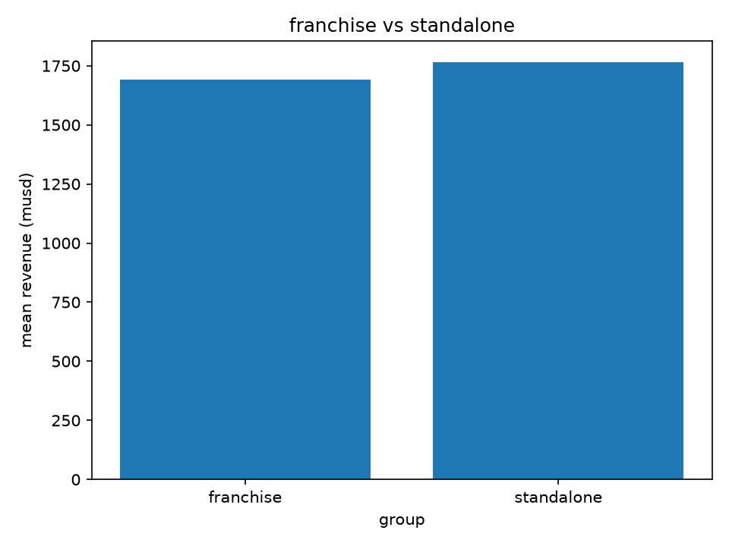
Chart 5. Mean revenue, franchise against standalone. Standalones edge it, but there are only two of them against sixteen.

8. Limitations
- 18 films is a small set and it is not a random sample. It is the brief's id list, which is heavy on modern blockbusters, so every conclusion here is about big films and nothing more.
- Four of the eleven genres rest on two films or fewer, so the genre chart is descriptive only. The counts are printed on the chart for that reason.
- Both cast searches return empty, so neither search path is demonstrated on the real data. The test suite covers the matching logic against fake records.
- roi is undefined for any film with no budget recorded. Those rows are excluded from roi rankings rather than treated as zero.
- The backup json is not committed, so a clone without an api key still runs the whole test suite against synthetic records, but cannot rebuild this report's numbers.

9. How to run it again
pip install -r requirements.txt
copy .env.example to .env and put your key in
pytest
python tmdb_client.py
python app/main.py
open analysis.ipynb and run it top to bottom

