Cheat-Sheet to Import OneNote Pages to Basket

Pre-Requisites (On OneNote machine)
You need to extract xml version of OneNote Pages. For this, you could either use a small GUI tool called DevPal (explained below); or you could script using OneNote Powershell Provider (See: http://bdewey.com/2007/07/18/onenote-powershell-provider/)
Install OneNote DevPal add-in from http://flimflan.com/blog/OneNoteDevPal.aspx. After installation, you will see DevPal button on the OneNote Toolbar:
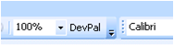

Steps to Import OneNote Pages to Basket

Exporting OneNote Pages
- Open OneNote and navigate to the page which needs to be exported to Basket
- From the OneNote toolbar, click on ‘DevPal’ icon. DevPal will popup with a window and will show the page content in XML
NOTE: If DevPal popup isn’t visible, click on its app Icon on Taskbar:
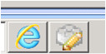
NOTE: Give sometime for OneNote DevPal to come with xml data. For large OneNote page, it may even take couple of minutes!
- In DevPal window, make sure to select xml for XML Display option of “Page”
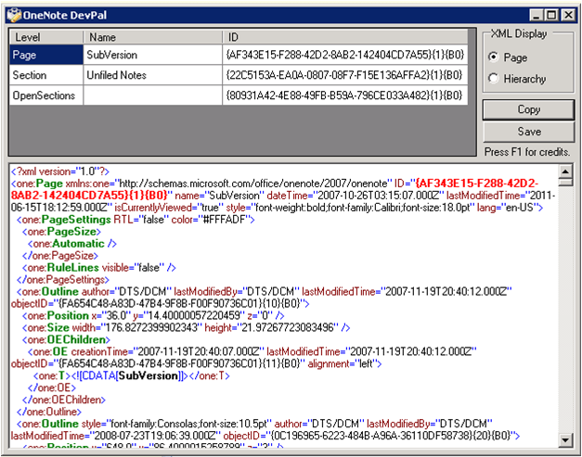
- Save the xml to file
- Ship the xml file to machine with Basket for import.

Importing OneNote XML
- From the Basket menu, click on Import → OneNote
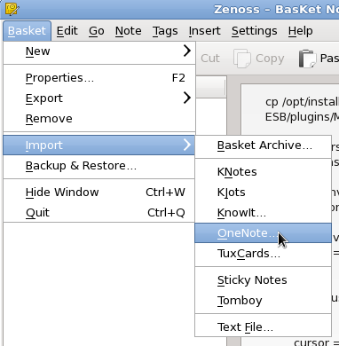
- This will bring pop-up to select the XML file
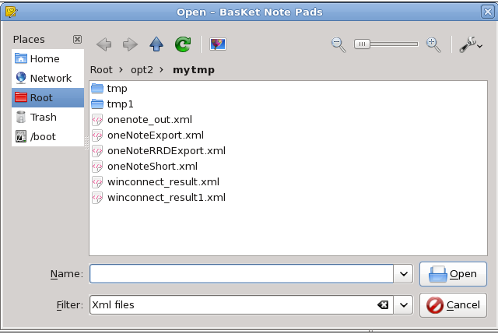
- Next step will be to select if the new page in Basket will be main page or a sub-page :
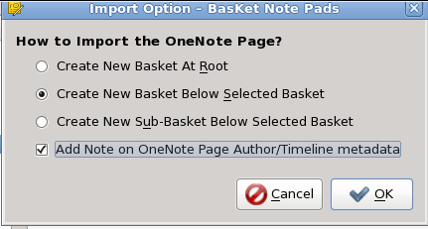
Import Option Dialog Details
- Selecting Option “Create New Basket At Root” will import all parts of OneNote page as notes in a new basket at top level of Basket
- Selecting Option “Create New Basket Below Selected Basket” will import all parts of OneNote page as notes in a new basket under currently selected Basket
- Selecting Option “Create New Sub-Basket Below Selected Basket” -- TBD
- Checking Option “Add Note on OneNote Page Author/Timeline metadata” will import OneNote’s page metadata such as Author, Create Date, Last Updated Date as a text note in the new basket
- Click OK to finish the import process and you will see the OneNote contents in Basket
