REPORT ON MY CHOICE OF WEBSITE: AN EVENT WEBSITE
Moi University event website - EventHive
Name: Dorcas Lotodo
Reg. No: CPR/5459/23
Course code: INS 322
Course Name: Web Design and Management
Task: Cat 1
Total Web pages: 4 HTML pages
Total CSS files: 3 stylesheets
No. of tables: 2
No. of forms: 2

Introduction
A report on my Moi university event website done by Dorcas Lotodo, Adm.No: CPR/5459/23 and submitted on the 8th of April to enhance the classroom-taught skills on HTML and CSS in their use to structure and design web pages so as to deliver content efficiently. The website is built entirely with HTML5 and CSS3, without any use of Javascript. The website serves as a site where students, professionals and event managers can discover, explore, advertise and book events based on their interests.

Inspiration
During my three year stay, I came to the realization that, not many students were being notified about events around the school or in the country that would help them in attaining more skills or in knowing how to network and market themselves. My first inspiration was to provide Moi University students with a platform where they could be notified of the current events around the school that could help them grow their career. Although, after visiting the Moi university gossip club, I realized that not that many events were being broadcast for the students and most of them weren’t career driven at all. So I went about to finding careers in Kenya that might be useful to the students in Moi and I did find several around Nairobi and that’s what the website is all about. Linking students to events that might help them grow, socially, emotionally and academically. This also ensures that all students get a fair access in succeeding in future by networking with the right people.

Page Layout
index.html
this file acts as the home page or the landing page of the website and it has been structured into different distinct sections with different purposes and styling.

Header/ navigation Bar
the header is configured to be sticky using the css tag(position:sticky;) and has been set to be exactly 0 pixels from the top. It has a z-index of 1 to enable navigation to the other pages from anywhere in the home page.
The navigation bar contains four buttons, which are; Find my events – which is linked internally to the table at the end of the page which technically include all the events that the user is interested in.
a sign in and create event buttons which link to the form.html. A user is required to sign in so as to be able to access more events.
A contact button that leads to a contact page incase of inquiries.

Main section
the background of the main section has been set as an image of a community event to make the website inviting and homely. The image(community_connect_series.jpeg) serves as the visual centerpiece of the page. The content is centre-aligned because not a lot of text is used on the main section making it very easy to read.

Statistics bar
it presents the current statistics of the platform such as the number of upcoming events and the number of events that are free to attend and so on.

Event Gallery
Being the largest section of the home page, it displays several event cards in a flex display layout with an information layer below every image that includes the event name, date/time, venue and the price of the event as the last element.

Event schedule table
this table holds the events that is believed the user is looking forward to attend.

Footer
the footer contains a subscribe form to allow users to be able to obtain exclusive information about the upcoming websites and it also includes a copyright notice.

Form.html
this page is a sign up registration form with a centered card component on a #EDE7DB background that is believed to be warm beige. The back link is positioned at the top left of the card to link the form back to index.html.

Form content
the form contains fields such as the username, email and the password of the new user and a submit button with emails and password marked as required and the password specified as to be longer than 8 characters enforced via HTML validation.

The form also contains a sign in link for recurring users which is non functional for now.

Contact.html
this page is used by the users incase of any inquiries on the website or events. It contains a contact form that asks for different fields such as first name, last name, email address, phone number(which is optional) the subject presented as a choice from the dropdown menu and a text area for additional messages and a submit button.

A contact table has been provided with the information on the different departments and whom to contact and how long the response time will be to enable a more personal level communication with the website users.

Design choices
The different web pages were first laid out and structured using HTML5 by making use of the
<main>, <header>, <section>, and <footer> tags. Tables and forms were also used to make the website layout more presentable.
The color palette
I was going for a black, gold and white color scheme with them being the colors that I most associate with. After consulting the w3c color palette, I settled on several color schemes which include;
- black , white , #3B2E00, #FDE992 - for text
- #1a1400 – Stats bar, footer, table headers and hero banner
- #7A6830 – Muted labels, venue
- #ede7db – background of the body of the form page
- #fdf7dc – most hover elements
- #fffef5 – gallery section and page background-position
- #b8860b – price column

typography
the site uses several fonts in the web pages with some being external, osme of them include:
- PlayFair Display
- Arial
- Cormorant Garamond
- Jost
- Serif

Several components were used to achieve the overal display of the web pages. Some of them include;
- Form inputs in both contact.html and form.html
- button elements in all the web pages
- internal links
- Cards

structure
The pages contain a navigation bar or a link back to the home page. Links and buttons have been used throughout for either navigation to a certain page or submission. Forms have been used to post inputs to the server. Moreover, <p> tags have been used for general or descriptive texts while the <h1> to <h6> headers have been used in the header structure and design.

Use of tables
The website, makes use of two tables one being in the landing page(index.html) which serves as a one glance presentation fo the events that are considered to be of interest to the user and the other one being in the contact.html used to enable the users facing issues to have a one on one communication with the technicians. It also confirms to them the response time to avoid an infinite wait of the response from the technicians enabling them to follow up on the issue.

Use of forms
The website has been designed with two forms; the subscribe form and the sign up form. The subscribe form in both the main landing page and the contact page is used by users who’d like to be notified about the upcoming events. Users are advised to sign in to be able to access personalized events recommendation, one click event booking and gain early access to new events.

Navigation
while in the main landing page, users are advised to make use of the navigation bar on the top of the page to navigate to the other pages. When in the contact page, a navigation bar has also been provided for navigation into the other pages. In the form page, a link has been provided at the top left of the card to enable navigation into the main landing page.
File and folder structure
All the .html files reside in the root folder while the styles and images reside on their own sub directories inside the root folder. The Readme.txt which contains the folders structure, resides in the root folder, together with the report in a pdf format. This organization keeps the project organized and the file paths consistent enabling the website to work as intended.

Evidence of validation
All the three HTML pages have been checked using the W3C Markup Validation Service
(https://validator.w3.org). The validator is used to make sure that the code is compliant to the
HTML standards and free from errors that could cause inconsistency rendering across browsers.
The key aspects that were checked during validation include: correct DOCTYPE declaration, proper
nesting of HTML elements, valid use of attributes, presence of alt attributes on images and correct
use of HTML character entities.

Several warnings were found during validation such as closed tags with no opening tags and a section that did not have a h2 although I did fix them in the end by removing the closed tags and removing the section tag and replacing it with a div as the validator suggested.

The validation process included;
Copying and pasting each .html file into the “Validate by File Upload” Tab which required me to choose the exact files I wanted to validate and the pages did pass the validation with no errors. I got back a popup message that said “Document Checking Completed. No errors or warnings to show.” signaling that I had finished validating the website and that feedback has been returned.

The following screenshots are proof of validation:

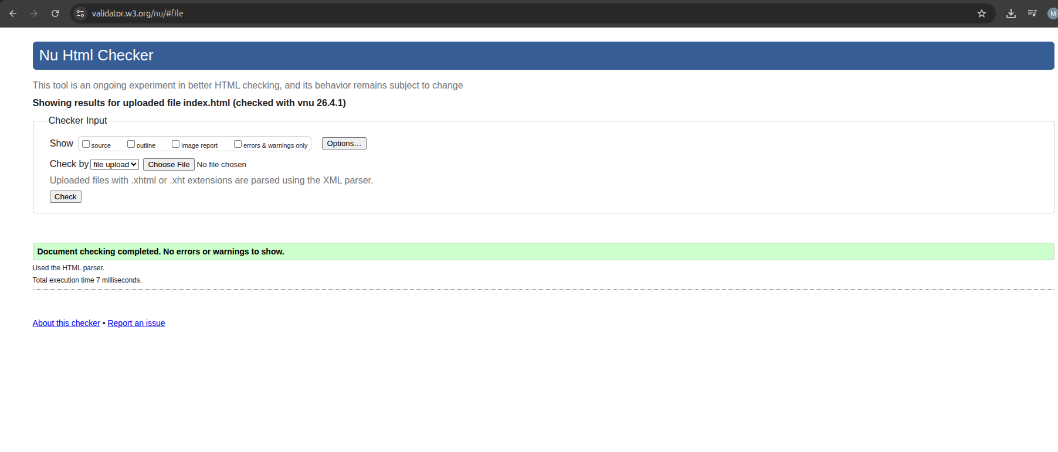
Validation of form.html
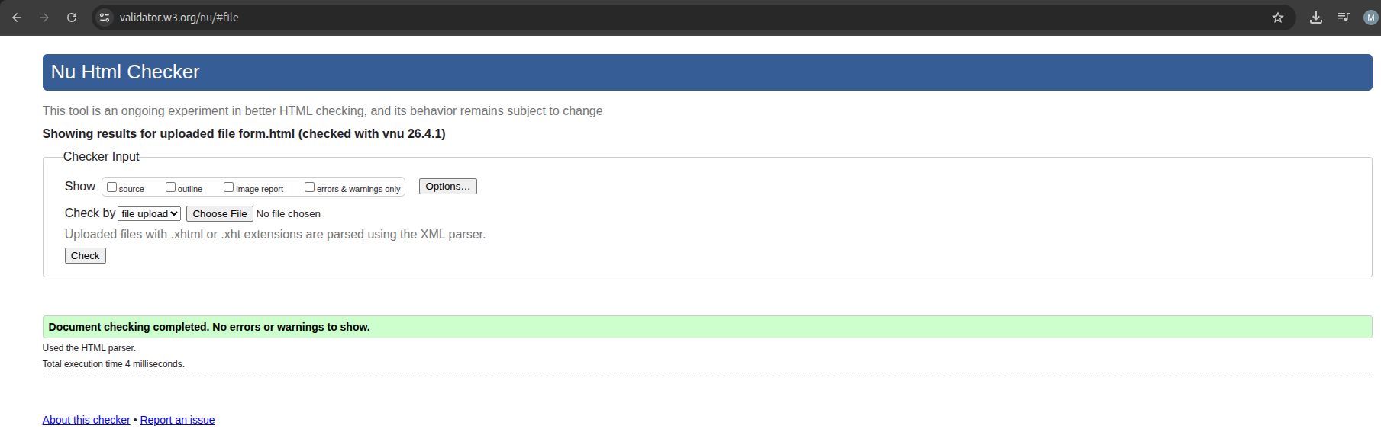
Validation of contact.html
Validation of contact.html

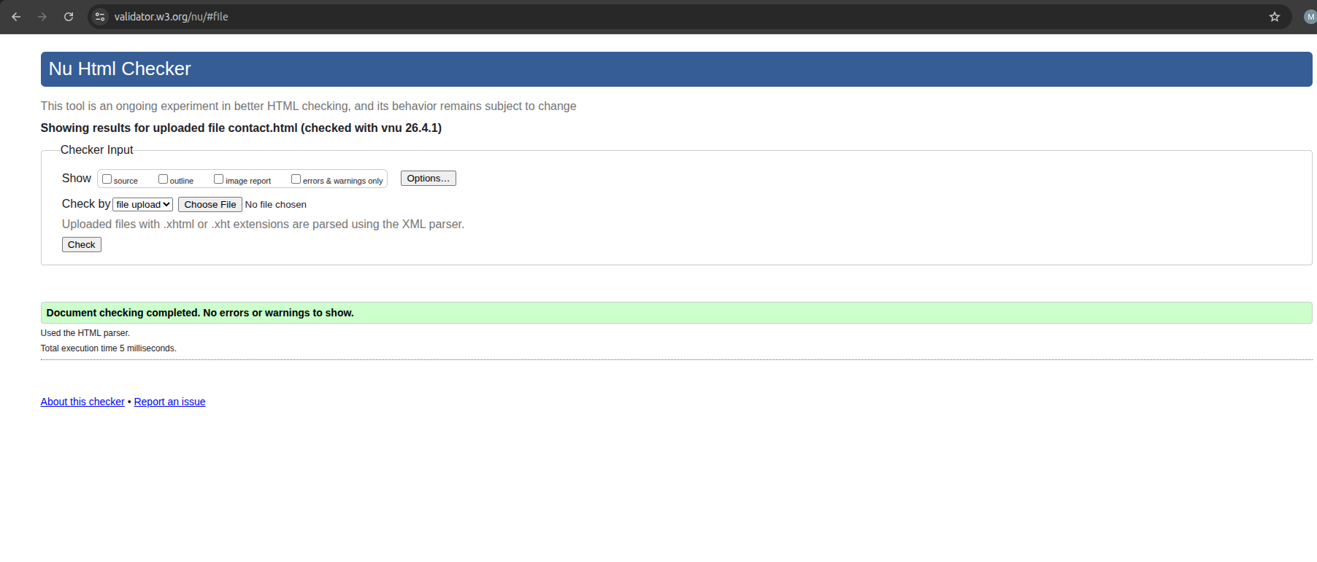
validation of .css files
During the validation of the CSS files I came to find out that CSS files cannot be validated due to their content type.

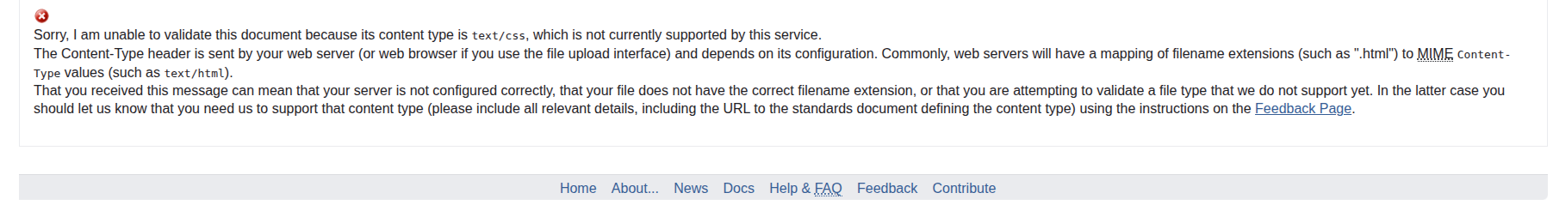

Problems encountered
1. Validation of CSS files
During the validation of the CSS files I came to find out that CSS files cannot be validated due to their content type.

2. Conversion from pixels to rem
The conversion between pixels and rem to make the website more responsive, were quite tiresome to do due to the amount of CSS code used to make the website more presentable.

3. CSS layout difficulties
To achieve the design I had in mind, it was quite tiresome to find the tags needed to make the website presentable. After some digging, I came by the display: flex function whose functionality impressed me and has been used continuously in the website because of how much I fell in love with it.

4.Text over image
while I was reading our notes before starting on the website, I realized that one of my design fundamentals of the website might not be able to work out because it was mentioned that it was not advisable. So I immersed myself into the website but it wasn’t just coming up. However I did decide to find out why it wasn’t advisable and in wcag.com I came to the realization, that what was meant was that only HTML tags and elements should be used to add text to the web pages and images can actually be used just as backgrounds and I ended up using an image as the background of my <main> tag.

5. Frustration
often enough, I’d get stuck at the worst moment in time, leading to frustrations of what I might have done wrong. Most of the time it was due to the fact that I started over complicating the design and after I while I did learn how to relax event hough the pressure of the deadline was on to me.

