To: Mr. John Eric Ferrer

PRICON MICROELECTRONICS INC.

PROJECT PROPOSAL

SYSTEM UPGRADE:

YPICS 3.1 to TPICS 4.0

From: Seiko IT Solutions Philippines Inc.
Dec 14, 2015

ACTIVITY SCHEDULE
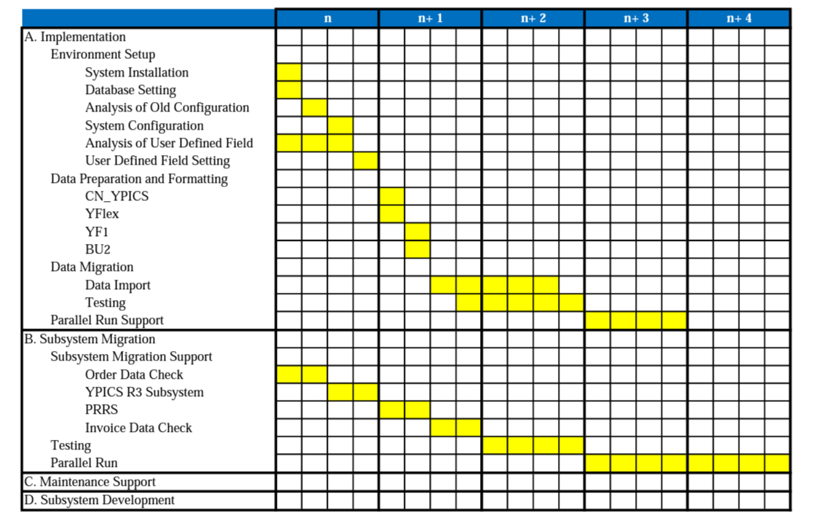

Project Cost
- Implementation Fee (Maximum of 15 days onsite visit, offsite support via remote, phone calls, offsite activities)
- Environment Setup P 250,000.00
- Data Preparation 150,000.00
- Data Migration 150,000.00
- Parallel Run Support 150,000.00

- Subsystem Migration Fee (Maximum of 10 days onsite visit, offsite support via remote, phone calls, offsite activities)
- Support Fee P 150,000.00
- Testing 100,000.00
- Parallel Run Support 150,000.00

- Annual Maintenance Fee P 360,000.00
Terms and Conditions specify on separate contract (1 visit per month, unlimited offsite support via, remote, phone calls)

- Subsystem Development (not yet included)
Will vary depending on allocated man-days for each work.

TOTAL PROJECT COST P 1, 460, 000.00

