**Transaction Isolation Level**

|  |  |  |  |  |
| --- | --- | --- | --- | --- |
| **Isolation Level** | **Dirty read** | **Lost Update** | **Non-repeatable read** | **Phantom** |
| **Read Uncommitted** | √ | √ | √ | √ |
| **Read Committed** | × | √ | √ | √ |
| **Repeatable Read** | × | × | × | √ |
| **Serializable** | × | × | × | × |

Isolation is one of the **ACID** properties.

Possible locking mechanism that solves various read phenomena:

*(Note: please refer to the corresponding phenomena tables)*

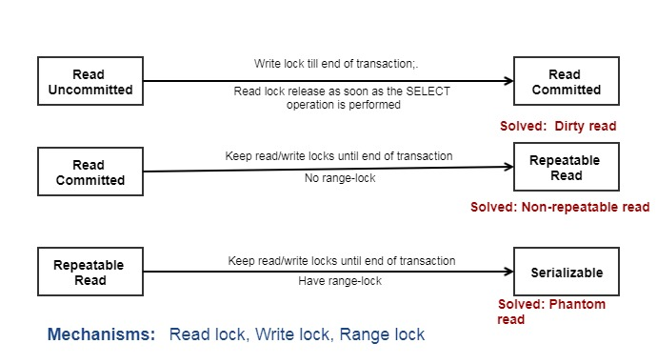

**Dirty read**

|  |  |
| --- | --- |
| **Transaction 1** | **Transaction 2** |
| */* Query 1 */*  **SELECT** age **FROM** users **WHERE** id = 1;  */* will read 20 */* |  |
|  | */* Query 2 */*  **UPDATE** users **SET** age = 21 **WHERE** id = 1;  */* No commit here */* |
| */* Query 1 */*  **SELECT** age **FROM** users **WHERE** id = 1;  */* will read 21 */* |  |
|  | **ROLLBACK**; */* lock-based DIRTY READ */* |

**Lost Update**

|  |  |
| --- | --- |
| **Transaction 1** | **Transaction 2** |
| */* Query 1 */*  **UPDATE** users **SET** age = 34 **WHERE** id = 1; |  |
|  | */* Query 2 */*  **UPDATE** users **SET** age = 21 **WHERE** id = 1;  **COMMIT**; |
| */* Query 1 */*  **COMMIT**;  */* Now age=34 for id=1 */* |  |

**Non-repeatable read**

|  |  |
| --- | --- |
| **Transaction 1** | **Transaction 2** |
| */* Query 1 */*  **SELECT** * **FROM** users **WHERE** id = 1; |  |
|  | */* Query 2 */*  **UPDATE** users **SET** age = 21 **WHERE** id = 1;  **COMMIT**; */* in multi-version concurrency control, or lock-based READ COMMITTED */* |
| */* Query 1 */*  **SELECT** * **FROM** users **WHERE** id = 1;  **COMMIT**; */* lock-based REPEATABLE READ */* |  |

**Phantom read**

|  |  |
| --- | --- |
| **Transaction 1** | **Transaction 2** |
| */* Query 1 */*  **SELECT** * **FROM** users  **WHERE** age **BETWEEN** 10 **AND** 30; |  |
|  | */* Query 2 */*  **INSERT** **INTO** users(id,name,age) **VALUES** ( 3, 'Bob', 27 );  **COMMIT**; |
| */* Query 1 */*  **SELECT** * **FROM** users  **WHERE** age **BETWEEN** 10 **AND** 30;  **COMMIT**; |  |

**Table-level lock compatibility**

|  |  |  |  |  |
| --- | --- | --- | --- | --- |
|  | **X** | **IX** | **S** | **IS** |
| **X** | Conflict | Conflict | Conflict | Conflict |
| **IX** | Conflict | Compatible | Conflict | Compatible |
| **S** | Conflict | Conflict | Compatible | Compatible |
| **IS** | Conflict | Compatible | Compatible | Compatible |