**Multiprocessing Server**

This essay is to illustrate that creating too many subprocesses really creates some troubles. In the multi-process version of server, we spawn one new child process for newly accepted connection. We run out system resources, and the server is in deny of service state.

**Before client connection**

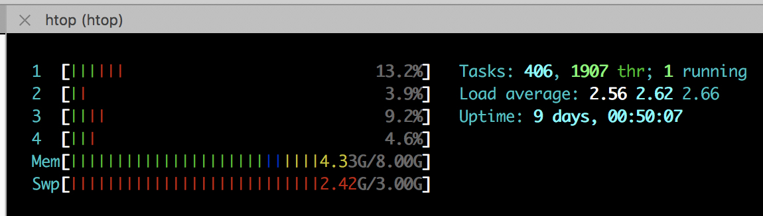



**Client issue many connection**

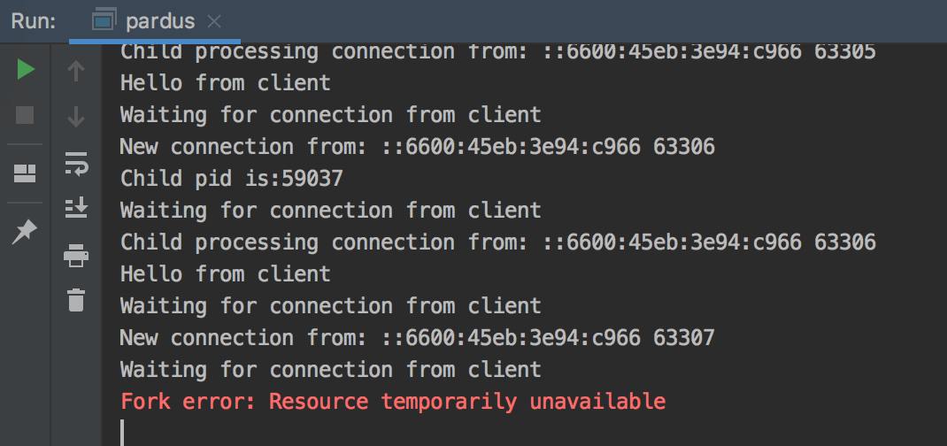

**Server output**

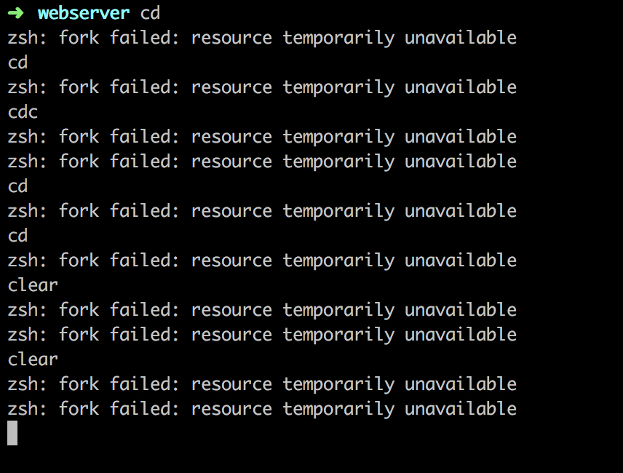

**Terminal denying service**

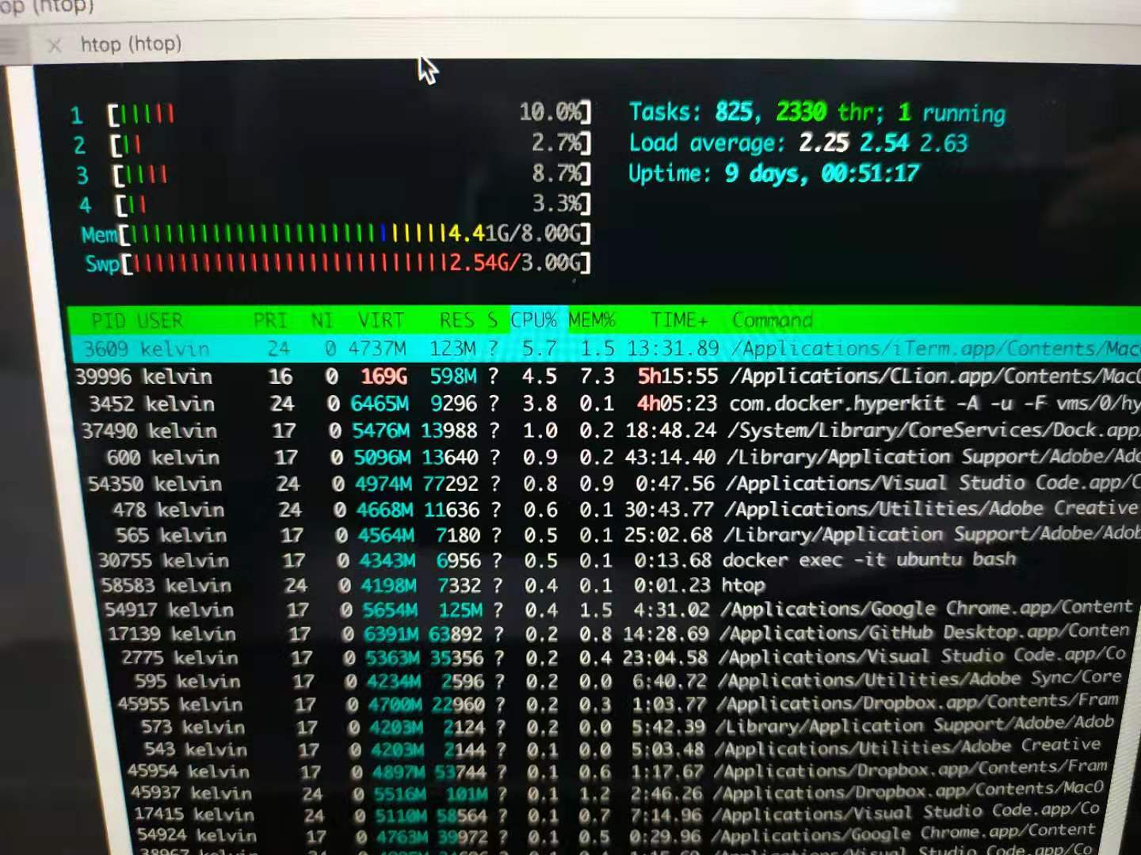



**Server spawn 400+ subprocess**