
Faculty Performance Criteria
- These Tables summarize faculty performance criteria for our department in each of the 4 medical school mission areas– Clinical, Education, Research, and Community Service– as well as performance expectations for each faculty member for a 5th important area of Departmental Culture activities. Criteria range from 1- Unsatisfactory to 4- Outstanding.

- These performance criteria help to determine whether you are meeting expectations for how your effort is allocated and compensated (in terms of cFTE and aFTE as well as compensation and incentives) and to set expectations for the coming year. They also provide guideposts as to whether you are meeting criteria for promotion to the Associate or Full Professor level in your specific faculty track. (See The Difference Between Promotion Criteria vs. Compensation Criteria).

- ALL faculty members are expected to meet at least a 2 (Low Satisfactory) in Community Service and a 3 (High Satisfactory) in Departmental Culture. These activities– which are the foundation of how we serve Minnesota and succeed as a department– justify the allocation of 0.05 aFTE to every faculty member.

- The flowchart below shows additional specific performance criteria by faculty track and role.

- For promotion, please pay particular attention to items that are listed in bold. Briefly, for promotion, faculty members who are in the Clinician track and the Academic Tracks are expected to achieve mostly 4s (and bolded items) in their chosen domain. Faculty in the Academic Tracks must also publish one peer-reviewed paper as first or last author per year.

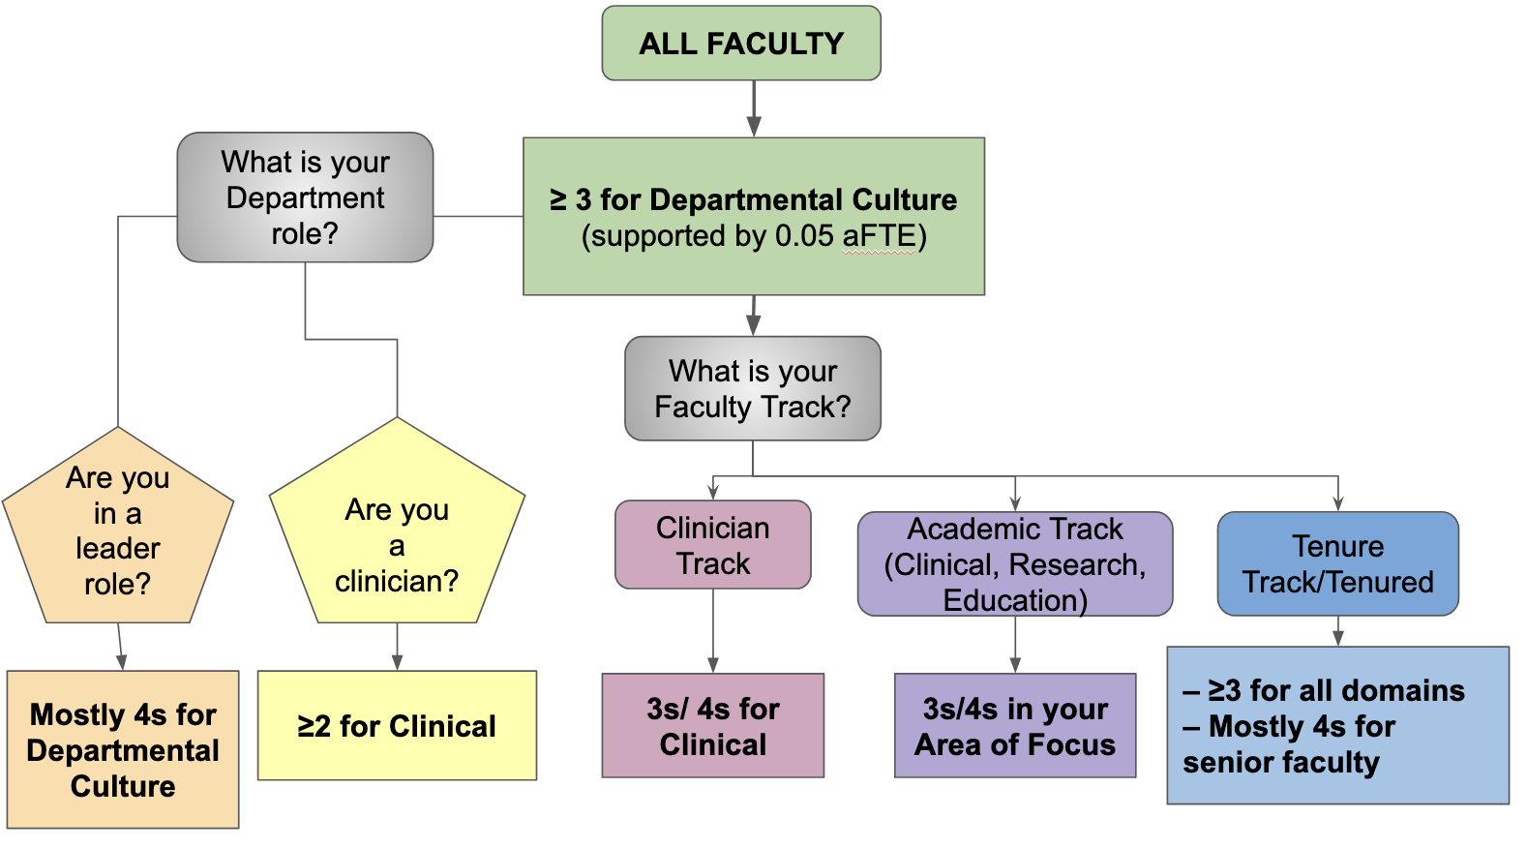

CLINICAL PERFORMANCE CRITERIA  ALL FACULTY WITH cFTE ARE EXPECTED TO AT LEAST MEET 2 (Low Satisfactory)  FACULTY IN THE CLINICIAN TRACK SHOULD MEET MOSTLY 3s  FACULTY SEEKING PROMOTION IN CLINICIAN TRACK OR ACADEMIC TRACK, CLINICAL FOCUS MUST MEET AT LEAST 2 OF THE 4 BOLDED CRITERIA.  FACULTY SEEKING PROMOTION IN ACADEMIC TRACK, CLINICAL FOCUS MUST HAVE AT LEAST ONE SCHOLARLY PEER-REVIEWED PUBLICATION PER YEAR AS FIRST OR SENIOR AUTHOR. | 1- Unsatisfactory  - wRVU productivity is 90% of benchmark or less  - Scheduling template is < 80% utilization  - Unavailable for assigned clinical duties; frequently cancels clinic or does not meet expected days/assigned hours of clinical responsibilities  - Documentation is consistently late and/or incomplete, or requires multiple prompts to complete  - Does not remain current in knowledge or skills; clinical work does not meet community standards  - Disrespectful to patients and/or clinic staff  - Patient satisfaction surveys, when available, show consistently low rankings | 2- Low Satisfactory  - wRVU productivity is 100% of benchmark  - Scheduling template averages 80-90 % utilization for 46 weeks  - Maintains a reliable clinic schedule; reschedules clinic for cancellations; willing to provide inpatient coverage as required  - Documentation is timely and complete, with only minimal reminders  - Knowledge is up-to-date, and maintains a skill set  - Interacts professionally with patients and staff  - Patient satisfaction surveys, when available, are adequate | 3- High Satisfactory  - wRVU productivity is 120% of benchmark  - Scheduling template consistently at or above 90 % utilization for 46 weeks  - Make themselves available during times of clinical need (outpatient and inpatient)  - Documentation is timely and complete with no reminders  - Regularly attends Complex Case Conferences, Clinical Forums, and Clinical Council  - Patient satisfaction surveys show consistently high ratings  - Publishes case report or case series  - Supports innovations in clinical care, new program models, materials, products, and/or technology.  - Invited to speak locally; serves on local/regional committees or projects related to clinical areas of expertise.  - Participates in quality improvement initiatives | 4- Outstanding  - wRVU productivity is > 120% of benchmark  - Scheduling template consistently at or above 90 % utilization for 46 weeks  - Actively participates during times of clinical need (outpatient and inpatient)  - Documentation is timely and complete with no reminders  - Known for specialized skill set; sought after for consultation and presentation on complex cases by colleagues; receives referrals, regionally or nationally  - An active participant in Complex Case Conferences, Clinical Forums, and Clinical Council  - Is nominated for and/or receives an award or recognition for outstanding work as a clinician or a clinical team member  - Patient satisfaction surveys show consistently high ratings  - Successfully leads a clinical program  - Publishes clinical review article  - Develops innovations in clinical care models,, products, and/or technology.  - Invited to speak regionally or nationally on a clinical specialty; serves on regional/national committees in professional societies  - Initiates/implements quality improvement initiatives and new models of care.

EDUCATION PERFORMANCE CRITERIA  ALL FACULTY WITH DEDICATED aFTE TO CONTRIBUTE TO EDUCATIONAL ACTIVITIES ARE EXPECTED TO AT LEAST MEET 3 (High Satisfactory)  FACULTY SEEKING PROMOTION IN ACADEMIC TRACK, EDUCATION FOCUS MUST ALSO MEET AT LEAST 2 OF THE BOLDED CRITERIA, INCLUDING HAVING AT LEAST ONE SCHOLARLY PEER-REVIEWED PUBLICATION PER YEAR WHERE THE CONTRIBUTOR IS LISTED AS AN AUTHOR WITH A SIGNIFICANT PORTION AS FIRST OR SENIOR AUTHOR. | - Limited teaching skills; difficulty interacting with learners  - Refuses to perform, or does not show up for, education activities; fails to perform supervision  - Student evaluations, when available, show consistently low rankings  - Is unprepared for education activities, and/or the material is out-of-date or of poor quality  - Does not participate in interviews for resident or other trainee recruitment | - Average teaching skills and knowledge; interacts well with learners  - Participates intermittently in relevant education activities  - Student evaluations, when available, show average rankings  - Is consistently prepared for education activities, and the material is up-to-date | - Recognized by peers and learners as a skilled educator  - Seeks out and participates actively in educational activities  - Student evaluations, when available, show consistently above-average rankings  - Leads an education activity; develops novel education activities and materials  - Requested to speak on education topics locally and regionally  - Disseminates new educational insights, approaches, or materials through publications or online  - Sits on a departmental, medical school, or university education committee | - Nominated for, or receives an award or recognition as a talented educator (from trainees, CME, patients, families, public)  - Is highly active in education activities; holds a formal education leadership position  - Sought out by learners and junior faculty as an education mentor and advisor; student evaluations, when available, show consistently high rankings  - Has developed innovative education approaches or technologies that have significantly changed education programs locally  - Requested to speak on education topics nationally or internationally  - First or last author in an education-focused publication in a peer-reviewed journal  - Serves on the editorial board of an education journal  - Serves on national-level committees related to education  - Demonstrates successful grant funding for education activities through an internal or external peer-reviewed process

RESEARCH PERFORMANCE CRITERIA  ALL FACULTY WITH aFTE FOR RESEARCH ARE EXPECTED TO MEET MOSTLY 2s and 3s  FACULTY SEEKING PROMOTION IN THE ACADEMIC TRACK, RESEARCH FOCUS ARE EXPECTED TO MEET MOSTLY 3s AND 4s.  THEY MUST ALSO MEET AT LEAST 2 OF THE BOLDED CRITERIA, INCLUDING AT LEAST TWO SCHOLARLY PEER-REVIEWED PUBLICATIONS PER YEAR AS FIRST OR SENIOR AUTHOR; AND HAVE EXTERNAL RESEARCH FUNDING. | - Does not have a current well-defined and active research project  - Does not currently carry any research funding from any sources  - No national institute or foundation grant submissions in the prior year  - No first/last author publications in the prior year  - No research mentorship activities  - No active collaborative work with a funded study  - No presentations at national or international conferences in the prior year  - Did not attend any Faculty Research Forum events in the prior year  - Did not attend the Grant Writing Group in the prior year  - Has compliance / research conduct problems. | - Is conducting 1 well-defined research project  - Carries intramural research funding  - Actively seeking federal or foundation funding through 2 or more submissions per year  - Regularly participates in the Grant Writing Group  - First/last author on 1 published research paper in the prior year  - Co-author on 1 or more peer-reviewed papers  - Actively collaborating on 1 funded research project  - At least 2 ongoing research mentorship activities  - Asked to review 1 article ad-hoc  - 1 presentation or abstract (poster session) at national or international conferences in the prior year  - Attended the Faculty Research Forum event in the prior year | - Is conducting 2 or more well-defined research projects as PI (1 project if early Asst. Prof)  - Carries research funding from 2 or more sources (at least 1 that is federal)  - Actively seeking federal funding through 2 or more submissions per year  - Active and highly engaged participant in Grant Writing Group  - First/last author on at least 2 peer-reviewed papers in the prior year  - Co-author on at least 2 papers in the prior year  - Actively collaborating on at least 2 funded research projects  - Actively engaged in at least 3 mentorship activities  - Invited to present nationally or internationally (symposia or talk) in the prior year  - 2 presentations or abstracts (poster sessions) accepted at national or international conferences in the prior year  - Serves on an editorial board  - Attended all Faculty Research Forum events  - Participates on an IRB panel | - Is PI of a well-funded and thriving lab group with 3 or more projects  - Holds 2 or more federal grants  - Has a consistent record of multiple grant submissions per year  - Active and highly engaged participant in Grant Writing Group  - Serves on the Research Council  - First or last author on >3 publications  - First or last author on 1 paper in a high-impact journal (eg, >10)  - Co-author on 3 or more peer-reviewed papers  - Recognized for multiple significant and highly collaborative projects  - Sought after as a research mentor; actively engaged in 4 or more mentorship activities  - Invited to present internationally (e.g., keynote speaker, symposium speaker)  - Serves as a journal editor or is appointed to a research advisory board  - Serves on departmental or graduate research program committees.  - Involved in leadership activities at regional/national/international research societies  - Serve as a grant reviewer for an external granting agency

COMMUNITY SERVICE PERFORMANCE CRITERIA  ALL FACULTY ARE EXPECTED TO AT LEAST MEET 2 (Low Satisfactory).  FACULTY WHO HAVE aFTE ALLOCATED TO SERVICE (DEFINED AS ADVOCACY & PUBLIC ENGAGEMENT) ARE EXPECTED TO AT LEAST MEET 3 (High Satisfactory).  TO BE CONSIDERED FOR PROMOTION BASED ON SERVICE ACTIVITIES (A RARE OCCURRENCE), FACULTY MUST ACHIEVE MOSTLY 4s, INCLUDING THE TWO BOLDED ITEMS | - If asked to participate in or help with a community service activity, is resistant or do not follow through  - Communicates with community members and the public in ways that undermine the medical school mission (e.g., inconsistent, negative, dismissive) | - Willingly participates in advocacy or public engagement activities  - Makes efforts to be a good communicator with community members and the public when opportunities arise, and/or seeks guidance in skill development in this area if needed | - Actively seeks out advocacy and/or community service and engagement activities  - Seen as effective and creative in service and public communication activities  - Sought out for communication with the public and/or community partners (may include invited talks, trainings) in support of mental health  - Forms active and positive relationships with the legislature, advocacy groups, the media, and/or community partners  - Develops new methods, approaches, and partnerships for advocacy, public engagement, and/or community partnerships | - Frequently sought out to represent the dept or the field in highly visible advocacy or communications activities  - Recognized regionally or nationally as an advocate and resource in the realm of mental health  - Has written or communicated at the national level (e.g., book, blog, YouTube) to provide community service, advocacy or public education and engagement  - Has played a key role in successfully driving change in legislative, public policy, or public awareness issues related to mental health  - Has developed new methods, studies, or advocacy and public engagement strategies, and published on their effects in peer-reviewed journals.

DEPARTMENTAL CULTURE PERFORMANCE CRITERIA  ALL FACULTY ARE EXPECTED TO MEET 3 (High Satisfactory)  0.05 aFTE is automatically funded for each faculty member to carry out these activities | - Does not perform needed administrative tasks in a timely manner; needs multiple prompts, including escalation to leadership, with consequences for non-response (eg, financial impact, denial of request, suspension of clinical duties; information not accepted; appeals to overturn consequences, etc.)  - Consistently does not answer emails from admin staff, department administrators, or the Head  - Does not attend Faculty Meetings  - Does not attend Grand Rounds  - Negative attitude toward workplace challenges — fosters complaints or problems instead of solutions.  - Undermines a culture of Inclusive Excellence  - Shows difficulty accepting feedback  - Unwilling to engage in productive Crucial Conversations  - Does not adhere to action plans that are in the best interest of the department  - Unethical in work with patients, families, or research | - Performs needed administrative tasks or requirements, but can be late or require multiple prompting  - Eventually may respond to administrative emails or messages from the Head, but is often late  - Attends Faculty  Meetings infrequently  - Attends Grand  Rounds infrequently  - Maintains cordial  relationships with  colleagues, trainees,  patients, and families  Participates in one IEWB activity per year  - Willing to accept feedback  - Willing to engage in department problem-solving activities if asked to do so  - Engages in ethical  behavior | - Responds to administrative responsibility(ies) in a timely, independent, positive manner  - Responds to administrative emails or messages from the Head in a timely manner  - Attends Faculty  Meetings regularly with  camera on  - Attends Grand  Rounds regularly  - Helps support methods to increase well-being, productivity, and efficient processes in the department  - Participates in at least two activities per year supported by IEWB  - Contributes actively to a positive problem-solving work environment  - Seeks and accepts feedback; offers respectful feedback when appropriate  - Engages in productive, Crucial Conversations to address conflictual or highly-emotional issues when needed  - Manifests personal integrity and high ethical standards | - Successfully serves in an administrative leadership role  - Consistently aims to be highly effective at solving problems, charting new directions, and finding efficient, innovative solutions to organizational needs, even during difficult situations  - Is consistently an active participant in Faculty Meetings and other department meetings (camera on)  - Is consistently an active participant at Grand Rounds  - Is an active participant in IEWB and/or similar activities  - Widely recognized for strong listening skills; frequently seeks to receive and offer feedback with respect, openness, and clarity  - Proactively engages in growth-promoting, Crucial Conversations that support learning and healthy change  - Embodies & fosters integrity and the highest ethical standards in every action; sought out for input during complex or conflictual issues

