EMA / CDA Simulation Analyses: SA3 Missingness and SA4 Target-FPR Selection
Date (CT): 2026-10-06 (report generated 2026-10-06 CT)
Repository: https://github.com/kelvinlim/cda_simthesis
Commit SHA: 8f8495bfc08a228ddd558869e8c37f16712ea0aa
Software: Python 3.12.3; fastcausal 0.1.11 (tetrad-port C++ backend; no Java / fastcda). Runner tradsim_fastcausal.py; simulation simdata.py + picause.py.
Grid: sim_data_v2 from default config.yaml — 10 graph iterations × 3 effect sizes (0.1, 0.2, 0.3) × 22 variables / 27 edges, n=10000. Discovery iterations=20 (proportion 1.0 runs once). FGES default except SA4-GFCI. SEM fitting off.

Methods
Ground-truth DAGs come from picause (CausalPowerAnalysis fork) structural equation models. Each simulated case writes a CSV of continuous observations and a companion .txt SEM dump whose --> edges are the true directed graph. Discovery is run with fastcausal FGES (SEM-BIC) or GFCI (Fisher-Z), comparing the recovered graph to that picause truth.
Metrics. dice_skeleton is the Sørensen–Dice coefficient on undirected endpoint pairs. dice_directed is Dice on oriented pairs (--> and o->). Oriented TPR = oriented_tp / n_true_directed. Oriented FPR = oriented_fp / (n_nodes*(n_nodes-1) − n_true_directed), i.e. directed false positives over possible directed non-edges. search_ok records whether that draw’s search finished (GFCI, and occasionally FGES, can fail, e.g. nonpositive precision diagonal).
SA3 vs subsample. discovery.proportions randomly keeps complete rows (a sample-size axis). Missingness blanks rows at a rate; a handler then listwise-deletes or imputes. Do not treat proportion=0.8 as “20% MCAR”. Row MCAR independently blanks the entire row (unit nonresponse); complete-case is the natural handler (mean/median on whole-row NaNs would reinsert a near-duplicate mean vector). Row MAR keeps one or more covariates fully observed (default first numeric column, picause x_1) and blanks the other columns with logistic probability of those covariates (mar_slope=1.5); complete-case and column-mean impute are both useful. Rate 0 collapses to a single complete-data cell.
SA4. On complete data at proportion 1.0, FGES sweeps penalty_discount {0.5, 1, 2, 4, 8} and GFCI sweeps Fisher-Z alpha {0.001, 0.005, 0.01, 0.05, 0.1}. For each target FPR in {0.05, 0.10}, the selected HP is the one whose mean empirical oriented FPR is absolutely closest to the target (|emp FPR − target|). The winner may exceed the target (e.g. 0.06 beats 0.01 for target 0.05). Ties go to higher TPR, then higher directed Dice, then the more conservative HP (larger penalty / smaller alpha).

A. Baseline subsample proportion sweep
- search_ok = 1.0 in every cell (3630 FGES draws; no failed searches).
- Effect size dominates sample size on this grid: ES 0.1 skeleton Dice stays ~0.881 at n=10000 vs 0.893 at 40% (weak-signal ceiling); ES 0.2 falls 0.977 → 0.918 and oriented FPR rises 0.005 → 0.016.
- ES 0.3 is near ceiling even at 40% (skeleton Dice 0.985 → 0.977; directed Dice 0.850 → 0.846).
Table: mean Dice, oriented FPR/TPR, and search_ok by effect size × subsample proportion. Proportion 1.0 is a single draw per case; proportions < 1.0 repeat 20 times.
algorithm | es | proportion | n_draws | search_ok | dice_skeleton | dice_directed | oriented_fpr | oriented_tpr
fges | 0.100 | 0.400 | 200 | 1.000 | 0.893 | 0.641 | 0.026 | 0.648
fges | 0.100 | 0.500 | 200 | 1.000 | 0.894 | 0.653 | 0.024 | 0.656
fges | 0.100 | 0.600 | 200 | 1.000 | 0.889 | 0.649 | 0.025 | 0.656
fges | 0.100 | 0.700 | 200 | 1.000 | 0.884 | 0.639 | 0.026 | 0.648
fges | 0.100 | 0.800 | 200 | 1.000 | 0.879 | 0.634 | 0.027 | 0.644
fges | 0.100 | 0.900 | 200 | 1.000 | 0.883 | 0.639 | 0.026 | 0.645
fges | 0.100 | 1.000 | 10 | 1.000 | 0.881 | 0.616 | 0.028 | 0.622
fges | 0.200 | 0.400 | 200 | 1.000 | 0.918 | 0.740 | 0.016 | 0.714
fges | 0.200 | 0.500 | 200 | 1.000 | 0.920 | 0.747 | 0.016 | 0.720
fges | 0.200 | 0.600 | 200 | 1.000 | 0.924 | 0.746 | 0.016 | 0.719
fges | 0.200 | 0.700 | 200 | 1.000 | 0.930 | 0.757 | 0.014 | 0.724
fges | 0.200 | 0.800 | 200 | 1.000 | 0.923 | 0.750 | 0.015 | 0.725
fges | 0.200 | 0.900 | 200 | 1.000 | 0.945 | 0.778 | 0.012 | 0.736
fges | 0.200 | 1.000 | 10 | 1.000 | 0.977 | 0.829 | 0.005 | 0.756
fges | 0.300 | 0.400 | 200 | 1.000 | 0.977 | 0.846 | 0.004 | 0.778
fges | 0.300 | 0.500 | 200 | 1.000 | 0.984 | 0.852 | 0.003 | 0.774
fges | 0.300 | 0.600 | 200 | 1.000 | 0.985 | 0.854 | 0.003 | 0.777
fges | 0.300 | 0.700 | 200 | 1.000 | 0.986 | 0.857 | 0.002 | 0.779
fges | 0.300 | 0.800 | 200 | 1.000 | 0.986 | 0.857 | 0.002 | 0.781
fges | 0.300 | 0.900 | 200 | 1.000 | 0.986 | 0.854 | 0.002 | 0.774
fges | 0.300 | 1.000 | 10 | 1.000 | 0.985 | 0.850 | 0.003 | 0.770

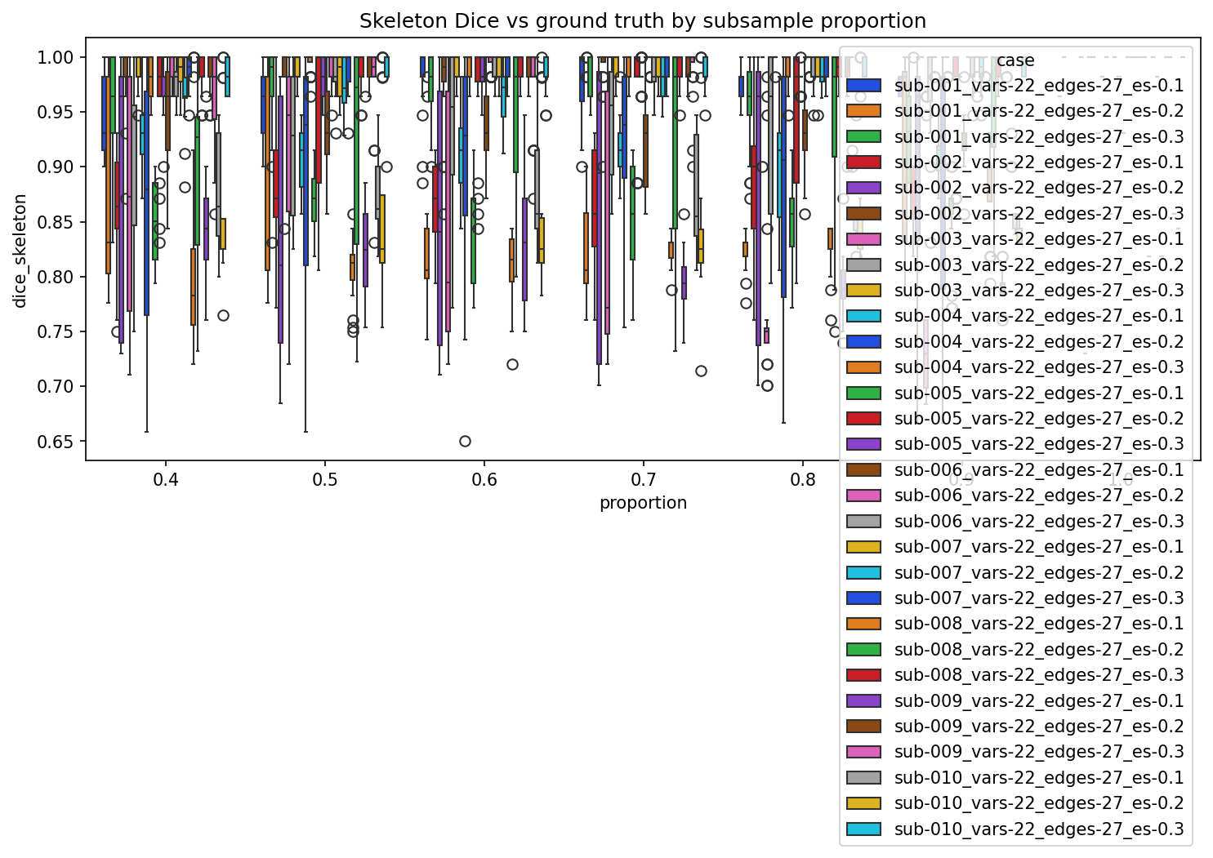
Figure A1. Official --cmd plot: skeleton Dice by subsample proportion (hue = case).
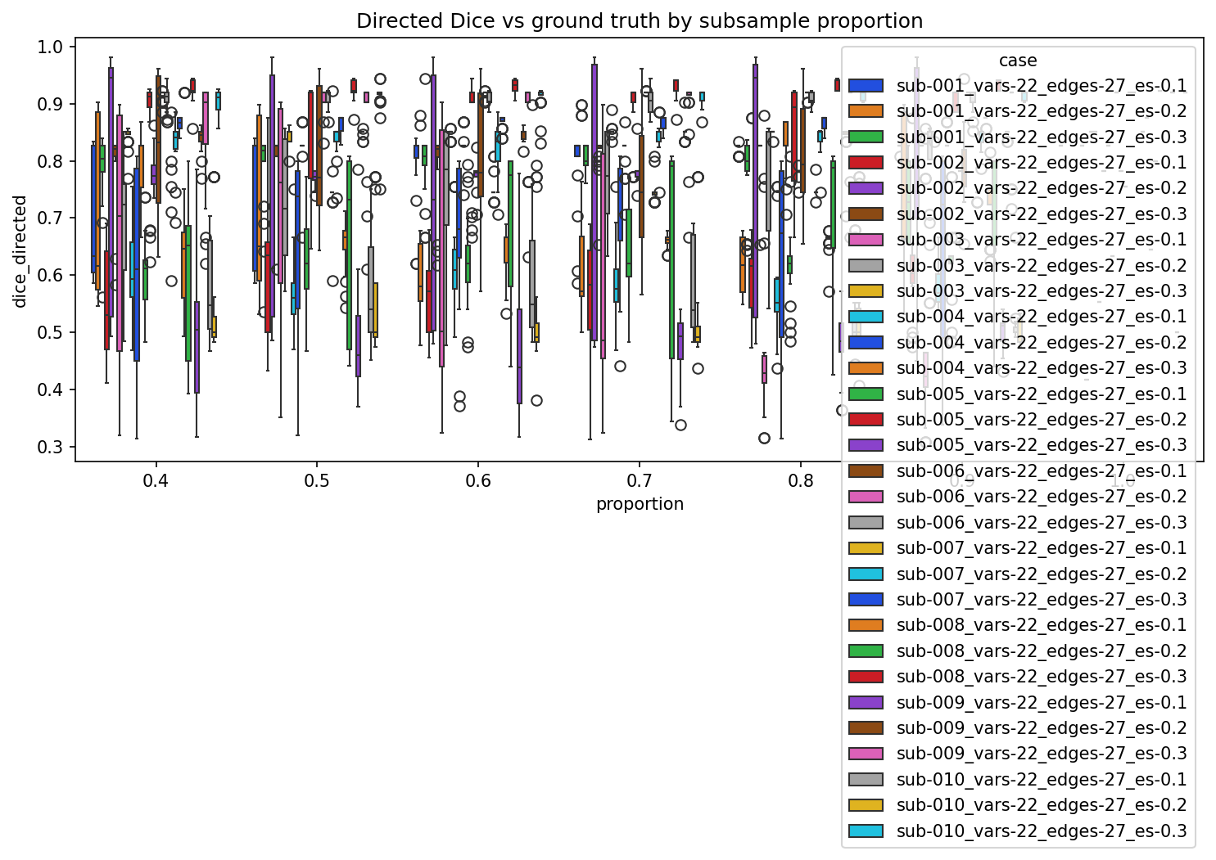
Figure A2. Official --cmd plot: directed Dice by subsample proportion (hue = case).
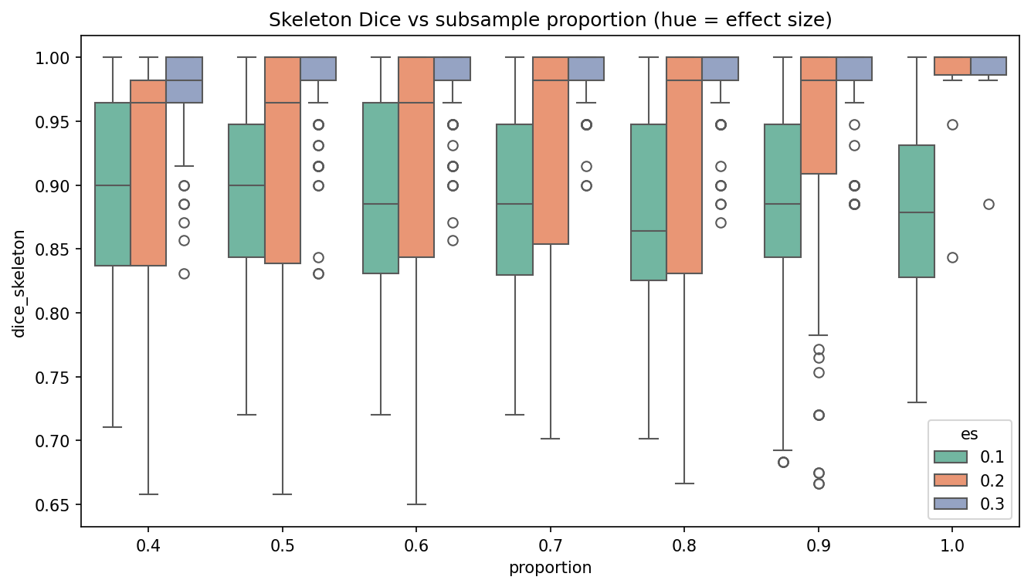
Figure A3. Same data, hue = effect size (more readable than 30 cases).
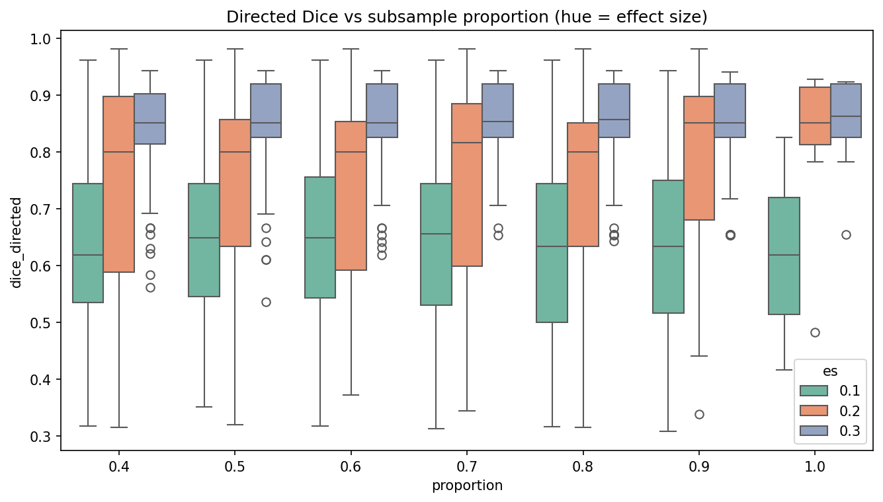
Figure A4. Directed Dice by proportion, hue = effect size.
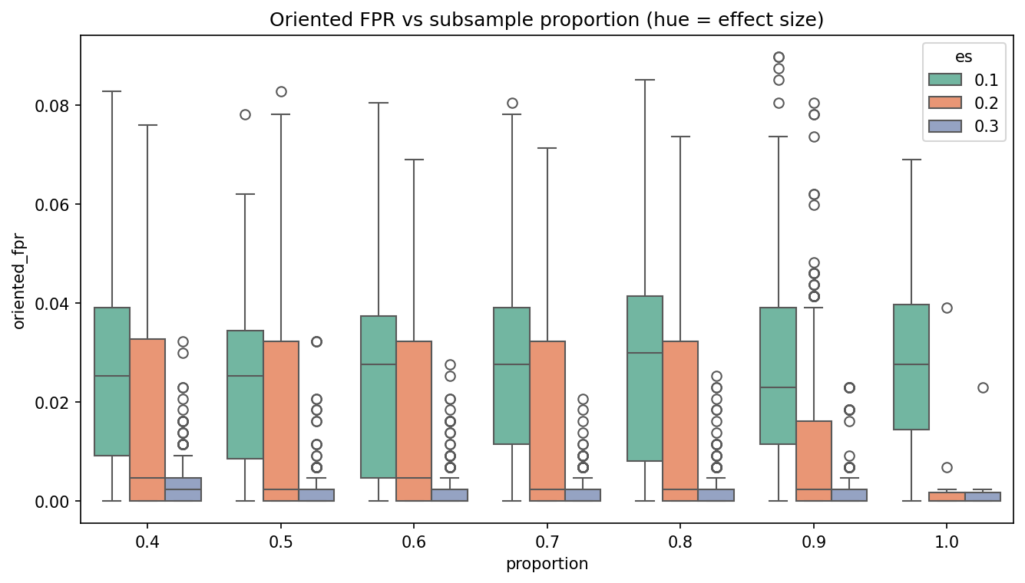
Figure A5. Oriented FPR by subsample proportion, hue = effect size.
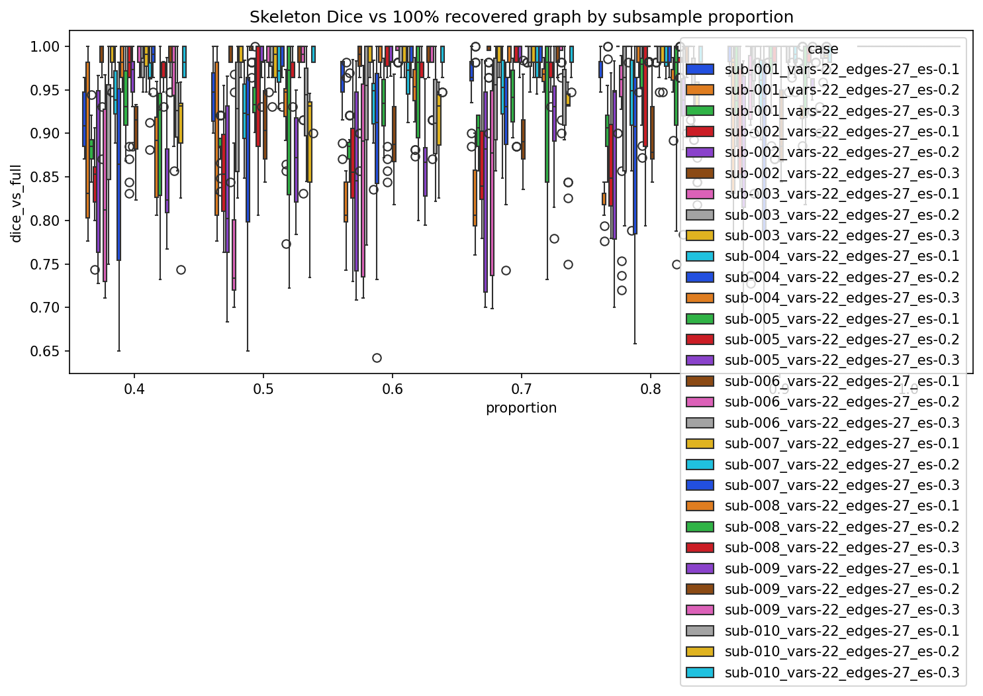
Figure A6. Legacy skeleton Dice vs the 100% recovered graph (not picause truth).

B. SA3 row MCAR (complete-case)
- search_ok = 1.0 in every MCAR cell (120 draws; no failed searches).
- Complete-case row MCAR is a sample-size hit, strongest at ES 0.2: ES 0.1 0.881→0.886; ES 0.2 0.977→0.919; ES 0.3 0.985→0.973 (skeleton Dice, rate 0 vs 0.4).
- This is not interchangeable with the subsample axis: 40% MCAR drops expected n to ~6000 after listwise delete, whereas proportion=0.4 keeps 4000 complete rows with no NaNs.
Complete-case after whole-row MCAR is equivalent to a random reduction in n, but it is not the same generator as the subsample axis (which samples complete rows without inserting NaNs).
algorithm | es | missing_mechanism | missing_rate | missing_strategy | n_draws | search_ok | dice_skeleton | dice_directed | oriented_fpr | oriented_tpr
fges | 0.100 | mcar | 0.100 | complete_case | 10 | 1.000 | 0.890 | 0.653 | 0.023 | 0.652
fges | 0.100 | mcar | 0.200 | complete_case | 10 | 1.000 | 0.886 | 0.645 | 0.025 | 0.656
fges | 0.100 | mcar | 0.400 | complete_case | 10 | 1.000 | 0.886 | 0.633 | 0.026 | 0.644
fges | 0.100 | none | 0.000 | none | 10 | 1.000 | 0.881 | 0.616 | 0.028 | 0.622
fges | 0.200 | mcar | 0.100 | complete_case | 10 | 1.000 | 0.901 | 0.697 | 0.022 | 0.696
fges | 0.200 | mcar | 0.200 | complete_case | 10 | 1.000 | 0.936 | 0.779 | 0.011 | 0.741
fges | 0.200 | mcar | 0.400 | complete_case | 10 | 1.000 | 0.919 | 0.749 | 0.017 | 0.726
fges | 0.200 | none | 0.000 | none | 10 | 1.000 | 0.977 | 0.829 | 0.005 | 0.756
fges | 0.300 | mcar | 0.100 | complete_case | 10 | 1.000 | 0.991 | 0.861 | 0.002 | 0.778
fges | 0.300 | mcar | 0.200 | complete_case | 10 | 1.000 | 0.986 | 0.844 | 0.003 | 0.763
fges | 0.300 | mcar | 0.400 | complete_case | 10 | 1.000 | 0.973 | 0.830 | 0.005 | 0.759
fges | 0.300 | none | 0.000 | none | 10 | 1.000 | 0.985 | 0.850 | 0.003 | 0.770

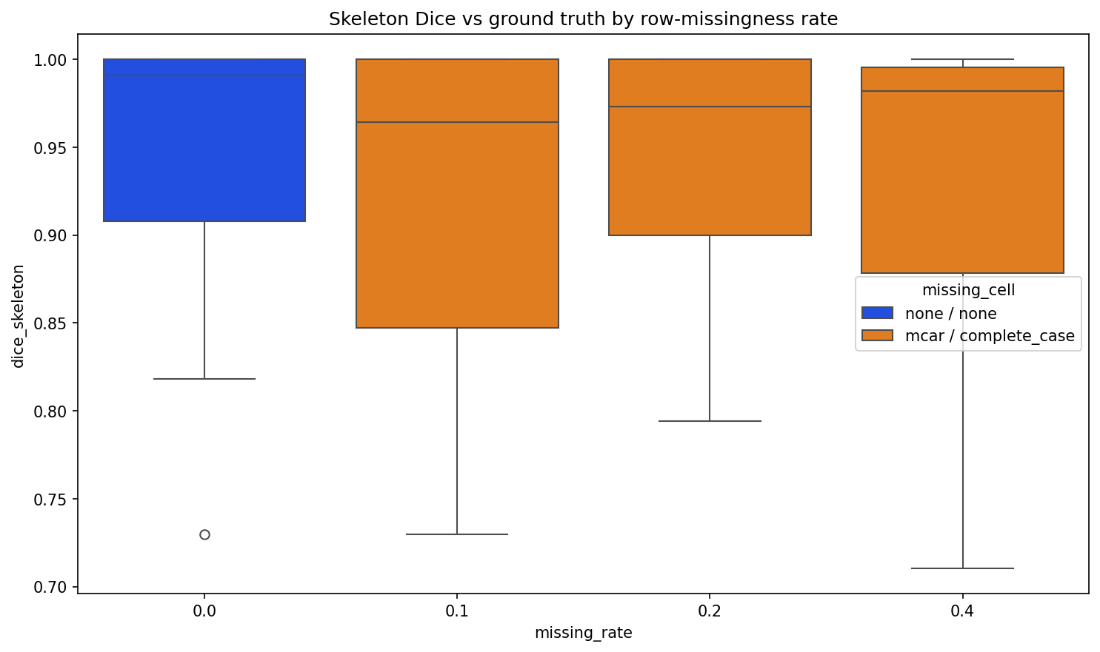
Figure B1. Official --cmd plot: skeleton Dice by MCAR rate.
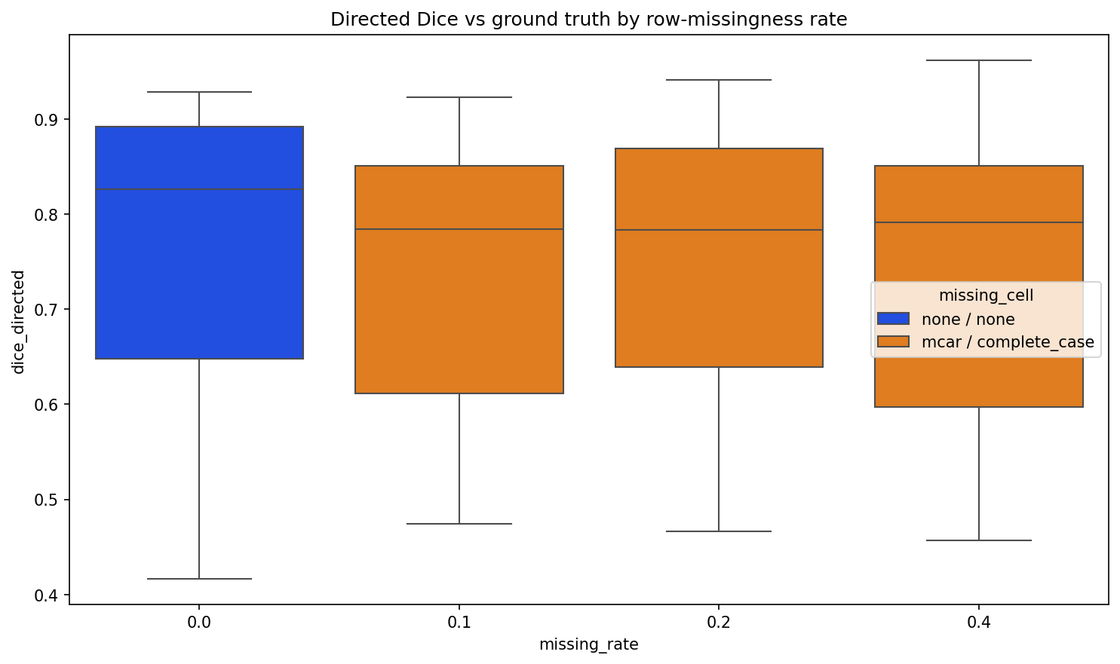
Figure B2. Official --cmd plot: directed Dice by MCAR rate.
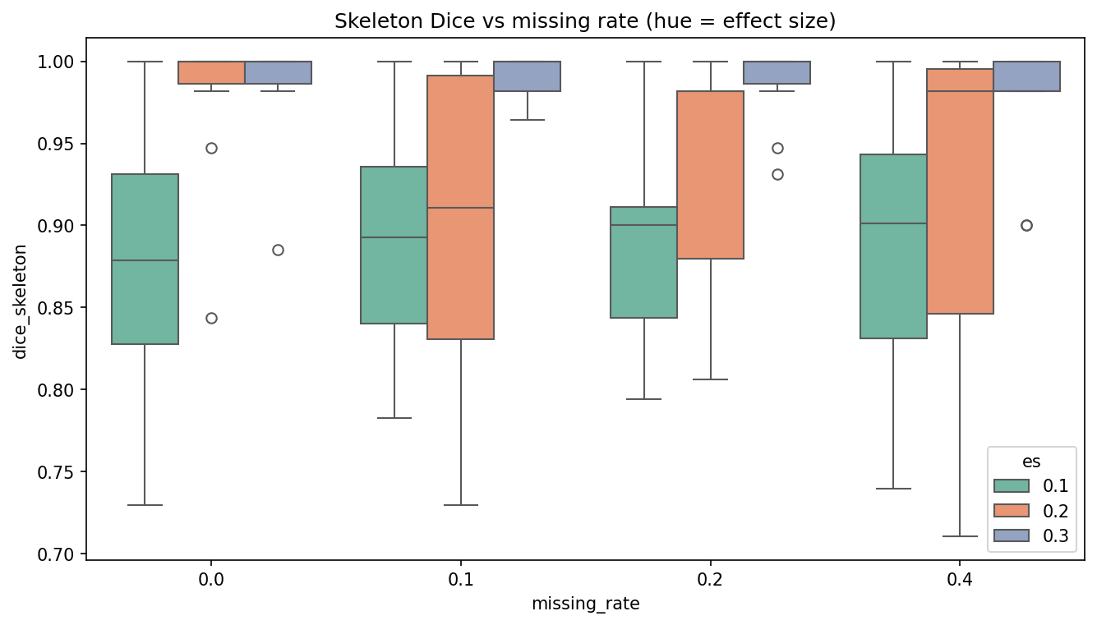
Figure B3. Skeleton Dice by MCAR rate, hue = effect size.

C. SA3 row MAR (complete-case and mean impute)
- search_ok = 1.0 in every MAR cell (210 draws; no failed searches).
- At MAR rate 0.4, column-mean impute underperforms complete-case (directed Dice 0.692 vs 0.750 pooled across ES; skeleton Dice 0.866 vs 0.924).
- ES 0.2 directed Dice: complete data 0.829; MAR 0.4 complete-case 0.775; MAR 0.4 mean-impute 0.697.
MAR blanks non-covariate columns only; x_1 stays observed. Mean impute therefore does not reinsert identical full-row duplicates (unlike whole-row MCAR + mean).
algorithm | es | missing_mechanism | missing_rate | missing_strategy | n_draws | search_ok | dice_skeleton | dice_directed | oriented_fpr | oriented_tpr
fges | 0.100 | mar | 0.100 | complete_case | 10 | 1.000 | 0.876 | 0.622 | 0.026 | 0.633
fges | 0.100 | mar | 0.100 | mean | 10 | 1.000 | 0.862 | 0.614 | 0.030 | 0.648
fges | 0.100 | mar | 0.200 | complete_case | 10 | 1.000 | 0.881 | 0.632 | 0.026 | 0.644
fges | 0.100 | mar | 0.200 | mean | 10 | 1.000 | 0.867 | 0.624 | 0.027 | 0.644
fges | 0.100 | mar | 0.400 | complete_case | 10 | 1.000 | 0.901 | 0.672 | 0.022 | 0.674
fges | 0.100 | mar | 0.400 | mean | 10 | 1.000 | 0.844 | 0.637 | 0.030 | 0.685
fges | 0.100 | none | 0.000 | none | 10 | 1.000 | 0.881 | 0.616 | 0.028 | 0.622
fges | 0.200 | mar | 0.100 | complete_case | 10 | 1.000 | 0.949 | 0.791 | 0.010 | 0.756
fges | 0.200 | mar | 0.100 | mean | 10 | 1.000 | 0.932 | 0.766 | 0.012 | 0.730
fges | 0.200 | mar | 0.200 | complete_case | 10 | 1.000 | 0.928 | 0.781 | 0.012 | 0.759
fges | 0.200 | mar | 0.200 | mean | 10 | 1.000 | 0.911 | 0.745 | 0.016 | 0.737
fges | 0.200 | mar | 0.400 | complete_case | 10 | 1.000 | 0.923 | 0.775 | 0.013 | 0.756
fges | 0.200 | mar | 0.400 | mean | 10 | 1.000 | 0.853 | 0.697 | 0.024 | 0.726
fges | 0.200 | none | 0.000 | none | 10 | 1.000 | 0.977 | 0.829 | 0.005 | 0.756
fges | 0.300 | mar | 0.100 | complete_case | 10 | 1.000 | 0.984 | 0.849 | 0.002 | 0.767
fges | 0.300 | mar | 0.100 | mean | 10 | 1.000 | 0.974 | 0.836 | 0.004 | 0.770
fges | 0.300 | mar | 0.200 | complete_case | 10 | 1.000 | 0.979 | 0.840 | 0.002 | 0.752
fges | 0.300 | mar | 0.200 | mean | 10 | 1.000 | 0.957 | 0.820 | 0.006 | 0.763
fges | 0.300 | mar | 0.400 | complete_case | 10 | 1.000 | 0.949 | 0.803 | 0.008 | 0.752
fges | 0.300 | mar | 0.400 | mean | 10 | 1.000 | 0.902 | 0.740 | 0.017 | 0.744
fges | 0.300 | none | 0.000 | none | 10 | 1.000 | 0.985 | 0.850 | 0.003 | 0.770

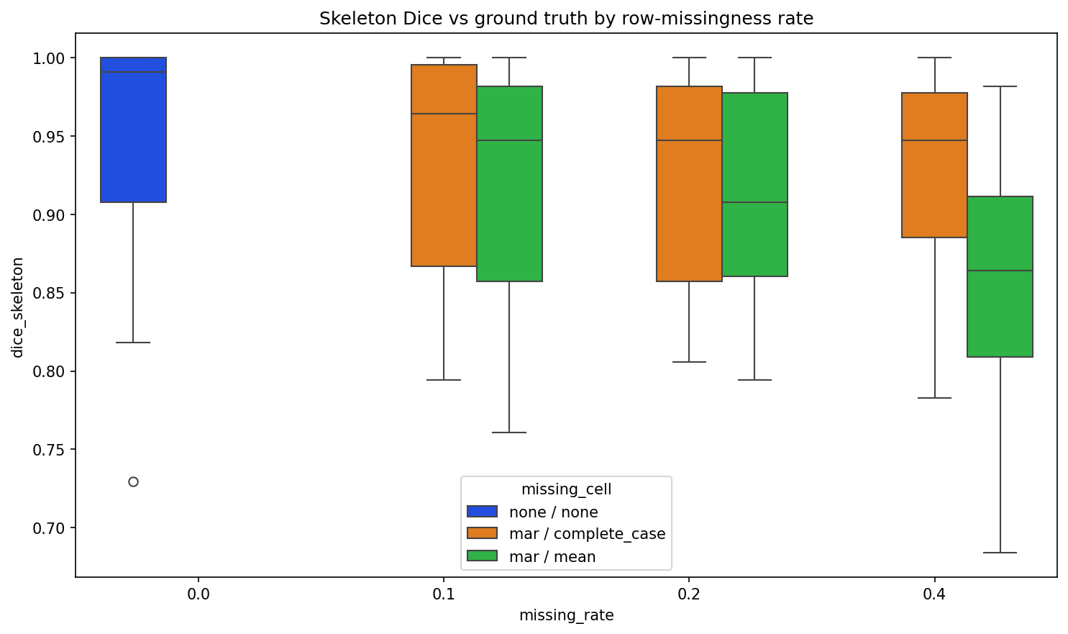
Figure C1. Official --cmd plot: skeleton Dice by MAR rate (hue = mechanism/strategy).
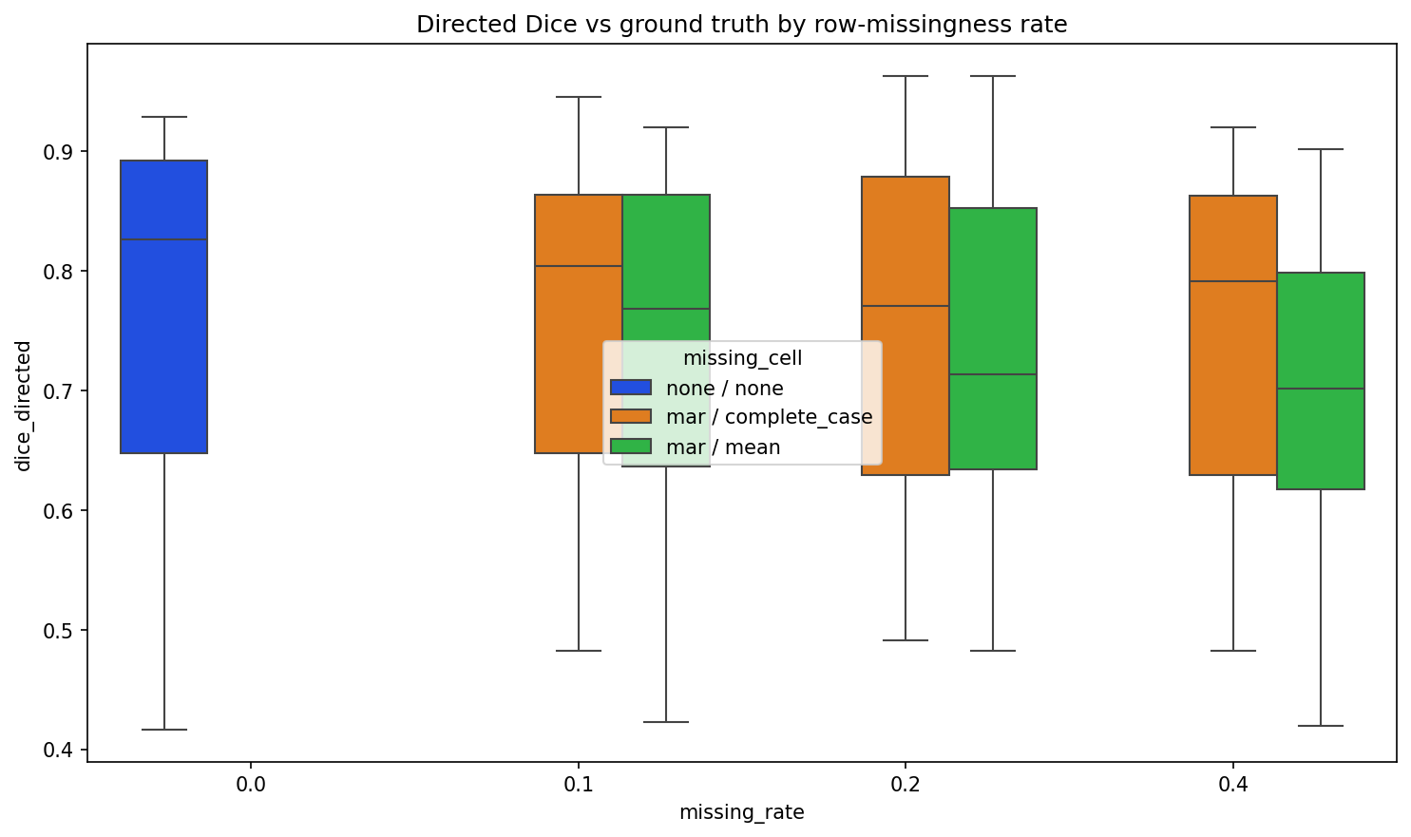
Figure C2. Official --cmd plot: directed Dice by MAR rate.
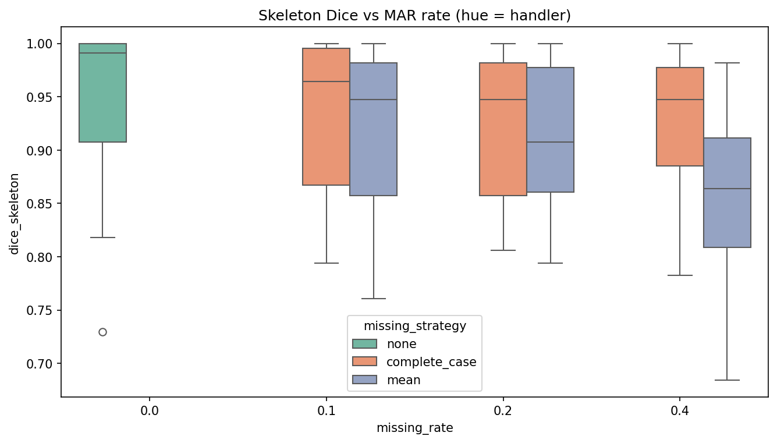
Figure C3. Skeleton Dice by MAR rate, hue = handler.
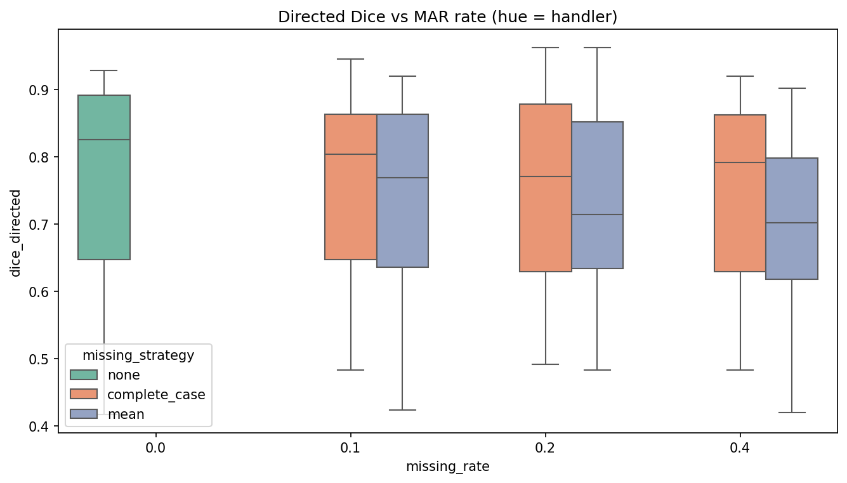
Figure C4. Directed Dice by MAR rate, hue = handler.
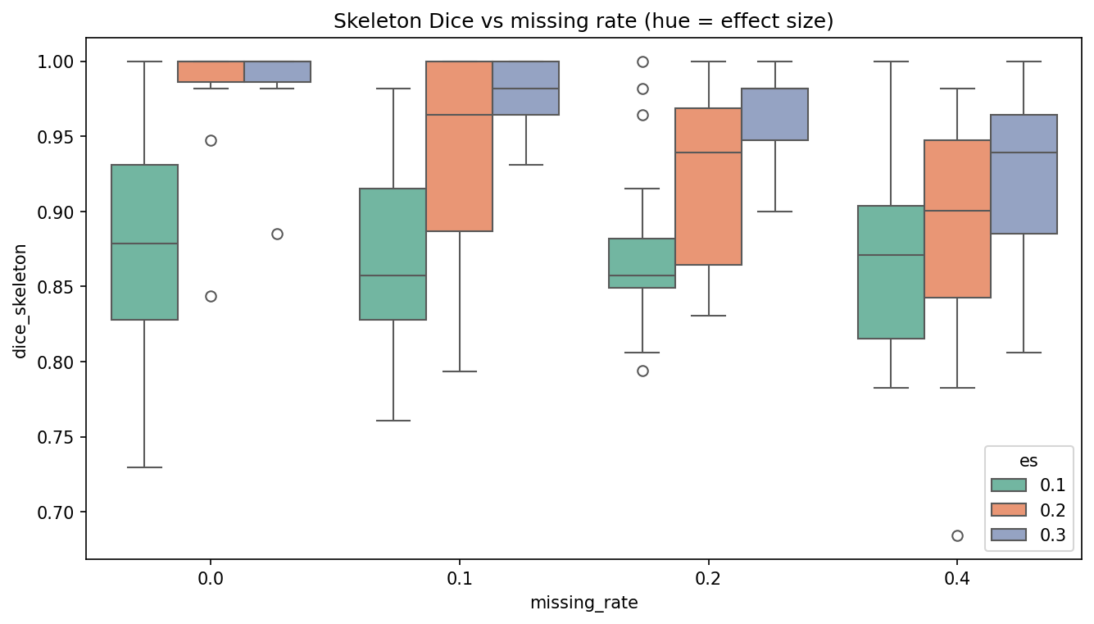
Figure C5. Skeleton Dice by MAR rate, hue = effect size.

D. SA4 FGES hyperparameter / target-FPR sweep
- Mean oriented FPR moves from 0.031 at penalty_discount=0.5 to 0.011 at penalty_discount=8.
- Absolute-closest selection: target 0.05 → penalty_discount=0.5 (emp FPR 0.031); target 0.10 → penalty_discount=0.5 (emp FPR 0.031).
- Every cell undershoots both targets: this n=10000 / 22-node SEM never reaches oriented FPR 0.05 or 0.10, so absolute-closest selection returns the highest-FPR HP in the grid (still below target).
Table: mean recovery by effect size × FGES penalty_discount (p=1.0, complete data).
algorithm | es | penalty_discount | n_draws | search_ok | dice_skeleton | dice_directed | oriented_fpr | oriented_tpr
fges | 0.100 | 0.500 | 10 | 1.000 | 0.783 | 0.560 | 0.047 | 0.663
fges | 0.100 | 1.000 | 10 | 1.000 | 0.881 | 0.616 | 0.028 | 0.622
fges | 0.100 | 2.000 | 10 | 1.000 | 0.898 | 0.637 | 0.023 | 0.630
fges | 0.100 | 4.000 | 10 | 1.000 | 0.904 | 0.626 | 0.024 | 0.622
fges | 0.100 | 8.000 | 10 | 1.000 | 0.905 | 0.620 | 0.023 | 0.607
fges | 0.200 | 0.500 | 10 | 1.000 | 0.869 | 0.722 | 0.023 | 0.763
fges | 0.200 | 1.000 | 10 | 1.000 | 0.977 | 0.829 | 0.005 | 0.756
fges | 0.200 | 2.000 | 10 | 1.000 | 0.995 | 0.861 | 0.000 | 0.767
fges | 0.200 | 4.000 | 10 | 1.000 | 0.976 | 0.820 | 0.003 | 0.733
fges | 0.200 | 8.000 | 10 | 1.000 | 0.945 | 0.762 | 0.008 | 0.693
fges | 0.300 | 0.500 | 10 | 1.000 | 0.877 | 0.742 | 0.022 | 0.793
fges | 0.300 | 1.000 | 10 | 1.000 | 0.985 | 0.850 | 0.003 | 0.770
fges | 0.300 | 2.000 | 10 | 1.000 | 0.996 | 0.865 | 0.001 | 0.774
fges | 0.300 | 4.000 | 10 | 1.000 | 0.993 | 0.857 | 0.001 | 0.767
fges | 0.300 | 8.000 | 10 | 1.000 | 0.993 | 0.857 | 0.001 | 0.767

Table: hp_sweep_metrics.csv (mean FPR/TPR/Dice per HP cell, pooled across cases).
algorithm | proportion | penalty_discount | alpha | n_draws | success_rate | oriented_fpr | oriented_tpr | dice_skeleton | dice_directed
fges | 1.000 | 0.500 | 0.010 | 30 | 1.000 | 0.031 | 0.740 | 0.843 | 0.675
fges | 1.000 | 1.000 | 0.010 | 30 | 1.000 | 0.012 | 0.716 | 0.948 | 0.765
fges | 1.000 | 2.000 | 0.010 | 30 | 1.000 | 0.008 | 0.723 | 0.963 | 0.788
fges | 1.000 | 4.000 | 0.010 | 30 | 1.000 | 0.009 | 0.707 | 0.958 | 0.768
fges | 1.000 | 8.000 | 0.010 | 30 | 1.000 | 0.011 | 0.689 | 0.948 | 0.747

Table: hp_selected_by_target_fpr.csv — absolute-closest |empirical oriented FPR − target|.
algorithm | proportion | target_fpr | selected_penalty_discount | selected_alpha | empirical_fpr | abs_fpr_error | empirical_tpr | dice_directed | dice_skeleton | n_draws | success_rate
fges | 1.000 | 0.050 | 0.500 | 0.010 | 0.031 | 0.019 | 0.740 | 0.675 | 0.843 | 30 | 1.000
fges | 1.000 | 0.100 | 0.500 | 0.010 | 0.031 | 0.069 | 0.740 | 0.675 | 0.843 | 30 | 1.000

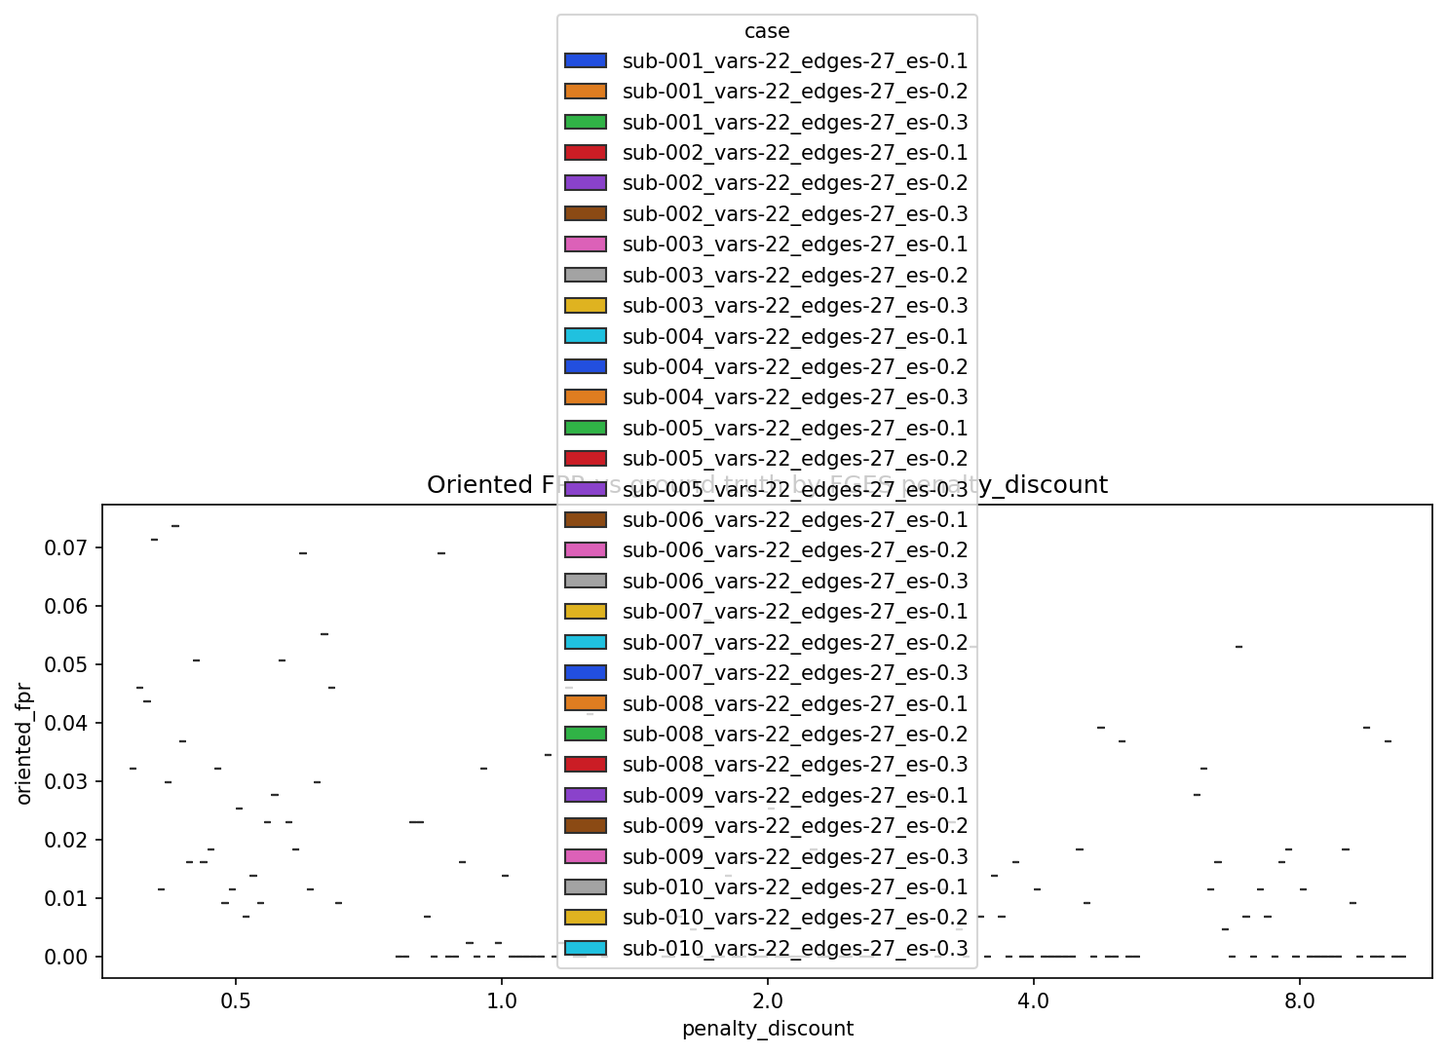
Figure D1. Official --cmd plot: oriented FPR by FGES penalty_discount.
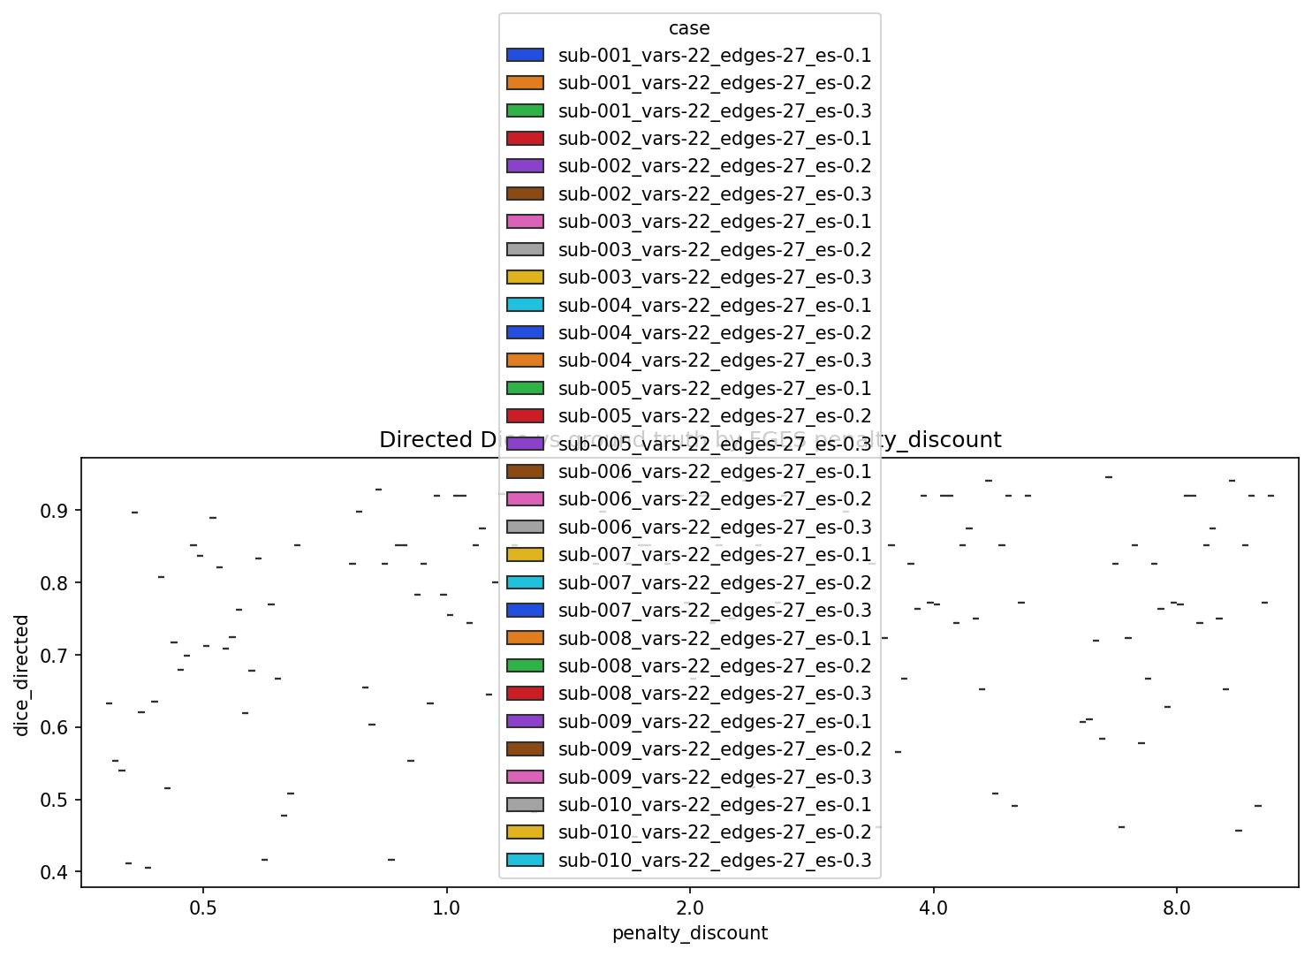
Figure D2. Official --cmd plot: directed Dice by FGES penalty_discount.
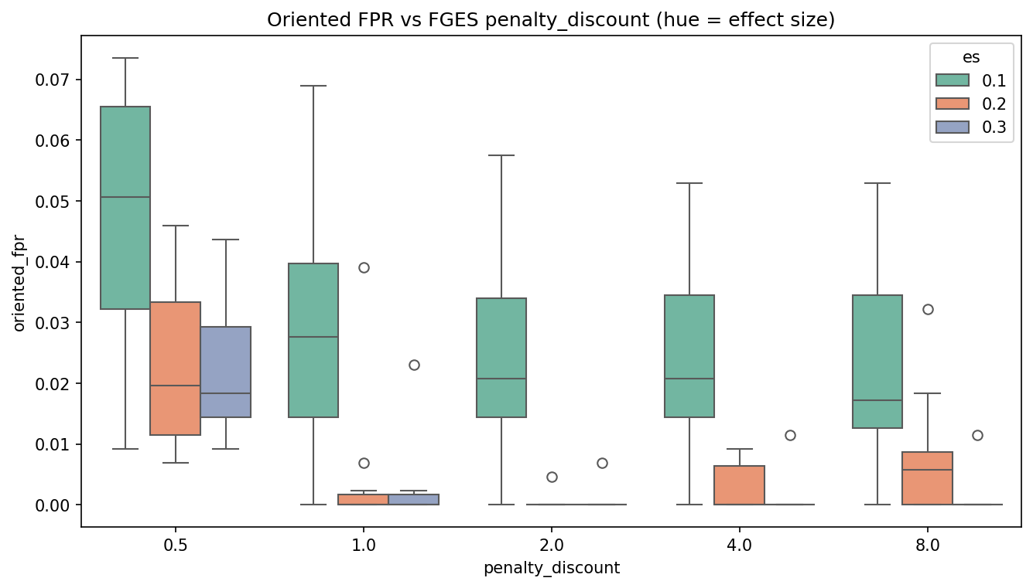
Figure D3. Oriented FPR by penalty_discount, hue = effect size.
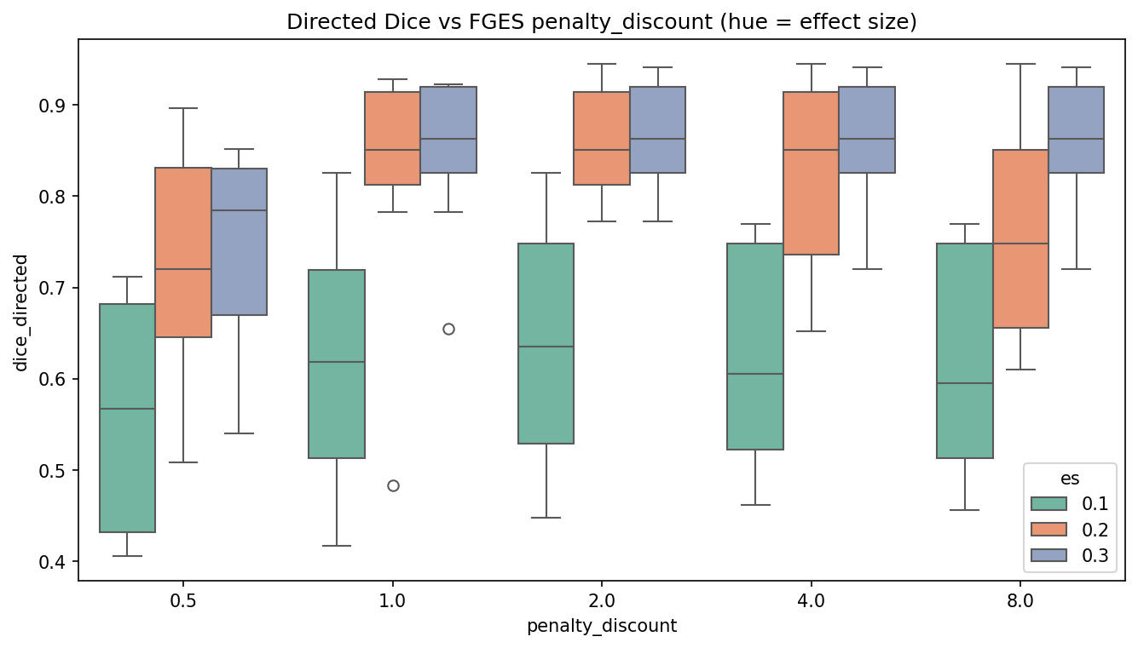
Figure D4. Directed Dice by penalty_discount, hue = effect size.

E. SA4 GFCI hyperparameter / target-FPR sweep
- Mean oriented FPR moves from 0.002 at alpha=0.001 to 0.002 at alpha=0.1.
- Absolute-closest selection: target 0.05 → alpha=0.1 (emp FPR 0.002); target 0.10 → alpha=0.1 (emp FPR 0.002).
- Every cell undershoots both targets: this n=10000 / 22-node SEM never reaches oriented FPR 0.05 or 0.10, so absolute-closest selection returns the highest-FPR HP in the grid (still below target).
Table: mean recovery by effect size × GFCI Fisher-Z alpha (p=1.0, complete data).
algorithm | es | alpha | n_draws | search_ok | dice_skeleton | dice_directed | oriented_fpr | oriented_tpr
gfci | 0.100 | 0.001 | 10 | 1.000 | 0.987 | 0.777 | 0.003 | 0.670
gfci | 0.100 | 0.005 | 10 | 1.000 | 0.987 | 0.772 | 0.002 | 0.656
gfci | 0.100 | 0.010 | 10 | 1.000 | 0.987 | 0.779 | 0.002 | 0.663
gfci | 0.100 | 0.050 | 10 | 1.000 | 0.980 | 0.772 | 0.003 | 0.663
gfci | 0.100 | 0.100 | 10 | 1.000 | 0.975 | 0.761 | 0.004 | 0.656
gfci | 0.200 | 0.001 | 10 | 1.000 | 0.979 | 0.839 | 0.001 | 0.744
gfci | 0.200 | 0.005 | 10 | 1.000 | 0.983 | 0.844 | 0.001 | 0.752
gfci | 0.200 | 0.010 | 10 | 1.000 | 0.985 | 0.844 | 0.001 | 0.752
gfci | 0.200 | 0.050 | 10 | 1.000 | 0.991 | 0.841 | 0.001 | 0.748
gfci | 0.200 | 0.100 | 10 | 1.000 | 0.989 | 0.839 | 0.001 | 0.744
gfci | 0.300 | 0.001 | 10 | 1.000 | 0.996 | 0.859 | 0.001 | 0.770
gfci | 0.300 | 0.005 | 10 | 1.000 | 0.996 | 0.859 | 0.001 | 0.770
gfci | 0.300 | 0.010 | 10 | 1.000 | 0.996 | 0.859 | 0.001 | 0.770
gfci | 0.300 | 0.050 | 10 | 1.000 | 0.996 | 0.859 | 0.001 | 0.770
gfci | 0.300 | 0.100 | 10 | 1.000 | 0.996 | 0.859 | 0.001 | 0.770

Table: hp_sweep_metrics.csv (mean FPR/TPR/Dice per HP cell).
algorithm | proportion | penalty_discount | alpha | n_draws | success_rate | oriented_fpr | oriented_tpr | dice_skeleton | dice_directed
gfci | 1.000 | 1.000 | 0.001 | 30 | 1.000 | 0.002 | 0.728 | 0.988 | 0.825
gfci | 1.000 | 1.000 | 0.005 | 30 | 1.000 | 0.002 | 0.726 | 0.989 | 0.825
gfci | 1.000 | 1.000 | 0.010 | 30 | 1.000 | 0.001 | 0.728 | 0.989 | 0.828
gfci | 1.000 | 1.000 | 0.050 | 30 | 1.000 | 0.002 | 0.727 | 0.989 | 0.824
gfci | 1.000 | 1.000 | 0.100 | 30 | 1.000 | 0.002 | 0.723 | 0.987 | 0.820

Table: hp_selected_by_target_fpr.csv — absolute-closest |empirical oriented FPR − target|.
algorithm | proportion | target_fpr | selected_penalty_discount | selected_alpha | empirical_fpr | abs_fpr_error | empirical_tpr | dice_directed | dice_skeleton | n_draws | success_rate
gfci | 1.000 | 0.050 | 1.000 | 0.100 | 0.002 | 0.048 | 0.723 | 0.820 | 0.987 | 30 | 1.000
gfci | 1.000 | 0.100 | 1.000 | 0.100 | 0.002 | 0.098 | 0.723 | 0.820 | 0.987 | 30 | 1.000

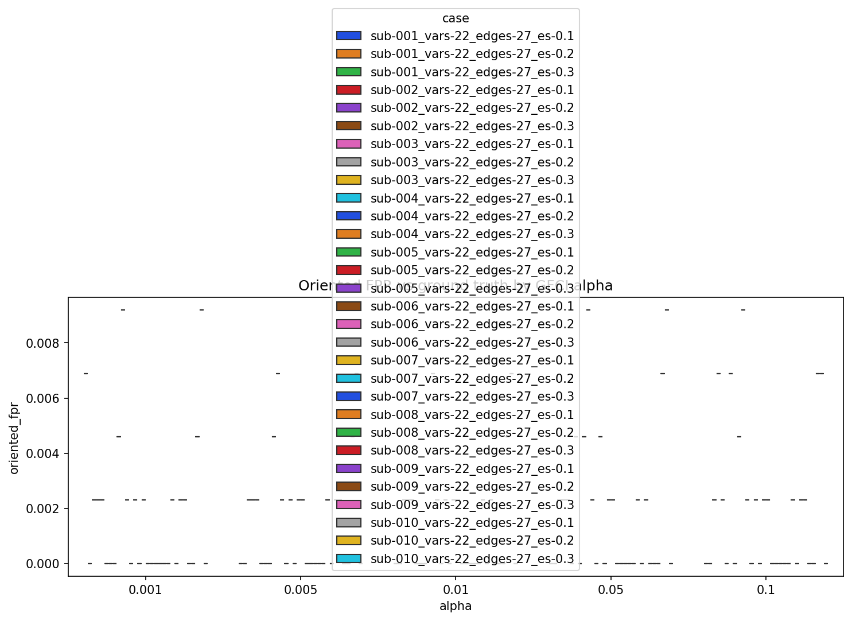
Figure E1. Official --cmd plot: oriented FPR by GFCI alpha.
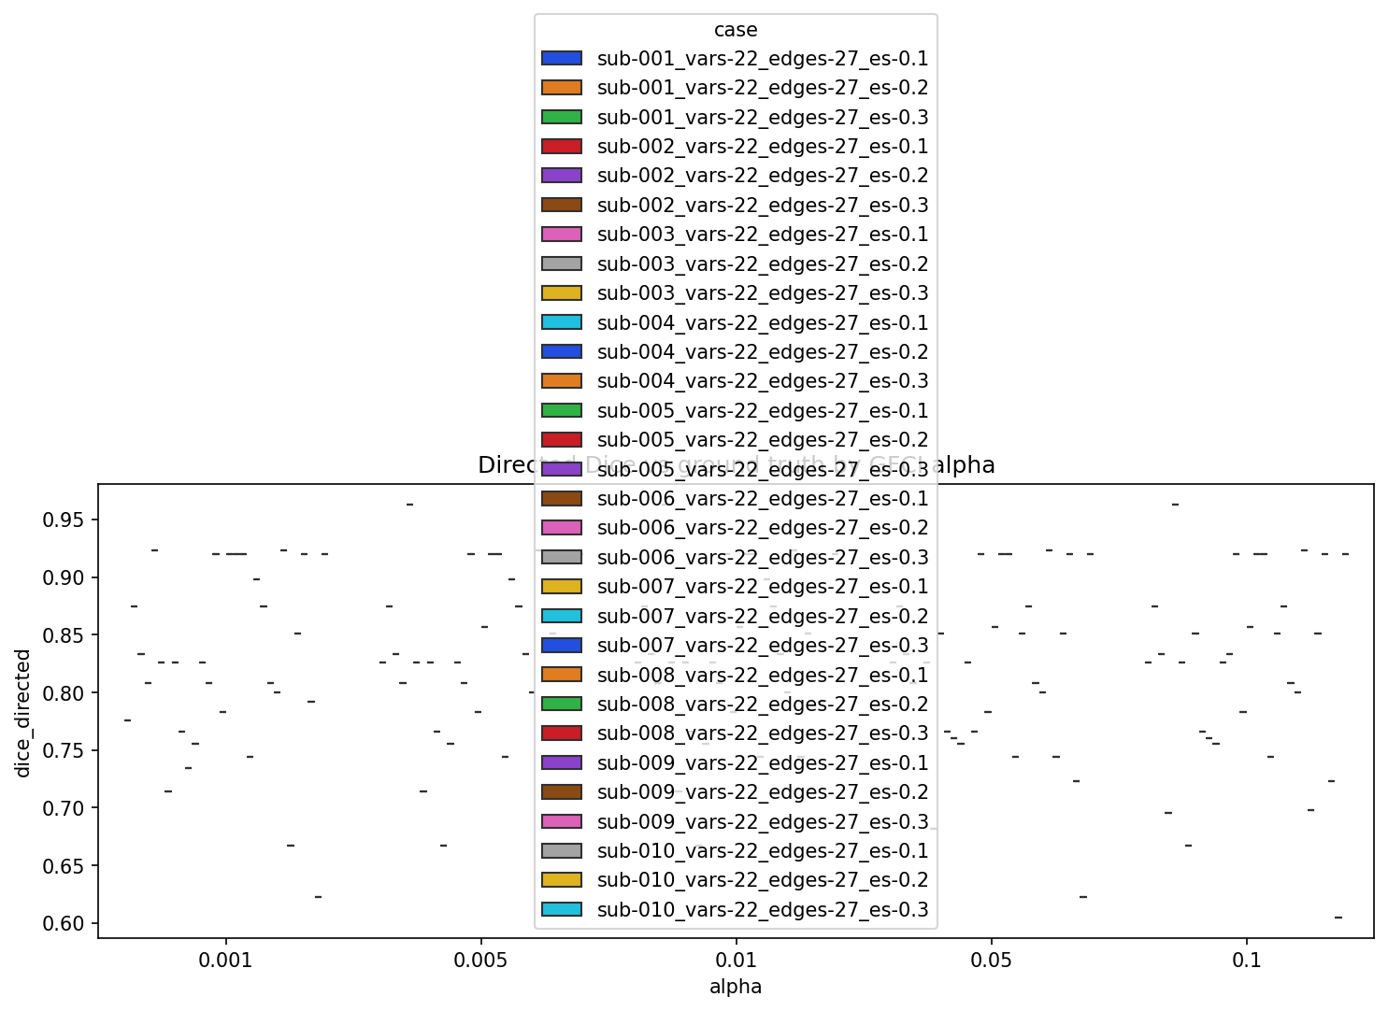
Figure E2. Official --cmd plot: directed Dice by GFCI alpha.
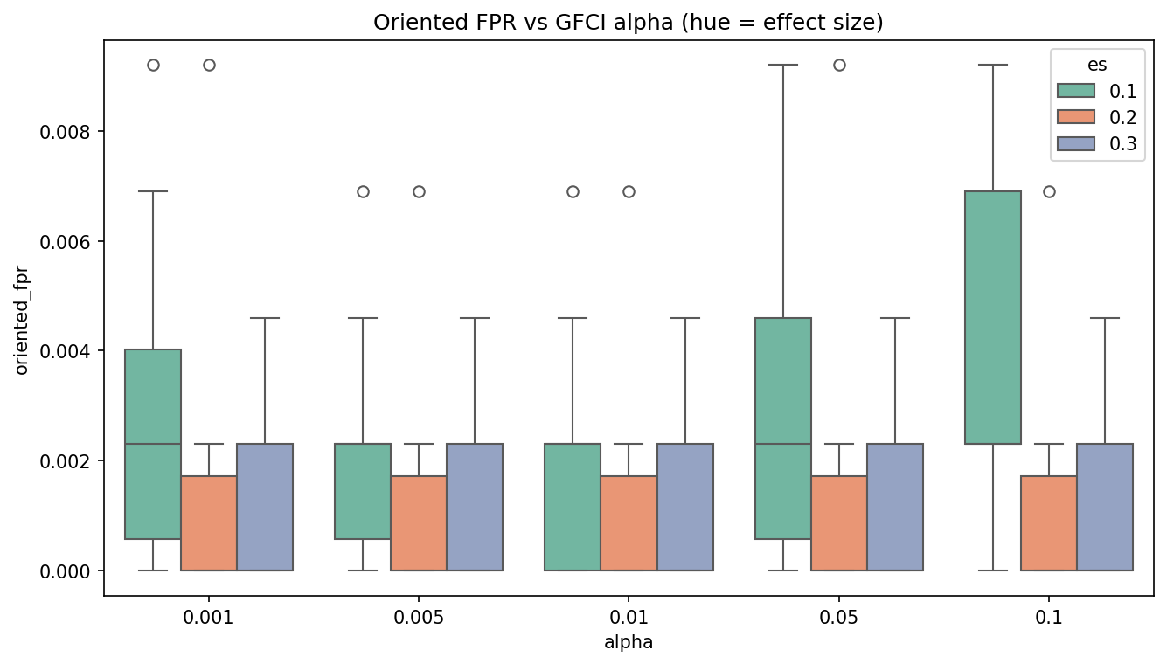
Figure E3. Oriented FPR by alpha, hue = effect size.
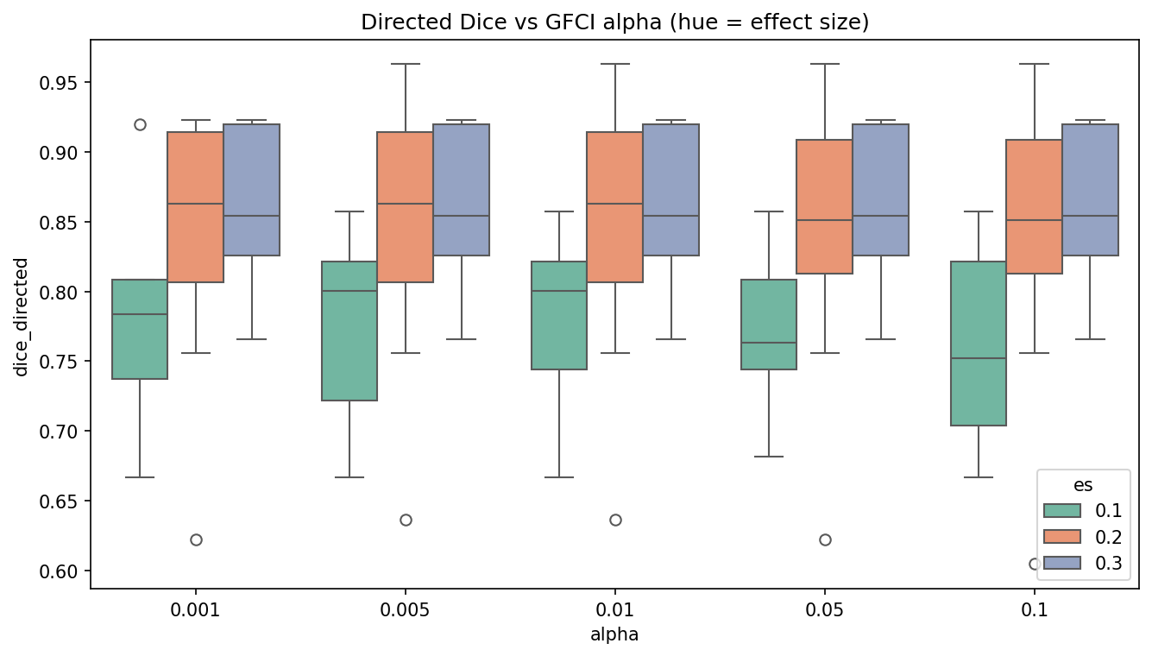
Figure E4. Directed Dice by alpha, hue = effect size.

Limitations
- Cell-wise MNAR, multiple imputation (MICE), and clinical/real-data missingness are not in this tree yet.
- SA4 selects hyperparameters against simulated picause truth only; clinical/real-data target-FPR calibration is out of scope.
- Absolute-closest |emp FPR − target| selection may exceed the target FPR; it is not “FPR ≤ target then max TPR.”
- simdata.py records Seed: 43 on every companion .txt file; the 30 graphs in this run were nonetheless unique (overflow retries / generator draws). Reproducibility of the exact DAG set should not be assumed from that printed seed alone.
- Official --cmd plot hues by case (30 colours). Effect-size-hued copies are included for readability.
- Proportion 1.0 is a single search per case; sampling variability at full n is not estimated by the 20-iteration loop.

