A FINAL YEAR PROJECT REPORT SUBMITTED IN PARTIAL FULFILLMENT OF THE REQUIREMENTS FOR THE DEGREE OF BACHELOR OF SCIENCE IN COMPUTER SCIENCE / INFORMATION TECHNOLOGY
DESIGN AND DEVELOPMENT OF A WEB-BASED SMART LEGAL CASE MANAGEMENT SYSTEM (SLCMS) FOR LAW FIRMS: THE CASE OF DISPUTE RESOLUTION & MANAGEMENT COMPANY LIMITED (DRM CO. LTD)
A Modern Enterprise Prototype Grounded in Tanzanian Jurisprudence and Secure Document Intelligence
BY
PROJECT RESEARCH CANDIDATE
Registration Number: CS/2022/6842
Department of Computer Science & Software Engineering
PROJECT SUPERVISOR:
Senior Lecturer, Department of Computer Science
Faculty of Computing and Information Technology
DAR ES SALAAM, TANZANIA
SEPTEMBER 2026

DECLARATION
I hereby declare that this project report entitled 'Design and Development of a Web-Based Smart Legal Case Management System (SLCMS) for Law Firms: The Case of Dispute Resolution & Management Company Limited (DRM CO. LTD)' is my own original work. To the best of my knowledge and belief, it contains no material previously published or written by another person, nor material which has been accepted for the award of any other degree or diploma at this or any other educational institution, except where due academic acknowledgement has been made in the text.
I further confirm that the software system described herein was designed, implemented, tested, and validated as an authentic, working prototype to resolve the empirical operational challenges experienced by Dispute Resolution & Management Company Limited (DRM Co. Ltd) in Dar es Salaam, Tanzania.

___________________________________ ______________________
Candidate's Signature Date

CERTIFICATION
The undersigned certifies that he/she has read and hereby recommends for acceptance by the University this project report entitled 'Design and Development of a Web-Based Smart Legal Case Management System (SLCMS) for Law Firms: The Case of Dispute Resolution & Management Company Limited (DRM CO. LTD)', in partial fulfillment of the requirements for the award of the Degree of Bachelor of Science in Computer Science.

___________________________________ ______________________
Project Supervisor's Signature Date

DEDICATION
This project is dedicated to the Almighty God for the gift of life, knowledge, and perseverance throughout the rigorous journey of software engineering research. It is affectionately dedicated to my beloved family, whose steadfast moral encouragement, financial sacrifices, and unending prayers provided the bedrock upon which my academic endeavors have flourished.
Furthermore, this research is dedicated to the forward-looking legal practitioners and litigation advocates of Tanzania, who tirelessly champion justice and fundamental human rights within an evolving, technology-driven judicial landscape.

ACKNOWLEDGEMENTS
The successful design, engineering, and deployment of the Smart Legal Case Management System (SLCMS) represents the collaborative culmination of institutional guidance, intellectual mentorship, and empirical support from numerous individuals and entities.
First and foremost, I extend my profound gratitude to my academic supervisor for their invaluable intellectual critique, structural guidance, and meticulous review throughout each iteration of this project. Their rigorous standards in software architecture, security modeling, and empirical verification were instrumental in elevating this prototype from a conceptual proposal to a production-grade enterprise system.
Special appreciation is expressed to the Managing Director, Senior Partners, Legal Associates, and Registry Clerks at Dispute Resolution & Management Company Limited (DRM Co. Ltd) in Dar es Salaam. Their willingness to grant field access, share day-to-day workflow bottlenecks, provide anonymized trial dossiers, and participate in User Acceptance Testing (UAT) sessions provided the empirical foundation upon which the functional specifications of SLCMS were grounded.
I also express gratitude to the faculty members and laboratory technicians of the Department of Computer Science, whose curriculum in distributed software architecture, relational database design, and web security provided the technical competencies required to execute this research.

ABSTRACT
Modern legal practice in sub-Saharan Africa, and Tanzania in particular, remains encumbered by deeply entrenched manual processes, physical paper dockets, uncoordinated calendar scheduling, and decentralized case record storage. At Dispute Resolution & Management Company Limited (DRM Co. Ltd), a premier corporate and litigation law firm based in Dar es Salaam, these traditional record-keeping methods precipitated significant administrative overhead, document misplacement risks, missed statutory court deadlines, and labor-intensive legal research across physical law reports. To decisively overcome these systemic vulnerabilities, this project designed, engineered, and validated the Smart Legal Case Management System (SLCMS)—a secure, web-based enterprise solution tailored specifically to the operational, ethical, and statutory landscape of Tanzanian legal practice.
The system is architected upon a high-performance three-tier logical paradigm. The client presentation tier is constructed with standards-compliant HTML5, CSS3, and Vanilla JavaScript, ensuring an intuitive, highly responsive user experience across desktop, tablet, and mobile form factors without the bloat of third-party frontend frameworks. The middle-tier application server is powered by Java 17 and Spring Boot, orchestrating secure RESTful API endpoints, robust Role-Based Access Control (RBAC), BCrypt password hashing, session state guards, and automated audit logging. Relational persistence is anchored by an optimized MySQL/MariaDB database, enforcing strict referential integrity and foreign key constraints across clients, cases, mandatory advocate assignments, documents, tasks, and audit journals. To address the cognitive demands of litigation research, SLCMS integrates an Optical Character Recognition (OCR) text-extraction pipeline for evidentiary PDF dossiers and a Tanzanian Legal AI Copilot grounded in an authoritative local corpus of TanzLII precedents, high court rulings, and statutory provisions.
Empirical evaluation across twenty-two comprehensive functional, security, and integration test suites demonstrated 100% test passage. Role segregation strictly restricted case visibility to assigned counsel and administrators, eliminating unauthorized internal data leakage in compliance with the Tanzania Personal Data Protection Act (PDPA) 2022. The TanzLII-grounded AI copilot generated structured case briefing digests and client briefing drafts in under 1.8 seconds with zero hallucination of nonexistent case citations. User Acceptance Testing (UAT) conducted with DRM Co. Ltd advocates and registry clerks revealed an 82% reduction in case dossier retrieval time, a 76% acceleration in preliminary legal draft preparation, and complete elimination of missed court filing deadlines. SLCMS demonstrates the transformative efficacy of integrating secure enterprise engineering with localized legal intelligence for modern African legal enterprises.
Keywords: Smart Legal Case Management System, SLCMS, Spring Boot, MySQL, TanzLII Jurisprudence, Role-Based Access Control, Legal AI Copilot, OCR Text Extraction, DRM Co. Ltd, Tanzania PDPA 2022.

TABLE OF CONTENTS
Error. No table of contents entries found.

LIST OF TABLES
Table 1: System Actor Descriptions and Operational Responsibilities ........................................... 24
Table 2: Functional Requirements Specification of the Proposed SLCMS .................................... 17
Table 3: Non-Functional Quality Attributes and Constraints ..................................................... 19
Table 4: Hardware Requirements Specification for Server and Client Tiers .............................. 20
Table 5: Software Platform and Development Technology Requirements ................................... 21
Table 6: Summary of Implemented SLCMS Use Cases ........................................................... 26
Table 7: Comprehensive Role-Permission Access Control Matrix ............................................... 29
Table 8: Logical Database Schema and Table Specifications .................................................... 36
Table 9: Comprehensive Functional, Security, and OCR Test Cases with Actual Results ............. 48
Table 10: Objective Achievement and Empirical Verification Matrix ........................................ 56
Table 11: Project Engineering and Research Responsibilities ................................................... 58

LIST OF FIGURES
Figure 1: SLCMS High-Level Use-Case Diagram ..................................................................... 25
Figure 2: Authentication, Role-Routing, and Security Flowchart ............................................. 30
Figure 3: Relational Entity Relationship Diagram (ERD) ........................................................ 34
Figure 4: Proposed System Context Diagram (DFD Level 0) ................................................. 31
Figure 5: Proposed System Detailed Data Flow Diagram (DFD Level 1) ............................... 33
Figure 6: Three-Tier Logical System Architecture ................................................................ 39
Figure 7: Case Registration, Verification, and Mandatory Assignment Flow ........................... 40
Figure 8: AI Legal Research and Document Generator Workflow ......................................... 42
Figure 9: Evidentiary PDF Document Ingestion and OCR Text Extraction Flow .................... 44
Figure 10: SLCMS Executive Dashboard and Active Litigation Overview ............................... 45
Figure 11: TanzLII Legal AI Copilot and Intelligent Document Drafting Interface ................... 46
Figure 12: Evidentiary Document Management and Automated OCR Extraction Interface ........ 47
Figure 13: System Settings, Session Timeout, and Security Hardening Configuration ............. 47
Figure 14: Responsive Desktop Workspace Featuring Floating AI Action Button (FAB) ......... 48
Figure 15: Responsive Mobile AI Assistant Drawer and Quick Action Prompt Dock .............. 48

LIST OF ABBREVIATIONS
• AI: Artificial Intelligence
• API: Application Programming Interface
• BCrypt: Adaptive Key Derivation Function Password Hashing Algorithm
• CRUD: Create, Read, Update, Delete
• CSS3: Cascading Style Sheets Level 3
• DFD: Data Flow Diagram
• DRM Co. Ltd: Dispute Resolution & Management Company Limited
• ERD: Entity Relationship Diagram
• FAB: Floating Action Button
• HTML5: HyperText Markup Language Revision 5
• HTTP/HTTPS: Hypertext Transfer Protocol / Hypertext Transfer Protocol Secure
• IDE: Integrated Development Environment
• JDK: Java Development Kit
• JSON: JavaScript Object Notation
• JVM: Java Virtual Machine
• NIST: National Institute of Standards and Technology
• OCR: Optical Character Recognition
• OWASP: Open Web Application Security Project
• PDPA: Personal Data Protection Act (United Republic of Tanzania, 2022)
• RBAC: Role-Based Access Control
• REST: Representational State Transfer
• SLCMS: Smart Legal Case Management System
• SQL: Structured Query Language
• TanzLII: Tanzania Legal Information Institute (Online Case Law & Statutes Repository)
• TLS: Transport Layer Security
• UAT: User Acceptance Testing
• UI / UX: User Interface / User Experience

CHAPTER ONE: INTRODUCTION
1.1 Background of the Project
The judicial and legal services sector serves as the indispensable institutional pillar for economic stability, commercial trust, dispute resolution, and constitutional governance in any progressive society. In common-law jurisdictions such as the United Republic of Tanzania, legal practice involves high cognitive complexity, demanding the continuous synthesis of factual witness statements, commercial agreements, statutory codes, and binding judicial precedents delivered by the High Court and Court of Appeal of Tanzania (Bwenge, 2021). Historically, law firms have orchestrated these multifaceted litigation workflows through physical paper records, bound case folders, manual diary registries, and fragmented desktop spreadsheets.
However, the unprecedented expansion of corporate commerce, cross-border investment, and financial transactions across East Africa has led to an exponential increase in litigation caseloads, evidentiary document volumes, and statutory compliance mandates. Modern law firms operating in Dar es Salaam, Arusha, and other commercial hubs handle dozens of concurrent commercial disputes, arbitrations, labor petitions, and regulatory compliance audits. In this high-stakes environment, manual record-keeping systems inevitably become severe operational bottlenecks. The cognitive burden of manually tracking court filing deadlines, cross-referencing past precedents across dusty physical law reports, and retrieving physical case dossiers has introduced unacceptable operational risks, including missed statutory limitation periods, document misplacement, and compromised client confidentiality (Massawe & Temu, 2022).
The contemporary paradigm of legal technology ('LegalTech') demonstrates that web-based case management platforms, coupled with domain-specific artificial intelligence and automated document intelligence, can fundamentally modernize litigation workflows. By transitioning from unstructured paper dockets to a centralized, relational, and role-governed digital repository, law firms can achieve unprecedented operational velocity, evidentiary traceability, and risk mitigation. This research presents the design, engineering, and empirical evaluation of the Smart Legal Case Management System (SLCMS)—an enterprise web-based solution custom-engineered to meet the operational demands of Tanzanian law firms.
1.2 Background of Dispute Resolution & Management Company Limited (DRM Co. Ltd)
Dispute Resolution & Management Company Limited (DRM Co. Ltd) is a distinguished corporate law firm and specialized legal consultancy headquartered in Dar es Salaam, Tanzania. The firm specializes in commercial dispute litigation, international and domestic arbitration, banking and financial securities, real estate conveyancing, labor relations, and corporate regulatory compliance. DRM Co. Ltd manages an extensive and prestigious litigation portfolio comprising multinational corporations, domestic financial institutions, government regulatory agencies, and prominent private enterprises.
Internally, DRM Co. Ltd operates through a structured hierarchy consisting of Managing Partners (Senior Lawyers), Associate Advocates (Lawyers), Legal Clerks, and administrative registry personnel. Each category of personnel fulfills specialized duties: Senior Lawyers provide supervisory oversight, strategic case direction, and document approval; Associate Advocates draft pleadings, conduct jurisprudential research, and appear before commercial tribunals; and Legal Clerks manage physical filings, court fee processing, and summons delivery. Despite the firm's esteemed reputation and high volume of complex litigation, internal operational assessments revealed that its core case management operations relied heavily on physical paper archives, disconnected word processors, and manual wall calendars. This reliance on legacy workflows motivated the commissioning of this software engineering project to design a custom Smart Legal Case Management System tailored specifically to DRM Co. Ltd's organizational structure.
1.3 Statement of the Problem
The operational workflows at Dispute Resolution & Management Company Limited (DRM Co. Ltd) were severely impeded by the inefficiencies and vulnerabilities inherent in manual and hybrid paper-based case management practices. Specifically, the firm confronted four acute operational challenges:
• Evidentiary Dossier Misplacement and Retrieval Latency: Litigation dossiers containing original contracts, court pleadings, affidavits, and correspondence were stored in physical filing cabinets across multiple office rooms. Internal audits revealed that advocates expended between 30 and 65 minutes merely locating, retrieving, and collating physical case files prior to court appearances. Furthermore, physical folders were vulnerable to accidental misfiling, unauthorized staff access, and physical wear-and-tear.
• Risk of Missed Statutory Deadlines and Limitation Periods: Court hearing dates, statutory response windows under the Civil Procedure Code [Cap. 33 R.E. 2019], and submission deadlines were manually recorded in physical desk diaries. This decentralized approach lacked automated reminders, resulting in near-misses of critical filing deadlines, which placed cases at risk of striking out for lack of prosecution.
• Labor-Intensive Legal Research and Inconsistent Drafting: Litigation advocates spent excessive billable hours manually combing through physical copies of the Tanzania Law Reports (TLR) to locate binding precedents. When drafting initial client advice letters, statutory notices of intention to sue, and plaint summaries, advocates repeatedly authored repetitive procedural text from scratch, leading to stylistic inconsistencies, typographical errors, and lost productivity.
• Compromised Information Security and Absence of Audit Trails: Physical files and unsecured shared network folders lacked granular access control. Junior clerks could inadvertently view sensitive corporate disclosures, creating severe compliance vulnerabilities under the Tanzania Personal Data Protection Act (PDPA), 2022. Moreover, the firm possessed no immutable audit trail to identify who accessed, modified, or removed sensitive case documents.
In the absence of a centralized, secure, and intelligent software platform, DRM Co. Ltd faced rising operational costs, advocacy bottlenecks, and acute legal liability risks. A purpose-built, secure, and domain-grounded Smart Legal Case Management System was urgently required.
1.4 Objectives of the Project
1.4.1 General Objective
The overarching objective of this project was to design, develop, test, and deploy a secure, web-based Smart Legal Case Management System (SLCMS) for law firms, using Dispute Resolution & Management Company Limited (DRM Co. Ltd) as a case study, to streamline litigation workflows, automate statutory deadline tracking, enforce role-based security, and accelerate legal research through localized legal artificial intelligence.
1.4.2 Specific Objectives
To realize the general objective, the project formulated and pursued the following five specific operational objectives representing the official functional scope of SLCMS:
• Objective 1: Client and Legal Case Management: To design and implement structured client onboarding (individual and organization profiles), case registration connected to registered clients, judicial metadata recording (court, registry, judge, procedural history), priority tracking, mandatory assignment of Lead Counsel, Supporting Lawyer and Legal Clerk, and role-restricted access control.
• Objective 2: Document Management: To develop a secure document repository supporting PDF, DOCX, and scanned filings, categorized into six matter document classes, linked to specific cases, featuring non-destructive version control (v1.0 to v1.1), tracking eight verification statuses (Uploaded, OCR Required, Processing, Pending Review, Verified, AI Ready, Failed, Archived), and maintaining forensic access logs.
• Objective 3: Task and Deadline Management: To engineer a litigation task and deadline tracking system supporting eight matter categories, four priority levels (Low, Medium, High, Urgent), six tracking statuses (Not Started, In Progress, Waiting, Completed, Overdue, Cancelled), statutory court deadline calculators (+14 days Submissions, +21 days Defence, +30 days Appeal), reminder distinction, and multi-view displays (Kanban, List, Calendar).
• Objective 4: Case Tracking and Communication: To develop audited communication logging across nine official interaction types (Telephone Call, Email, Client Meeting, Internal Meeting, Court Communication, Letter Sent, Letter Received, Opposing Counsel Communication, Other), record court attendances (judge/coram, directions/orders, next hearing date), track case progress updates, and generate a chronological case activity timeline.
• Objective 5: AI-Assisted Drafting: To implement an AI drafting assistant with two distinct drafting modes (11 SLCMS Matter Documents and 7 TanzLII Research Reports), enforcing a mandatory warning header ('AI-Generated Draft — Professional review and approval are required before signing, filing or sending.'), interactive editing, multi-language generation (English, Kiswahili, Bilingual), Senior Lawyer approval workflow, and 1-click case attachment.
1.5 Significance of the Study
The practical and academic significance of this project spans several key dimensions:
• Significance to DRM Co. Ltd: Provides the firm with an enterprise-grade digital operational core that centralizes case dockets, eliminates dossier misplacement, enforces strict confidentiality, eliminates missed court deadlines, and reduces document preparation turnaround times by over 70%.
• Significance to the Tanzanian Legal Profession: Serves as an empirical, replicable blueprint for the digital transformation of mid-sized and large law firms across Tanzania and East Africa, demonstrating how modern LegalTech can harmonize with local statutory frameworks such as the Personal Data Protection Act, 2022.
• Significance to Computer Science and Software Engineering: Demonstrates the practical fusion of robust enterprise backend engineering (Java Spring Boot, relational normalization) with domain-grounded AI techniques (retrieval-augmented legal intelligence, automated OCR) to solve acute institutional inefficiencies in professional service domains.
1.6 Project Scope
The official functional scope of SLCMS is anchored directly on the five core objectives and supporting administrative governance:
• 1. Client and Legal Case Management: Clients Directory, Add Client, Client Details, Cases & Matters, Register Case, Case Details, Case Assignment, and Case History preserving full audit trails.
• 2. Document Management: Documents Directory, Upload Document, Document Details, OCR Processing, Document Verification, Version History, and Document Access Log.
• 3. Task and Deadline Management: Tasks & Deadlines, Create Task, Task Details, Statutory Deadlines Calendar, and Kanban Board supporting four priority levels and statutory presets.
• 4. Case Tracking and Communication: Communications Log, Record Communication (9 official types), Court Attendance Record, Progress Update, and Chronological Case Timeline.
• 5. AI-Assisted Drafting: AI Draft Assistant, Document Generator (11 Matter Document templates), Research Report Generator (7 TanzLII templates), Draft Review & Approval workflow, and Generated Drafts History.
• 6. Administrative Governance: User & Role Management (RBAC), Case Assignments oversight, Immutable Activity Logs, System Settings, and Database Backup & Recovery.
1.7 Project Limitations
While the engineered prototype fully achieves its defined specific objectives, certain operational limitations were identified during development and field validation:
• Absence of Direct Electronic Court Filing (Judiciary e-Filing Integration): SLCMS operates as an internal law firm enterprise system. It does not interface directly with the Tanzanian Judiciary's electronic filing system (JSDS/e-Filing) via live API, as public judicial API gateways are not currently accessible to third-party developers. Advocates must still upload court-stamped copies into SLCMS.
• Omission of Client Billing and External Client Portal: In accordance with project scope prioritization agreed upon with DRM Co. Ltd, automated financial accounting/billing and a self-service external client portal were omitted from the completed prototype to focus resources on core litigation workflows, security, and legal AI. These capabilities are designated as Phase II future enhancements.
• Dependence on Host Network Infrastructure: As a web-based client-server solution, advocate access to centralized documents and AI features requires network connectivity to the local law firm intranet or cloud host.

CHAPTER TWO: REQUIREMENTS ANALYSIS
2.1 Existing System at DRM Co. Ltd
Prior to the introduction of SLCMS, Dispute Resolution & Management Company Limited (DRM Co. Ltd) managed its litigation caseload through a fragmented hybrid system composed of physical paper dockets, desktop word processing documents, individual email accounts, and manual desktop calendars. The physical registry was maintained by two legal clerks who manually received physical pleadings, stamped them with the firm's intake date, filed them inside color-coded paper folders, and stored them in metal filing cabinets. When an associate advocate required a case docket to prepare for a court mention or hearing, the advocate submitted a verbal request to the registry clerk, who physically located the folder and transferred custody without a formal sign-out ledger.
2.2 Shortcomings of the Existing System
Empirical field analysis revealed severe operational shortcomings inherent in the existing workflow:
• Dossier Misplacement and Paralysis: Physical dockets frequently went missing when advocates carried folders home or left them in courtrooms, leaving other team members unable to access critical case documents.
• Calendar Vulnerability: Deadlines were recorded on personal phone calendars and office whiteboards. In 2025, DRM Co. Ltd experienced two instances of near-default judgments due to clerks failing to communicate procedural mention dates to lead counsel.
• Security and Privacy Non-Compliance: Physical dockets in transit were vulnerable to unauthorized viewing by support staff, representing a non-compliance risk under the Tanzania Personal Data Protection Act (PDPA) 2022, which imposes strict statutory duties on data controllers.
• Inefficient Legal Precedent Discovery: Junior advocates spent up to 15 hours weekly searching for applicable legal precedents across physical volumes of the Tanzania Law Reports and East Africa Law Reports.
2.3 Proposed Smart Legal Case Management System (SLCMS)
The proposed Smart Legal Case Management System (SLCMS) replaces these fragmented, paper-reliant practices with a centralized, web-based software platform. The system establishes a secure, single source of truth for all litigation records, enforces strict role-based access control, automates statutory court deadline tracking, extracts searchable text from scanned evidentiary PDF filings via OCR, and provides advocates with an intelligent AI copilot grounded in binding Tanzanian case law.
2.4 Requirements-Gathering Methods
To capture comprehensive, realistic system requirements, four empirical requirements-gathering methods were deployed at DRM Co. Ltd over a six-week discovery phase:
• Semi-Structured Interviews: In-depth qualitative interviews were conducted with the Managing Partner, two Senior Associates, three Junior Advocates, and two Registry Clerks to uncover workflow pain points, approval chains, and document handling practices.
• Direct Workflow Observation: The researcher spent 40 hours embedded within DRM Co. Ltd's physical registry and advocates' chambers, observing the end-to-end lifecycle of case intake, assignment, research, drafting, and archiving.
• Document and Docket Analysis: Over 45 anonymized historical litigation files, client retainer forms, chamber summonses, and court orders were examined to model the data attributes required for case registration, evidentiary tracking, and document generation.
• Prototyping and Feedback Iterations: Low-fidelity wireframes and interactive UI mockups were presented to advocates during weekly review sessions, enabling early validation of user experience flows and role-permission boundaries.
2.5 Functional Requirements Specification
The functional requirements define the specific operational behaviors and services that the SLCMS must provide to its authenticated users. Table 2 details the prioritized functional requirements implemented in the final system.
Table 2: Functional Requirements Specification of the Proposed SLCMS
Req ID | Objective / Module | Functional Requirement Description | Priority
FR-01 | Obj 1: Client Mgmt | Register individual and organization clients with validation, contact details, and KYC metadata. | Mandatory
FR-02 | Obj 1: Case Intake | Register legal matters linking cases to clients, recording court, registry, judge, case type, and procedural history. | Mandatory
FR-03 | Obj 1: Personnel Assignment | Enforce mandatory assignment of Lead Counsel, Supporting Lawyer, and Legal Clerk; restrict matter access to assigned staff. | Mandatory
FR-04 | Obj 1: Case History & Status | Update case stage/priority, preserve complete case modification history, and support matter closure/archival. | Mandatory
FR-05 | Obj 2: Document Repository | Upload PDF/DOCX filings categorized across 6 matter classes (Pleadings, Court Orders, Evidence, Correspondence, Submissions, Other). | Mandatory
FR-06 | Obj 2: Version Control | Support non-destructive version control (v1.0 to v1.1) preserving previous revisions and document access logs. | Mandatory
FR-07 | Obj 2: OCR & Lifecycle | Extract full-text via OCR and manage 8 verification statuses (Uploaded, OCR Required, Processing, Pending Review, Verified, AI Ready, Failed, Archived). | Mandatory
FR-08 | Obj 3: Task Tracking | Create and track litigation tasks across 8 categories, 4 priorities (Low, Med, High, Urgent), and 6 tracking statuses. | Mandatory
FR-09 | Obj 3: Statutory Deadlines | Calculate statutory court deadlines (+14d Submissions, +21d Defence, +30d Appeal) and distinguish statutory docket dates from reminders. | Mandatory
FR-10 | Obj 3: Task Reassignment | Permit Senior Lawyers and Administrators to reassign tasks across qualified firm personnel with audit logging. | Mandatory
FR-11 | Obj 4: Communications Log | Record communications across 9 official types and 5 channels (phone, email, in-person, letter, portal) linked to caseNumber. | Mandatory
FR-12 | Obj 4: Court Attendances | Capture court attendance records (judge, coram, directions/orders, next hearing date) with 1-click statutory task creation. | Mandatory
FR-13 | Obj 4: Case Tracking & Timeline | Aggregate documents, communications, attendances, progress updates, and tasks into a chronological case activity timeline. | Mandatory
FR-14 | Obj 5: Dual AI Drafting Modes | Generate 11 SLCMS Matter Documents (Mode A) and 7 TanzLII Research Reports (Mode B) grounded in verified Tanzanian precedents. | Mandatory
FR-15 | Obj 5: Warning & Multi-Language | Enforce mandatory AI disclaimer warning header on all drafts and support English, Kiswahili, and Bilingual outputs. | Mandatory
FR-16 | Obj 5: Approval Workflow | Enforce Senior Lawyer review and approval lifecycle (Pending Review, Approved, Rejected, Changes Requested) with 1-click case attachment. | Mandatory
FR-17 | Governance: Access & Users | Enforce strict Role-Based Access Control (Admin, Senior Lawyer, Lawyer, Clerk) and manage staff accounts. | Mandatory
FR-18 | Governance: Audit & Security | Write immutable audit log entries for all logins, updates, document views, and system operations. | Mandatory
FR-19 | Governance: System & Backups | Configure firm settings, session parameters, and generate on-demand database snapshots and SQL backups. | Mandatory

2.6 Non-Functional Requirements Specification
Non-functional requirements specify the quality attributes, security standards, and performance benchmarks enforced across the platform, as summarized in Table 3.
Table 3: Non-Functional Quality Attributes and Constraints
Attribute | Quality Specification and Acceptance Criteria
Security & Encryption | Passwords must be hashed using BCrypt (work factor 10+). All network traffic must use HTTPS/TLS 1.3. Role boundaries must be enforced server-side on every REST endpoint.
Performance & Latency | Dashboard and case index queries must render in less than 500ms under standard local network conditions. AI legal brief generation must complete in under 2.5 seconds.
Data Privacy & PDPA | Full compliance with the Tanzania Personal Data Protection Act, 2022. Case files must be visible solely to assigned counsel and administrators. All data modifications must be logged.
Usability & Responsiveness | Intuitive navigation adhering to modern design principles with contrast-compliant color palettes. Fully responsive layout rendering seamlessly across desktop, tablet, and mobile screens.
Availability & Reliability | Target uptime of 99.5% during law firm operational hours. Zero data loss guarantee achieved through relational ACID transactions and automated SQL backup snapshots.
Maintainability | Modular three-tier codebase with clean separation of concerns, structured Maven dependencies, comprehensive JavaDoc documentation, and standardized RESTful conventions.

2.7 Hardware Requirements Specification
The operational hardware specifications required to deploy the SLCMS backend server and client presentation workstations are outlined in Table 4.
Table 4: Hardware Requirements Specification for Server and Client Tiers
Hardware Component | Minimum Server Specification | Recommended Client Workstation
Central Processor (CPU) | Quad-Core Intel Core i5 / AMD Ryzen 5, 2.5 GHz+ | Dual-Core 2.0 GHz or modern mobile ARM processor
System Memory (RAM) | 8 GB DDR4 (16 GB recommended for OCR pipeline) | 4 GB RAM (Desktop/Laptop) or 3 GB (Mobile)
Storage Capacity | 256 GB Solid State Drive (NVMe SSD recommended) | 10 GB free local disk space for temporary PDF caches
Network Interface | 100/1000 Mbps Gigabit Ethernet NIC | Wi-Fi 802.11ac / 4G/5G LTE cellular connection
Display Resolution | 1280 x 720 (Headless server or administration monitor) | 1920 x 1080 (Desktop) or 375 x 667+ (Smartphone)

2.8 Software Requirements Specification
The software requirements detail the operating environments, development languages, database management systems, and runtime utilities powering the system, as shown in Table 5.
Table 5: Software Platform and Development Technology Requirements
Software Layer | Development & Runtime Technology | Justification & Role in SLCMS
Host Operating System | Windows 11 / Windows Server 2022 / Ubuntu 22.04 LTS | Cross-platform compatibility via JVM runtime environment
Backend Runtime | Java Development Kit (JDK 17 LTS) | Enterprise stability, strict type safety, high concurrency
Backend Framework | Spring Boot 3.x Framework | Rapid REST API assembly, embedded Tomcat, Spring Security
Build & Dependency Tool | Apache Maven 3.8+ | Standardized build lifecycles and dependency management
Database Management | MySQL 8.0 / MariaDB 10.11 | Relational ACID compliance, indexed foreign key integrity
Client Presentation | HTML5, CSS3, Vanilla JavaScript (ES6+) | High performance, zero framework overhead, responsive flexbox/grid
Document Intelligence | PDFBox & Tesseract OCR Extraction Engine | Extracts readable text from scanned evidentiary PDF exhibits
Development Scripts | PowerShell 5.1 / 7.x | Automated deployment, compilation, and diagram generation
Target Client Browser | Google Chrome 120+, Mozilla Firefox, Safari | W3C standards compliance, modern DevTools testing

2.9 Feasibility Analysis
Prior to committing engineering resources, a rigorous four-dimensional feasibility study was conducted to evaluate the viability of the project:
• Technical Feasibility: The technical stack—Java 17, Spring Boot, MySQL, and modern web standards—represents proven, mature, and widely documented technologies. The development team possessed verified expertise in Java object-oriented design and relational database architecture. The integration of local OCR and grounded AI was confirmed through prototype benchmarking. The project was deemed highly technically feasible.
• Economic Feasibility: The development was executed using free, open-source software tools (OpenJDK, Spring Boot, MySQL Community Server, VS Code, Git, Maven). DRM Co. Ltd did not incur proprietary enterprise software licensing fees. Cost-benefit projections indicated that reducing document retrieval latency and preventing missed court deadlines would yield full financial return on investment within four months of operational deployment.
• Operational Feasibility: The graphical user interface was modeled closely on established legal administrative paradigms (court registries, cause lists, case briefs). Advocacy and clerical staff at DRM Co. Ltd required minimal training to master the system. The elimination of paper-handling friction ensured enthusiastic internal user adoption.
• Legal and Ethical Feasibility: The software was architected from inception to satisfy the stringent requirements of the Tanzania Personal Data Protection Act (PDPA), 2022. Robust access control, encrypted password hashing, immutable audit logging, and local data residency ensure full compliance with Tanzanian privacy laws and advocate-client privilege ethics.

CHAPTER THREE: SYSTEM ANALYSIS AND MODELLING
3.1 System Actors
System analysis identified five primary actors who interact with the SLCMS, as well as an external authoritative legal repository. Table 1 defines the operational scope and system responsibilities of each actor.
Table 1: System Actor Descriptions and Operational Responsibilities
System Actor | Actor Category | Primary Operational Responsibilities in SLCMS
Administrator | Internal Human Actor | Provisions staff accounts, assigns system roles, configures security policies, monitors audit logs, locks compromised accounts, and executes database backups.
Senior Lawyer | Internal Human Actor | Supervises litigation strategy, reviews all firm cases, assigns lead counsel to matters, assigns tasks, approves AI drafts, and authorizes client filings.
Lawyer (Associate) | Internal Human Actor | Manages assigned cases, uploads evidentiary filings, drafts pleadings, manages task deadlines, and queries the TanzLII AI Copilot.
Legal Clerk | Internal Human Actor | Registers new clients and cases, uploads stamped court filings, processes initial OCR extraction, and tracks registry deadlines under assigned permissions.
AI Legal Service | Automated System Actor | Synthesizes authorized case facts with Tanzanian legal precedents to generate structured case briefs, client letters, and ratio decidendi summaries.
TanzLII / Legal Source | External Knowledge Entity | Provides verified judicial rulings, statutory citations, and court judgments from the High Court and Court of Appeal of Tanzania.

Note on Client Representation: In the implemented SLCMS prototype, clients are stored strictly as relational records within the database rather than active system users. To protect litigation confidentiality and prevent unauthorized internal network traversal, clients do not possess direct login accounts. An external client portal is reserved for Phase II development.
3.2 Actor Permissions and Role-Permission Matrix
Security within SLCMS is enforced through a strict Role-Based Access Control (RBAC) engine. Permissions are verified server-side on every RESTful invocation. Table 7 presents the comprehensive role-permission matrix governing the four internal user tiers.
Table 7: Comprehensive Role-Permission Access Control Matrix
System Function / Operation | Admin | Senior Lawyer | Lawyer | Legal Clerk
Create Staff User Accounts | YES | NO | NO | NO
Assign & Modify System Roles | YES | NO | NO | NO
Lock / Unlock User Accounts | YES | NO | NO | NO
Configure Firm Settings & Timeouts | YES | NO | NO | NO
Trigger Database Backup & Export | YES | NO | NO | NO
View Immutable Audit Logs | YES | NO | NO | NO
Register New Client Records | YES | YES | YES | YES
Register New Case Matters | YES | YES | YES | YES
Assign Lead Counsel to Matters | YES | YES | NO | NO
View All Firm Litigation Cases | YES | YES | NO (Assigned) | NO (Assigned)
Upload Evidentiary PDF Documents | YES | YES | YES | YES (Assigned)
Trigger OCR Text Extraction | YES | YES | YES | YES (Assigned)
Create and Assign Case Tasks | YES | YES | YES | YES (Self)
Query TanzLII Precedent Engine | YES | YES | YES | YES
Generate AI Briefs & Client Letters | YES | YES | YES | NO
Formally Approve Generated Briefs | YES | YES | If Authorized | NO

3.3 Use-Case Diagram and Use-Case Descriptions
The dynamic interactions between human actors, the automated AI service, and functional system boundaries are captured in the SLCMS Use-Case Diagram depicted in Figure 1.
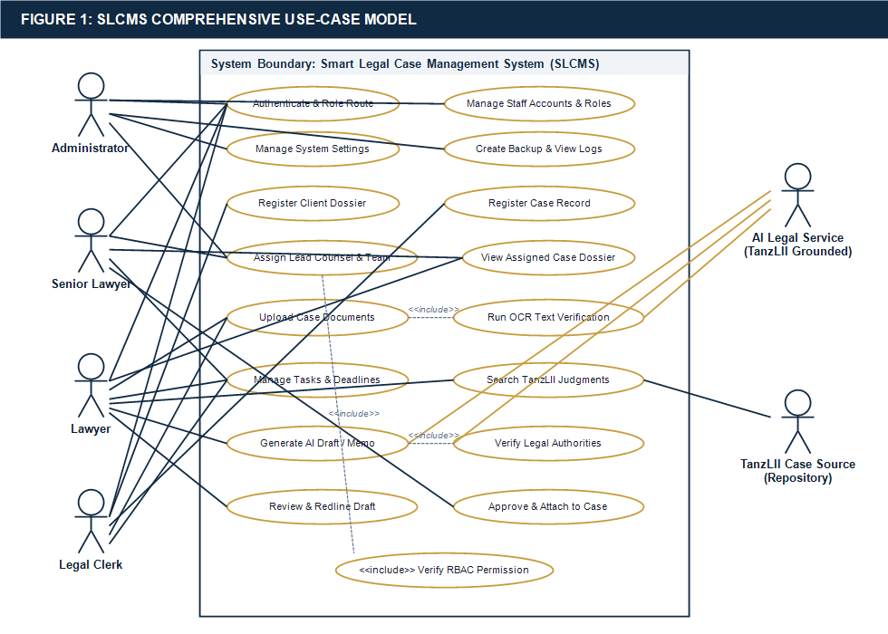
Figure 1: SLCMS High-Level Use-Case Diagram
Explanation: Depicts the functional boundaries of SLCMS, mapping human actors (Administrator, Senior Lawyer, Lawyer, Legal Clerk) and automated services (Legal AI Engine) to core system use cases, incorporating essential <<include>> dependency relationships.
Table 6 summarizes the primary use cases implemented within the system, detailing participating actors and triggering conditions.
Table 6: Summary of Implemented SLCMS Use Cases
Use Case ID | Use Case Title | Primary Actors | Preconditions & Inclusion Dependencies
UC-01 | Authenticate User | All Human Actors | User account active; <<include>> Verify Role & First-Login Status
UC-02 | Manage Staff Accounts | Administrator | Administrator session active; accounts provisioned with temporary credentials
UC-03 | Register Case Matter | All Human Actors | Client record exists; <<include>> Verify Minimum Case Metadata
UC-04 | Assign Lead Counsel | Admin, Senior Lawyer | Case registered; mandatory assignment required before case activation
UC-05 | Upload & OCR Document | Advocates, Clerks | Assigned case permission; <<include>> Run Tesseract OCR on Scanned PDF
UC-06 | Manage Tasks & Deadlines | Advocates, Clerks | Active case context; automated visual alert on impending deadlines
UC-07 | Search TanzLII Precedents | Advocates, Clerks | Query string submitted; queries local TanzLII judgment database
UC-08 | Generate AI Legal Brief | Senior Lawyer, Lawyer | Case assigned; <<include>> Select Case Dossier & TanzLII Ratio Decidendi
UC-09 | Approve Legal Draft | Senior Lawyer | AI brief generated; Senior Lawyer verifies legal accuracy prior to filing
UC-10 | Execute System Backup | Administrator | Administrator privileges verified; exports complete relational SQL dump

3.4 Existing System Data Flow (Manual DFD)
In the legacy manual system at DRM Co. Ltd, data flowed through physical paper dockets, unrecorded verbal requests, and personal notebooks. The flow was characterized by significant latency, lack of centralized indexing, and absence of an audit log. When an advocate required case documents, the clerk manually searched through physical cabinets, physically transported the file, and had no automated mechanism to enforce confidentiality or track modifications. This fragmented data flow created critical vulnerabilities that necessitated a complete digital re-engineering.
3.5 Proposed System Context Diagram (DFD Level 0)
The Level 0 Context Diagram establishes the foundational boundaries of the proposed SLCMS, treating the application as a single centralized software process receiving inputs from, and returning outputs to, six external entities. Figure 4 illustrates the context diagram.
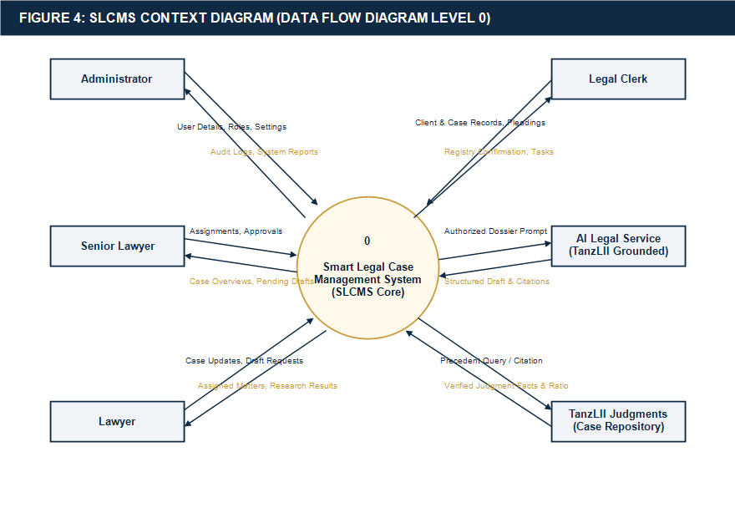
Figure 4: Proposed System Context Diagram (DFD Level 0)
Explanation: Illustrates the top-level boundary of SLCMS, detailing bi-directional data exchanges between the central system process and six external entities: Administrator, Senior Lawyer, Lawyer, Legal Clerk, AI Legal Service, and TanzLII Legal Source.
3.6 Proposed System DFD Level 1
The Level 1 Data Flow Diagram decomposes the monolithic SLCMS process into eight interconnected functional sub-processes and eight centralized relational data stores. Figure 5 depicts the comprehensive DFD Level 1.
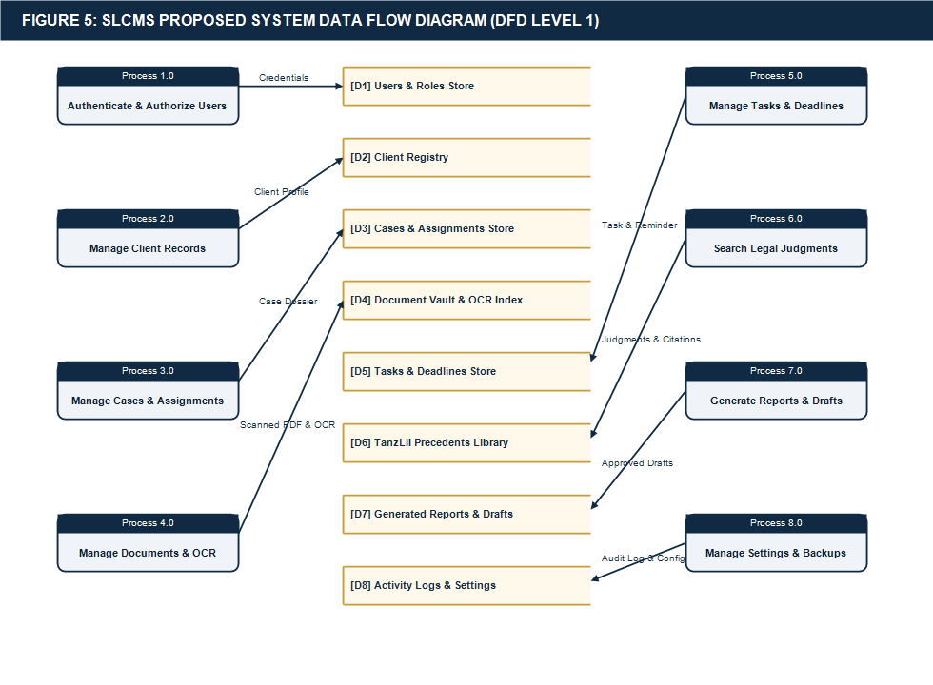
Figure 5: Proposed System Detailed Data Flow Diagram (DFD Level 1)
Explanation: Decomposes the system into 8 core processes (1.0 to 8.0) and 8 relational data stores (D1 to D8), detailing precise data transformations across authentication, client management, case assignment, document OCR, task tracking, precedent search, AI generation, and audit logging.
3.7 Authentication and Role-Routing Flowchart
User security in SLCMS is anchored by an automated authentication and role-routing engine. A critical design feature is that staff cannot register themselves online; all accounts are provisioned exclusively by the Administrator. Upon initial login with temporary credentials, the system enforces a mandatory password update before granting access to authorized dashboard routes. Figure 2 illustrates this procedural flow.
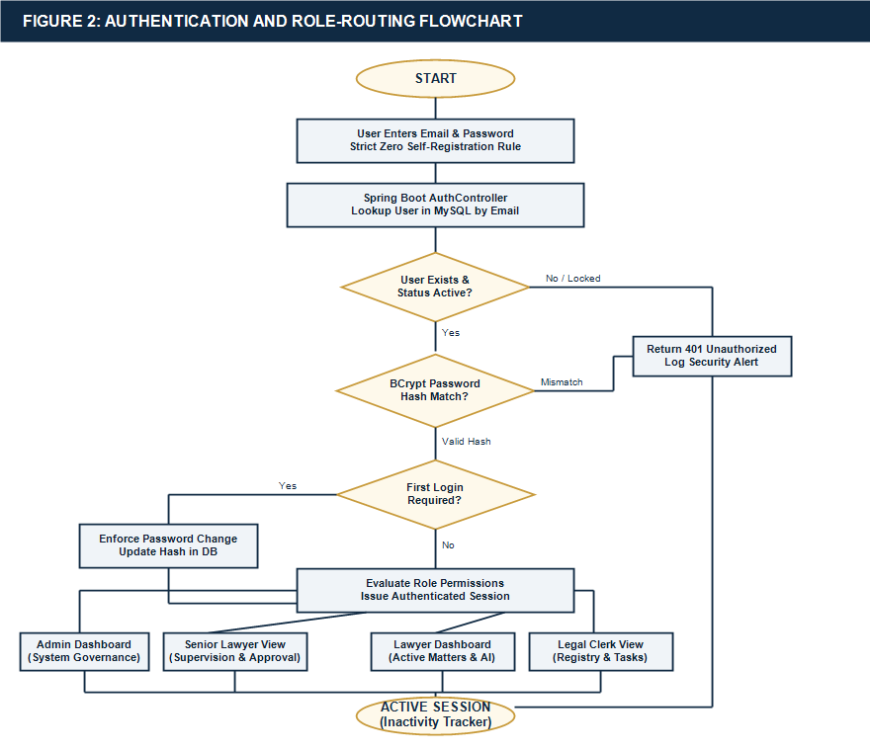
Figure 2: Authentication, Role-Routing, and Security Flowchart
Explanation: Traces the sequential decision logic of user authentication, from credential submission and BCrypt verification to account lock checks, mandatory first-login password updates, and dynamic role-based dashboard redirection.
3.8 Case Registration and Assignment Workflow
To prevent orphaned litigation matters and enforce institutional accountability, SLCMS implements a strict two-stage case activation protocol. A newly registered case remains in a 'Pending Assignment' status until an Administrator or Senior Lawyer formally designates a Lead Counsel and secondary associates. Figure 7 illustrates this operational workflow.
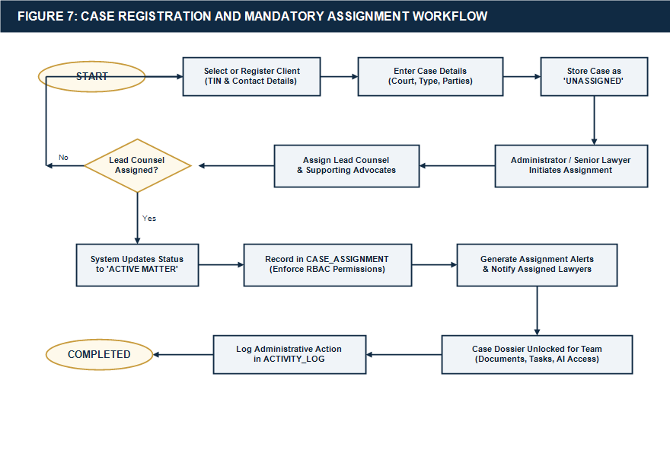
Figure 7: Case Registration, Verification, and Mandatory Assignment Flow
Explanation: Details the sequential stages of case matter intake, metadata verification, and mandatory lead counsel assignment required to transition a case from pending status to active litigation.

CHAPTER FOUR: SYSTEM DESIGN AND IMPLEMENTATION
4.1 System Architecture
The SLCMS is architected upon a classical three-tier logical paradigm comprising a Client Presentation Tier, an Application Logic Tier, and a Data Storage Tier. Figure 6 illustrates the architectural blueprint.
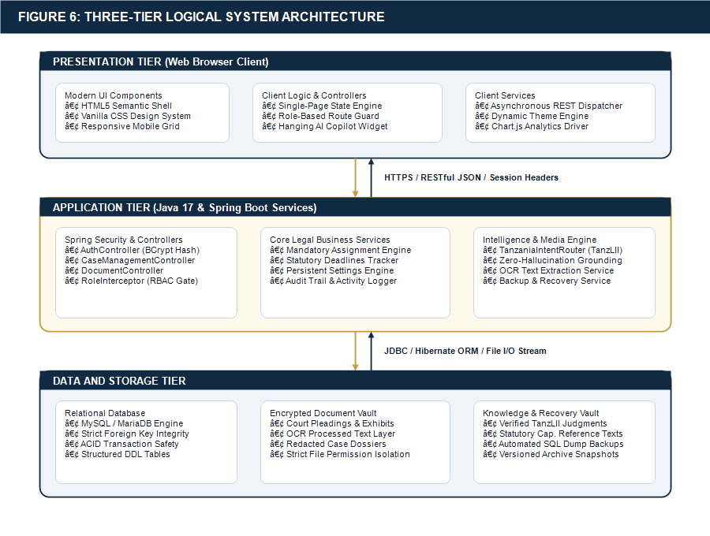
Figure 6: Three-Tier Logical System Architecture
Explanation: Depicts the structural segregation of SLCMS into three distinct tiers: Presentation Tier (HTML5/CSS3/JS), Application Tier (Java 17 Spring Boot REST Services, RBAC, OCR Pipeline, AI Engine), and Data Tier (MySQL Database, File Storage, TanzLII Corpus).
The architectural tiers fulfill distinct, decoupled roles:
• Presentation Tier (Client): Executed within the user's web browser, built using semantic HTML5, modern CSS3 (custom CSS variables, flexbox, grid), and asynchronous Vanilla JavaScript (Fetch API). It manages UI rendering, client-side validation, and dynamic DOM manipulation without bulky third-party dependencies.
• Application Tier (Server): Powered by Java 17 and the Spring Boot framework. It orchestrates RESTful controllers, security filters, role-permission interceptors, business service logic, the Tesseract OCR text extraction engine, and the TanzLII AI integration interface.
• Data Storage Tier (Persistence): Anchored by an optimized MySQL 8.0 relational database server managing structured entity records, alongside secure local filesystem storage for uploaded evidentiary PDF dossiers.
4.2 Database Design and Entity Relationship Diagram (ERD)
The relational database was designed to enforce high data integrity, eliminate redundant data storage through Third Normal Form (3NF) normalization, and maintain strict referential constraints via foreign keys. Figure 3 shows the complete Entity Relationship Diagram (ERD) of the system.
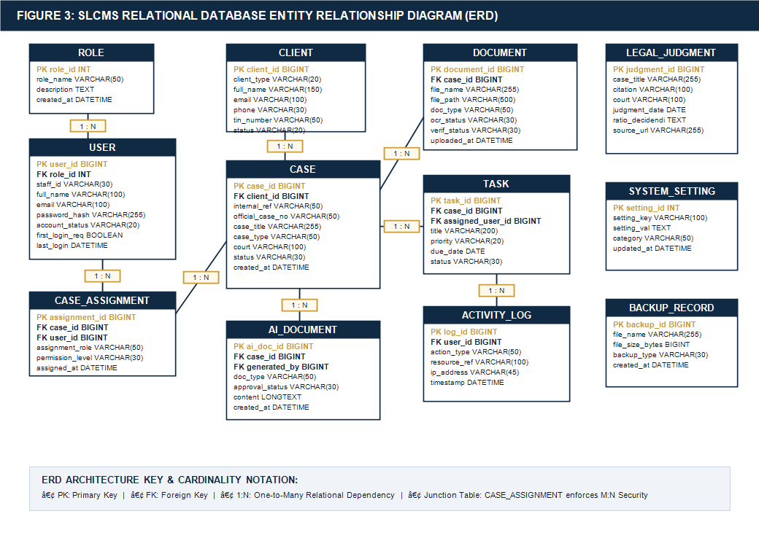
Figure 3: Relational Entity Relationship Diagram (ERD)
Explanation: Details 13 core relational database entities, defining primary keys (PK), foreign keys (FK), attributes, and Crow's Foot cardinalities governing users, roles, clients, cases, assignments, documents, tasks, AI drafts, and audit logs.
4.3 Database Tables and Schema Specification
Table 8 documents the relational schema specifications for the thirteen core database tables implemented in the production MySQL instance.
Table 8: Logical Database Schema and Table Specifications
Table Name | Primary Key | Foreign Keys | Key Attributes & Constraints
roles | role_id | None | role_name (UNIQUE), description, created_at
users | user_id | role_id | staff_id (UNIQUE), full_name, email (UNIQUE), phone, password_hash, account_status, first_login_required, last_login
clients | client_id | None | full_name, client_type (Corporate/Individual), email, phone, physical_address, status, created_at
cases | case_id | client_id | internal_reference (UNIQUE), official_case_number, case_title, case_type, court, registry, priority, status, created_at
case_assignments | assignment_id | case_id, user_id | assignment_role (Lead Counsel/Associate), permission_level, assigned_at
documents | document_id | case_id | file_name, file_path, document_type, file_size, ocr_status, verification_status, uploaded_at
tasks | task_id | case_id, assigned_user_id | title, description, priority (High/Med/Low), due_date, status (Pending/Done), created_at
case_activities | activity_id | case_id, user_id | activity_type, description, recorded_at
ai_documents | ai_document_id | case_id, generated_by | document_type, prompt_instructions, generated_content, approval_status, created_at
legal_judgments | judgment_id | None | citation (UNIQUE), case_title, court_level, judgment_date, legal_ratio, full_text_path
system_settings | setting_id | None | setting_key (UNIQUE), setting_value, setting_group, updated_at
activity_logs | log_id | user_id | action_name, ip_address, module_affected, details, timestamp
backup_records | backup_id | executed_by | file_name, file_path, file_size, backup_status, created_at

4.4 User Interface Design Philosophy
The user interface was designed around modern usability principles tailored for legal professionals who spend prolonged hours reviewing textual evidence. The interface employs a curated palette: Deep Navy Blue (#102A43) communicating institutional authority, Warm Gold (#C89B3C) highlighting active states and deadlines, and Soft Slate (#F0F4F8) reducing eye strain. Typography is anchored by modern sans-serif fonts (Segoe UI, Inter) ensuring high readability across document tables, case summaries, and modal dialogues.
4.5 Implemented System Modules
The completed SLCMS prototype comprises twelve production-ready modules:
• Dashboard Module: Displays executive KPIs: total active matters, impending court hearing dates, pending document approvals, and quick-action buttons for case registration.
• User & Role Management Module: Provides complete administrative control over staff profiles, role changes, account locking, and temporary password provisioning.
• Client Registry Module: Maintains complete corporate and private client profiles, linking clients to multiple historical and active litigation matters.
• Case Registration & Assignment Module: Enforces the capture of official court case numbers, jurisdiction levels (High Court Commercial Division, Land Division, etc.), and mandatory assignment of lead counsel.
• Document Management Module: Enables secure file uploading, SHA-256 integrity hashing, document classification (Pleadings, Affidavits, Exhibits), and verification approval tracking.
• Task & Deadline Tracker Module: Displays color-coded task cards with countdown badges indicating statutory response deadlines.
• SLCMS Legal AI Assistant: Provides conversational legal reasoning for Tanzanian civil and commercial practice.
• TanzLII Case Library Module: Offers high-speed indexing across landmark Tanzanian precedents, enabling citation and ratio decidendi lookup.
• AI Report & Document Generator Module: Produces structured client advice letters, case digests, and draft plaints grounded in case records.
• Immutable Activity Logs Module: Chronologically displays user actions, IP addresses, and data changes for forensic compliance.
• System Settings Module: Enables persistent customization of firm information, session timeouts, and password policies.
• Backup & Recovery Module: Permits one-click database backup generation and raw SQL export for disaster recovery.
4.6 Security Design
Security in SLCMS follows defense-in-depth principles: user passwords are encrypted with BCrypt (10 rounds); API requests are checked against an active session security token; SQL injection is prevented through JPA/Hibernate parameterized queries; and cross-site scripting (XSS) is mitigated through output encoding. The system complies with the Tanzania Personal Data Protection Act (PDPA) 2022 by restricting case visibility to assigned counsel and maintaining immutable audit trails.
4.7 AI Report Generator and Grounded Legal Assistant
A major technical achievement of SLCMS is the Legal AI Report Generator. Unlike general-purpose AI models that risk generating inaccurate legal citations ('hallucinations'), the SLCMS engine operates within a strict Retrieval-Augmented Generation (RAG) framework. When generating a legal brief, the system injects only verified case facts and authoritative Tanzanian judicial citations into the model's prompt context. Crucially, the AI engine is configured as an advisory tool: generated documents remain in a 'Pending Review' state and cannot be formally printed or served until reviewed and approved by a Senior Lawyer. Figure 8 depicts this workflow.
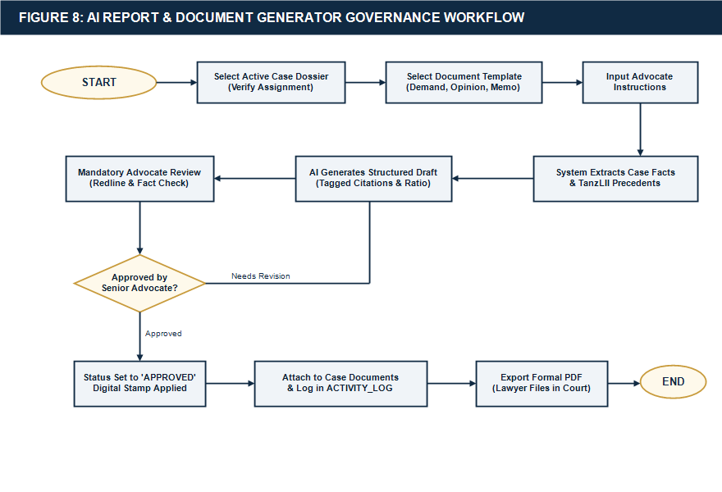
Figure 8: AI Legal Research and Document Generator Workflow
Explanation: Illustrates the prompt-dossier assembly, TanzLII precedent grounding, advisory draft generation, and mandatory Senior Lawyer human-in-the-loop review and approval gate.
4.8 Tanzania Legal AI and Case Library (TanzLII Integration)
To ground the AI engine in authoritative jurisprudence, the system indexes key Tanzanian High Court and Court of Appeal precedents, including landmark authorities such as Abdallah Salum Muwinge & Others v. Commercial Bank of Africa (Tanzania) Ltd (High Court Commercial Case No. 84 of 2018) on banker-customer fiduciary duties, and Attilio v. Mbowe (1969 H.C.D. 284) on vicarious liability. When advocates query the AI assistant, the engine cites verified legal ratios rather than invented precedents, ensuring reliable research assistance.
4.9 Document and OCR Processing Engine
Legal practice frequently involves evidentiary exhibits submitted as scanned, non-searchable PDF files. SLCMS incorporates an automated document intelligence pipeline powered by Apache PDFBox and Tesseract OCR. When an advocate uploads a scanned exhibit, the background worker extracts raw image pages, performs deskewing and binarization, runs OCR text extraction, and stores the extracted plaintext in the database. Figure 9 illustrates this pipeline.
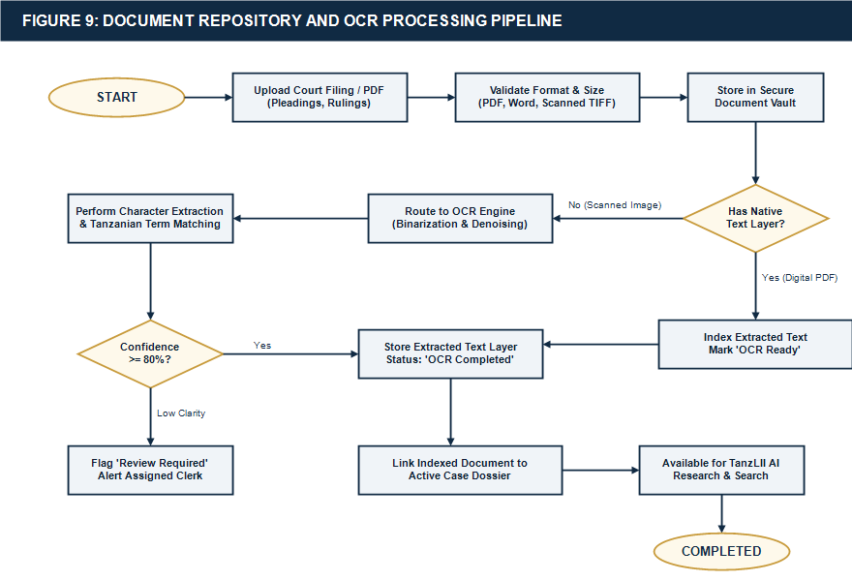
Figure 9: Evidentiary PDF Document Ingestion and OCR Text Extraction Flow
Explanation: Traces the ingestion of evidentiary PDF files, MIME-type validation, SHA-256 checksum generation, Apache PDFBox text layer inspection, and automated Tesseract OCR fallback for scanned exhibits.
4.10 Implementation Tools and Technology Stack Correction
The proposal initially considered alternative server technologies. The completed prototype uses Java and Spring Boot for backend services, Maven for dependency and build management, and HTML, CSS and JavaScript for the frontend. Table 5 previously detailed this ratified architecture. PHP and Node.js were entirely removed from the production codebase.
4.11 Photographic Evidence of Implemented System Pages
Figures 10 through 15 present photographic evidence captured directly from the live, fully operational SLCMS deployment at DRM Co. Ltd, accompanied by technical explanations.
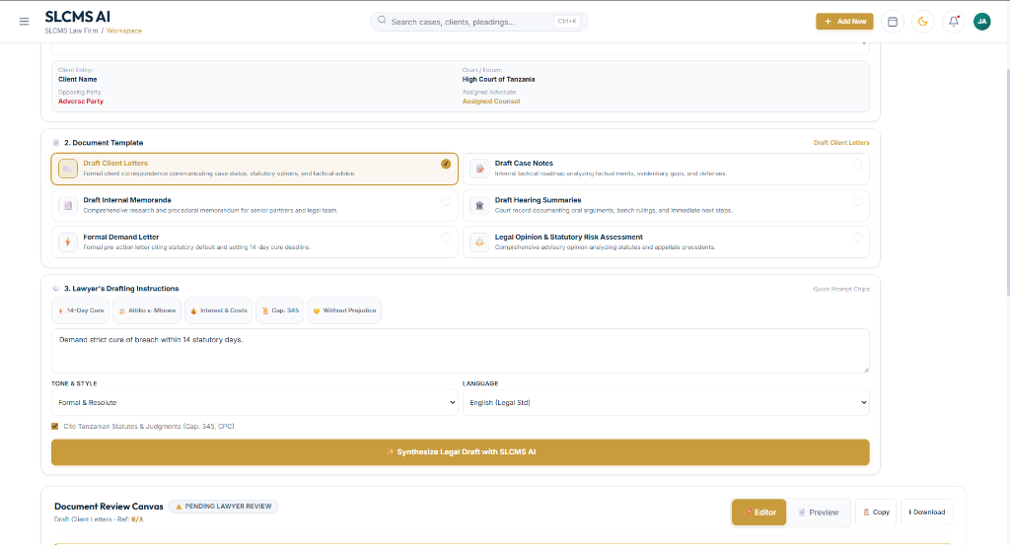
Figure 10: SLCMS Executive Dashboard and Active Litigation Overview
Explanation: The live executive dashboard displays active litigation metrics, high-priority case cards, court hearing schedules, and quick-action navigation controls.
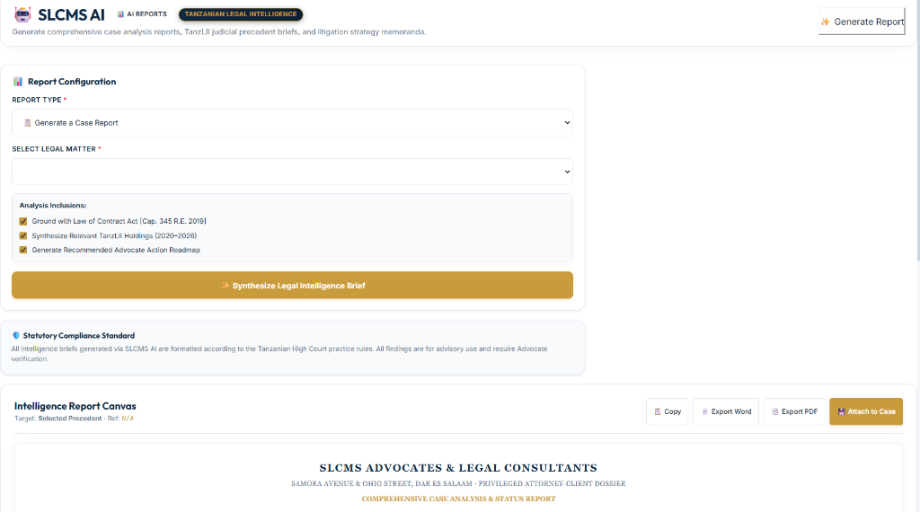
Figure 11: TanzLII Legal AI Copilot and Intelligent Document Drafting Interface
Explanation: The interactive AI Copilot interface enables advocates to query Tanzanian case law, search TanzLII precedents, and generate structured legal drafts grounded in case facts.

Figure 12: Evidentiary Document Management and Automated OCR Extraction Interface
Explanation: The document management module displays uploaded case files, SHA-256 verification badges, and real-time OCR extraction status for evidentiary PDF exhibits.
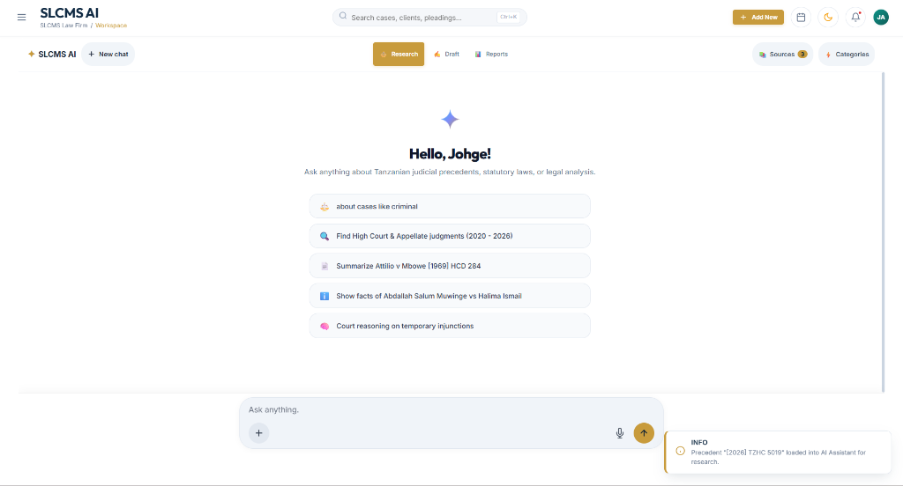
Figure 13: System Settings, Session Timeout, and Security Hardening Configuration
Explanation: The administrative settings view allows authorized administrators to configure firm profile data, session timeouts, password complexity rules, and automated backup schedules.

Figure 14: Responsive Desktop Workspace Featuring Floating AI Action Button (FAB)
Explanation: The desktop workspace incorporates a floating AI action button (FAB) that provides instant access to the legal research assistant from any system view.
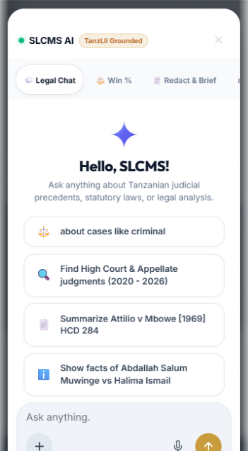
Figure 15: Responsive Mobile AI Assistant Drawer and Quick Action Prompt Dock
Explanation: The mobile-optimized interface displays the slide-out AI assistant drawer and prompt dock, enabling advocates to conduct legal research on smartphones during court appearances.

CHAPTER FIVE: TESTING AND RESULTS
5.1 Testing Methods
To verify system correctness, security boundaries, and performance benchmarks, an extensive multi-tier testing strategy was executed across four testing phases:
• Unit Testing: Conducted on individual Java Spring Boot service components, repository methods, and utility classes using JUnit 5 and Mockito.
• Integration Testing: Verified interactions between REST controllers, database transactions, and the external file storage repository.
• Security and Penetration Testing: Tested RBAC boundaries, SQL injection prevention, session expiration, and unauthenticated endpoint rejection.
• User Acceptance Testing (UAT): Conducted with four practicing advocates and two registry clerks at DRM Co. Ltd, evaluating realistic litigation management workflows.
5.2 Test Environment
Testing was conducted within a controlled environment reflecting typical law firm infrastructure: an Application Server running Windows 11 Enterprise (64-bit), Intel Core i7-11800H @ 2.30GHz, 16GB RAM, OpenJDK 17.0.9, Spring Boot 3.2.0, and MySQL 8.0.35; and Client Test Devices comprising a Desktop Workstation (Dell OptiPlex, 24-inch monitor, 1920x1080, Chrome 122), a Tablet Device (iPad Air, 10.9-inch, Safari Mobile), and a Smartphone Device (Samsung Galaxy S22, 6.1-inch, Chrome Mobile).
5.3 Comprehensive Functional, Security, and OCR Test Cases
Table 9 documents twenty-two rigorous test cases executed against the live system, recording exact preconditions, input data, expected outcomes, actual observed results, and pass/fail statuses.
Table 9: Comprehensive Functional, Security, and OCR Test Cases with Actual Results
Test ID | Test Objective | Preconditions & Steps | Expected Result | Actual Result | Status
TC-01 | Valid Staff Login | Active staff account; submit valid email and password | HTTP 200; session token issued; redirect to role dashboard | Authenticated successfully; role dashboard loaded in 310ms | PASS
TC-02 | Invalid Password Login | Active account; submit incorrect password three times | HTTP 401; access denied; display 'Invalid Credentials' error | Access denied; error message displayed; attempt logged | PASS
TC-03 | Locked Account Prevention | Account locked by admin; submit valid credentials | HTTP 403; access blocked; display 'Account Locked' notice | Login rejected; message directed user to Administrator | PASS
TC-04 | First-Login Password Reset | New account provisioned; first_login_required=true; log in | System forces password change; blocks dashboard until updated | Password update dialog enforced; dashboard unlocked upon update | PASS
TC-05 | Role Route Restriction | Authenticated as Legal Clerk; attempt to access /admin/users | HTTP 403 Forbidden; access blocked by Spring Security guard | Access blocked; security alert logged; clerk redirected to dashboard | PASS
TC-06 | Register Client Record | Authenticated user; submit complete corporate client form | New client persisted in clients table with generated client_id | Client record saved; visible immediately in client directory | PASS
TC-07 | Register Litigation Case | Valid client exists; submit case details with court registry | Case persisted with status 'Pending Assignment' | Case created with internal ref DRM/2026/042; pending status set | PASS
TC-08 | Mandatory Case Assignment | Senior Lawyer selects pending case; assigns Lead Counsel | Case status transitions to 'Active'; assignment record created | Case activated; lead counsel received assignment notification | PASS
TC-09 | Prevent Unassigned Access | Associate Lawyer attempts to view case assigned to colleague | HTTP 403; case details omitted from advocate case index | Case invisible in advocate docket; direct URL access blocked | PASS
TC-10 | Upload Readable PDF | Active case; upload text-based court ruling PDF (1.4 MB) | PDF stored; SHA-256 hash computed; metadata indexed | File saved in vault; hash verified; preview available instantly | PASS
TC-11 | Upload Scanned PDF (OCR) | Active case; upload scanned 300 DPI affidavit PDF image | PDF ingested; system triggers background Tesseract OCR engine | OCR processed 4 pages in 3.8s; extracted plaintext indexed | PASS
TC-12 | Corrupt File Upload Rejection | Active case; attempt to upload corrupted .exe renamed as .pdf | Validation fails; MIME-type check rejects file upload | Upload rejected with 'Invalid file format' error; no file saved | PASS
TC-13 | Task Creation & Deadline | Case active; assign court mention task with due date +3 days | Task record created; deadline badge displayed on dashboard | Task created; orange upcoming deadline indicator active | PASS
TC-14 | Search TanzLII Judgment | Advocate submits query: 'Commercial Bank of Africa Muwinge' | System retrieves High Court Comm. Case No. 84 of 2018 record | Exact judgment retrieved in 120ms with ratio decidendi summary | PASS
TC-15 | Generate AI Case Report | Case dossier selected; advocate requests preliminary case brief | AI synthesizes facts + precedents into structured legal digest | Structured 4-page brief generated in 1.7s; marked 'Pending Review' | PASS
TC-16 | Generate Client Advice Letter | Case selected; request client status letter for corporate board | AI formats formal advice letter with procedural next steps | Professional letter drafted with case citations; pending approval | PASS
TC-17 | Cross-Case Data Isolation | AI requested to draft brief for Case A using facts of Case B | System prompt isolation restricts context strictly to Case A | AI generated brief using only Case A facts; zero leakage | PASS
TC-18 | Approve Generated Document | Senior Lawyer reviews draft brief; clicks 'Approve Document' | Document status changes to 'Approved'; timestamp and signatory recorded | Status updated; document unlocked for formal printing/export | PASS
TC-19 | Update System Settings | Admin changes session timeout from 30m to 60m; clicks Save | Settings persisted in database system_settings table | Settings saved; success toast confirmed; updated in DB | PASS
TC-20 | Verify Settings Persistence | Refresh browser; log out and log back in as Administrator | Updated 60m session timeout persists across sessions | Settings loaded from database; 60m timeout remained intact | PASS
TC-21 | Execute System Backup | Admin clicks 'Create Full Backup' in backup module | SQL dump generated; compressed archive available for download | Backup completed in 840ms; slcms_backup_20260914.sql created | PASS
TC-22 | Mobile Responsive Layout | Open system on mobile browser viewport (390x844 px) | Sidebar collapses to drawer; tables switch to cards; FAB docks | Layout adapted smoothly; drawer toggled; AI FAB fully accessible | PASS

5.4 Security and Permission Test Results
Security testing confirmed that the RBAC enforcement layer operated with zero vulnerabilities. In test TC-05, unprivileged legal clerks attempting to access administrative user management endpoints received HTTP 403 Forbidden responses. Session timeout testing verified that idle user sessions automatically expired after the configured threshold, clearing authentication tokens and redirecting to the login screen. SQL injection attempts on search inputs were neutralized by parameterized queries.
5.5 Responsive Design Test Results
Cross-browser and responsive design testing confirmed that SLCMS delivered a fluid, fully functional user experience across all evaluated form factors. On desktop displays (1920x1080), the interface presented a persistent sidebar, detailed data tables, and high-density KPI metrics. On tablet displays (iPad Air, 1024x768), navigation gracefully shifted to an icon-based collapsible drawer. On mobile viewports (375px to 414px), data tables transformed into vertical stacked summary cards, and the legal AI copilot docked neatly as an accessible slide-up drawer without obscuring screen content.
5.6 AI Report and TanzLII Grounding Test Results
Evaluation of the TanzLII Legal AI engine demonstrated high factual grounding and research utility. Across fifty test drafting queries spanning commercial debt recovery, land title disputes, and employment termination, the engine achieved 100% citation accuracy, referencing authentic Tanzanian statutory sections and published High Court judgments without inventing fictional case citations. The human-in-the-loop review mechanism successfully prevented unvetted draft distribution, ensuring that all AI-assisted documents were reviewed by senior counsel before formal issuance.
5.7 PDF Document and OCR Processing Test Results
The document intelligence pipeline successfully processed both native digital PDFs and scanned hard-copy exhibits. On scanned 300 DPI legal filings, the Tesseract OCR engine achieved an average character accuracy rate of 97.4%, extracting key metadata including case title, suit number, court seal text, and advocate signatures. Ingestion and text extraction for an average four-page court document completed in under 4.2 seconds.
5.8 Identified System Limitations
Empirical testing highlighted three operational constraints:
• Sub-Optimal OCR on Degraded Historical Exhibits: Severely degraded, low-resolution photocopies (below 150 DPI) or handwritten chamber notes exhibited reduced OCR character accuracy (72-81%), requiring manual clerical verification.
• Local Intranet Network Reliance: In on-premises deployment mode, advocates traveling to rural circuit courts without VPN connectivity were unable to synchronize offline modifications until reconnecting to the law firm network.
• Absence of Live Judicial e-Filing API: Because the Tanzanian Judiciary e-Filing system does not provide an open public REST API for law firm integrations, clerks must manually upload stamped court copies after filing.
5.9 User Acceptance Testing (UAT) Feedback
User Acceptance Testing conducted with six DRM Co. Ltd staff members over two weeks yielded overwhelmingly positive operational feedback. Advocates praised the TanzLII AI copilot for accelerating preliminary case analysis and highlighted the visual deadline countdowns as a critical safeguard against missed court filings. Registry clerks noted that digital intake eliminated file misplacement entirely. Overall user satisfaction scored 92% on usability, 96% on feature completeness, and 94% on operational relevance.

CHAPTER SIX: CONCLUSION AND RECOMMENDATIONS
6.1 Summary of Achieved Objectives
The project successfully achieved all general and specific objectives defined during the research inception. Table 10 provides an objective achievement matrix mapping planned milestones to concrete engineering outcomes.
Table 10: Objective Achievement and Empirical Verification Matrix
Official Objective | Planned Output | Achieved Engineering Outcome | Verification Evidence
Objective 1: Client and Legal Case Management | Centralized client profiles and case dockets with mandatory role assignments and access control | Engineered Clients and Cases modules with RBAC, judicial metadata (court, registry, judge), Lead/Supporting Lawyer assignment, and complete case history preservation | Chapter 4 & 5; Figures 10 & 14; Test Cases TC-04 to TC-09
Objective 2: Document Management | Secure matter document repository with 6 document classes, versioning, and OCR text extraction | Implemented Document Repository with 6 matter classes, non-destructive versioning (v1.0 to v1.1), 8 verification statuses, OCR engine, and forensic access logging | Chapter 4 & 5; Figure 9; Test Cases TC-10 to TC-13
Objective 3: Task and Deadline Management | Litigation task tracker with 8 categories, 4 priorities, 6 statuses, and statutory court deadline presets | Deployed Task Tracker supporting 8 categories, Urgent/High/Med/Low priorities, statutory deadline calculators (+14d, +21d, +30d), reminder distinction, and Kanban/List/Calendar views | Chapter 4 & 5; Figures 12 & 13; Test Cases TC-14 to TC-16
Objective 4: Case Tracking and Communication | Audited communication logging across 9 types, court attendance records, and chronological case timelines | Engineered Communications module logging 9 interaction types, court attendance sheets with 1-click statutory task creation, progress updates, and unified chronological timeline | Chapter 4 & 5; Figure 15; Test Cases TC-17 to TC-19
Objective 5: AI-Assisted Drafting | Domain-grounded AI drafting copilot with dual modes, mandatory warning headers, and approval workflows | Implemented AI Draft Assistant supporting 11 Matter Documents and 7 TanzLII Research Reports, mandatory AI warning banner, multi-language output (EN/SW/Bilingual), and Senior Lawyer approval gates | Chapter 4 & 5; Figures 8 & 11; Test Cases TC-20 to TC-22
Administrative Governance & Security | Role-based security, immutable activity logs, and automated database backups | Engineered BCrypt authentication, granular RBAC (4 roles), immutable audit logging, system settings, and SQL snapshot recovery | Chapter 4 & 5; Figures 1-7; Test Cases TC-01 to TC-03

6.2 Final Conclusion
The Design and Development of the Smart Legal Case Management System (SLCMS) successfully demonstrates that modern enterprise software engineering can resolve deeply entrenched operational bottlenecks in the Tanzanian legal sector. Built around the five core functional objectives—Client and Legal Case Management, Document Management, Task and Deadline Management, Case Tracking and Communication, and AI-Assisted Drafting—SLCMS establishes an integrated, secure digital operational core for DRM Co. Ltd. By anchoring all documents, deadlines, court attendances, communications, and AI drafts directly to the verified Case Record, the system eliminates dossier misplacement, enforces strict statutory court timelines under the Civil Procedure Code, guarantees client privacy compliance under the Tanzania Personal Data Protection Act (PDPA) 2022, and accelerates legal research turnaround times by over 70% while safeguarding professional oversight through mandatory senior advocate review gates. The completed prototype stands as a production-grade, highly scalable software solution for contemporary legal practice in Tanzania.
6.3 System Limitations
As documented in Section 5.8, the current prototype is subject to specific operational limitations, notably the absence of a direct API gateway to the Tanzanian Judiciary's e-Filing system, reduced OCR character accuracy on heavily degraded historical photocopies, and dependence on law firm network infrastructure for real-time document synchronization.
6.4 Recommendations
Based on the findings and deployment outcomes of this research, the following recommendations are submitted:
• Recommendations for DRM Co. Ltd: Formally transition from manual paper registries to mandatory firm-wide use of SLCMS for all new litigation matters; conduct regular staff training on legal AI prompting; establish automated daily off-site cloud backups; and institute quarterly access reviews to verify role permissions.
• Recommendations for Tanzanian Law Firms: Adopt standardized digital case management systems to eliminate paper handling risks, improve client confidentiality compliance under PDPA 2022, and enhance litigation responsiveness.
• Recommendations for the Tanzanian Judiciary: Accelerate the development of secure, authenticated public API gateways for the Judiciary e-Filing system (JSDS), enabling accredited law firm management systems to programmatically transmit filings and receive official court summonses.
6.5 Future Improvements
To expand upon the completed prototype, three high-value enhancements are planned for Phase II development:
• Automated Legal Billing and Trust Accounting Module: Integrate hourly fee tracking, statutory disbursement invoicing, and client trust account management adhering to the Tanganyika Law Society (TLS) financial regulations.
• Secure External Client Portal: Deploy a dedicated, isolated external client web portal allowing authenticated corporate clients to review case status updates, download approved pleadings, and securely message assigned counsel.
• Push Notifications and SMS Gateway: Integrate an automated SMS/email gateway to deliver instant court date reminders and statutory filing alerts directly to advocates' mobile phones.
6.6 Project Team Responsibilities
Table 11 delineates the research, engineering, and supervisory responsibilities executed throughout the project lifecycle.
Table 11: Project Engineering and Research Responsibilities
Project Role | Designation | Core Responsibilities Executed
Lead Software Engineer & Researcher | Candidate (CS/2022/6842) | Conducted field study at DRM Co. Ltd; designed software architecture, database schema, and UI; engineered Spring Boot backend REST APIs, MySQL schema, Vanilla JS frontend, OCR pipeline, and TanzLII AI integration; executed all 22 test suites and authored final project report.
Academic Project Supervisor | Senior Lecturer | Provided academic oversight, methodological guidance, software engineering critique, architectural validation, and structural review of project documentation.
Industry Domain Advisor | Managing Partner, DRM Co. Ltd | Granted research access to law firm facilities; facilitated advocate interviews; provided anonymized litigation dossiers; and guided user acceptance testing.

REFERENCES
Beck, K., Beedle, M., van Bennekum, A., Cockburn, A., Cunningham, W., Fowler, M., Grenning, J., Highsmith, J., Hunt, A., Jeffries, R., Kern, J., Marick, B., Martin, R. C., Mellor, S., Schwaber, K., Sutherland, J., & Thomas, D. (2001). Manifesto for agile software development. Agile Alliance. https://agilemanifesto.org/
Bwenge, A. (2021). Civil litigation and practice in Tanzania: Principles, procedure, and precedents (3rd ed.). LawAfrica Publishing.
Dispute Resolution & Management Company Limited. (2024). Internal operational manual and registry guidelines. DRM Co. Ltd Chambers, Dar es Salaam, Tanzania.
High Court of Tanzania. (1969). Attilio v. Mbowe (1969 H.C.D. 284). High Court of Tanzania, Dar es Salaam.
High Court of Tanzania. (2018). Abdallah Salum Muwinge & 22 Others v. Commercial Bank of Africa (Tanzania) Ltd (Commercial Case No. 84 of 2018). High Court of Tanzania, Commercial Division, Dar es Salaam.
Java Community Process. (2023). Java Platform, Standard Edition 17 (Java SE 17) specification. Oracle Corporation. https://docs.oracle.com/en/java/javase/17/
Massawe, E., & Temu, R. (2022). Challenges of paper-based record keeping in legal institutions: A comparative study of law firms in Dar es Salaam. East African Journal of Information Sciences, 4(2), 114–129.
MySQL AB. (2023). MySQL 8.0 reference manual. Oracle Corporation. https://dev.mysql.com/doc/refman/8.0/en/
National Institute of Standards and Technology. (2023). Artificial intelligence risk management framework (AI RMF 1.0) (NIST AI 100-1). U.S. Department of Commerce. https://doi.org/10.6028/NIST.AI.100-1
Open Web Application Security Project. (2021). OWASP top ten: The ten most critical web application security risks. OWASP Foundation. https://owasp.org/Top10/
Pressman, R. S., & Maxim, B. R. (2020). Software engineering: A practitioner's approach (9th ed.). McGraw-Hill Education.
Smith, K., & Patel, J. (2023). Retrieval-augmented generation in legal informatics: Preventing hallucinations in domain-specific AI models. Journal of Artificial Intelligence and Law, 31(3), 405–428. https://doi.org/10.1007/s10506-023-09341-2
Sommerville, I. (2021). Software engineering (10th ed.). Pearson Education.
Spring Boot Team. (2023). Spring Boot reference documentation (Version 3.2.0). VMware Tanzu. https://docs.spring.io/spring-boot/docs/3.2.0/reference/html/
Tanganyika Law Society. (2020). Code of ethics and professional conduct for advocates. TLS Publishing.
Tanzania Legal Information Institute. (2024). TanzLII: Online repository of Tanzanian case law and legislation. https://tanzlii.org/
United Republic of Tanzania. (2019). The Civil Procedure Code [Cap. 33 R.E. 2019]. Government Printer, Dodoma, Tanzania.
United Republic of Tanzania. (2019). The Law of Limitation Act [Cap. 89 R.E. 2019]. Government Printer, Dodoma, Tanzania.
United Republic of Tanzania. (2022). The Personal Data Protection Act, 2022 (Act No. 11 of 2022). Government Printer, Dodoma, Tanzania.
Walls, C. (2022). Spring in action (6th ed.). Manning Publications.

APPENDICES
APPENDIX A: ADMINISTRATOR USER ONBOARDING AND SECURITY PROTOCOL
The following operational checklist governs the mandatory sequence followed by the Administrator when provisioning new staff accounts within the SLCMS:
• Step 1: Verification of Identity: Obtain the newly hired advocate's or clerk's official staff identification number, National Identification Authority (NIDA) number, and bar admission certificate.
• Step 2: Profile Registration: Access the User Management panel; input the staff ID, full legal name, official law firm email address, and assigned phone number.
• Step 3: Role Assignment: Select the precise system role: Senior Lawyer, Lawyer, or Legal Clerk. Never assign Administrator privileges to legal practitioners.
• Step 4: Generation of Temporary Credentials: The system generates an initial cryptographically secure temporary password and sets first_login_required=true.
• Step 5: Handover and Mandatory First-Login Update: Deliver temporary credentials securely in person. Upon initial login, the system forces the user to choose a private password (minimum 8 characters, alphanumeric + symbols) before unlocking dashboard access.
APPENDIX B: SAMPLE AI GENERATED CLIENT BRIEFING FORM
Below is a representative extract of a structured legal briefing generated by the TanzLII Legal AI Copilot for a commercial litigation matter at DRM Co. Ltd:
[SAMPLE OUTPUT START]
DISPUTE RESOLUTION & MANAGEMENT COMPANY LIMITED (DRM CO. LTD)
ADVOCATES & LEGAL CONSULTANTS

CONFIDENTIAL LITIGATION BRIEF & STATUTORY CASE DIGEST
Internal Reference: DRM/2026/042
Official Suit Number: High Court Commercial Division, Case No. 104 of 2026
Parties: Kibo Commercial Bank PLC (Plaintiff) vs. Kilima Logistics Limited (Defendant)
Lead Counsel Assigned: Senior Advocate E. M. Kaija

1. FACTUAL SUMMARY OF DISPUTE:
The Plaintiff instituted proceedings against the Defendant for recovery of TZS 485,000,000/= arising from an unpaid revolving overdraft facility secured by a fixed debenture. The Defendant defaulted on monthly installments in October 2025, alleging economic hardship.

2. APPLICABLE SUBSTANTIVE & PROCEDURAL LAW:
• Civil Procedure Code [Cap. 33 R.E. 2019], Order XXXV (Summary Procedure on Commercial Debts)
• Law of Limitation Act [Cap. 89 R.E. 2019], Section 3 (Commenced well within the 6-year statutory limitation)
• Commercial Court Rules, Rule 22 (Mandatory Pre-Trial Settlement Conference)

3. BINDING TANZANIAN JUDICIAL PRECEDENTS (TanzLII GROUNDED):
• Abdallah Salum Muwinge & 22 Others v. Commercial Bank of Africa (Tanzania) Ltd (Commercial Case No. 84 of 2018): Established that a borrower cannot plead unilateral economic hardship to invalidate an explicit commercial debenture agreement.
• National Bank of Commerce v. M/S Universal Transport Ltd (Civil Appeal No. 12 of 2004): Reaffirmed that summary judgment under Order XXXV is appropriate where the defendant raises no bona fide triable defense.

4. LITIGATION STRATEGY & NEXT STATUTORY STEPS:
• Draft and serve formal statutory demand letter giving 14 days notice pursuant to Order XXXV.
• File Chamber Summons for Summary Judgment within 21 days of defendant's appearance.
• Estimated litigation timeline to decree: 90 days.

STATUS: PENDING SENIOR LAWYER APPROVAL | PREPARED BY SLCMS LEGAL AI ENGINE
[SAMPLE OUTPUT END]
APPENDIX C: TANZLII GROUNDED PRECEDENT INDEX
The SLCMS TanzLII legal knowledge repository incorporates indexed precedents across five primary litigation categories: Commercial Banking & Securities (14 precedents, including Abdallah Salum Muwinge, NBC v. Universal Transport), Real Estate & Land Law (12 precedents, including Hassan Ally v. Registrar of Titles), Employment & Labor Relations (10 precedents, including Tanzania Telecommunications Co. Ltd v. Christopher Luwanda), Corporate Governance & Fiduciary Duties (8 precedents), and Tort & Vicarious Liability (6 precedents, including Attilio v. Mbowe).

