**BUSINESS PROPOSAL FORM: SAGS AND ASES**

|  |  |
| --- | --- |
| **SECTION ONE: BUSINESS BACKGROUND** | |
| Name of business/organization/group: | Cianyi Tujinge Youth Group Fish eatery |
| Physical location: | Siakago Town |
| Telephone number: | 0799501267-James Wachira 0113840040-Simon Mwaniki |
| **Vision**: Where do you want to be in the next 5-10 years?  To Be a leading fish firm in mbeere north | |
| **Mission**: Purpose of being in business  To Eradicate poverty in the community by providing job opportunities and enhancing nutrition value in the community. | |
| **Leadership structure**: |  |
| (Tick appropriately)  Chief Executive Officer  Chairperson  Secretary  Treasurer  Finance officer  Marketing officer  Procurement officer | Name:  James Wachira  Nelly Gakii  Charles Njiru  Japheth Muteti  Benson kinyua  Geoffrey njiru |
| **SECTION TWO: BUSINESS SITUATIONA L ANALYSIS** | |
| **SWOT analysis of the Business**  SWOT analysis describes the current state the Business. Describe an outline of the Business’s current Strengths, Weaknesses, Opportunities, and Threats? | |
| Strengths | **Labor-** we have readily available skilled youths from the local community. |
| Weaknesses | **Water**-within the town there is water scarcity, therefore we need storage tanks.  **Equipment**-We lack enough equipment and facilities for running a fish eatery point, i.e**. electric cooker ,deep freezer gas, tables ,sufurias**  **Transport-**Moving fish from the farmers to the eateries requires transport mechanism  **Rent –**We will need a house to run the business therefore we require some finances for the rent.  **Furniture’s** –we will need tables, chairs kitchens cabinets.  **Business permit**- We will need several business permits. I.e.  Embu county business permit , health permit |
| Opportunity | **Market**-There are few competitors within a market  **Stock of raw materials**-There are many farmers who are rearing fish within and they lack market for their fish  **Strategic position**- there is a flow of customers within the targeted area |
| Threats | **Competition**-Within the town there some existing fish eateries which might be a threat through prices and products  **Theft-** in our premises we will require security for our working equipment’s. |
| How will you address the weaknesses? | **Water**- we will buy storage facilities e.g. tanks  **Equipment**-if well financed we will purchase modern facilities e.g. fish driers oven tables and chairs  **Transport-** purchase of second-hand motorbike for transport fish  **Rent-** the funding we will help to pay rent of a decent house for fish business  **Furniture’s**-funding will help- us acquire modern decent equipment’s such as tables chairs tables that will attract customers  **Business Permit-**if well-funded we will be able to register all required business permits |
|  |  |
| How will you utilize the opportunities available? | **Market**-due to high demand of fish and low competition it will be easy for us to supply fish  **Stock of law materials-**due to readily available materials from the farmers we shall be able to acquire fish within our locality  **Strategic position**-due to high demand of fish in targeted area it will be easier for us to run the business |
| How will threats be mitigated? | **Competitors**- within the market there are a few existing fish eateries which might be a threat to us through prices and quality  **Theft** – installation of cctv cameras and security guard |
| **SECTION THREE: MARKET ASSESSMEN T** | |
| What is your target market? | Urban center – **Siakago town** |
| How do you plan to expand your target market? | Opening up eatery shop in other towns within and out of the area |
| Describe the products and services you plan to sell. | Selling of tilapia and mudfish |
| How do you plan to sell your products/services? | 1. Selling whole fish 2. Fish fillets , fish balls 3. Raw fish 4. Fish soup |
| Who are your key competitors? | Existing fish eateries |
| What will you do better to overcome your competitors? | Employing skilled personnel to serve customers  Observing hygiene  Entertaining facilities such as TV  Decent layout of business primer |
| How much will you sell your product for? | 1kg at Ksh 1,000 |
| How will you promote your product/service (word of mouth, social gatherings, sale agents, samples, posters, etc)? | Use of social media ,facebook,whatsapp  Word of mouth to friends family  Posters and flyers |
| How do you plan to reach your customers? | Employing of business marketers  Use of Posters and sign board |
| **SECTION FOUR: MANAGEMENT AND R ESOURCE NEEDS** | |
| What key expertise do you need to run the business? | Manager  Accountant  Chefs  Waiters  Security Guard |
| How many staff will you need to effectively run the business? | ***8***  1-manager  2-chefs  2-waters  2-cleaners  1-security guard |

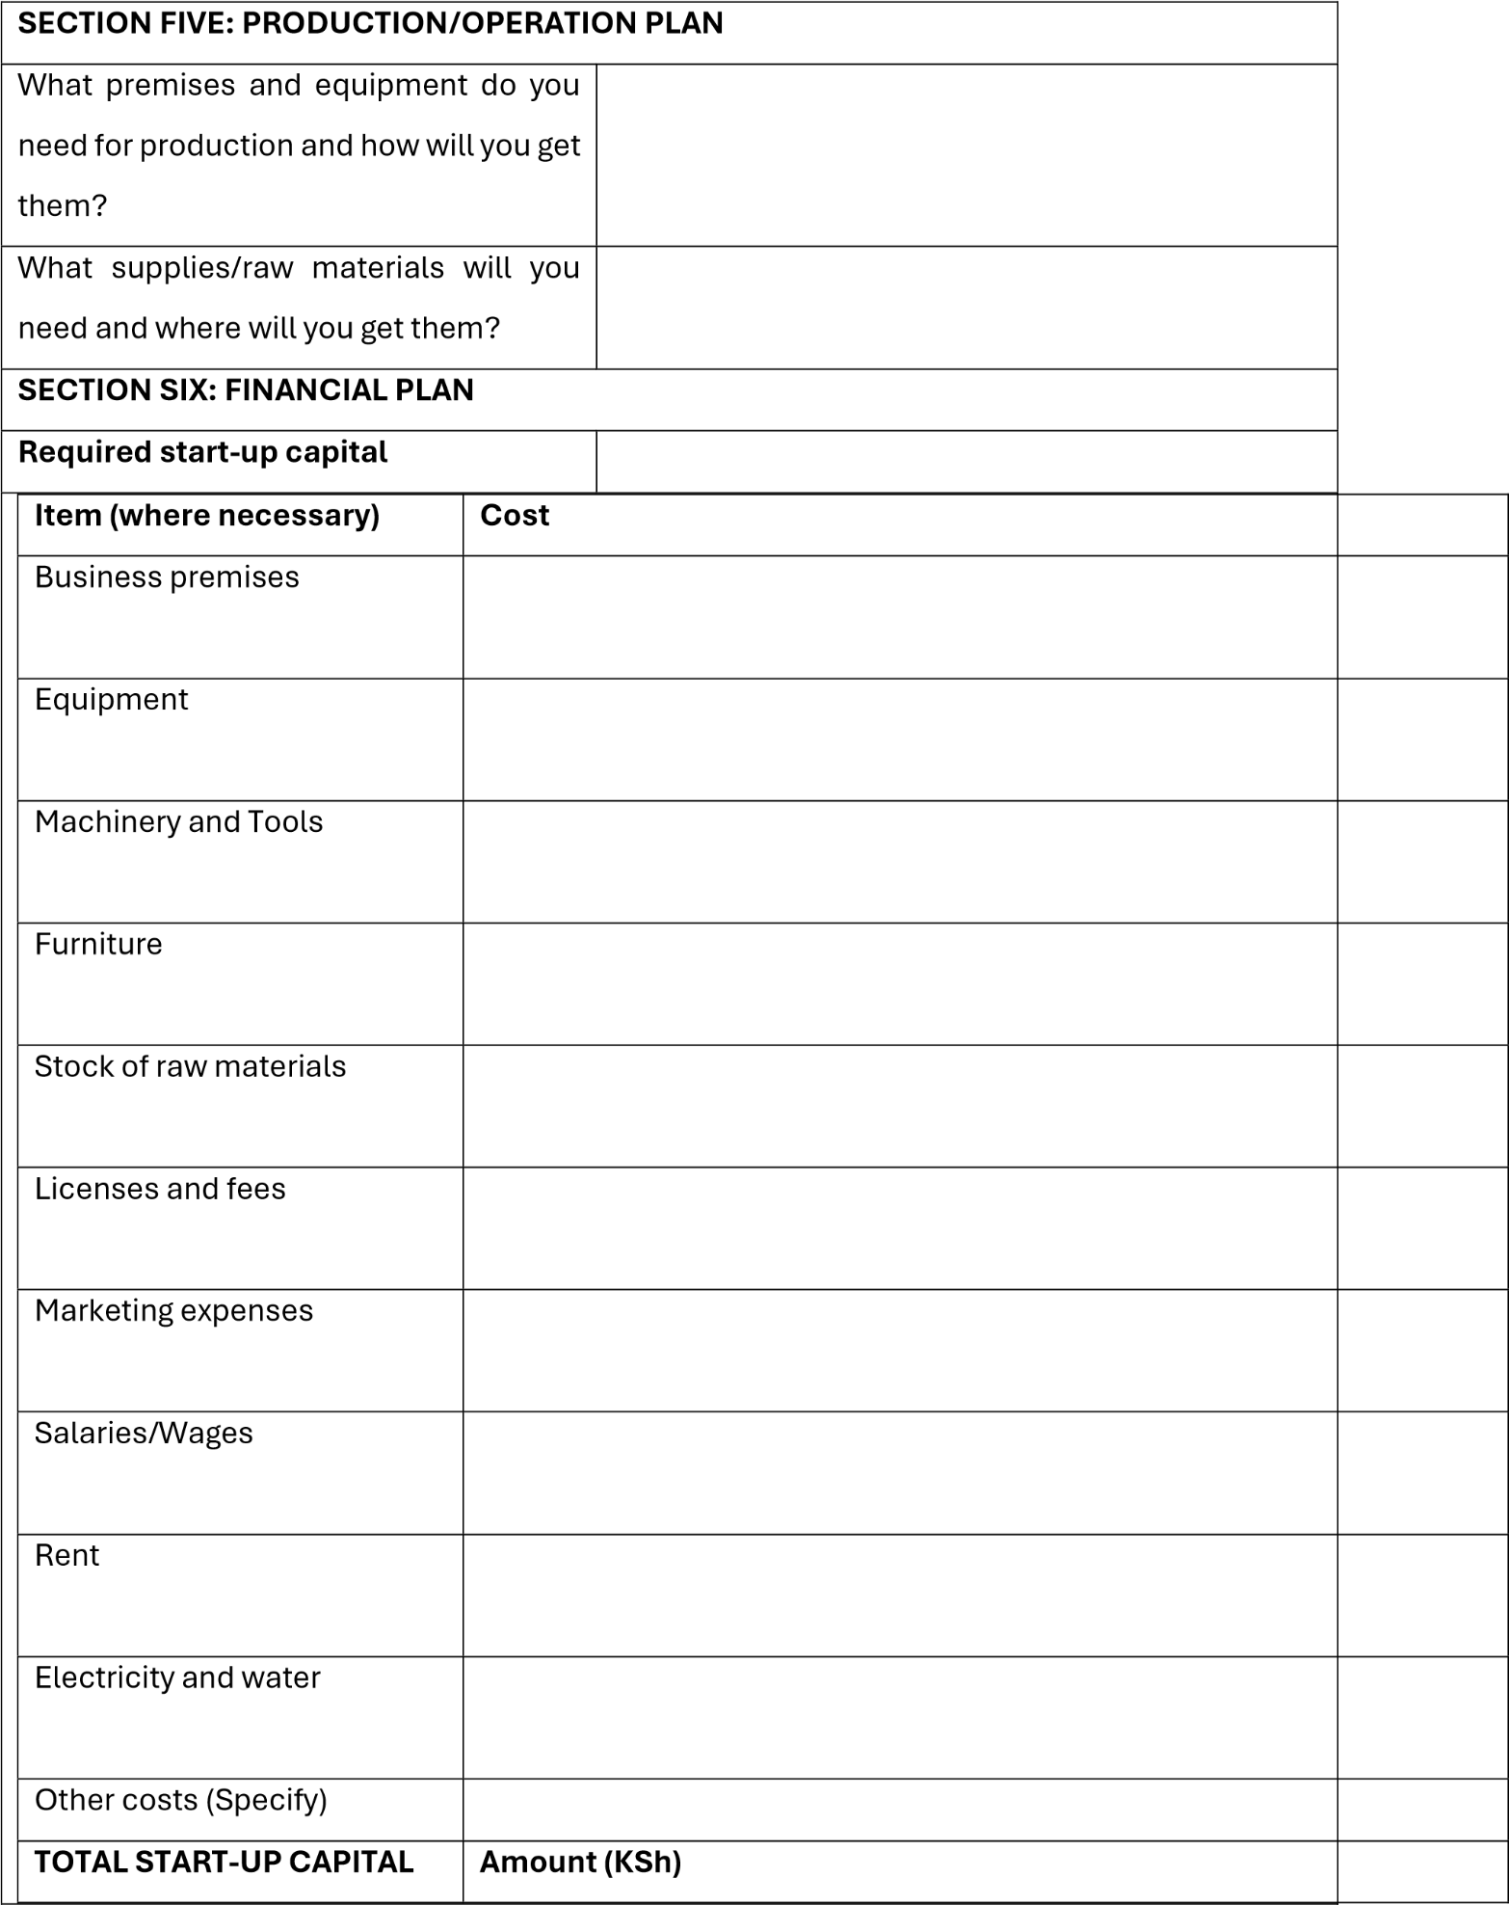

Figure 1a house to rent

We certify that the above information is true to the best of our knowledge.

**Source of start**

**-**

**up capital**

**Group/Owners contribution**

**Grant amount**

**SECTION SEVEN: RISK MANAGEMENT**

What challenges do you

Expect and how will you address them?

Challenge

How to address them

**Business Proposal Form for SAGs/ASEs compiled by:**

Name;…………………………………………………….. Position……………………………..………

Date……………………………………………………… Signature……………………………………

SAGs/ASEs STAMP……………………………………….

# For the ABDP Business Proposal Form for SAGs/ASEs received by:

Name………………………………………………………… Position…………………………… Date…………………………………………………………… Signature………………………………

County ABDP STAMP………………………………………………………..

# For the ABDP Business Proposal Form for SAGs/ASEs verified by:

Name………………………………………………………… Position……………………………

Date…………………………………………………………… Signature………………………………

County ABDP STAMP………………………………………………………