Script3.py

**Description**

Subscribe the anc policy status using pxGrid websocket pubsub.

**Configuration**

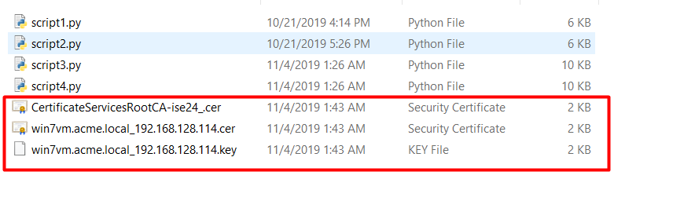

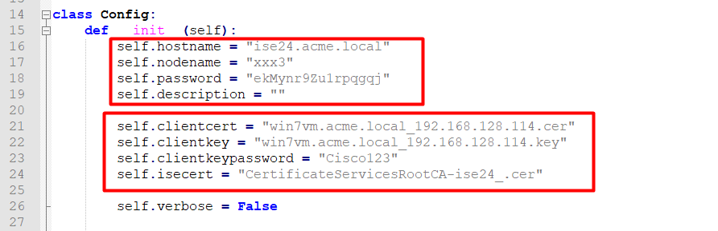

Run the script3.py

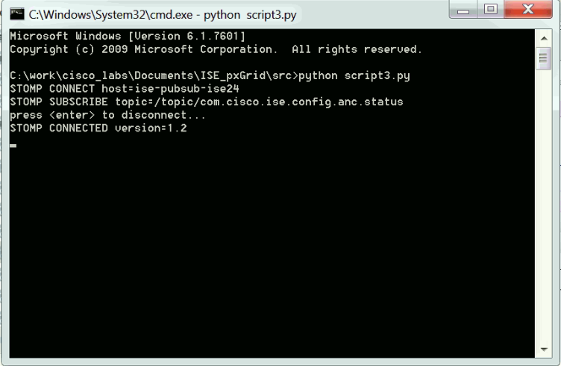

Change the anc policy using the Script2.py, then you can see the immediate message on the Script3.py running.

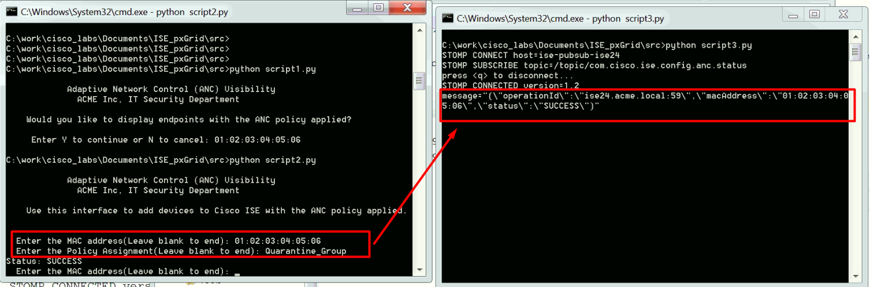

**Source code explanation**

Get the websocket URL and secret key.

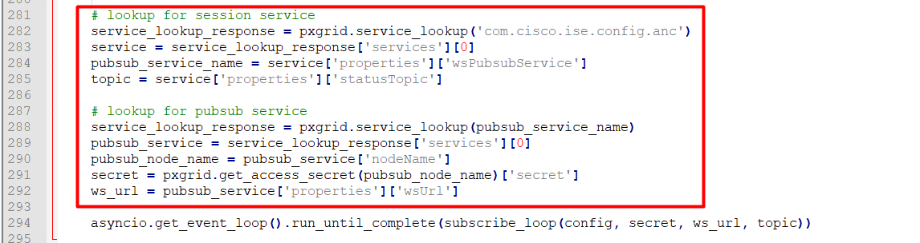

Connect to the websocket.

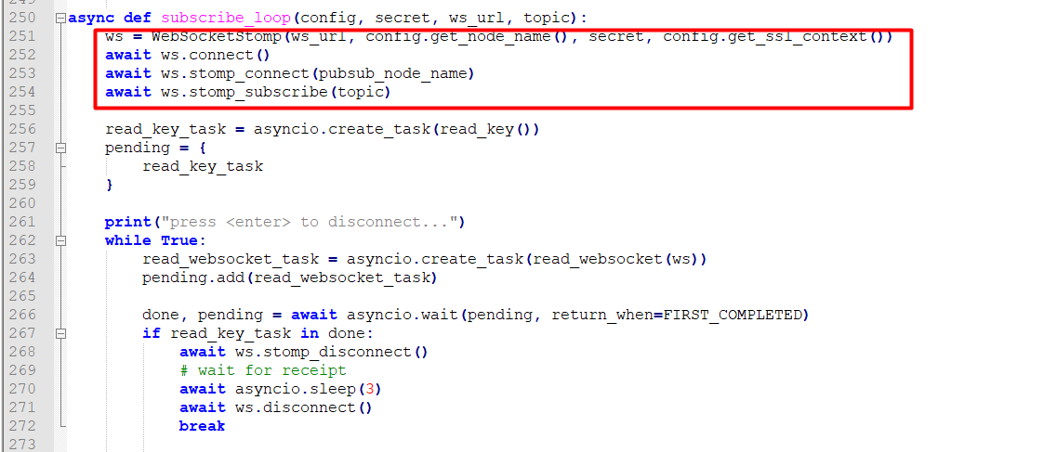

Waiting a keyboard ‘q’ is pressed, or received a message from websocket.

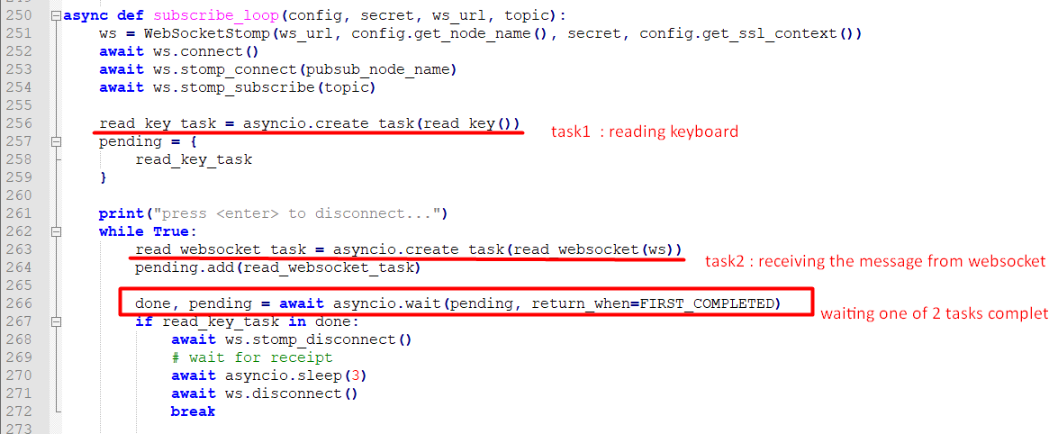

**Specific parameter for anc policy:**

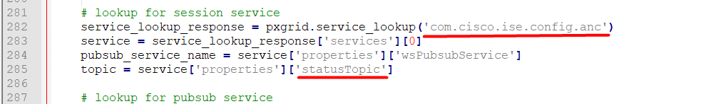

<https://github.com/cisco-pxgrid/pxgrid-rest-ws/wiki/ANC-configuration>

