Script4.py

**Description**

Subscribe the radius failure using pxGrid websocket pubsub.

Run the script4.py

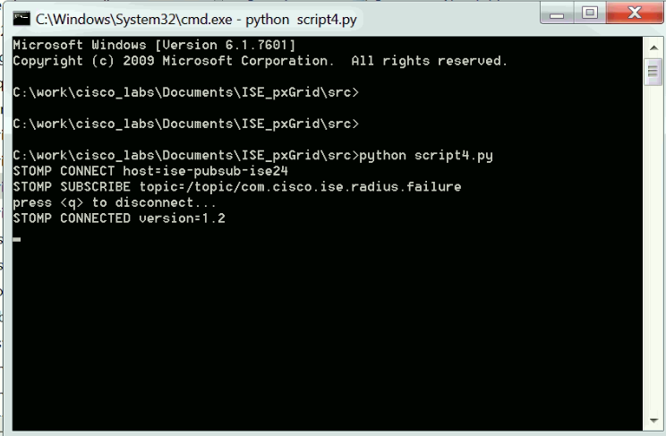

Radius success: Connect with correct user information.

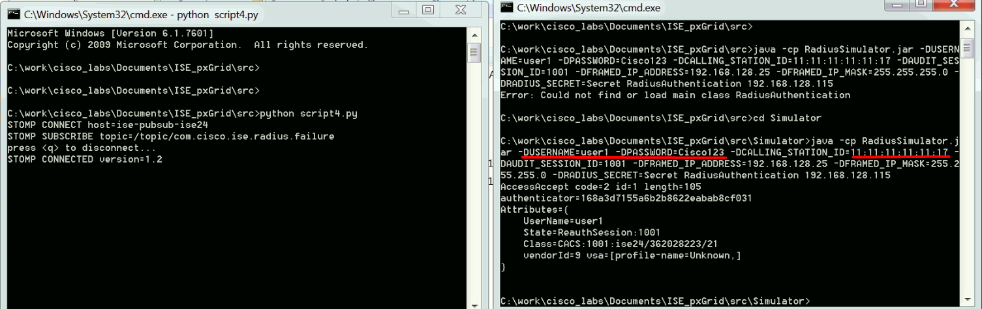

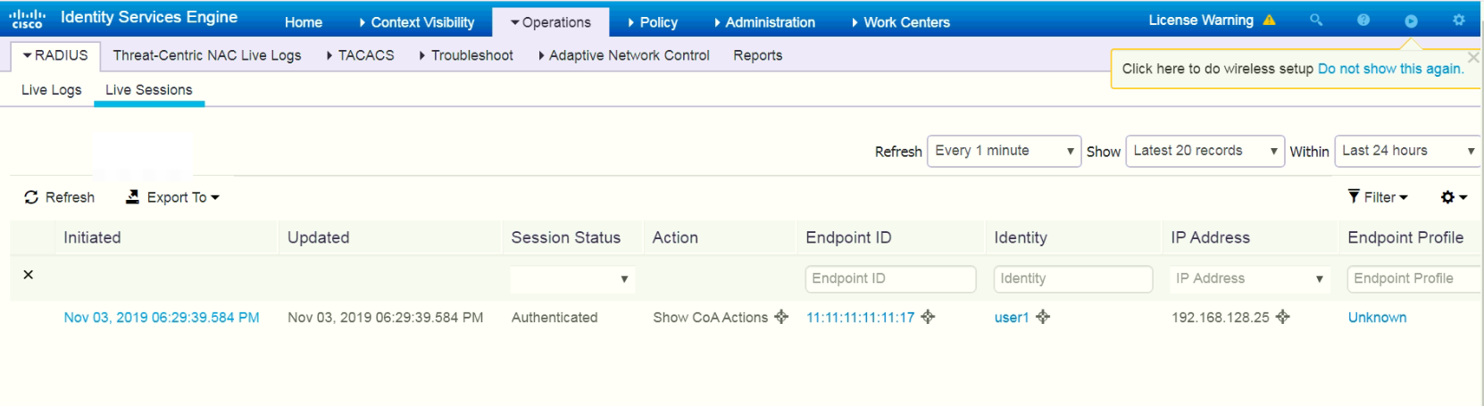

Radius failure: Connect with wrong user information.(bad username/password).

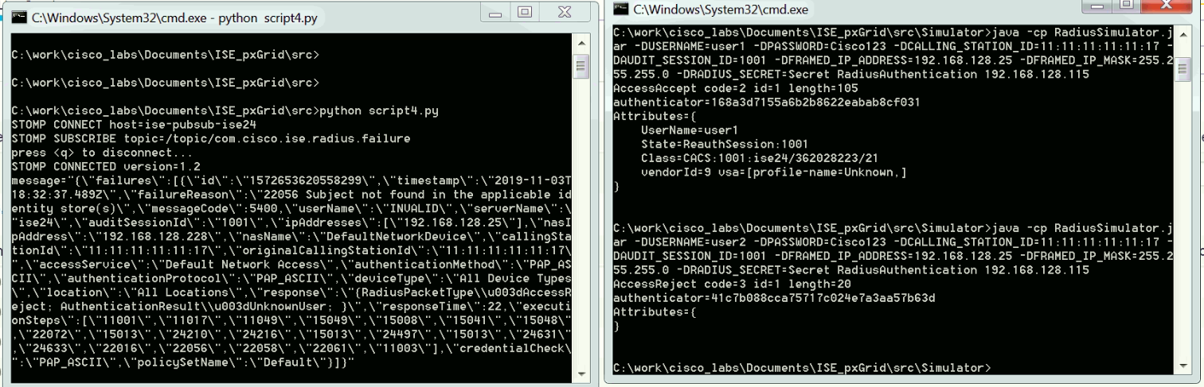

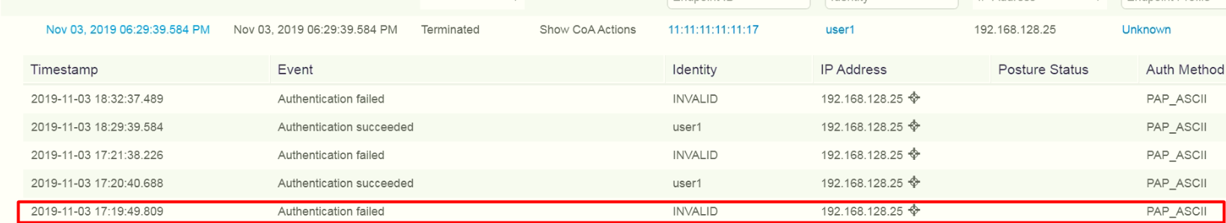

Radius another failure: Connect with wrong user information.(bad username/password, change the MAC).

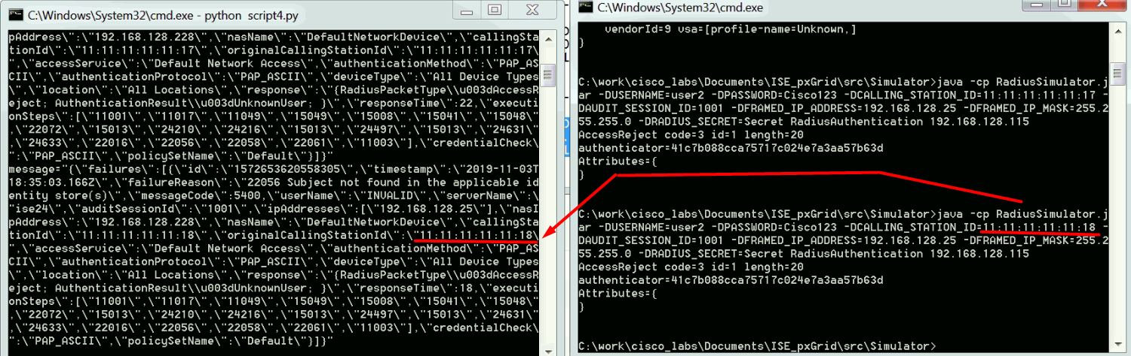

**Specific parameter for radius failure:**

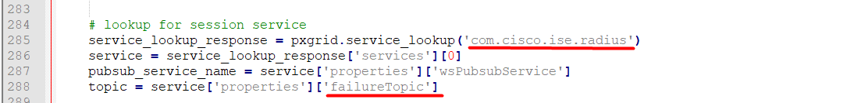

<https://github.com/cisco-pxgrid/pxgrid-rest-ws/wiki/Radius-Failure>

