pxGrid setting on ISE

Step 1 - Enable the pxGrid

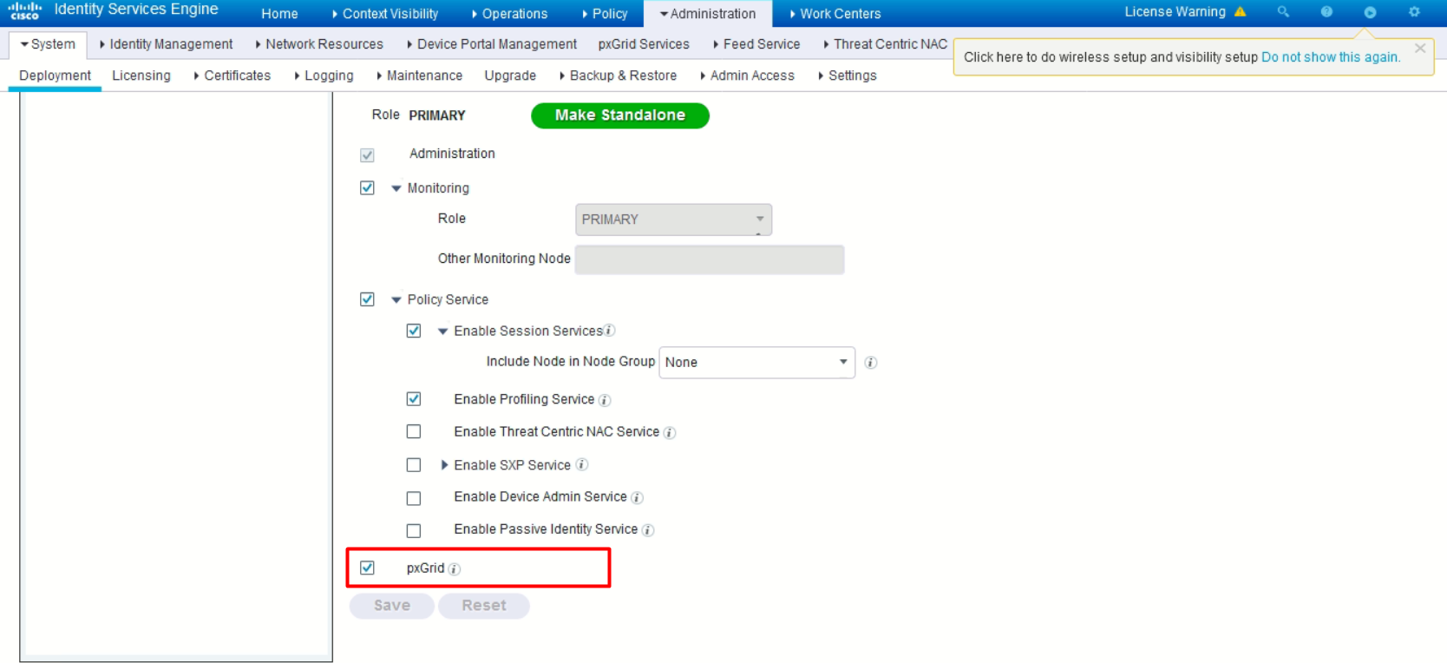

Step 2 – Allow password based account creation

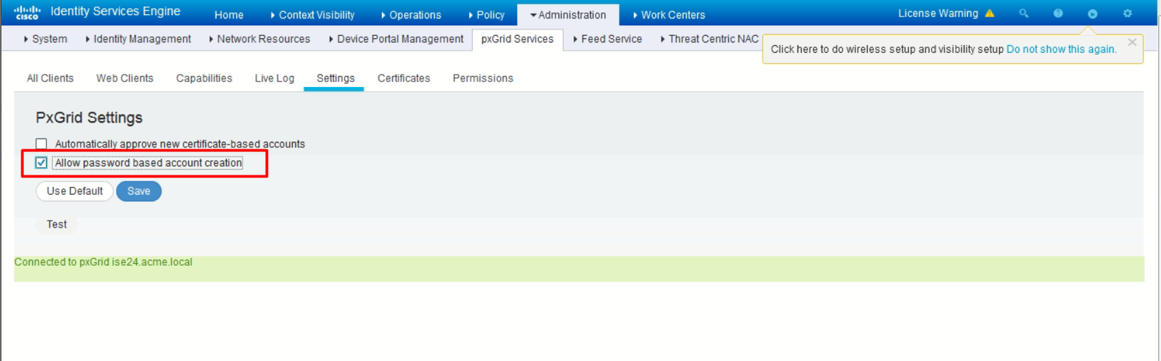

(Note: In this lab, standalone PostMan Windows application is used, rather than the PostMan Chrome Extension.

And it is needed to turn off the SSL verification on the PostMan settings page.)

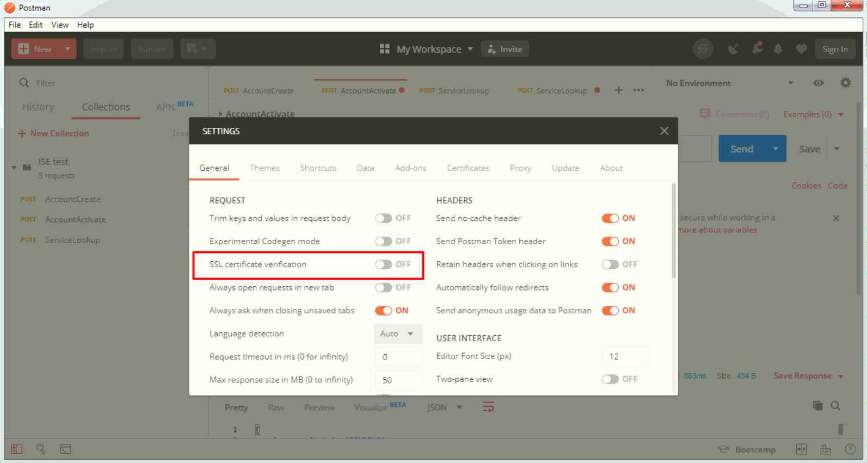

Creating the pxGrid client Account

- Method

POST

- URL

https://ise24.acme.local:8910/pxgrid/control/AccountCreate

- Header

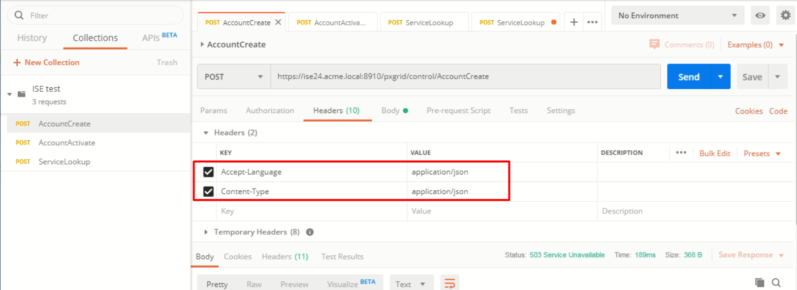

- Body

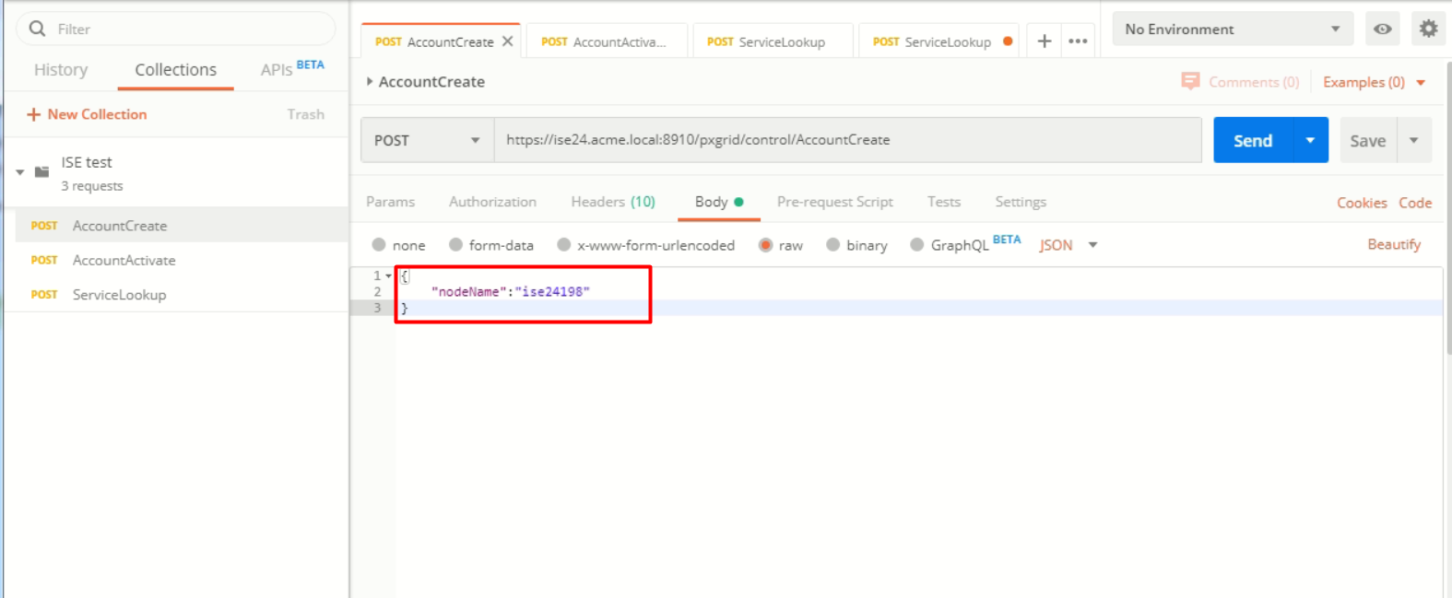

- Response

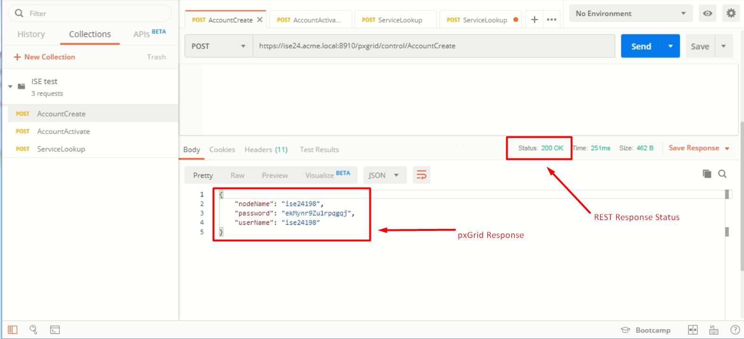

Activating the Account

- Method

POST

- URL

https://ise24.acme.local:8910/pxgrid/control/AccountActivate

- Authorization

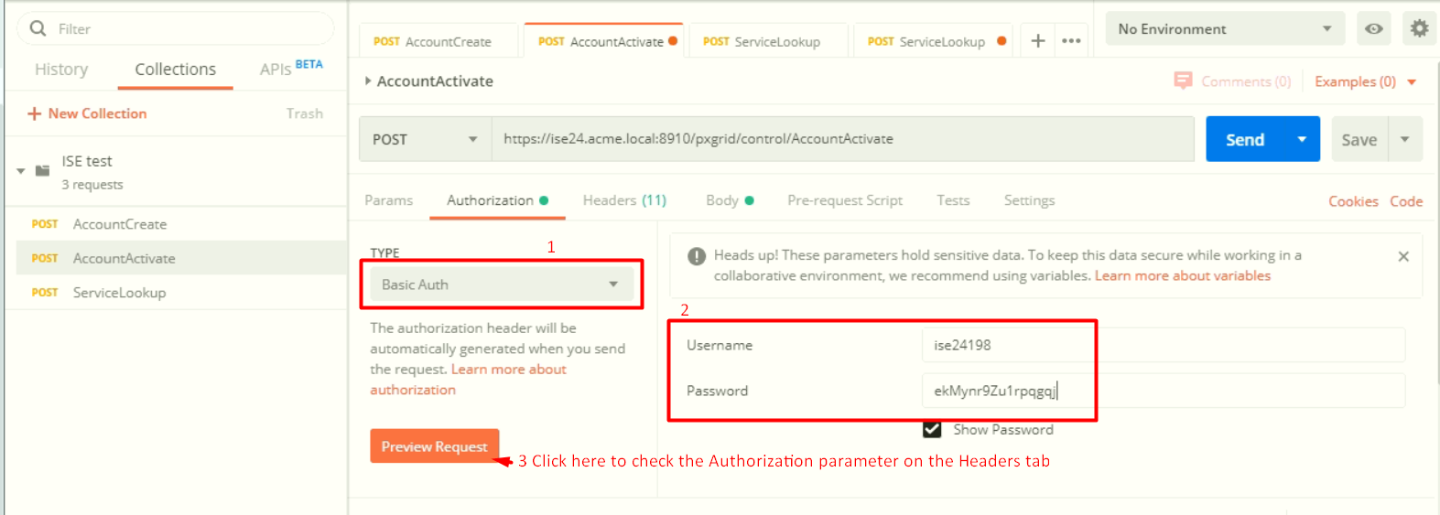

- Header

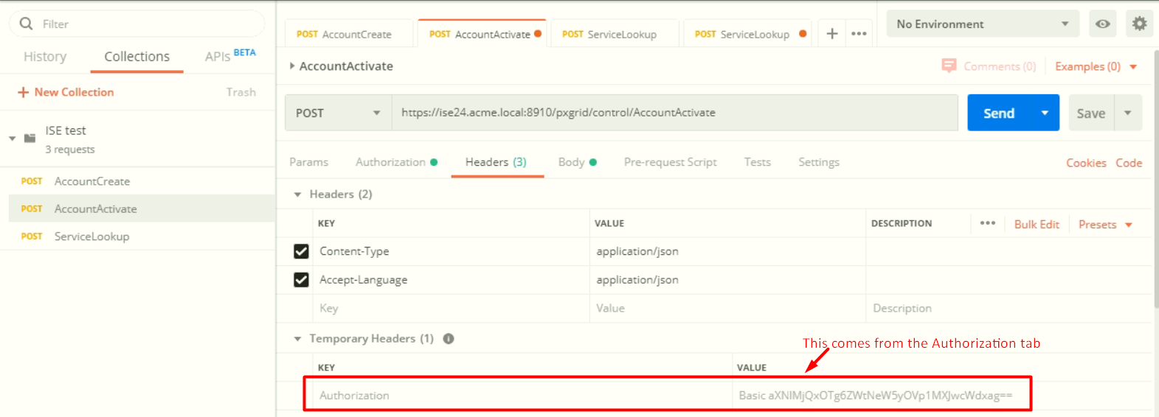

- Body

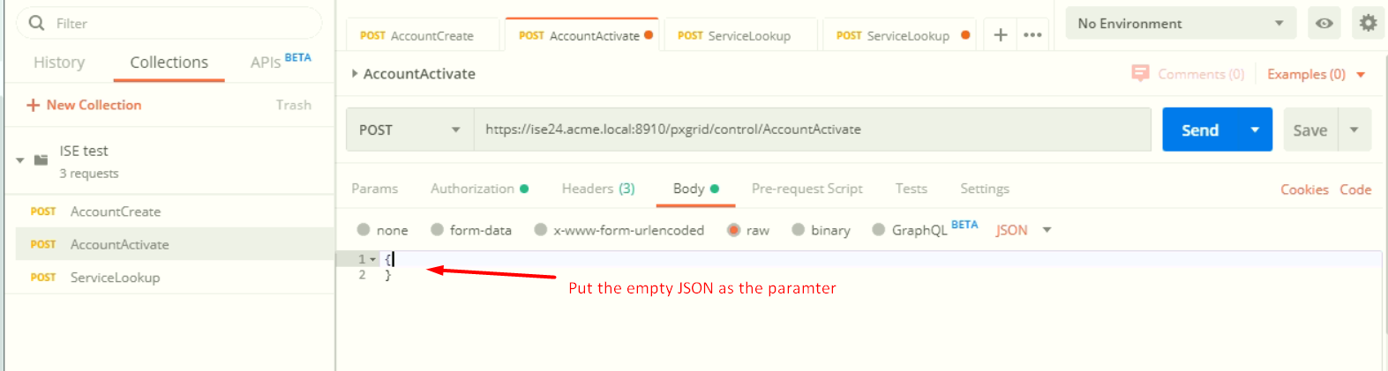

- Response

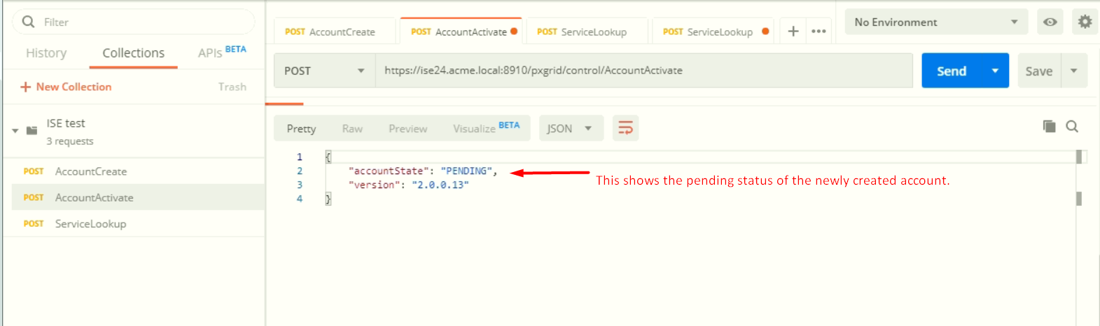

Activate the Account on ISE web interface

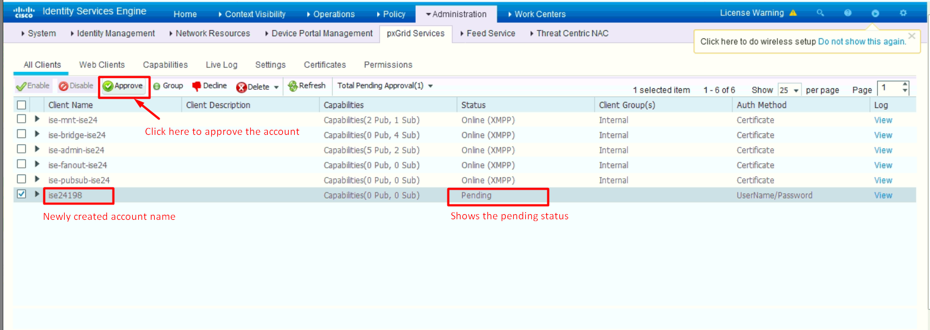

Check the account activation on PostMan

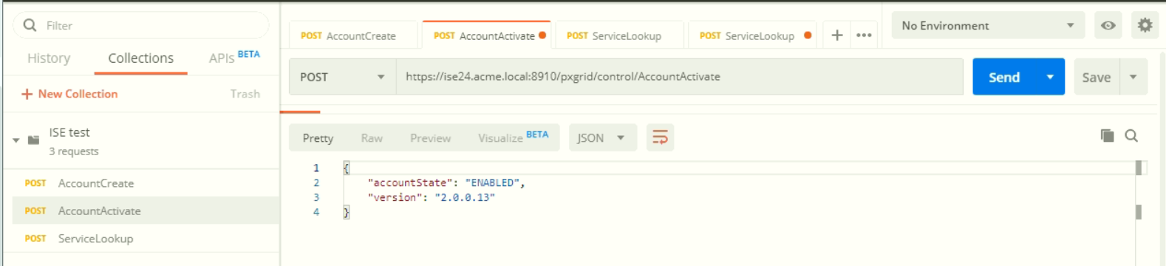

How to run the script1.py

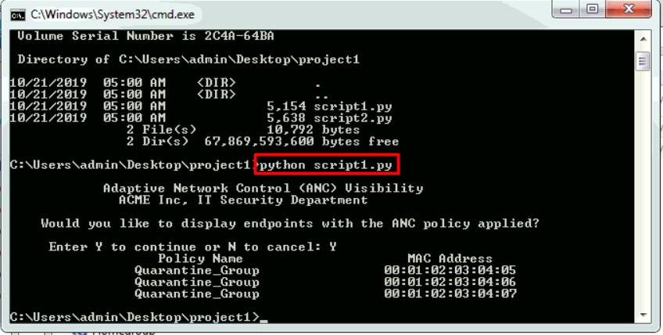

(Note: The most recommended python editor is the Sublime Text Editor. It support the python syntax highlight.

And add some comments on the original scripts.)

Explanation about the Script1.py

Retrieve all the endpoints.

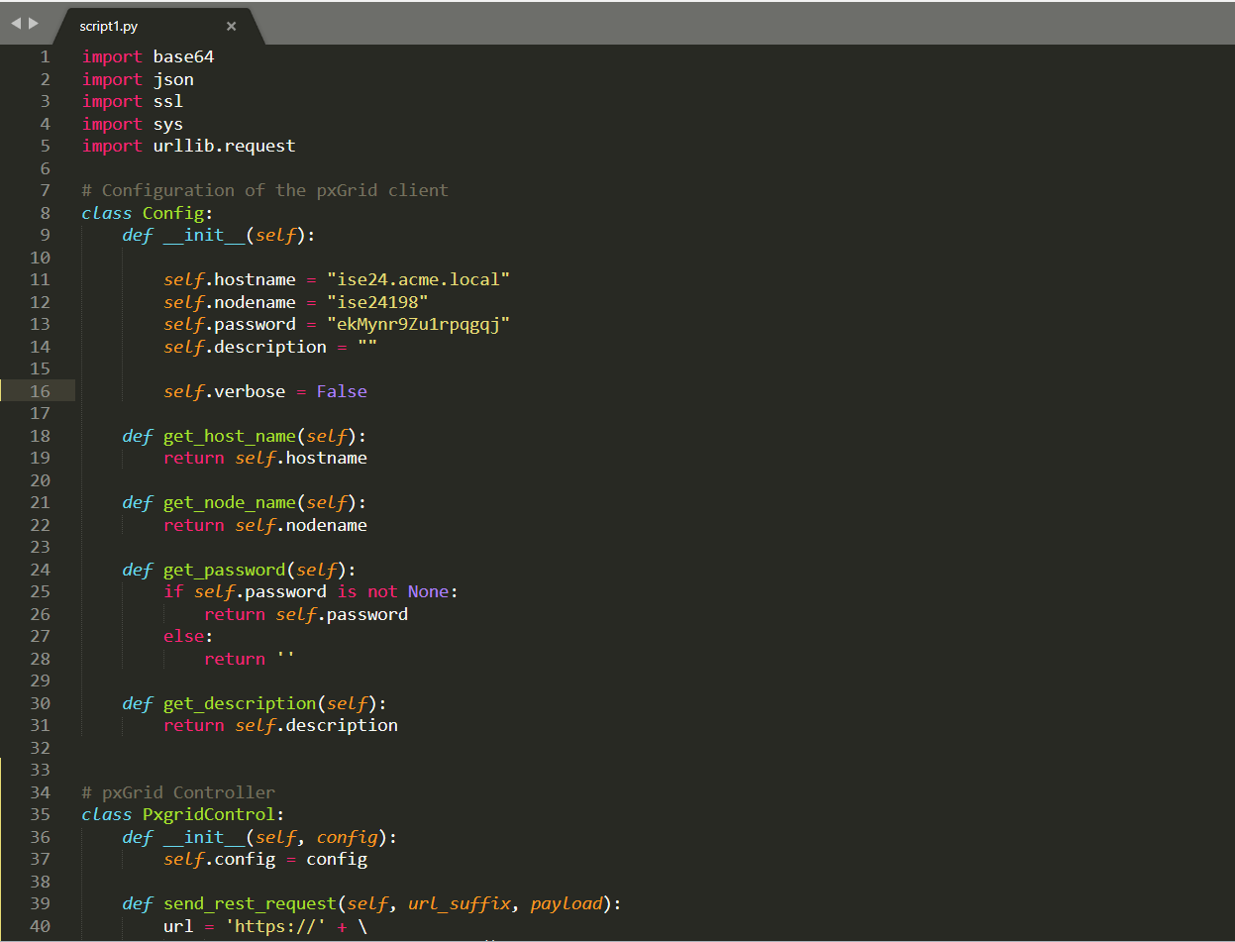

- Set the configuration

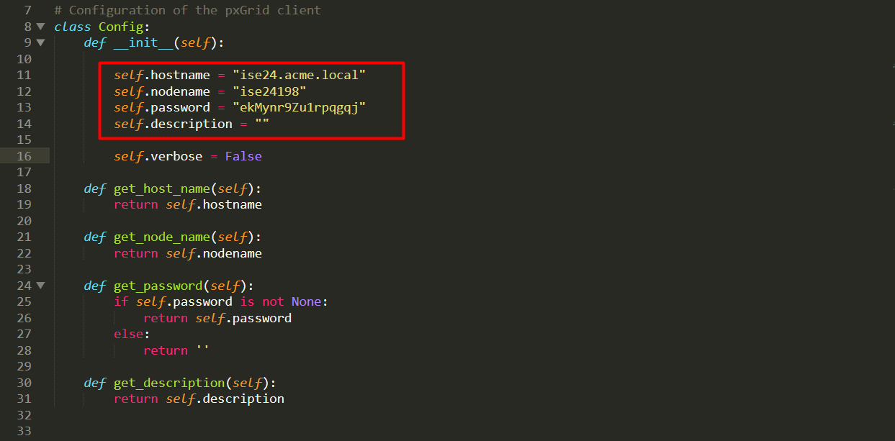

- PxgridControl

This class provide the features which performs the common pxGrid call, such as Account Activation, Service Lookup, etc.

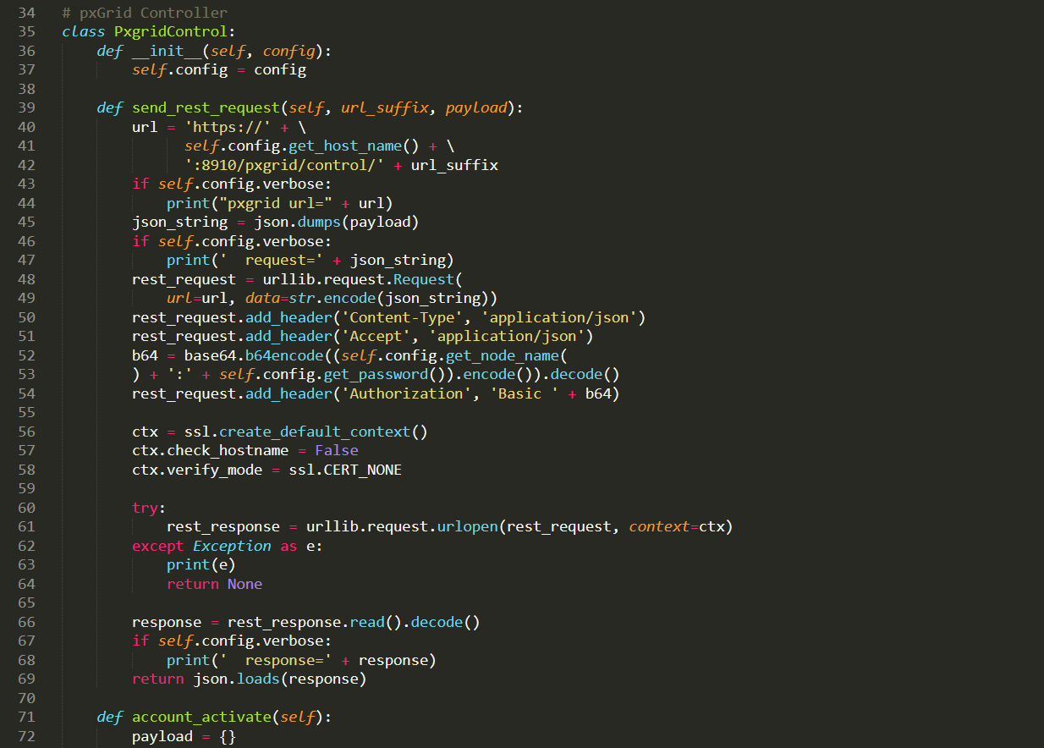

- query() function

This function performs the common REST API call using POST method.

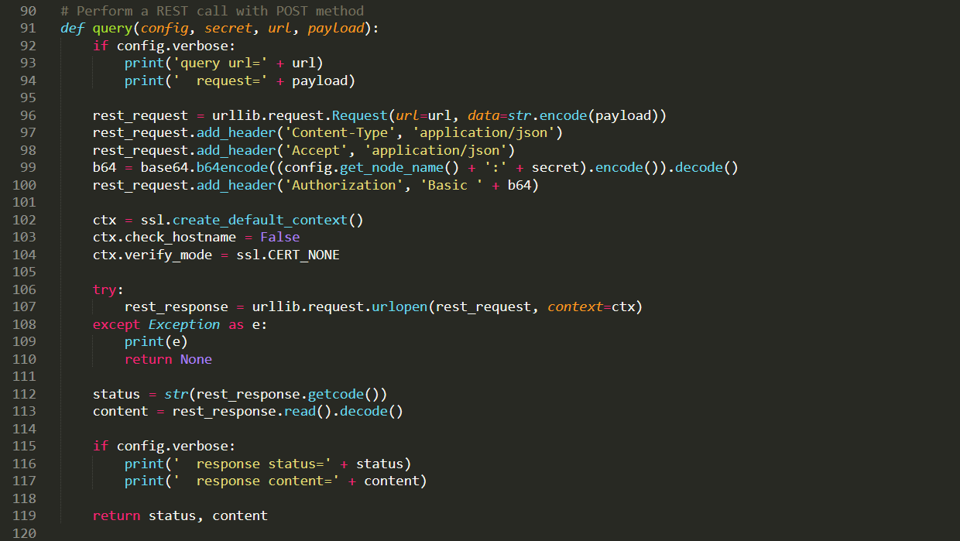

- retrieving_all_endpoints()

Performs the main functionality for this script.

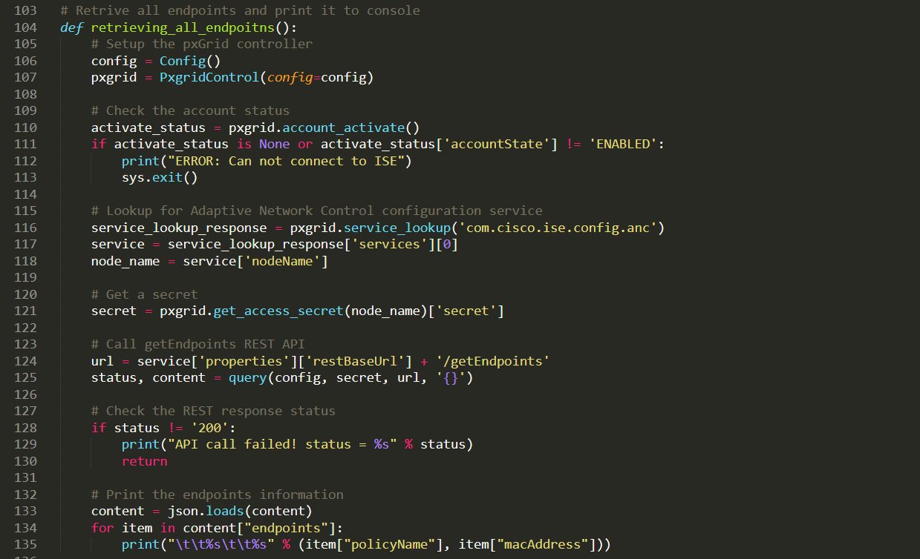

- main script

Display the menu and call the retrieving_all_endpoints() function according to the user’s choice.

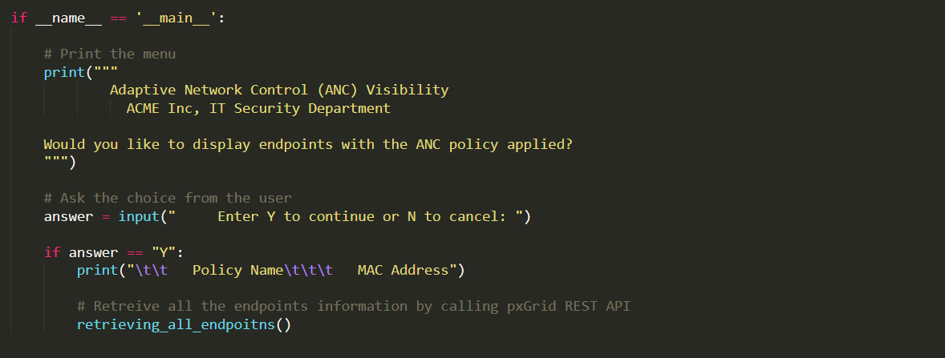

Inspecting the running process of the script1.py

1. Set the verbose mode to be true.

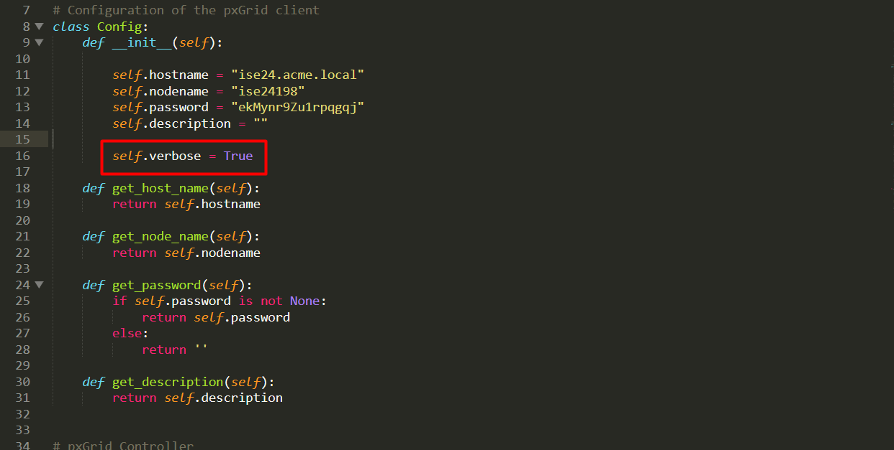

2. Run the script

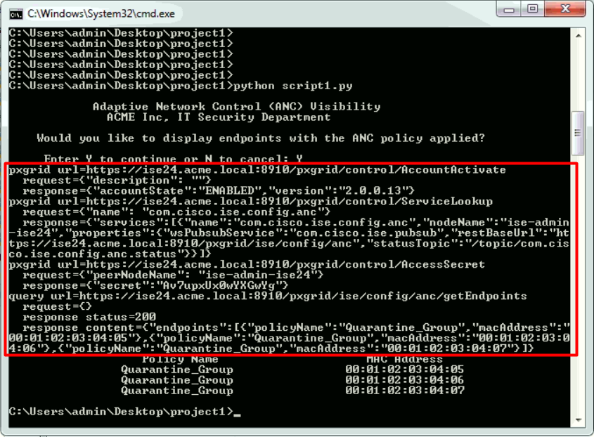

1) Check the account status

- Code on script1.py

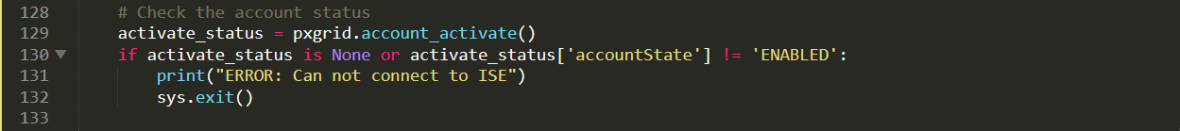



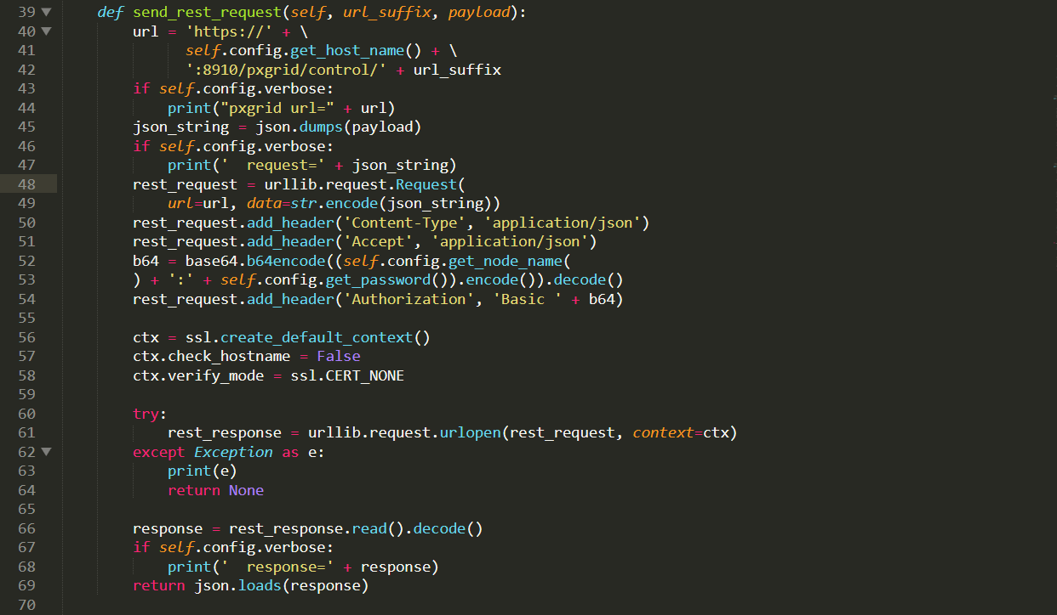

- Console output



- PostMan output

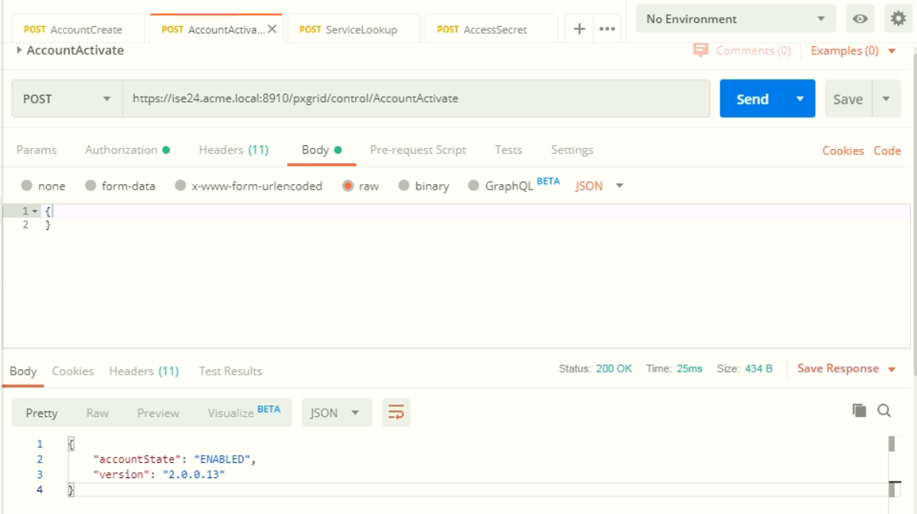

2) Service Lookup

- Code on script1.py





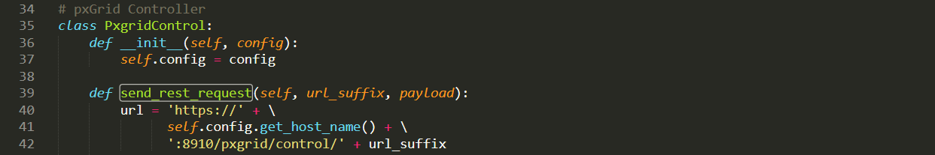

- Console output

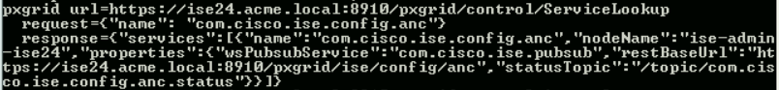

- PostMan output

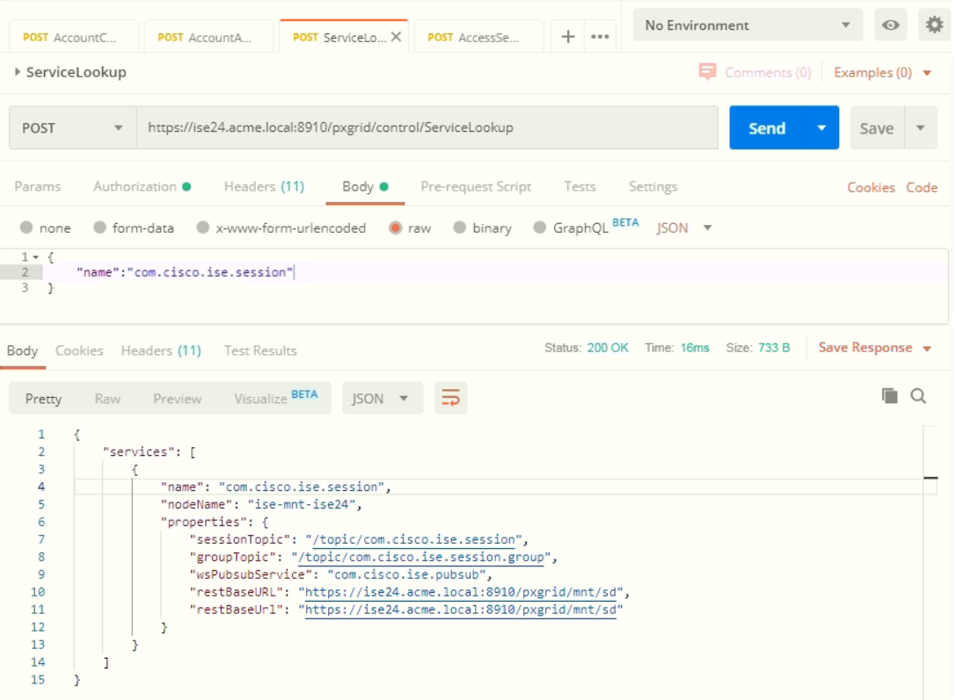

3) Get the access secret

- Code on script1.py





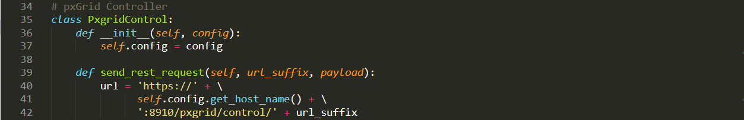

- Console output



- PostMan output

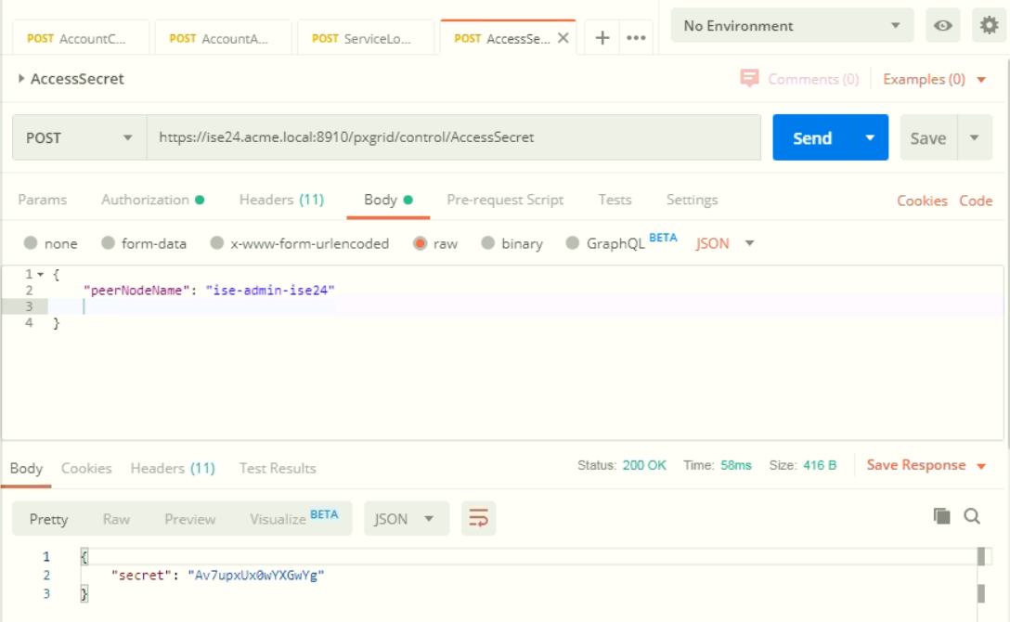

4) Get all the endpoints

- Code on script1.py



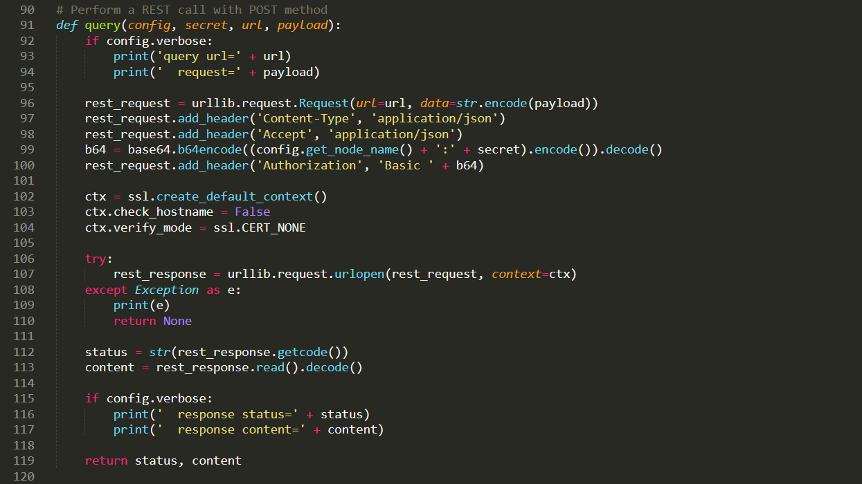

- Console output

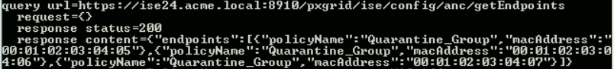

- PostMan output

(Note: For this time, change the authorization with the secret key which is acquired in the previous step.)

Authorization

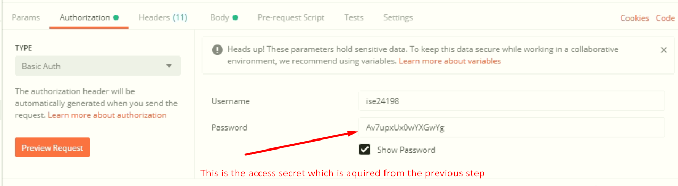

Response

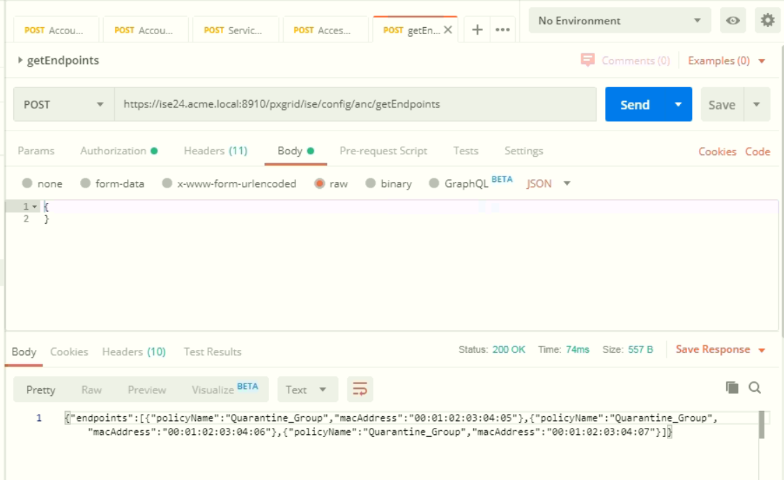

Thank you