How to run the script1.py

Before running the script2.py

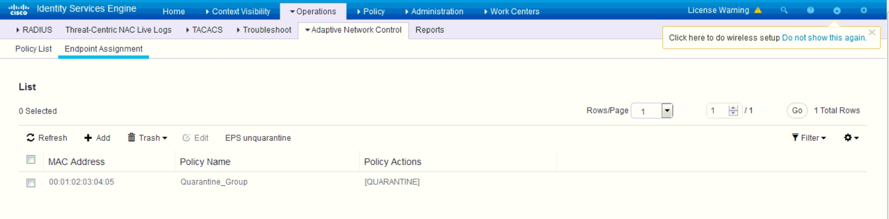

Run the script2.py

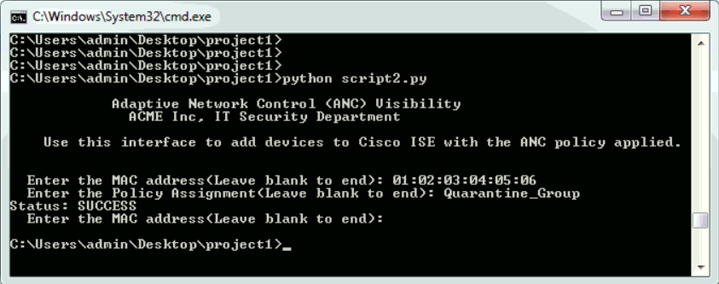

After running the script2.py

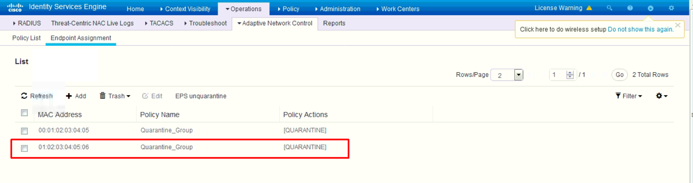

Explanation about the Script2.py

Add an ANC policy with MAC address and policy assignment.

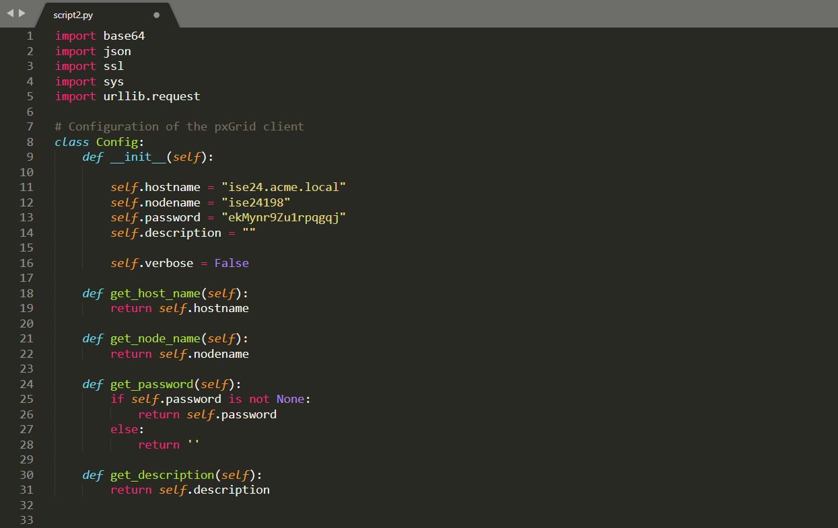

- Set the configuration

(Same with Script1.py)

- PxgridControl

This class provide the features which performs the common pxGrid call, such as Account Activation, Service Lookup, etc.

(Same with Script1.py)

- query() function

This function performs the common REST API call using POST method.

(Same with Script1.py)

- creating_an_anc_policy() function

Create an ANC policy

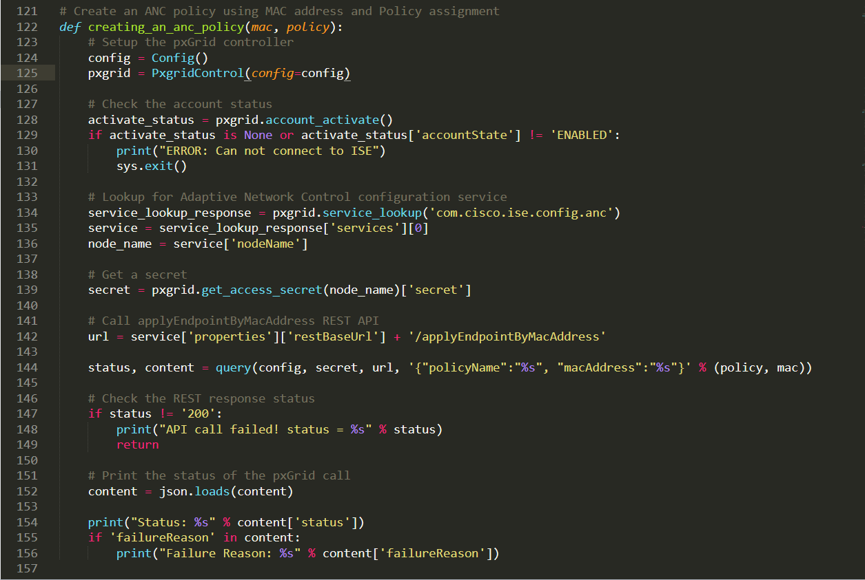

- main script

Input the MAC address and policy assignment name from the user, and call the creating_an_anc_policy() function.

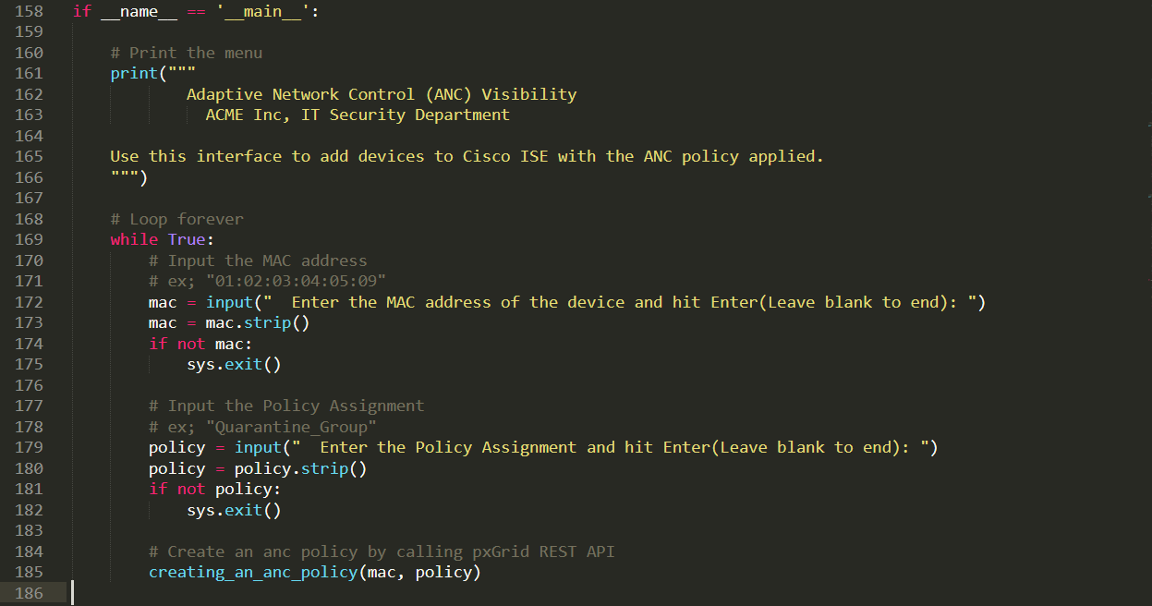

Inspecting the running process of the script2.py

1. Set the verbose mode to be true.

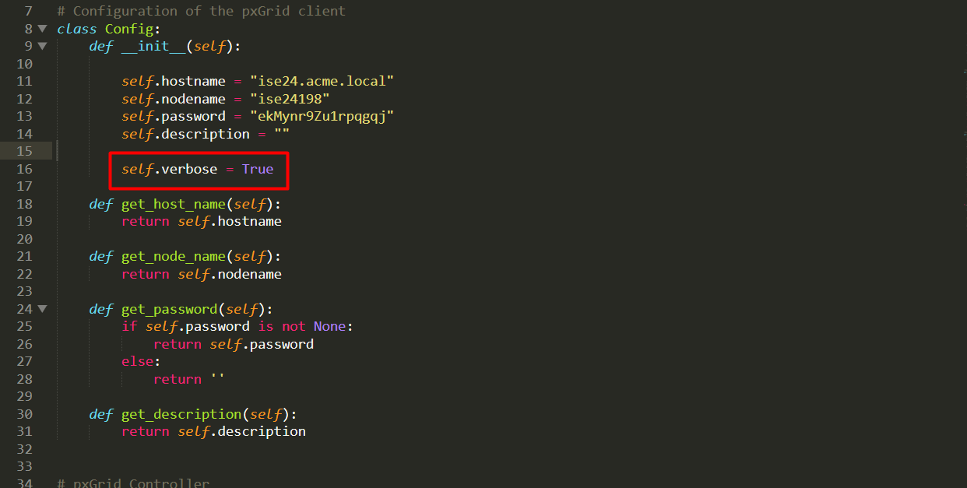

2. Run the script

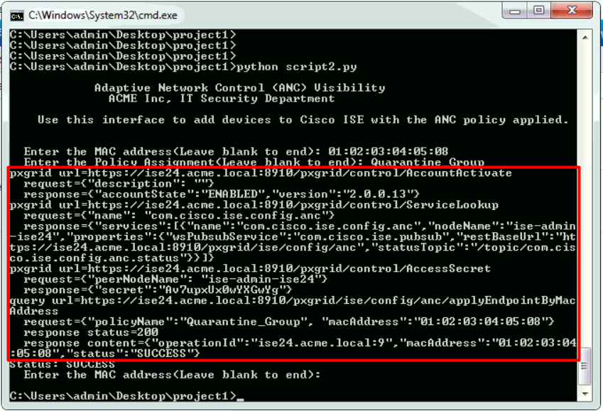

1) Check the account status

(Same with Script1.py)

2) Service Lookup

(Same with Script1.py)

3) Get the access secret

(Same with Script1.py)

4) Create an ANC policy

- Code on script2.py

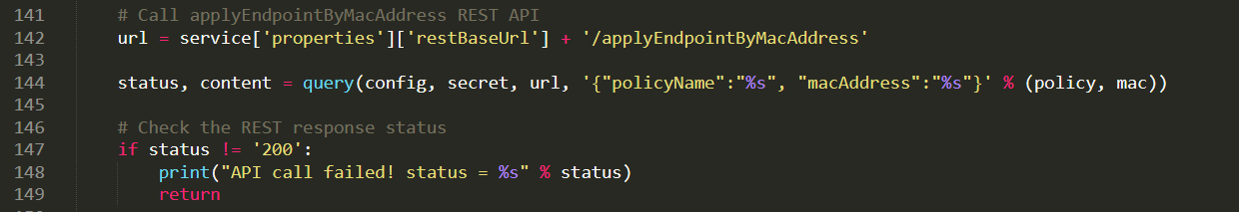

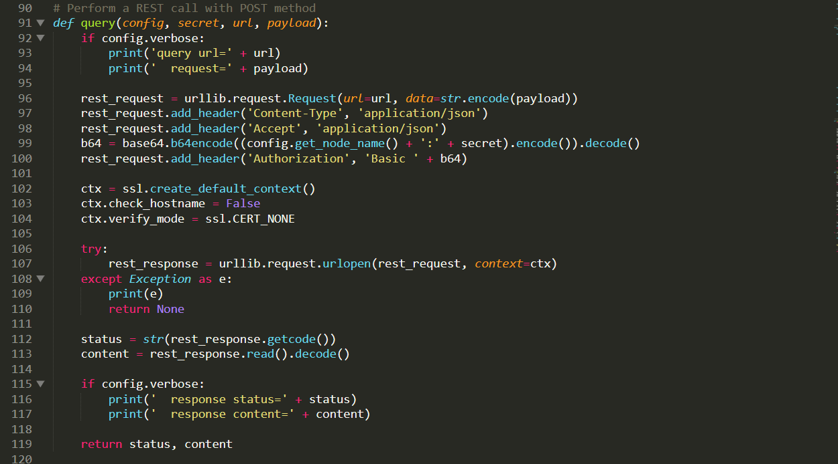

- Console output

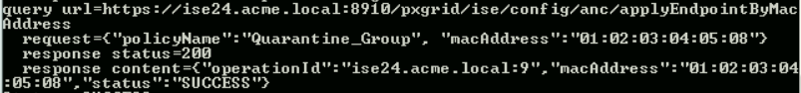

- PostMan output

Authorization

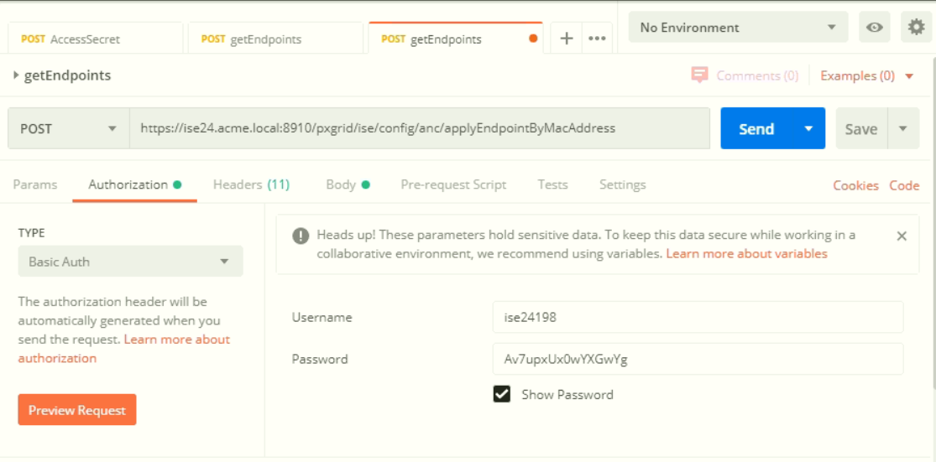

Response

Thank you

