Script1.py

(Status and Categories for a domain)

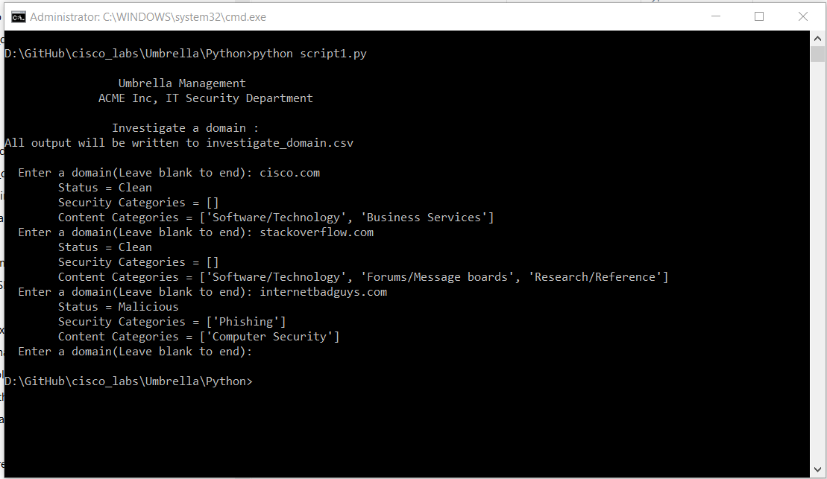

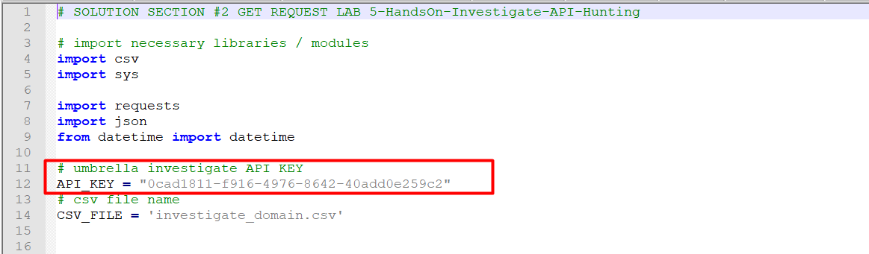

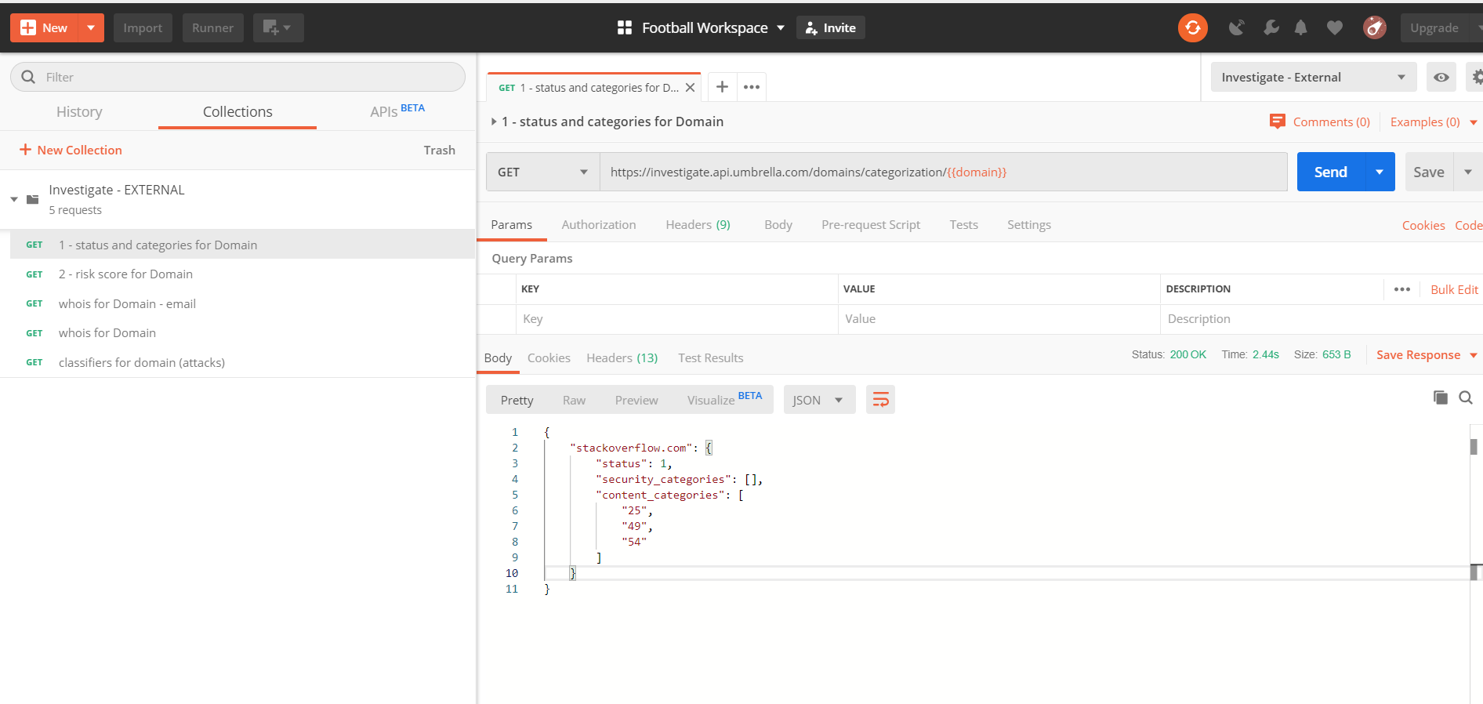

Status :

1 : Clean

-1: Malicious

Else: Undefined