**45) TG - Authenticate to Cisco Threat Grid API**

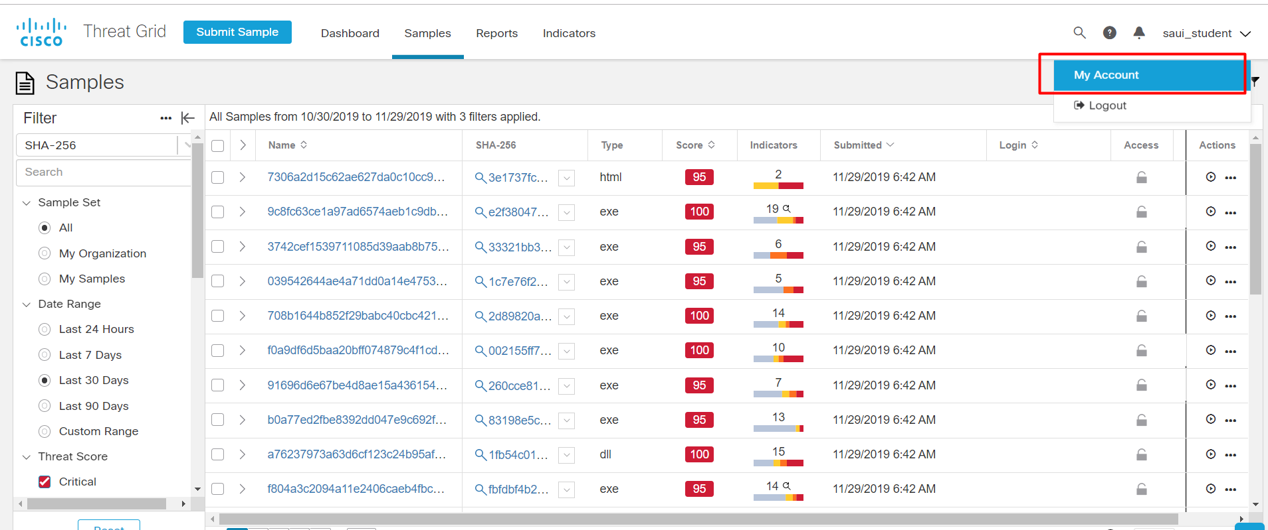

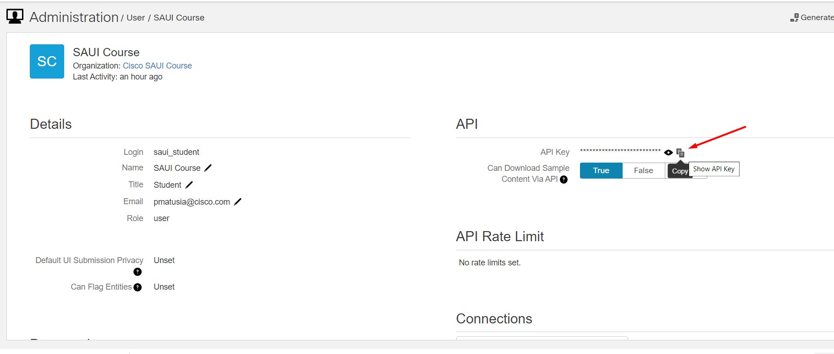

**46) TG - Search the Submissions Endpoint with the Given SHA Value**

<https://panacea.threatgrid.com/mask/samples>

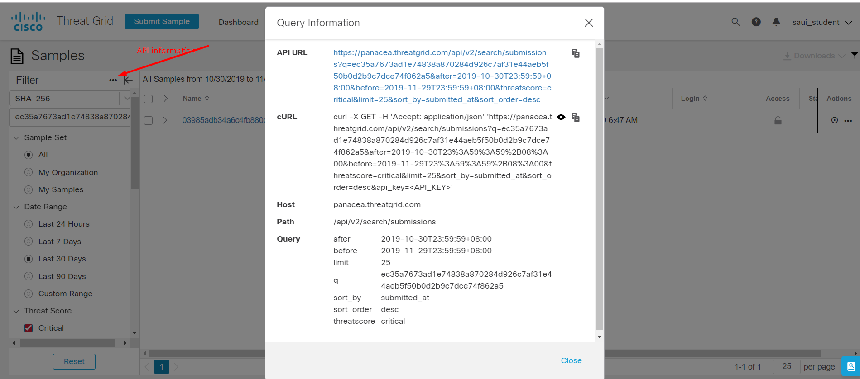

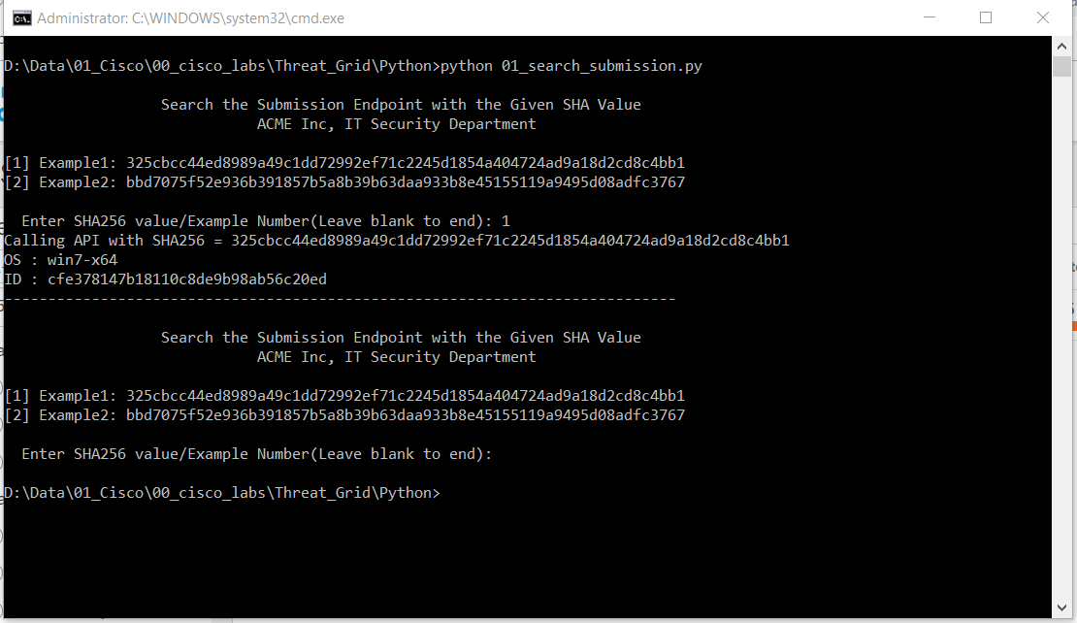

API_KEY



API_URL



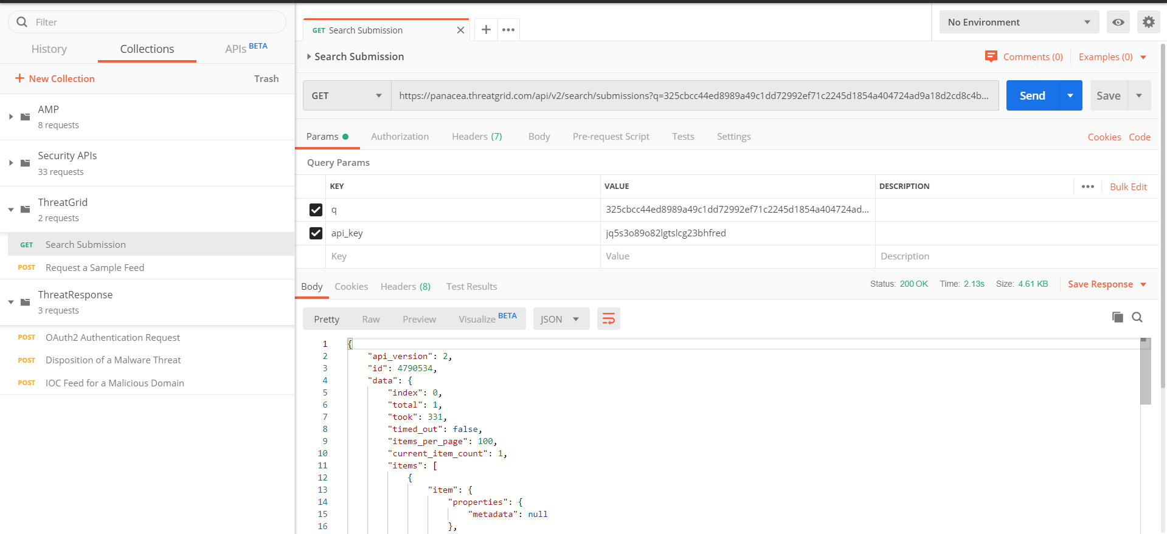

47) TG - Query the Indication of Compromise Feed for a Malicious Domain

- On the site

<https://visibility.amp.cisco.com/investigate>

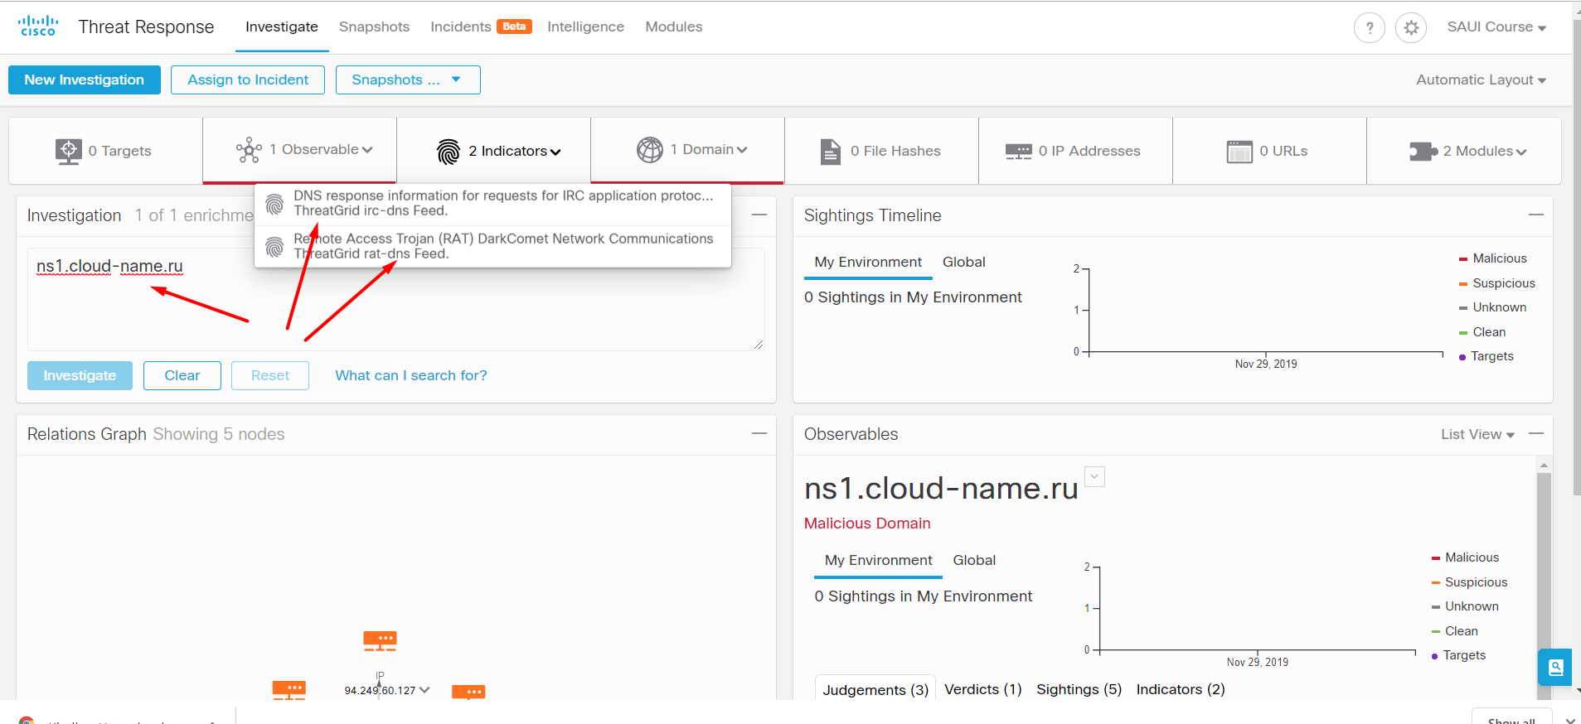

- Using the Postman

API key

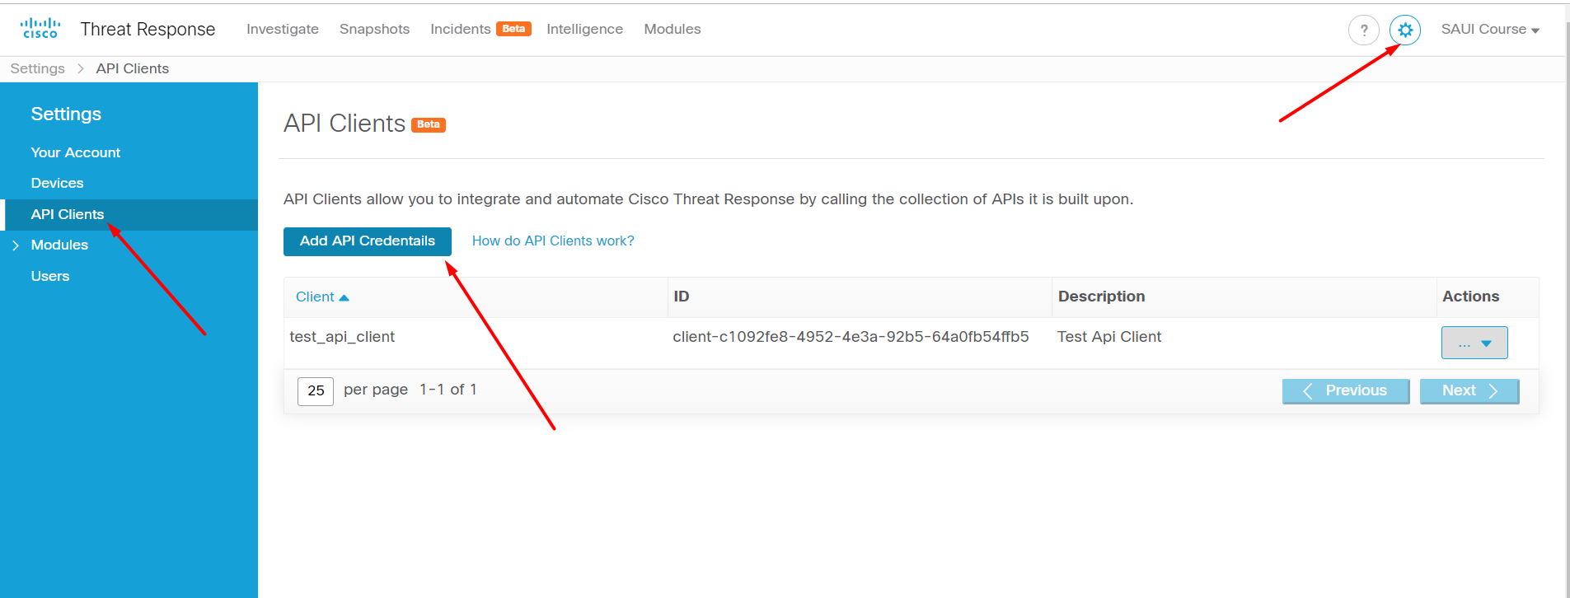

-Get the OAuth2 Authentication code

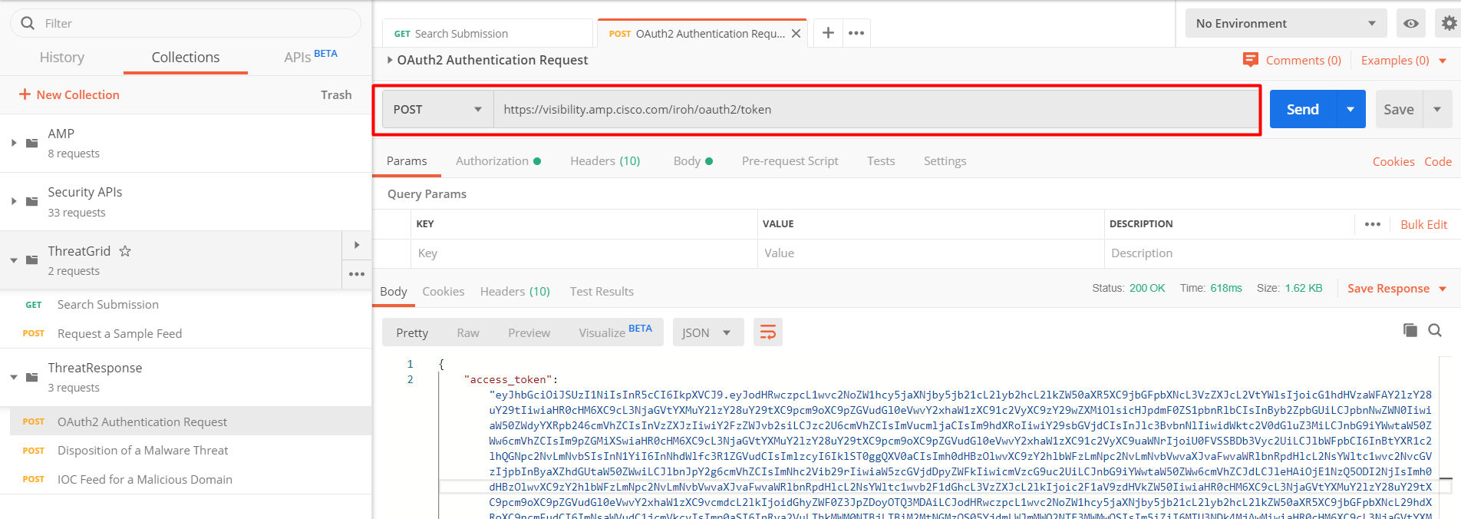

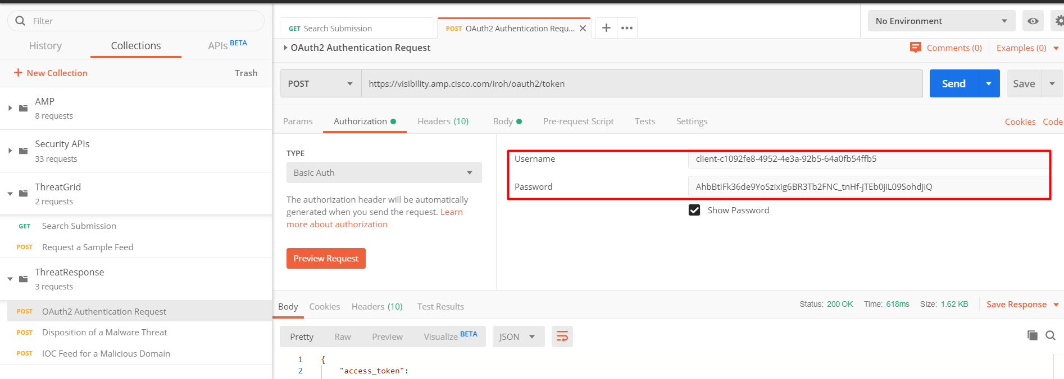

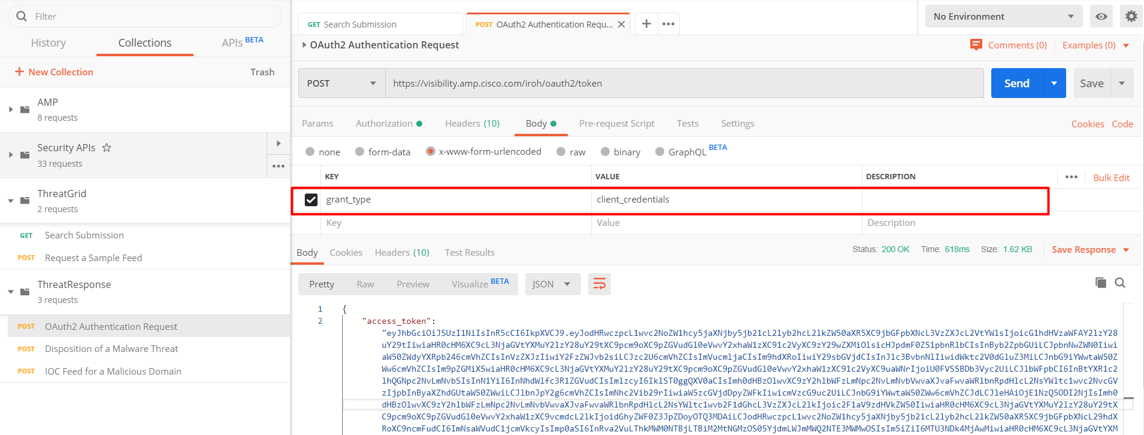

After clicking the “Send” button, copy the access token. This is bearer token.

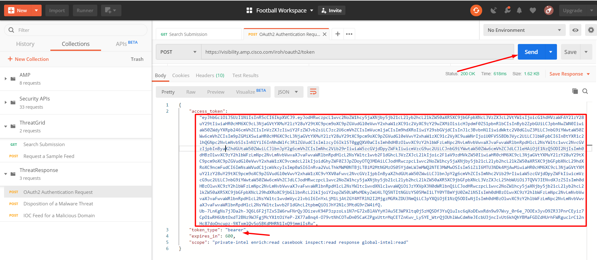

- Set the Authentication code when calling the “IOC Feed for a Malicious Domain”.

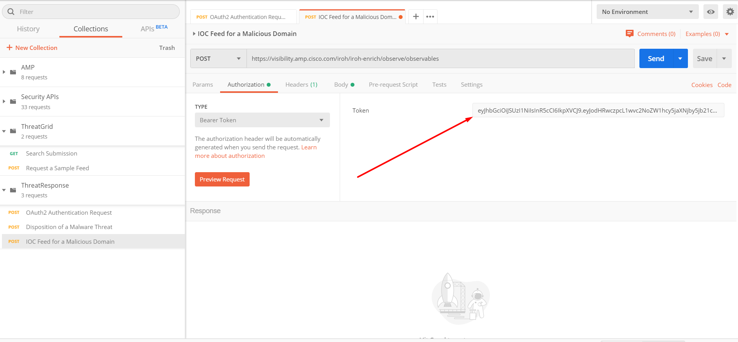

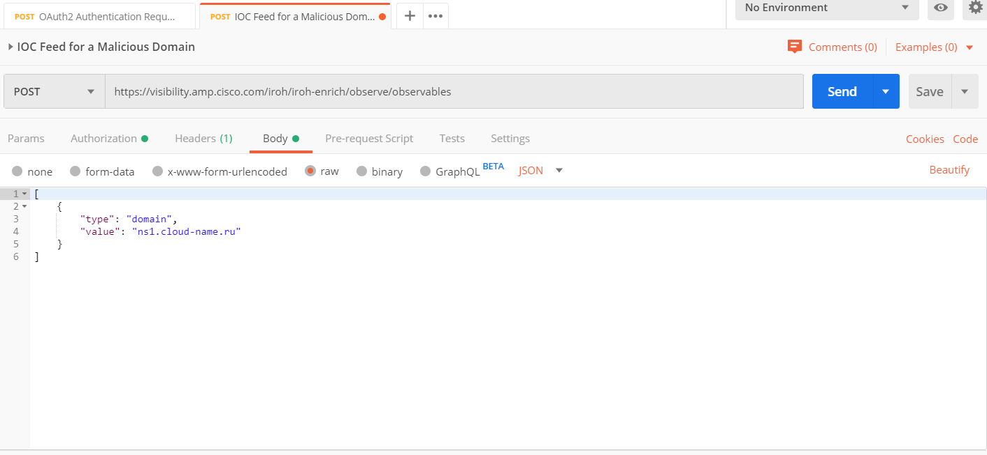

Result:

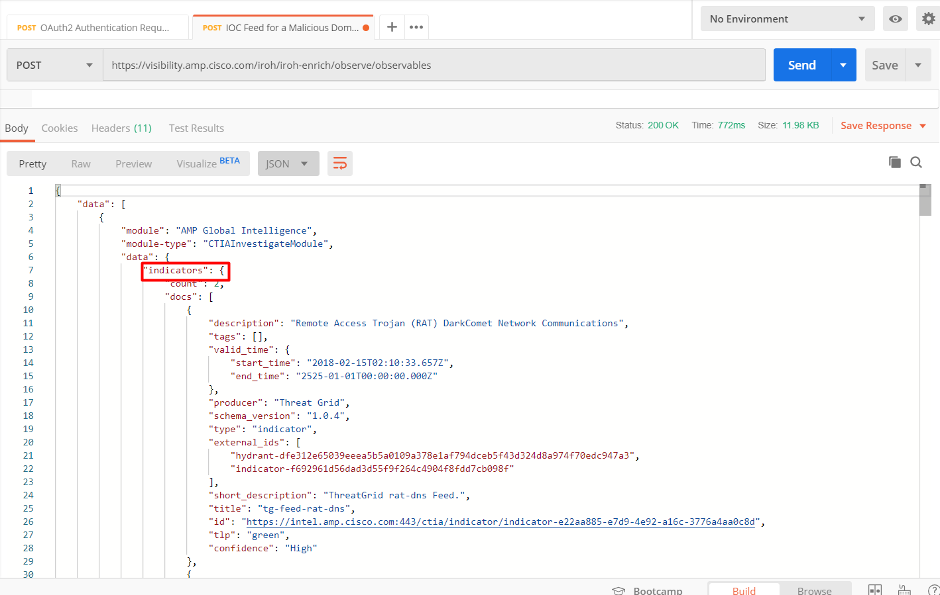

- Using the Python

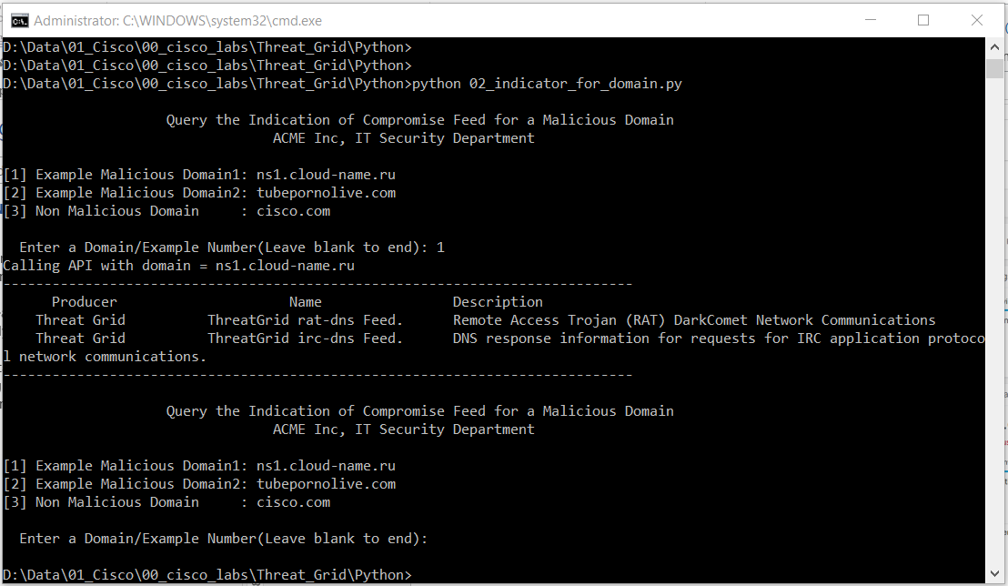

48) TG - Request with the API for Sample Feeds

- On the site

<https://panacea.threatgrid.com/mask/samples>

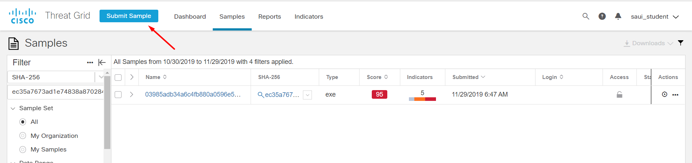

Reset result

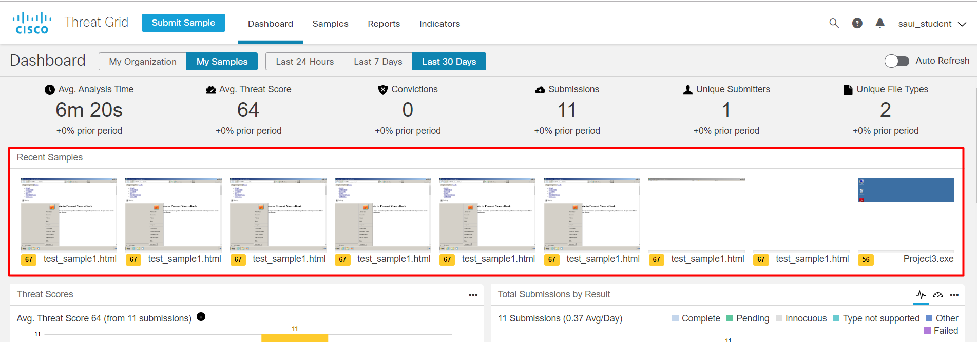

- Using Postman

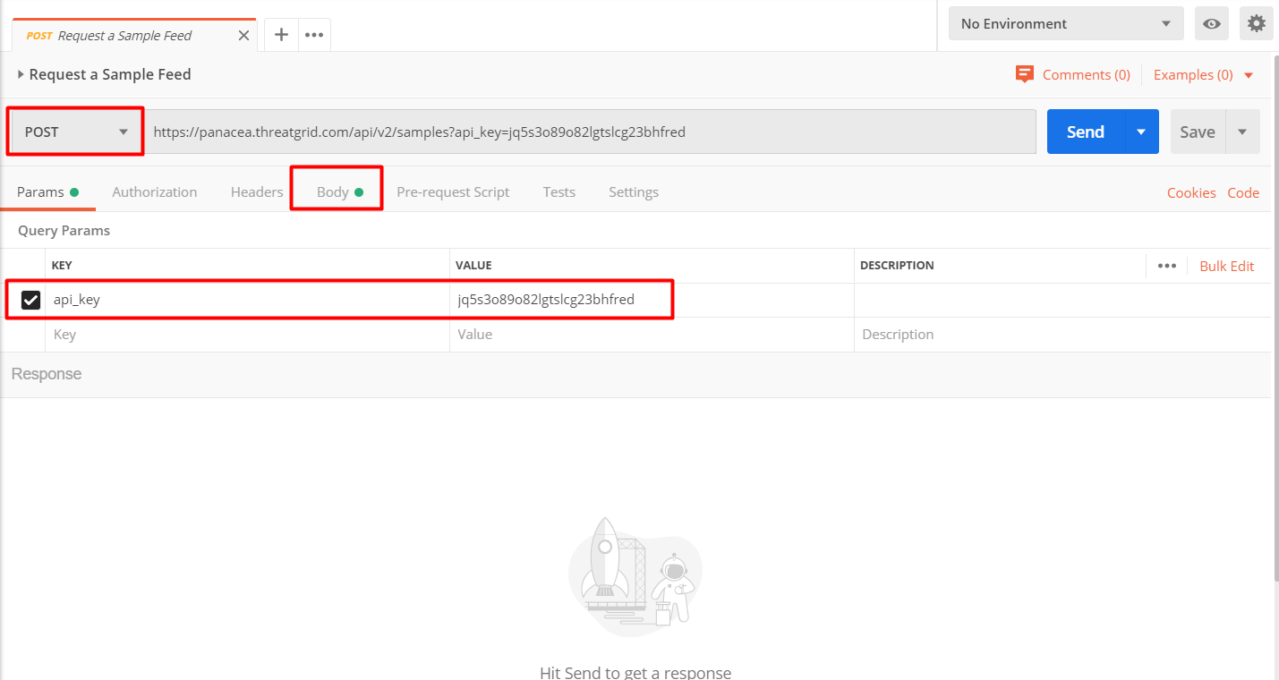

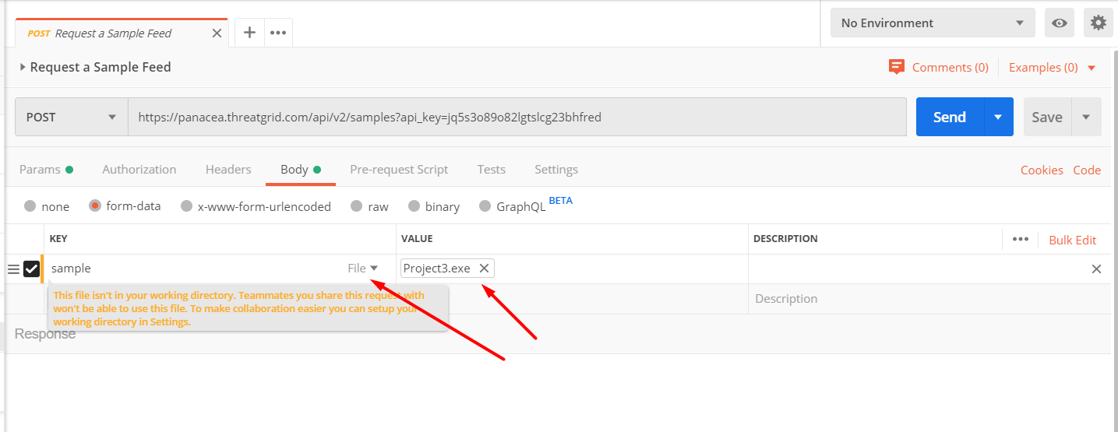

Result

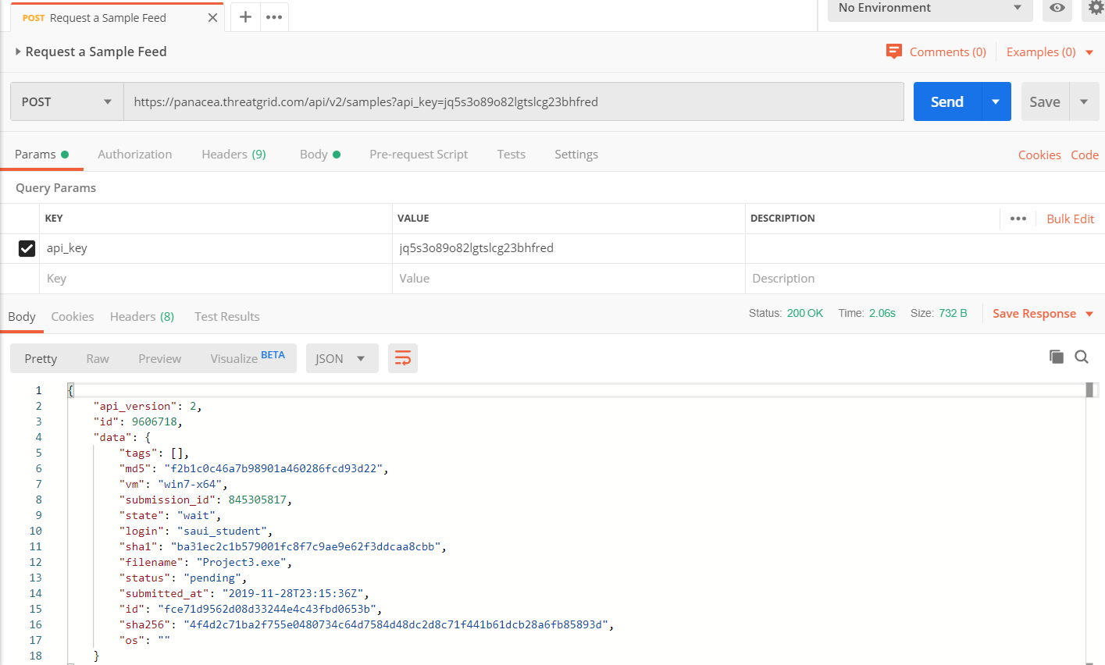

- Using the Python

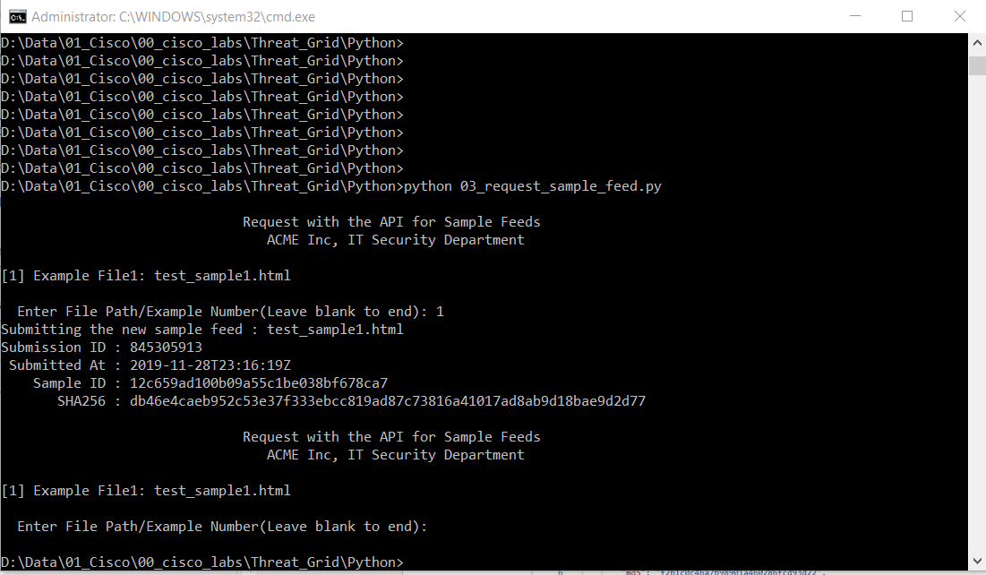

49) TG - Disposition of a Malware Threat

- On the site

<https://visibility.amp.cisco.com/investigate>

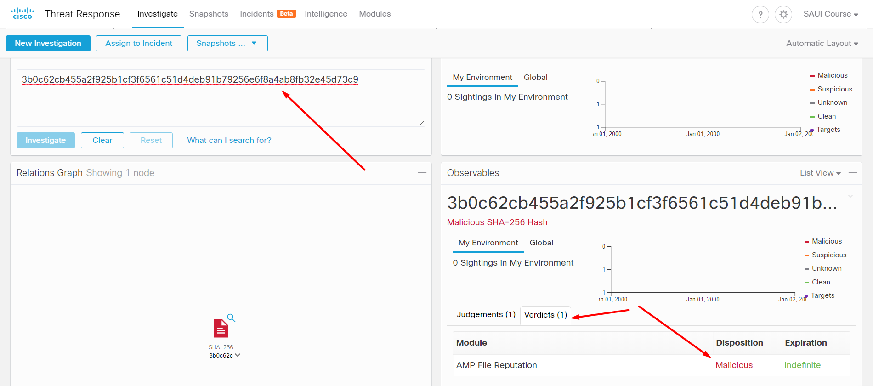

- Using the Postman

Get the OAuth2 authentication code and set it on the bearer code.

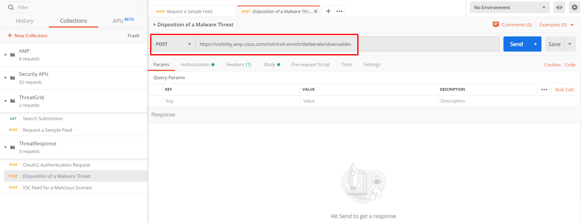

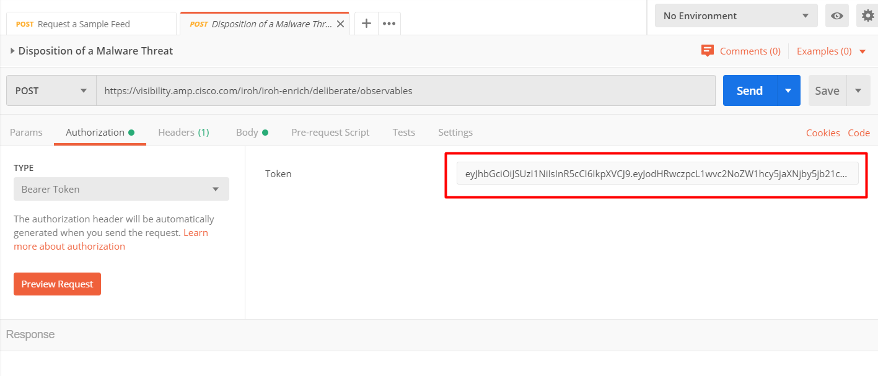

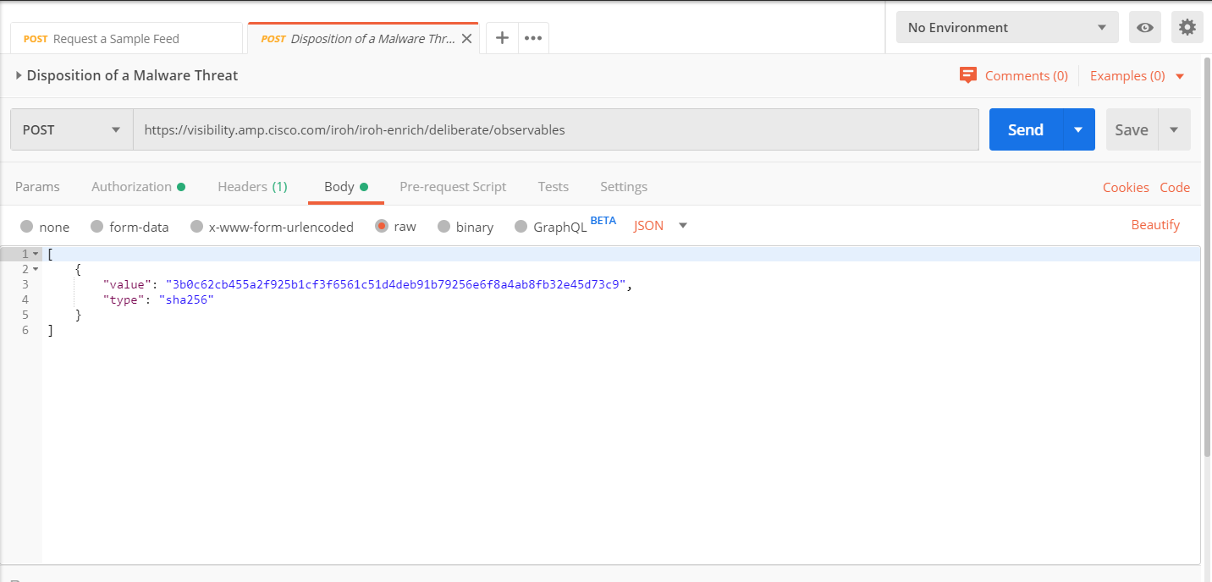

- Using the Python